Feasibility & Engineering Economics Report
  - New Valley Hub — Smart Tourism Platform
SandScript Team
April 2026
Table of Contents

Feasibility & Engineering Economics Report
Project: New Valley Hub
Prepared by: SandScript Team
Date: April 2026

1. Executive Summary
The New Valley Hub represents a strategic, high-yield digital infrastructure project aimed at transforming the eco-tourism ecosystem of Al Wadi Al Jadid (New Valley), Egypt. Structured similarly to a smart infrastructure system (e.g., a “Smart Garage” controlling throughput and value extraction), this platform centralizes diverse services—accommodation, local crafts, and AI-guided tours—into a unified digital gateway. By addressing severe market inefficiencies and bridging the digital divide, we unlock a sustainable and scalable revenue model with minimal initial capital expenditure and incredibly high margins. This report details the technical feasibility, economic viability, and precise cash flow structures validating the project’s long-term profitability.

2. Problem Statement & Opportunity
The Economic Problem:
Al Wadi Al Jadid contains unparalleled historical and natural assets, yet remains economically isolated due to a severe infrastructure and digital divide.
- Economic Isolation of Artisans: Local craftsmen and small merchants depend entirely on negligible physical foot traffic, severing them from a multi-million-dollar national souvenir and craft market.
- Data & Information Scarcity: Potential tourists face friction at every step—from navigating untracked desert routes to booking non-digitized eco-lodges.
- Fragmented Yield Management: The absence of a unified booking directory means massive lost revenue for both hospitality vendors and municipal oversight.
The Strategic Opportunity:
By deploying a centralized digital hub, we inject immediate liquidity into the local ecosystem. We act as the primary intermediary for all transactions, capturing value at multiple touchpoints while drastically reducing the customer acquisition cost (CAC) for local vendors.

3. Revenue Streams & Model
Our economic model relies on a diversified, low-marginal-cost revenue architecture. Similar to a toll-booth model in infrastructure economics, New Valley Hub captures value from throughput across its ecosystem.
- Hotel Commissions (12-15%): Primary volume driver. We take a commission on every room night booked through our API integrations.
- Marketplace Fees (10%): A direct transactional cut on the gross merchandise value (GMV) of local crafts and dates sold.
- Sponsored Listings: Predictable monthly recurring revenue (MRR) from local businesses prioritizing their placement on the platform.
- B2G Licensing (White Label): High-ticket, high-margin software licensing to municipal governments and tourism boards utilizing our data dashboards.
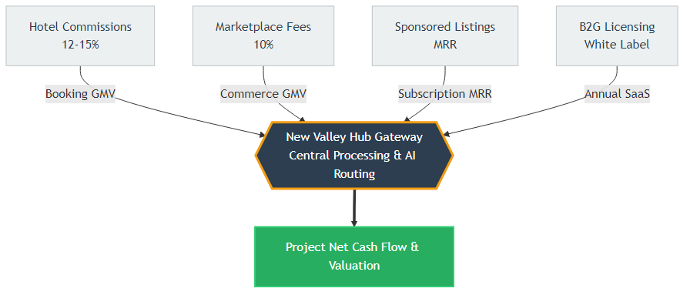
Revenue Streams Model

4. Detailed Cash Flow Analysis (Year 1)
The first year (Months 1 – 12) is focused on platform deployment, vendor onboarding, and initial market penetration. Our capital expenditure is heavily subsidized by the initial grant, leading to immediately positive aggregate cash flow.

Cash Inflows (Revenues) — in EGP
Revenue Stream | M 1 | M 2 | M 3 | M 4 | M 5 | M 6 | M 7 | M 8 | M 9 | M 10 | M 11 | M 12 | Total Y1
Grant Funding (Prize) | 200,000 | 0 | 0 | 0 | 0 | 0 | 0 | 0 | 0 | 0 | 0 | 0 | 200,000
Hotel Commissions | 0 | 0 | 0 | 15,000 | 35,000 | 65,000 | 100,000 | 150,000 | 220,000 | 300,000 | 350,000 | 400,000 | 1,635,000
Marketplace Fees | 0 | 0 | 0 | 500 | 1,000 | 2,000 | 3,500 | 5,000 | 6,500 | 8,000 | 9,000 | 10,000 | 45,500
Sponsored Listings | 0 | 0 | 0 | 0 | 0 | 500 | 1,000 | 2,000 | 3,000 | 5,000 | 8,000 | 10,000 | 29,500
Total Cash In | 200,000 | 0 | 0 | 15,500 | 36,000 | 67,500 | 104,500 | 157,000 | 229,500 | 313,000 | 367,000 | 420,000 | 1,910,000

Cash Outflows (Expenses) — in EGP
Expense Category | M 1 | M 2 | M 3 | M 4 | M 5 | M 6 | M 7 | M 8 | M 9 | M 10 | M 11 | M 12 | Total Y1
Hosting (AWS/GCP) | 10,000 | 10,000 | 10,000 | 10,000 | 10,500 | 10,500 | 11,000 | 11,000 | 12,000 | 12,000 | 13,000 | 13,000 | 133,000
Marketing & PR | 10,000 | 10,000 | 10,000 | 10,000 | 10,000 | 10,000 | 12,000 | 12,000 | 15,000 | 15,000 | 15,000 | 15,000 | 144,000
AI API Costs | 100 | 100 | 100 | 200 | 400 | 600 | 800 | 1,000 | 1,500 | 2,000 | 3,000 | 4,000 | 13,800
Operations & Misc | 1,500 | 1,500 | 1,500 | 1,500 | 2,000 | 2,000 | 2,500 | 3,000 | 3,000 | 3,500 | 3,500 | 4,000 | 29,500
Total Cash Out | 21,600 | 21,600 | 21,600 | 21,700 | 22,900 | 23,100 | 26,300 | 27,000 | 31,500 | 32,500 | 34,500 | 36,000 | 320,300

Net & Cumulative Cash Flow — in EGP
Metric | M 1 | M 2 | M 3 | M 4 | M 5 | M 6 | M 7 | M 8 | M 9 | M 10 | M 11 | M 12 | Total Y1
Net Cash Flow | 178,400 | -21,600 | -21,600 | -6,200 | 13,100 | 44,400 | 78,200 | 130,000 | 198,000 | 280,500 | 332,500 | 384,000 | 1,589,700
Cumulative Balance | 178,400 | 156,800 | 135,200 | 129,000 | 142,100 | 186,500 | 264,700 | 394,700 | 592,700 | 873,200 | 1,205,700 | 1,589,700 | 1,589,700

5. Cash Flow Diagram (Engineering Economics)
The following diagram acts as a traditional Engineering Economics cash flow representation. It models the cash injections (Inflows on top) versus our burn rate (Outflows on bottom) over critical milestone timeline periods.
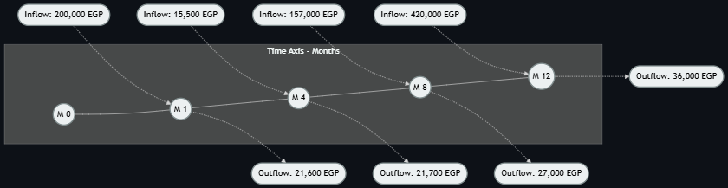
Year 1 Cash Flow Diagram
(Note: Data shown is a milestone snapshot. Complete cumulative value matches the EOY 1 table above).

6. 4-Year Financial Growth Projection
Moving beyond the startup phase, the subsequent years (Year 2 to Year 4) model aggressive scaling. Market saturation increases exponentially while backend operational costs securely amortize, leading to highly accelerated compounding of our Net Cash Flow.
Category | Year 2 (Growth) | Year 3 (Expansion) | Year 4 (Regional Scale)
Opening Cash Balance | 1,589,700 EGP | 6,639,700 EGP | 13,289,700 EGP
CASH INFLOWS (REVENUE)
Hotel & Market Revenue | 5,000,000 | 6,000,000 | 7,200,000
Premium Subscriptions | 250,000 | 500,000 | 1,000,000
B2G Licensing (White Label) | 300,000 | 800,000 | 1,500,000
Total Cash In | 5,550,000 EGP | 7,300,000 EGP | 9,700,000 EGP
CASH OUTFLOWS (EXPENSES)
Hosting & AI Scaling | 200,000 | 250,000 | 350,000
Marketing & Expansion | 200,000 | 300,000 | 500,000
Operations & Salaries | 100,000 | 100,000 | 150,000
Total Cash Out | 500,000 EGP | 650,000 EGP | 1,000,000 EGP
Net Cash Flow | 5,050,000 EGP | 6,650,000 EGP | 8,700,000 EGP
Cumulative Cash Balance | 6,639,700 EGP | 13,289,700 EGP | 21,989,700 EGP

7. Social & Environmental Impact
Our economic viability is inextricably tied to our Environmental, Social, and Governance (ESG) deliverables:
- Carbon Footprint Management (CO₂ Calculator): Taking inspiration from smart infrastructural planning, the Hub dictates eco-friendly travel routing, allowing users to measure and directly offset their personal travel emissions.
- Micro-Economic Artisan Empowerment: The digital marketplace dismantles predatory supply chains, allowing rural craftsmen to achieve substantially higher profit margins via direct consumer reach. This effectively subsidizes the local agrarian and artisanal economy.
- Heritage Digitization: Providing a perpetual, zero-degradation archive of regional antiquities via the virtual AR museum format, aggressively safeguarding unique Egyptian heritage from climactic friction.

© 2026 SandScript Team — New Valley Hub. All rights reserved.

