Approach
My approach for Project 1 was primarily based on the guidelines in Project1Approach.pdf. This document made the project more manageable and boosted my confidence in completing it. Although my approach was simple, it was not always straightforward. Initially, I struggled because my output did not match the screenshots in Project1Approach.pdf. For example, in the first step, I spent more time than anticipated resolving a decimal-point lexical error, which I unknowingly addressed by completing Step 12 early. Ultimately, I adopted a Test-Driven Development (TDD) style, tackling the project one step at a time. Before proceeding to each new task, I debugged my code using the provided test cases.
Test Plan
The following tests are primarily based off the provided test txt files. The tests cover all requirements outlined in the requirements pdf. Additionally, two tests were created to verify terminal commands function properly as they can not be seen in any of the previous screenshots (test 9 and 10).
Test case # | Test Details | Expected Result | Screenshot | Pass or Fail
- Test1.txt | Tests a Function with Arithmetic Expression and no errors. | File should be printed to the terminal. File should end with Compiled Successfully | 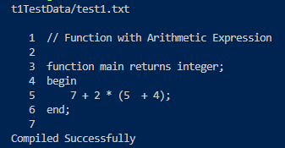 | Pass
- Test2.txt | Tests a function with a lexical error. | File should be printed with a Lexical Error message and 1 count for the Lexical Error total at the end of the file | 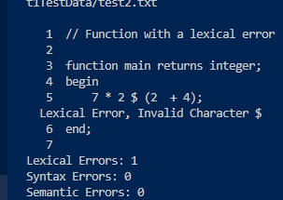 | Pass
- Test3.txt | Tests function symbols with no errors. | Prints the file to the terminal with Compiled Successfully at the end. | 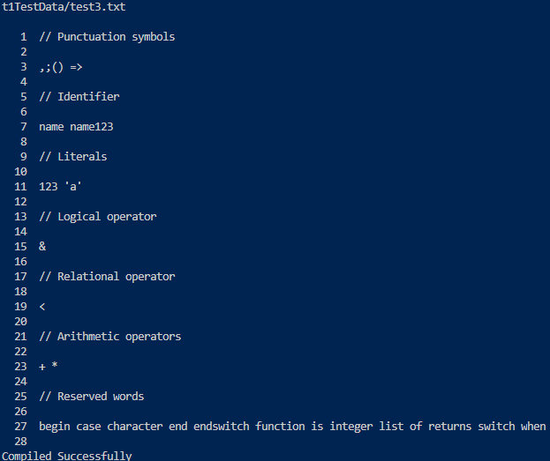 | Pass
- Test4.txt | Tests function with all reserved words with no errors. | Prints the file to the terminal with Compiled Successfully at the end. | 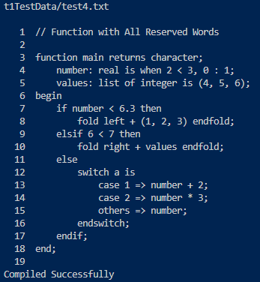 | Pass
- Test5.txt | Tests function containing added operators with no errors. | Prints the file to the terminal with Compiled Successfully at the end. | 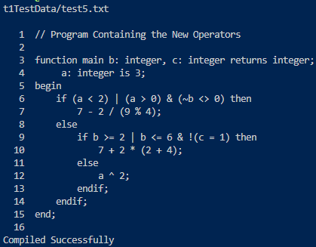 | Pass
- Test6.txt | Tests function with the added new comment, modified ID, real literal, and character literal with no errors. | Prints the file to the terminal with Compiled Successfully at the end. | 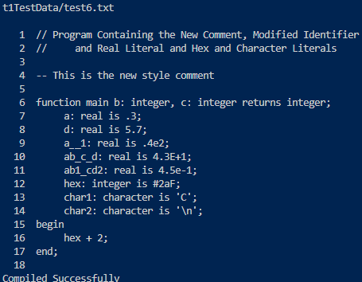 | Pass
- Test7.txt | Tests function with two lexical errors to test the use of the counter at the end of the file. | Two in line errors should print with the file and the lexical error counter should equal 2 at the end of the file. | 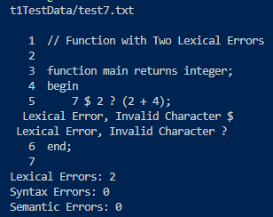 | Pass
- Test8.txt | Tests function with punctuation symbols, valid/invalid IDs, reserved words, and operators with multiple errors. | Test should have 5 Lexical errors total at the end of the file and 5 in line Lexical error messages. | 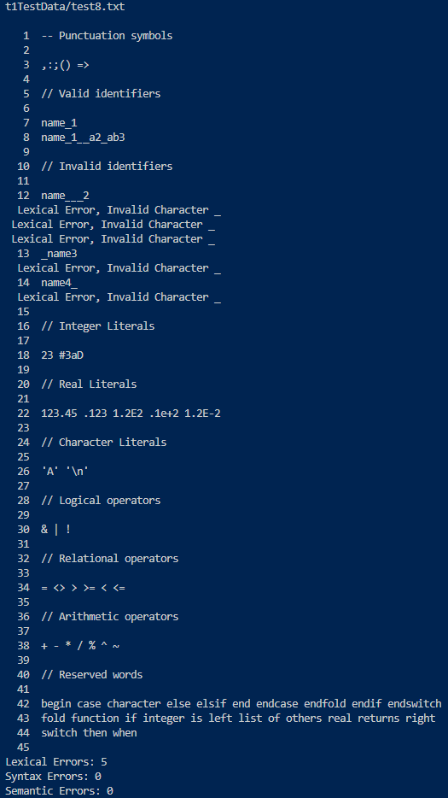 | Pass
- ‘make’ command | Command compiles the files and adds all the new files based off the Makefile. | Compiles the program and generates all object files and executables per the Makefile. | Pasted below the table | Pass
- ‘make clean’ command | Command removes all files created by ‘make’. | Removes all object files and executables created during compilation. | Pasted below the table | Pass
- Lexemes.txt | Tests lexemes with no errors | Prints the file to the terminal with Compiled Successfully at the end. | Pasted below the table | Pass
Extra Screenshots:
9. “make” command:
10 “make clean” command: 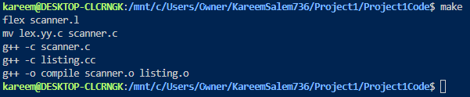
11.Lexemes.txt:
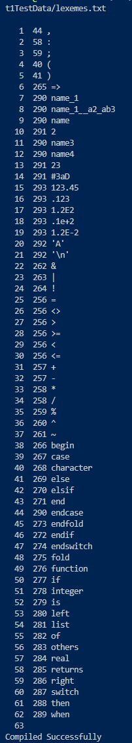
Lessons Learned
One key lesson I learned was the importance of thoroughly reviewing the requirements, codebase, and supporting documents before beginning a project. This initial investment of time helps clarify the execution plan and ensures a smoother process. I encountered this lesson in two situations: first, I struggled with a decimal lexical error in Step 1 that remained unresolved until Step 12; second, I attempted to implement “Compiled Successfully” earlier than required. While being proactive is not a drawback, adhering to the outlined steps can prevent unnecessary overwhelm and keep the project on track. Overall, I believe creating a clear roadmap and following it closely is an effective strategy for avoiding complications

