Recommended Header Structure for ClienTech Solutions

🔹 Left (Brand)
ClienTech Solutions
Shaping Tomorrow

🔹 Center (Primary Navigation)
About Us
Our Services
Industries
Digital Audits
Our Solutions
News & Updates
This mirrors WebFX’s clarity while aligning with your positioning.

🔹 Right (Trust + CTA)
📞 Talk to an Expert
🟢 Get a Proposal
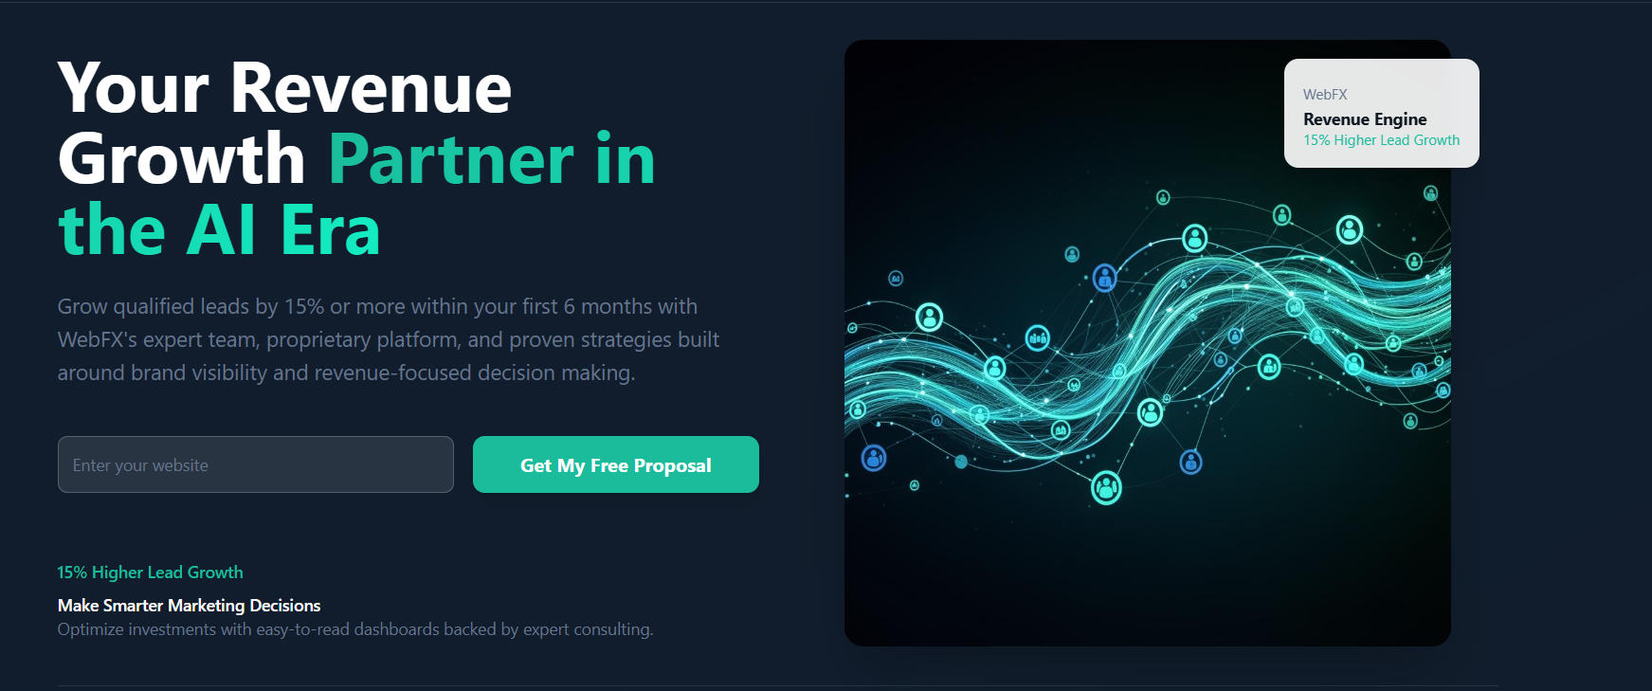

HOMEPAGE – HERO SECTION (FINAL CONTENT)

Primary Headline
Transforming Challenges Into Intelligent Digital Solutions
Directly anchors your slogan and positioning. Timeless and enterprise-safe.

Secondary Headline (Support Line)
Digital foundations, smart solutions, and transformation—designed to help organizations move forward with clarity and confidence.
Explain what you do in one breath. No buzzwords, no over-promising.

Intro Paragraph
Business challenges are inevitable. Stagnation is not.
ClienTech Solutions partners with organizations to build resilient digital foundations, implement scalable solutions, and drive meaningful transformation. We solve for today’s challenges while illuminating the path forward—through strategy-led execution and technology that delivers real outcomes.
This can live under the hero or flow directly into the next section without changes.

Primary CTA
🟢 Get a Proposal
Secondary (optional): Speak with an Expert
“Proposal” keeps it enterprise. Avoids gimmicks like “Free Audit”.

CREDIBILITY STRIP (BELOW HERO) – FINAL

Option A: Minimal, High-Impact (Recommended at Launch)
Built for scale. Designed for impact.
Strategy-led. Execution-focused.
From foundations to transformation.
Clean. Confident. Works globally.

Option B: Trust-Focused (Use when you add clients/case studies)
Trusted by growing enterprises and forward-thinking teams
Delivering measurable digital outcomes
Drop-in replacement when social proof matures.

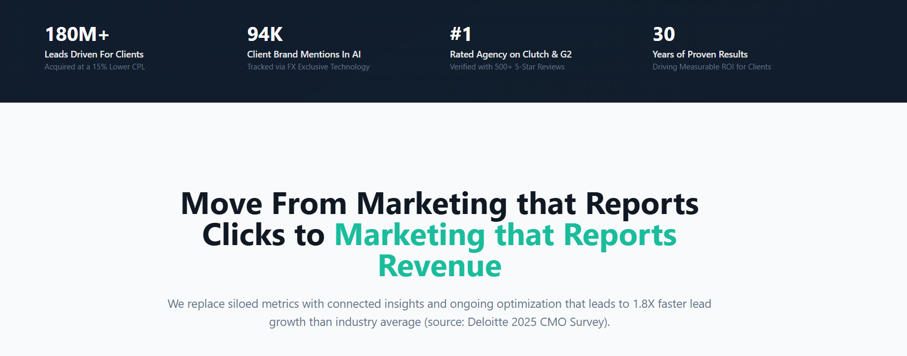

🔹 MAIN SECTION HEADLINE (REWRITTEN FOR CLientech)

Move From Digital Effort to Digital Impact
Shorter. Broader. Works across IT, AI, UX, and transformation.

🔹 SUPPORTING SUBHEAD (CRITICAL & CLEAN)
We help organizations move beyond fragmented initiatives by aligning strategy, technology, and execution—turning digital investments into outcomes that matter.
No clicks. No marketing fluff. Enterprise-safe language.

🔹 BODY PARAGRAPH (OPTIONAL, BUT STRONG)
Too many organizations invest in technology without a clear path to value.
ClienTech Solutions replaces disconnected systems and siloed decision-making with integrated digital foundations, intelligent solutions, and continuous optimization—so progress is measurable, scalable, and sustainable.

🔹 OPTIONAL “PROOF WITHOUT NUMBERS” LINE
Grounded in industry best practices and real-world execution, our approach prioritizes clarity, accountability, and long-term value creation.
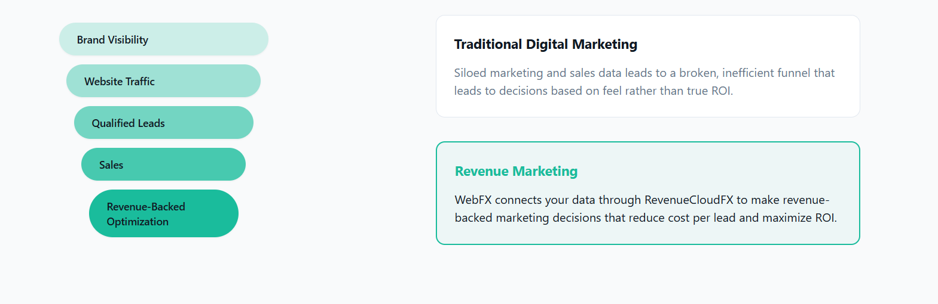

Left Progress Stack (REWRITTEN FOR CLientech)
These stay as pill-shaped steps, but with more enterprise meaning:
- Digital Visibility
- User & System Engagement
- Qualified Demand
- Operational Enablement
- Outcome-Driven Optimization
This subtly shifts the conversation from “marketing funnel” to business systems & outcomes.

Right Side – Comparison Panels

🔹 Panel 1: Traditional Digital Execution
Traditional Digital Execution
Disconnected tools, siloed teams, and fragmented data often result in initiatives that look active but lack clarity, alignment, and measurable impact—leading to decisions driven by assumptions rather than outcomes.
Notice:
- No “marketing-only” language
- Applies to IT, digital, AI, UX, ops
- Enterprise-safe

🔹 Panel 2: ClienTech’s Integrated Approach
Integrated, Outcome-Driven Transformation
ClienTech aligns strategy, technology, and execution through connected digital foundations—enabling organizations to optimize continuously, reduce inefficiencies, and make informed decisions backed by real-world performance.
This is strong without claiming:
- Proprietary platforms
- Revenue guarantees
- Aggressive ROI numbers
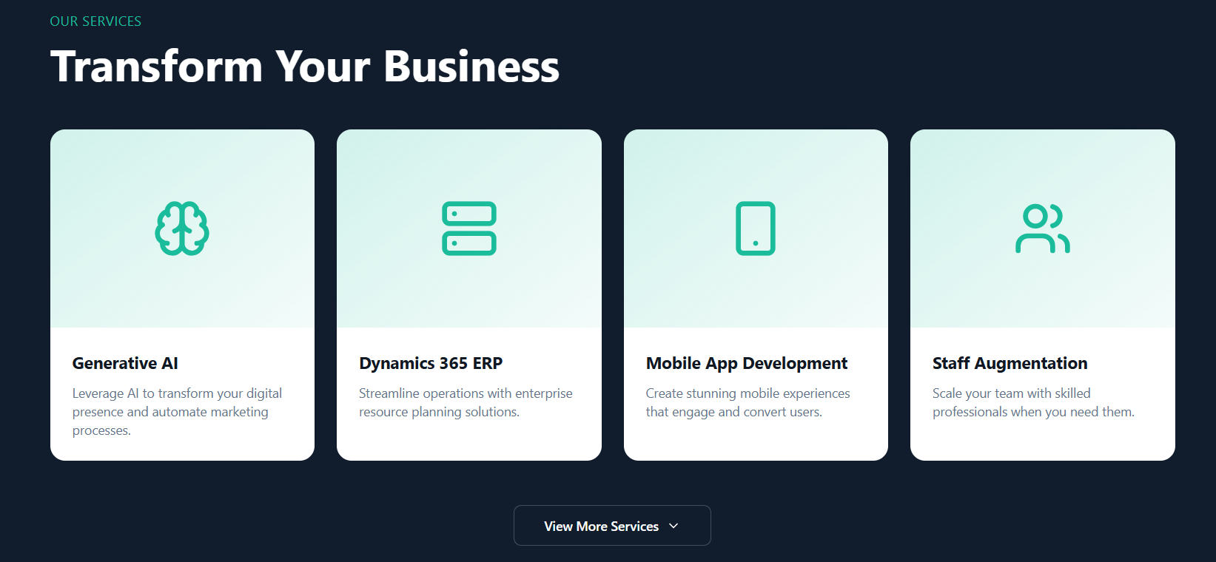

PRIMARY SERVICES (TOP ROW – 4 FEATURED CARDS)
(Larger cards, icons, higher visual weight)

Digital Foundations
Build secure, scalable, and future-ready digital infrastructure that enables growth, resilience, and long-term performance.

Digital Solutions Engineering
Design and develop tailored digital solutions that solve real business challenges and integrate seamlessly with existing systems.

AI, Data & Intelligent Systems
Apply AI and data-driven intelligence to enhance decision-making, automate processes, and unlock smarter ways of working.

Digital Transformation & Advisory
Align strategy, technology, and execution to drive meaningful transformation with measurable, sustainable outcomes.

🔽 SUPPORTING SERVICES (SECOND ROW – 6 CARDS)
(Slightly smaller cards or icon-based tiles)

Cloud & Infrastructure Services
Enable cloud readiness, modernization, and performance optimization across enterprise environments.

Enterprise Systems & Platforms
Implement and optimize enterprise platforms to improve visibility, efficiency, and operational control.

UX, Product & Experience Design
Create intuitive, user-centered digital experiences that balance usability, performance, and business goals.

Integration & Automation
Connect systems, data, and workflows to eliminate silos and improve operational efficiency.

Security, Compliance & Reliability
Design and maintain systems with security, compliance, and resilience built in from the ground up.

Staff Augmentation & Managed Teams
Scale your delivery capacity with skilled professionals aligned to your technology stack and business objectives.

🎯 OPTIONAL CTA (Below Services Grid)
🟢 View All Capabilities
Secondary: Talk to an Expert
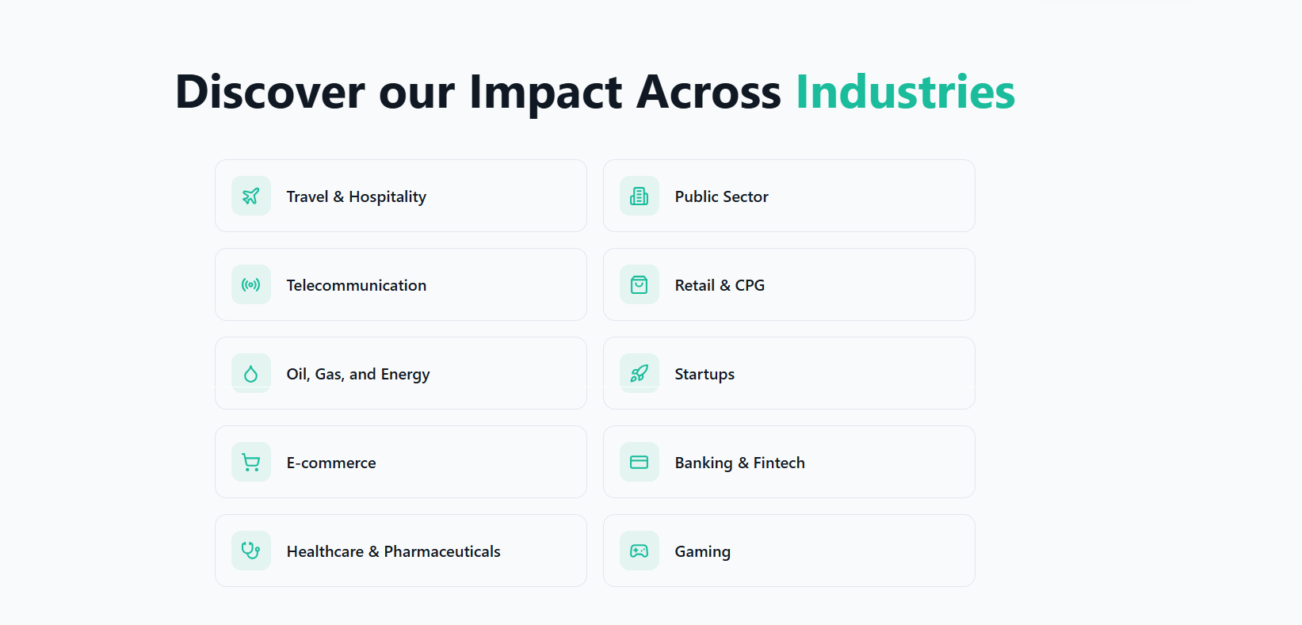

Discover Our Impact Across Industries
ClienTech Solutions partners with organizations across industries to design, build, and transform digital capabilities adapting our approach to each sector’s unique challenges, regulations, and opportunities.

INDUSTRIES WE SERVE (READY FOR TILE VIEW)

Public Sector
Supporting government and public organizations with secure, scalable, and compliant digital systems that improve service delivery and operational efficiency.

Banking & Fintech
Enabling financial institutions and fintechs with robust digital foundations, intelligent automation, and systems built for security, compliance, and scale.

Healthcare & Life Sciences
Designing digital solutions that enhance patient experiences, streamline operations, and support data-driven decision-making within regulated environments.

Retail & Consumer Goods
Helping retailers and CPG brands modernize systems, connect data, and improve customer engagement across digital and physical channels.

Telecommunications
Supporting telecom providers with scalable platforms, system integration, and optimization to improve performance and customer experience.

Energy, Oil & Utilities
Delivering resilient digital systems and data-driven solutions that support complex operations, compliance, and long-term sustainability.

Travel & Hospitality
Enhancing digital experiences and operational platforms to improve customer journeys, efficiency, and service reliability.

E-commerce
Building and optimizing digital platforms that support growth, performance, and seamless customer experiences.

Startups & Growth-Stage Companies
Partnering with startups to establish strong digital foundations, accelerate execution, and scale responsibly.

Media, Gaming & Digital Entertainment
Supporting digital-first businesses with scalable platforms, engaging user experiences, and performance-focused systems.
CTA:
“Do they understand my industry?
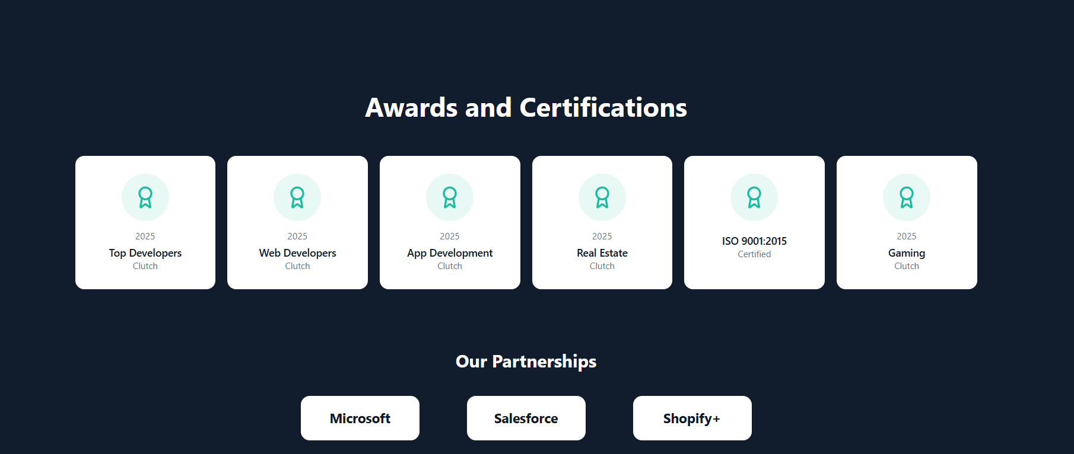

❌ Replace the heading
Awards and Certifications

✅ With

Standards, Expertise & Recognition
This single change makes everything below defensible.

🧩 CARD CONTENT (6 CARDS – SAME VISUAL STYLE)

Quality & Delivery Excellence
Aligned with ISO 9001:2015 quality management principles to ensure consistent, reliable delivery across engagements.

Security & Compliance Practices
Security-by-design approach with practices aligned to global data protection and compliance standards.

Enterprise Systems Expertise
Proven experience delivering and integrating enterprise-grade platforms across complex environments.

AI & Digital Engineering Capability
Applied experience in AI, data, and intelligent systems to support automation and informed decision-making.

Scalable Delivery Model
Flexible delivery frameworks designed to support startups, growing organizations, and enterprises alike.

Continuous Improvement Framework
Ongoing optimization, governance, and performance review embedded into every engagement.

FINAL SECTION COPY (READY TO USE)

Technology Ecosystem Experience
ClienTech Solutions brings hands-on experience across leading enterprise and cloud technology platforms. Our teams design, implement, and optimize solutions within these ecosystems to meet diverse business and industry requirements.

🔹 LOGO ROW (VISUAL – SAME AS YOUR IMAGE)
Microsoft Salesforce Shopify

🔒 REQUIRED DISCLAIMER (Small, Subtle, Important)
Platform logos represent technology experience and implementation expertise. ClienTech Solutions is not an official partner unless explicitly stated.
This single line protects you legally and reputationally.

