Project :
CPU Scheduling Simulator using Priority Scheduling and SRTF Scheduling Algorithms.

Project Description :
The simulator compares two scheduling algorithms:
1- Priority Scheduling
2- Shortest Remaining Time First (SRTF)

Priority Scheduling :
Priority Scheduling selects the process with the highest priority.
In this project:
1- Smaller priority number = Higher priority.
2- Preemptive scheduling is used.

SRTF Scheduling :
SRTF stands for: Shortest Remaining Time First.
The CPU always selects the process with the shortest remaining burst time.
Features
1- Preemptive scheduling.
2- Processes may be interrupted.
3- Optimized for short jobs.

Scenario (A) : Mixed workload
In Priority Scheduling :

P1: P2:
TAT = CT – AT = 12 – 0 = 12 TAT = CT – AT = 5 – 1 = 4
WT = TAT – BT = 12 – 8 = 4 WT = TAT – BT = 4 – 4 = 0
RT = First Start Time - AT = 0 – 0 = 0 RT = First Start Time - AT = 1 – 1 = 0

P3: P4:
TAT = CT – AT = 26 – 2 = 24 TAT = CT – AT = 17 – 3 = 14
WT = TAT – BT = 24 – 9 = 15 WT = TAT – BT = 14 – 5 = 9
RT = First Start Time - AT = 17 – 2 = 15 RT = First Start Time - AT = 12 – 3 = 9

Average WT = 7.0
Average TAT = 13.5
Average RT = 6.0

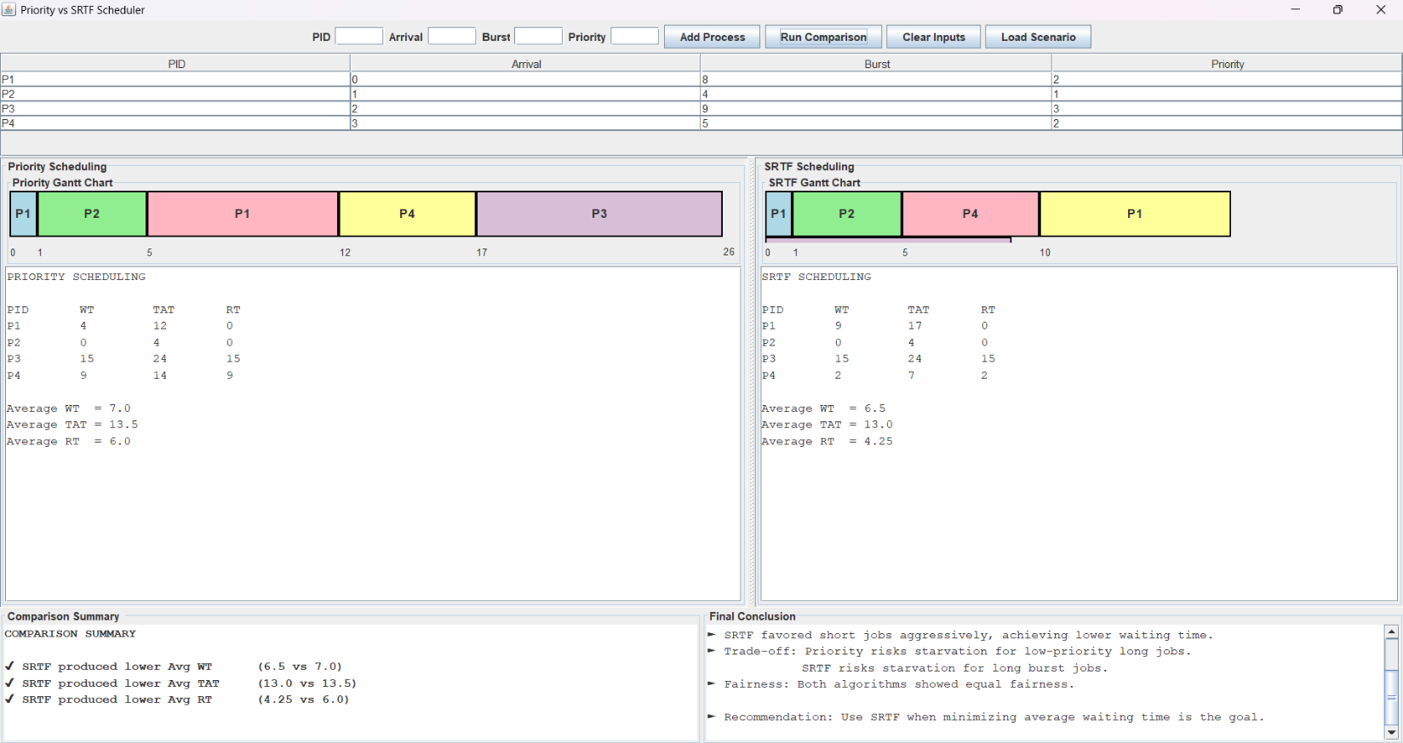

In SRTF Scheduling :

P1: P2:
TAT = CT – AT = 17 – 0 = 17 TAT = CT – AT = 5 – 1 = 4
WT = TAT – BT = 17 – 8 = 9 WT = TAT – BT = 4 – 4 = 0
RT = First Start Time - AT = 0 – 0 = 0 RT = First Start Time - AT = 1 – 1 = 0

P3: P4:
TAT = CT – AT = 26 – 2 = 24 TAT = CT – AT = 10 – 3 = 7
WT = TAT – BT = 24 – 9 = 15 WT = TAT – BT = 7 – 5 = 2
RT = First Start Time - AT = 17 – 2 = 15 RT = First Start Time - AT = 5 – 3 = 2

Average WT = 6.5
Average TAT = 13.0
Average RT = 4.25

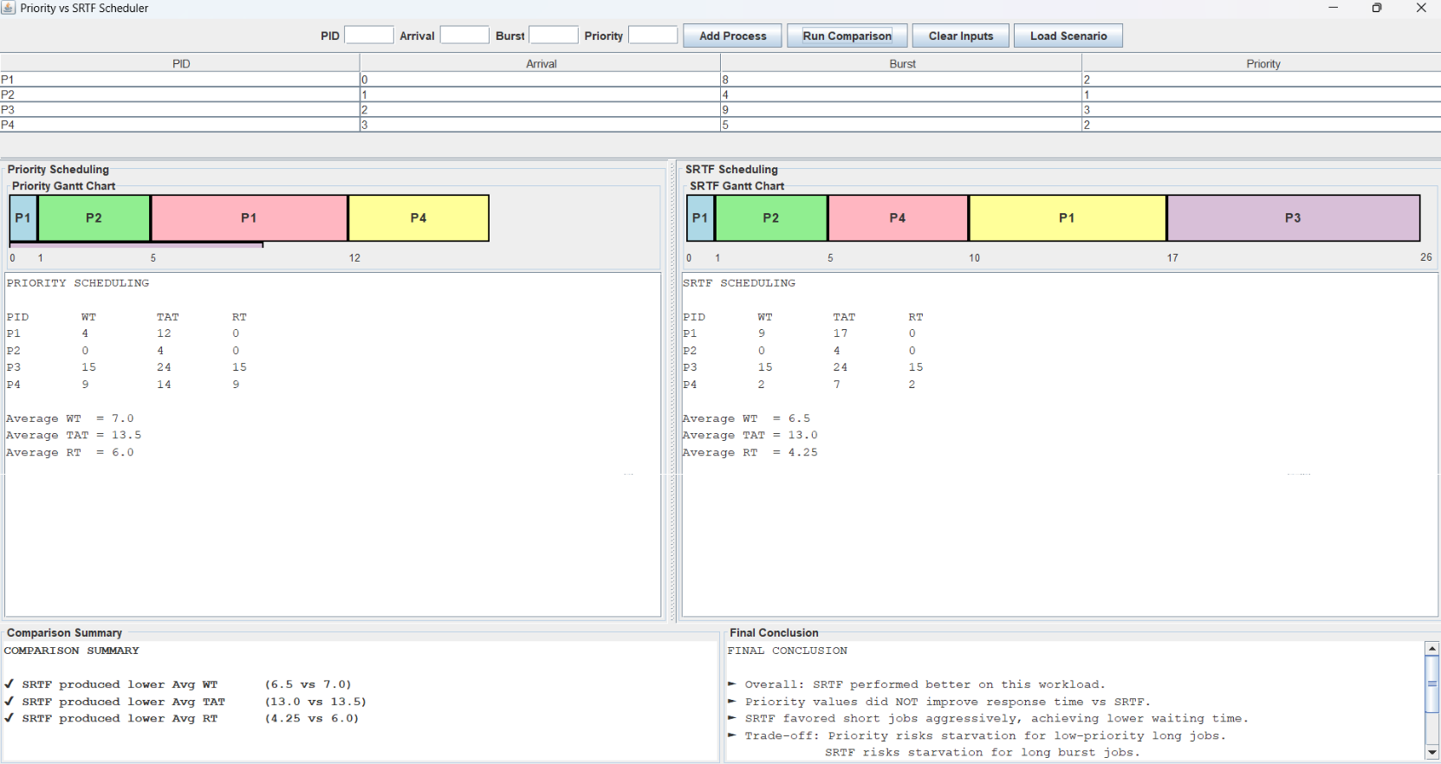

Scenario (B) : Priority vs Burst conflict
In Priority Scheduling :

P1: P2:
TAT = CT – AT = 10 – 0 = 10 TAT = CT – AT = 20 – 1 = 19
WT = TAT – BT = 10 – 10 = 0 WT = TAT – BT = 19 – 2 = 17
RT = First Start Time - AT = 0 – 0 = 0 RT = First Start Time - AT = 18 – 1 = 17

P3: P4:
TAT = CT – AT = 21 – 2 = 19 TAT = CT – AT = 18 – 3 = 15
WT = TAT – BT = 19 – 1 = 18 WT = TAT – BT = 15 – 8 = 7
RT = First Start Time - AT = 20 – 2 = 18 RT = First Start Time - AT = 10 – 3 = 7

Average WT = 10.5
Average TAT = 15.75
Average RT = 10.5

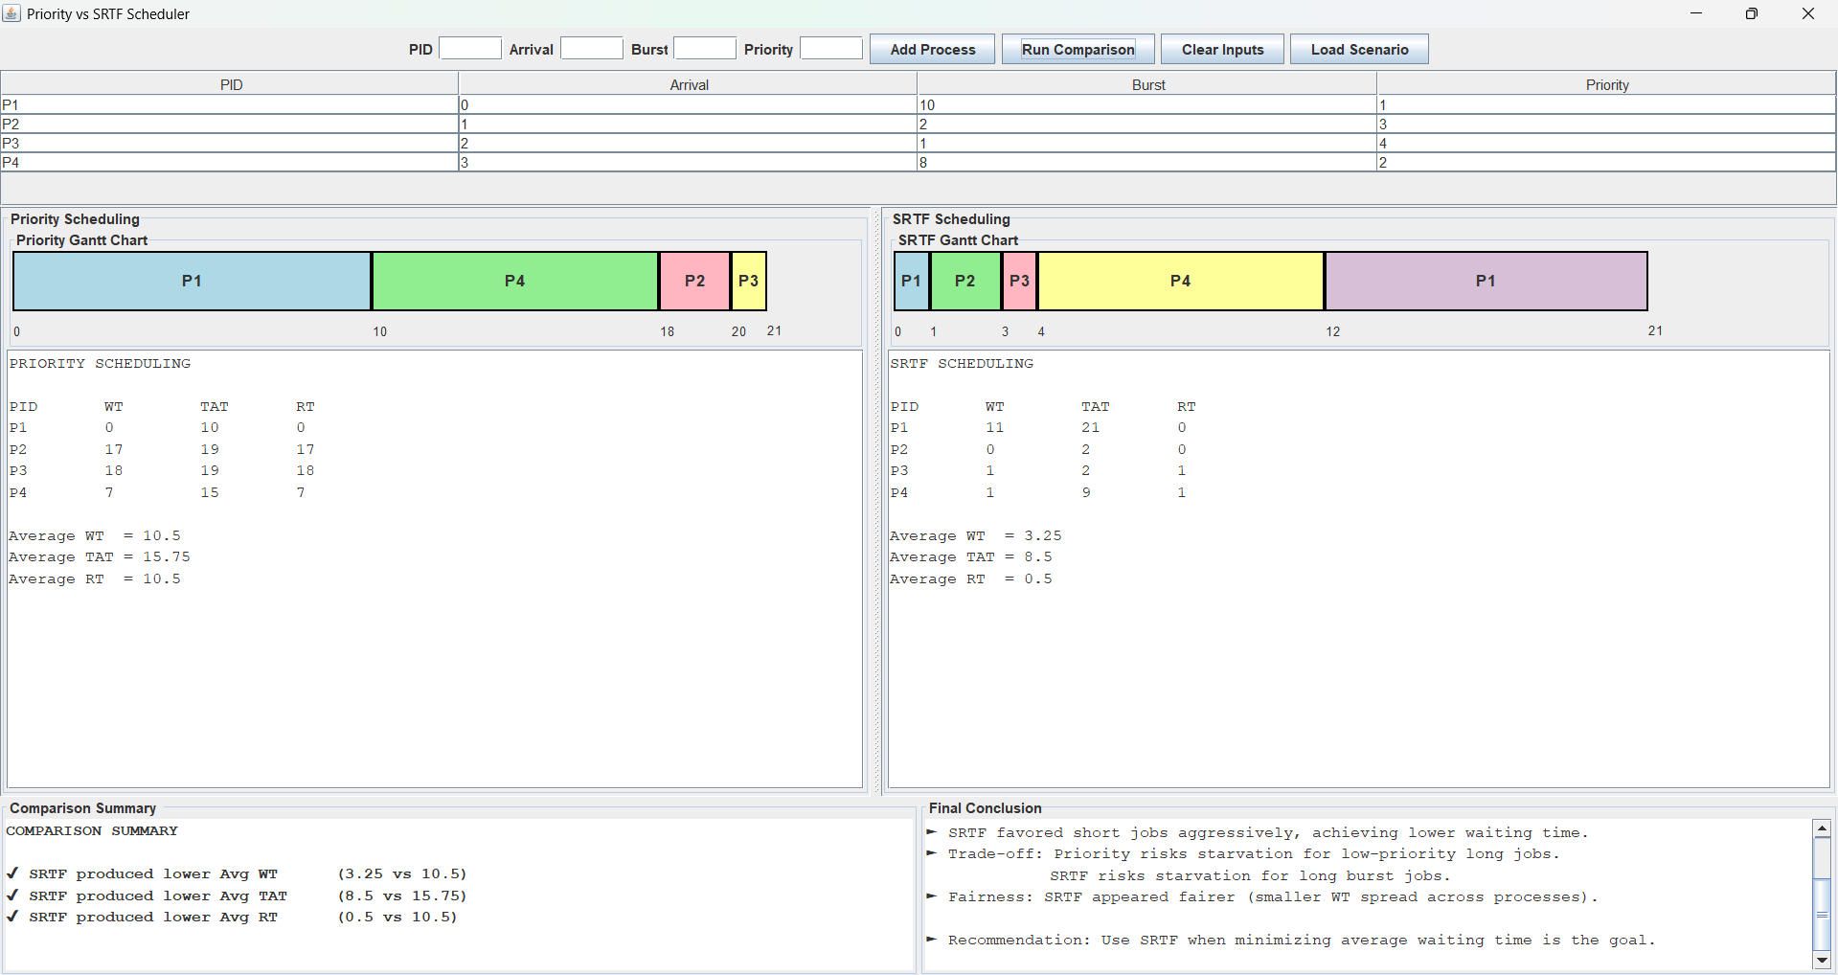
In SRTF Scheduling :

P1: P2:
TAT = CT – AT = 21 – 0 = 21 TAT = CT – AT = 3 – 1 = 2
WT = TAT – BT = 21 – 10 = 11 WT = TAT – BT = 2 – 2 = 0
RT = First Start Time - AT = 0 – 0 = 0 RT = First Start Time - AT = 1 – 1 = 0

P3: P4:
TAT = CT – AT = 4 – 2 = 2 TAT = CT – AT = 12 – 3 = 9
WT = TAT – BT = 2 – 1 = 1 WT = TAT – BT = 9 – 8 = 1
RT = First Start Time - AT = 3 – 2 = 1 RT = First Start Time - AT = 4 – 3 = 1

Average WT = 3.25
Average TAT = 8.5
Average RT = 0.5



Scenario (C) : Starvation-Sensitive
In Priority Scheduling :

P1: P2:
TAT = CT – AT = 26 – 0 = 26 TAT = CT – AT = 3 – 1 = 2
WT = TAT – BT = 26 – 20 = 6 WT = TAT – BT = 2 – 2 = 0
RT = First Start Time - AT = 0 – 0 = 0 RT = First Start Time - AT = 1 – 1 = 0

P3: P4:
TAT = CT – AT = 5 – 2 = 3 TAT = CT – AT = 7 – 3 = 4
WT = TAT – BT = 3 – 2 = 1 WT = TAT – BT = 4 – 2 = 2
RT = First Start Time - AT = 3 – 2 = 1 RT = First Start Time - AT = 5 – 3 = 2

Average WT = 2.25
Average TAT = 8.75
Average RT = 0.75

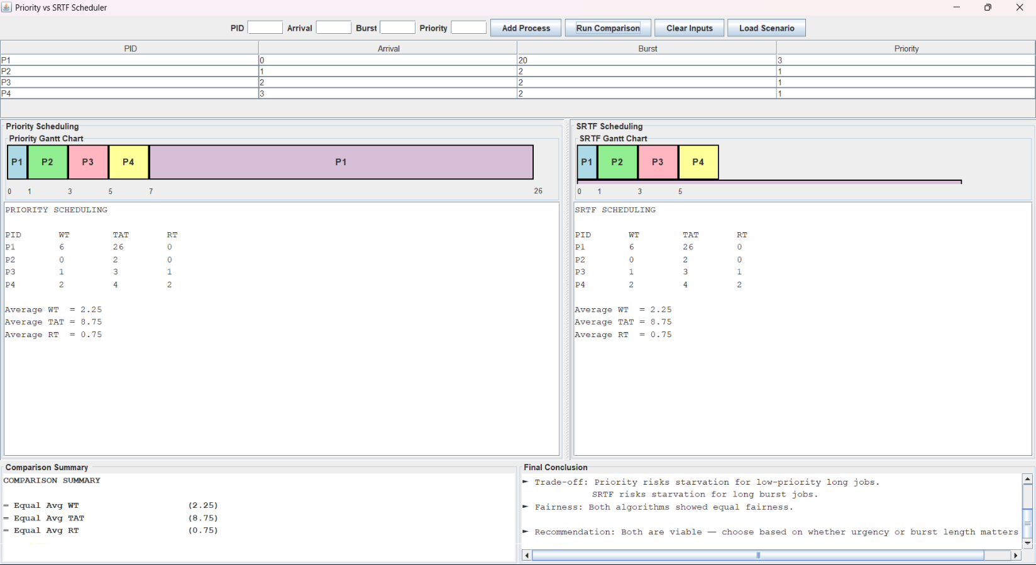

In SRTF Scheduling :

P1: P2:
TAT = CT – AT = 26 – 0 = 26 TAT = CT – AT = 3 – 1 = 2
WT = TAT – BT = 26 – 20 = 6 WT = TAT – BT = 2 – 2 = 0
RT = First Start Time - AT = 0 – 0 = 0 RT = First Start Time - AT = 1 – 1 = 0

P3: P4:
TAT = CT – AT = 5 – 2 = 3 TAT = CT – AT = 7 – 3 = 4
WT = TAT – BT = 3 – 2 = 1 WT = TAT – BT = 4 – 2 = 2
RT = First Start Time - AT = 3 – 2 = 1 RT = First Start Time - AT = 5 – 3 = 2

Average WT = 2.25
Average TAT = 8.75
Average RT = 0.75

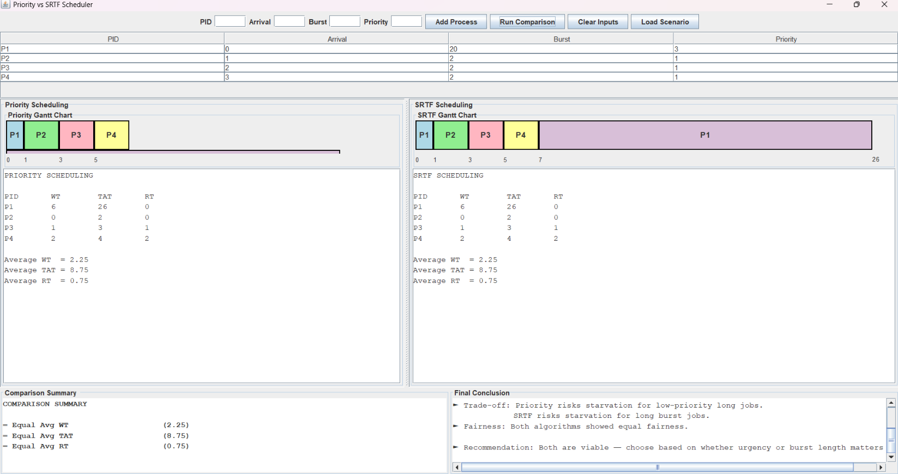

Scenario (D): Validation Case
