# Comp 3350: Computer Organization & Assembly Language

# HW # 3: Theme: Data declarations, Small program

*All main questions carry equal weight.*

*(Credit awarded to only those answers with work shown)*

1. Declare the following:
2. An un-initialized data declaration for a 32-bit signed and unsigned integer
   1. val1 DWORD
   2. val2 SDWORD
3. An initialized data declaration for a 32-bit unsigned integer with the value “A45C2EB1h” and a signed integer with the value of your choice.
   1. val1 DWORD 23
   2. val2 SDWORD -12
4. A null terminated string variable containing the name of your favorite car.
   1. str1 BYTE “Lamborghini”, 0
5. A symbolic constant named “*HoursinFortnight*” using the equal-sign directive and assign it an arithmetic expression that calculates the total number of hours in a Fortnight.
   1. *HoursinFortnight = 14*24*
6. Show the order of individual bytes in memory *(lowest to highest****)*** for the following double word variable *(use little endian order****):*** GoTigers DWORD A1B2C3D4h
   1. D4
   2. C3
   3. B2
   4. A1
7. Show the following using assembler directives:
8. How to declare an unsigned dword array of five elements and initialize the array with the following values: 1Ah, 2Bh, 3Ch, 4Dh, 5Eh
   1. num DWORD 1Ah, 2Bh, 3Ch, 4Dh, 5Eh
9. Using the array created in part A of this question, show how to calculate the number of elements contained and assign that value to a symbolic constant named “*ArraySize*”
   1. ArraySize = ($ - num) / 4
10. Why is a string variable declared using the reserved word BYTE as opposed to WORD, DWORD or QWORD?
    1. Because each ASCII character uses a byte of storage, the string variable is saved as an array of characters.
11. Using the *AddVariables* program from the textbook as a reference, write a program that adds three signed byte sized integers using only *8-bit registers*. Please embed program code into your homework submission.
12. Write a program that prints your *<FirstName Lastname>* on your screen. You can use the following. Assemble and generate the output using MASM and Visual Studio. Embed your output in your submission.

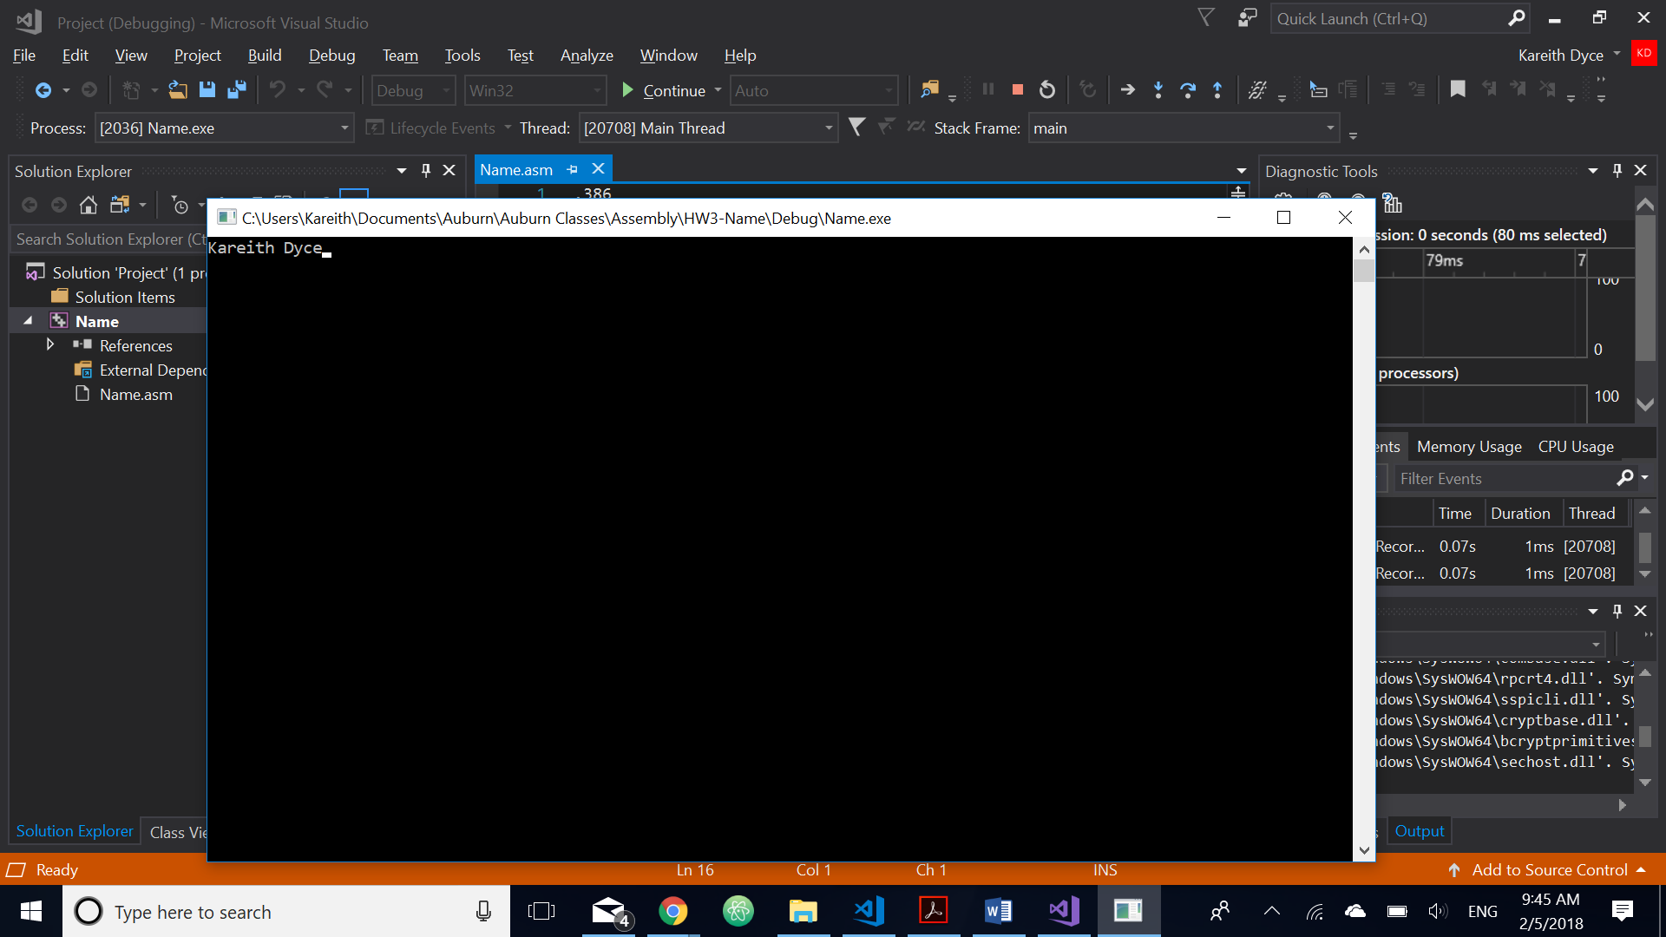

TITLE My first assembly program

INCLUDE Irvine32.inc

.DATA

Message BYTE “*FirstName Lastname*”,0

.CODE

main PROC

mov edx, offset message

Call WriteString

exit

main ENDP

END main