Grading Guidelines:

A right answer will get full credit when:

1. It is right (worth 25%)
2. It is right **AND** neatly presented making it easy and pleasant to read. (worth an **extra** 15%)
3. There is an **obvious and clear link** between 1) the information provided in the exercise and in class and 2) the final answer. A clear link is built by properly writing, justifying, and documenting an answer (worth an **extra** 60%).
4. Calculation mistakes will be minimally penalized (2 to 5% of full credit) while errors on units will be more heavily penalized.

**Late Submission** : as specified in the syllabus. Days counting starts one minute after the deadline.

You are welcome/encouraged to discuss exercises with other students or the instructor. But, ultimately, **personal** writing is expected.

* USE THIS FILE AS THE STARTING DOCUMENT YOU WILL TURN IN. **KEEP IN THE QUESTIONS** AND INSERT YOUR ANSWERS.
* IF USING HAND WRITING (STRONGLY DISCOURAGED), REWRITE THE QUESTIONS.
* FAILING TO FOLLOW TURN IN DIRECTIONS /GUIDELINES WILL COST A 30% PENALTY.

Objectives of this assignment:

* to learn independently about an important topic
* to answer questions about the independently studied topic
* to empower you: you can learn any networking topic on your own
* to learn independently new concepts

What you need to do:

Answer the questions and/or solve the exercises described below.

KEEP THE GRADING GUIDELINES ABOVE TO REMEMBER THE DIRECTIONS AND HOW THE HOMEWORK IS GRADED.

Objective: The objective of this assignment is to explore the impact of favoring some flows over others and discuss *Net(work) Neutrality*. The assignment is based on the *Conservation Law* that states that if a scheduler is work-conservative (i.e., the resource is idle only if the queue is empty), then:

$$\sum_{i=1}^{n}{λ_{i}x_{i}q_{i}=K (a constant)}$$

where:

- is the mean arrival rate for the ith flow

- is the mean service time for the ith flow

- is the mean queueing (waiting) time for the ith flow

- K is a constant independent of the scheduling policy.

Resources:

1. **Internet**
2. This module slides, videos, and SSQs.

**Exercise**

Consider two flows A and B with arrival rates 10 Mbps and 25 Mbps that share an OC3 (150 Mbps). The packet size can be any size $P_{S}$.

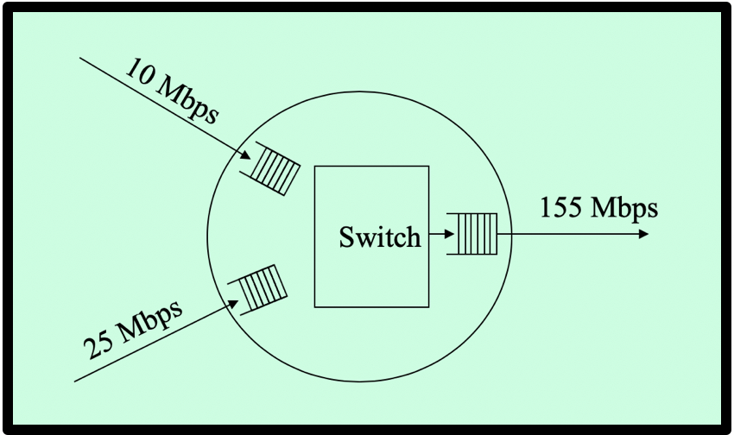

When using *First Come First Serve* (FCFS) as the packet scheduling policy, we observe that the mean queueing delays for Flows A and B are 0.5 ms.

When using a new packet scheduling policy, the mean queueing delays for Flows A and B become $x$ and $y$.

(a) (30 points) Using the *Conservation Law*, the information about *FCFS*, express the mean queueing delay $y$ for Flow B as a function of the mean queueing delay $x$ for Flow A. (**Hint**: See Slide about how I related queueing delays of FCFS with those of a different scheduling policy))

(b) (20 points) **Plot** the mean queueing delay $y$ for Flow B as a function of the mean queueing delay $x$ for Flow A.

(c) (10 points) A researcher claims that he designed a packet scheduling policy that would perform better than FCFS: with the new policy, **both** the mean queueing delays for Flows A and B would **decrease** (i.e., be both less than 0.5 ms). Using the plot, explain whether such a claim is possible or not.

(d) (20 points) If we want to decrease **both** the mean queueing delays for Flows A and B, what must be changed: the packet scheduling policy, the mean arrival rate, the packet size, and/or switch output line rate? (Discuss separately the different parameters: do not combine the effects of two parameters (for example policy and mean arrival rate).

(e) (20 points) This question is about of *Net Neutrality*. Explain what *Net Neutrality* is and discuss it:

i) what is *Net Neutrality*?

ii) Is *Net Neutrality* enforced in the US? If, yes/no, who decides about enforce it in the US? Discuss *Net Neutrality* in the last 4-5 years.

iii) In light of the *Conservation Law*, discuss the pros and cons of *Net Neutrality*?

**What you need to turn in**:

* Electronic copy of this file (including your answers) (standalone). Submit the file as a Microsoft Word or PDF file.
* Recall that answers must be well written, documented, justified, and presented to get full credit.
* How this assignment will be graded:
* A right answer will get full credit when:
* It is right (worth 25%)
* It is right AND neatly presented making it easy and pleasant to read. (worth 15%)
* There is an obvious and clear link between 1) the information provided in the exercise and in class and 2) the final answer. A clear link is built by properly writing, justifying, and documenting an answer (worth 60%).
* Calculation mistakes will be minimally penalized (2 to 5% of full credit) while errors on units will be more heavily penalized.
* You are welcome/encouraged to discuss exercises with other students or the instructor. But, ultimately, personal writing is expected.