**Grading Guidelines:**

A right answer will get full credit when:

1. It is right (worth 25%)
2. It is right **AND** neatly presented making it easy and pleasant to read. (worth an **extra** 15%)
3. There is an **obvious and clear link** between 1) the information provided in the exercise and in class and 2) the final answer. A clear link is built by properly writing, justifying, and documenting an answer (worth an **extra** 60%).
4. Calculation mistakes will be minimally penalized (2 to 5% of full credit) while errors on units will be more heavily penalized.

**Late Submission** : as specified in the syllabus. Days counting starts one minute after the deadline.

You are welcome/encouraged to discuss exercises with other students or the instructor. But, ultimately, **personal** writing is expected.

* USE THIS FILE AS THE STARTING DOCUMENT YOU WILL TURN IN. **KEEP IN THE QUESTIONS** AND INSERT YOUR ANSWERS.
* IF USING HAND WRITING (STRONGLY DISCOURAGED), REWRITE THE QUESTIONS.
* FAILING TO FOLLOW TURN IN DIRECTIONS /GUIDELINES WILL COST A 30% PENALTY.

**Objectives of this assignment:**

* to learn independently about an important topic
* to answer questions about the independently studied topic
* to empower you: you can learn any networking topic on your own
* to learn independently new concepts

**What you need to do:**

Answer the questions and/or solve the exercises described below.

**KEEP THE GRADING GUIDELINES ABOVE TO REMEMBER THE DIRECTIONS AND HOW THE HOMEWORK IS GRADED.**

**Objective:** The objective of this assignment is explore the relationship between the packet size and the efficiency and show how a software engineering can determine the optimal packet size to tune the Stop-And-Wait protocol to maximize the efficiency over a noisy channel.

**Resources**:

1. **Basic math**
2. Your instructor

**Exercise**

We derived in the lecture the expression of the efficiency of the Stop-And-Protocol as a function of the bit rate *br*, the propagation time *Tp*, and the bit error rate *ber*:

Suppose the bit rate *br*, the propagation time *Tp*, and the bit error rate *ber* are given (known).

1) (80 points) Derive the expression of the optimal packet size Smax that maximizes the efficiency. Express Smax as a function of the bit rate *br*, the propagation time *Tp*, and the bit error rate *ber*.

(**Hint**: a function f(x) is optimal for some value x0 if and only if f'(x)=. In other words, derive the function f(x) and solve f'(x0) = 0.

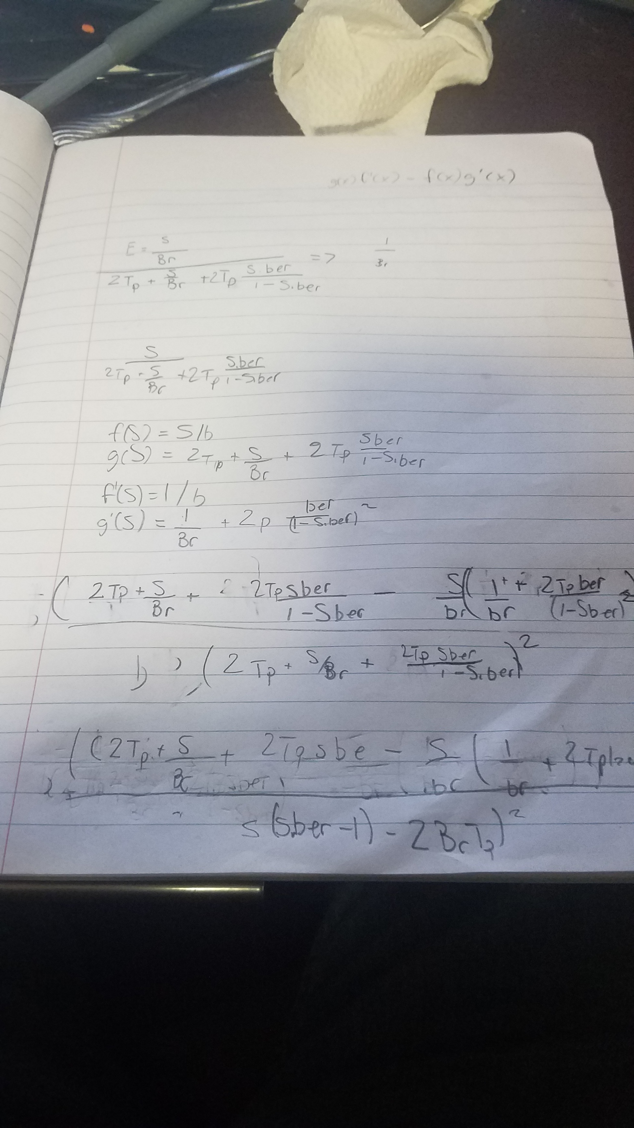 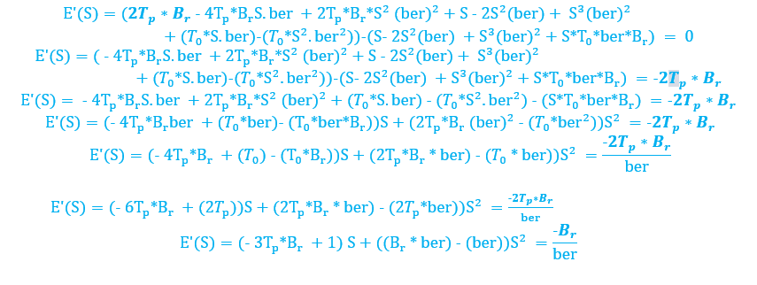

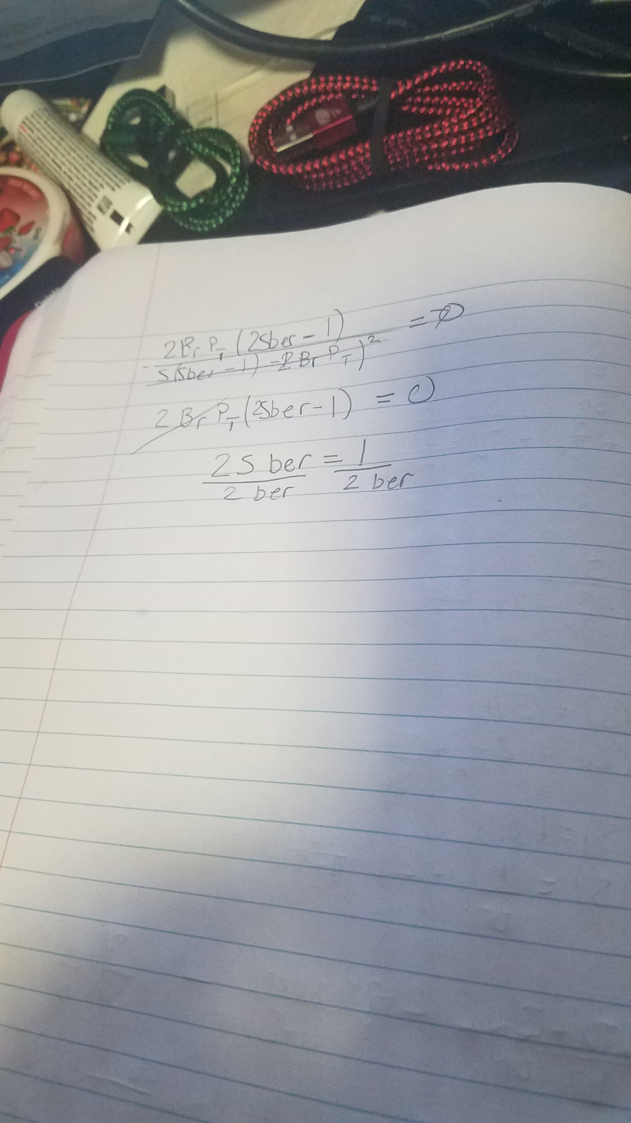

**Smax =**

2) (2.5 points) Suppose br = 1.5 Mbps, Tp = 50ms, and ber = 5.10-6. What is the optimal packet size Smax?

Smax = 100,000 bits

3) (15 points) Suppose br = 1.5 Mbps, Tp = 50ms, and ber = 5.10-6. Plot the efficiency as a function of the packet size S from 0 to 100,000 bits.

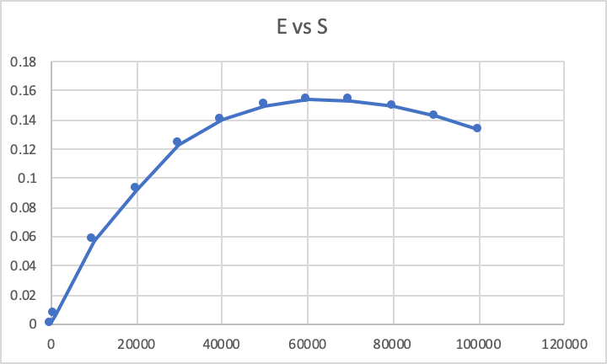

4) (2.5 points) Using the plot, check the value of the packet size S you found in Question 3).

The most efficient packet according to Smax and the graph did not match. This is most likely because Smax only really depended on the bit error rate and not anything else.

**What you need to turn in**:

* Electronic copy of this file (including your answers) (standalone). Submit the file as a Microsoft Word or PDF file.
* Recall that answers must be well written, documented, justified, and presented to get full credit.
* How this assignment will be graded:
* A right answer will get full credit when:
* It is right (worth 25%)
* It is right AND neatly presented making it easy and pleasant to read. (worth 15%)
* There is an obvious and clear link between 1) the information provided in the exercise and in class and 2) the final answer. A clear link is built by properly writing, justifying, and documenting an answer (worth 60%).
* Calculation mistakes will be minimally penalized (2 to 5% of full credit) while errors on units will be more heavily penalized.
* You are welcome/encouraged to discuss exercises with other students or the instructor. But, ultimately, personal writing is expected.