**Grading Guidelines:**

A right answer will get full credit when:

1. It is right (worth 25%)
2. It is right **AND** neatly presented making it easy and pleasant to read. (worth an **extra** 15%)
3. There is an **obvious and clear link** between 1) the information provided in the exercise and in class and 2) the final answer. A clear link is built by properly writing, justifying, and documenting an answer (worth an **extra** 60%).
4. Calculation mistakes will be minimally penalized (2 to 5% of full credit) while errors on units will be more heavily penalized.

**Late Submission** : as specified in the syllabus. Days counting starts one minute after the deadline.

You are welcome/encouraged to discuss exercises with other students or the instructor. But, ultimately, **personal** writing is expected.

* USE THIS FILE AS THE STARTING DOCUMENT YOU WILL TURN IN. **KEEP IN THE QUESTIONS** AND INSERT YOUR ANSWERS.
* IF USING HAND WRITING (STRONGLY DISCOURAGED), REWRITE THE QUESTIONS.
* FAILING TO FOLLOW TURN IN DIRECTIONS /GUIDELINES WILL COST A 30% PENALTY.

**Objectives of this assignment:**

* to learn independently about an important topic
* to answer questions about the independently studied topic
* to empower you: you can learn any networking topic on your own
* to learn independently new concepts

**What you need to do:**

Answer the questions and/or solve the exercises described below.

**KEEP THE GRADING GUIDELINES ABOVE TO REMEMBER THE DIRECTIONS AND HOW THE HOMEWORK IS GRADED.**

**Objective:** The objective of this assignment is to explore the impact of favoring some flows over others and discuss *Net(work) Neutrality*. The assignment is based on the *Conservation Law* that states that if a scheduler is work-conservative (i.e., the resource is idle only if the queue is empty), then:

$\sum_{i=1}^{n}{}λ_{i}x_{i}q_{i}=K (a constant)$

where:

- is the mean arrival rate for the ith flow

- is the mean service time for the ith flow

- is the mean queueing (waiting) time for the ith flow

- K is a constant independent of the scheduling policy.

**Resources**:

1. **Internet**
2. This module slides, videos, and SSQs.

**Exercise**

Consider two flows A and B with arrival rates 10 Mbps and 25 Mbps that share an OC3 (150 Mbps). The packet size can be any size $P_{S}$.

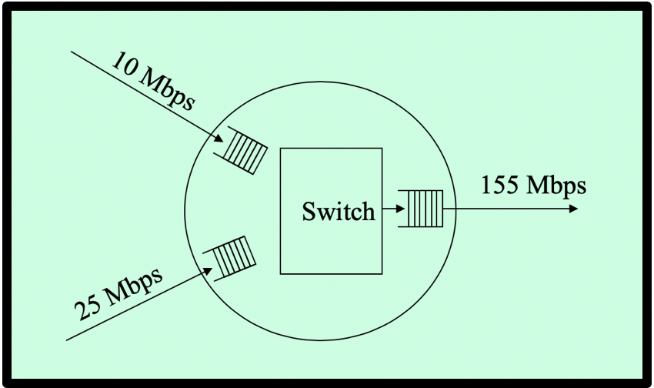

When using *First Come First Serve* (FCFS) as the packet scheduling policy, we observe that the mean queueing delays for Flows A and B are 0.5 ms.

When using a new packet scheduling policy, the mean queueing delays for Flows A and B become $x$ and $y$.

(a) (30 points) Using the *Conservation Law*, the information about *FCFS*, express the mean queueing delay $y$ for Flow B as a function of the mean queueing delay $x$ for Flow A. (**Hint**: See Slide about how I related queueing delays of FCFS with those of a different scheduling policy))

AxAqA + BxBqB = AxA + BxB =>

=

(b) (20 points) **Plot** the mean queueing delay $y$ for Flow B as a function of the mean queueing delay $x$ for Flow A.

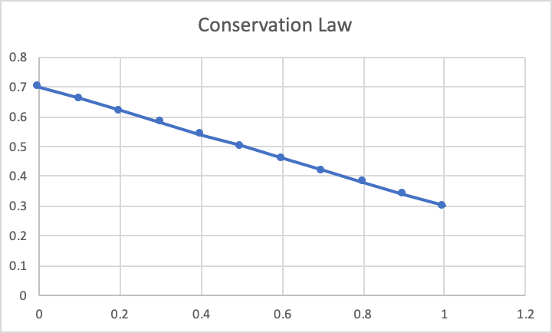

(c) (10 points) A researcher claims that he designed a packet scheduling policy that would perform better than FCFS: with the new policy, **both** the mean queueing delays for Flows A and B would **decrease** (i.e., be both less than 0.5 ms). Using the plot, explain whether such a claim is possible or not.

After looking at the plot, it would be impossible to reduce the mean queueing delays for Flows A and B, because decreasing one flow value will hurt the other flow value which is represented by the negative slope graph. The only point on x and y that are equal is the value 0.5.

(d) (20 points) If we want to decrease **both** the mean queueing delays for Flows A and B, what must be changed: the packet scheduling policy, the mean arrival rate, the packet size, and/or switch output line rate? (Discuss separately the different parameters: do not combine the effects of two parameters (for example policy and mean arrival rate).

Without combining the effects of two parameters: changing the packet scheduling policy and mean arrival rate, decreasing both the mean queueing delays for Flows A and B is not possible. This is due to the Conservation Law, which says you can not decrease the mean queueing delay for one flow without making it worse for the other flow. The packet size has no effect on the mean queueing delay time. Increasing the output line rate will decrease the mean queue delay for both Flow A and B.

(e) (20 points) This question is about of *Net Neutrality*. Explain what *Net Neutrality* is and discuss it:

i) what is *Net Neutrality*?

*Net Neutrality is where* internet service providers must treat all Internet communications equally. Without this it can be possible for certain sites like Youtube to not count towards your data cap for some ISP’s while others make it so that Youtube is throttled and it a much slower experience just because they want to.

ii) Is *Net Neutrality* enforced in the US? If, yes/no, who decides about enforce it in the US? Discuss *Net Neutrality* in the last 4-5 years.

Depends on the state. Some states enforce it while others don’t. Nationally it has be repelled as of 2017. This means that who enforces these rules depends from state to state. After the repeal was planned in many states made laws or planned laws to combat the repeal. In the last few years Net Neutrality has been an issue because of debate because of data caps have been implemented means that these slow downs and free data points are very important to users.

iii) In light of the *Conservation Law*, discuss the pros and cons of *Net Neutrality*?

The pros as I have mentioned above are that some websites will use less of the data cap or actually load faster than usual. The cons of course would that that other websites will load slower or even cost more data than other sites. This is similar to the Conservation law as when there is slow down in one place there will be speed up on another website. However another con of this is the possibility of censorship of this slow down.

**What you need to turn in**:

* Electronic copy of this file (including your answers) (standalone). Submit the file as a Microsoft Word or PDF file.
* Recall that answers must be well written, documented, justified, and presented to get full credit.
* How this assignment will be graded:
* A right answer will get full credit when:
* It is right (worth 25%)
* It is right AND neatly presented making it easy and pleasant to read. (worth 15%)
* There is an obvious and clear link between 1) the information provided in the exercise and in class and 2) the final answer. A clear link is built by properly writing, justifying, and documenting an answer (worth 60%).
* Calculation mistakes will be minimally penalized (2 to 5% of full credit) while errors on units will be more heavily penalized.
* You are welcome/encouraged to discuss exercises with other students or the instructor. But, ultimately, personal writing is expected.