**Questions and Exercises to work out and turn in:**

**Grading Guidelines:**

A right answer will get full credit when:

1. It is right (worth 25%)
2. It is right **AND** neatly presented making it easy and pleasant to read. (worth an **extra** 15%)
3. There is an **obvious and clear link[1]** between 1) the information provided in the exercise and in class and 2) the final answer. A clear link is built by properly writing, justifying, and documenting an answer (worth an **extra** 60%).
4. Calculation mistakes will be minimally penalized (2 to 5% of full credit) while errors on units will be more heavily penalized.

**Late Submission** : as specified in the syllabus. Day counting starts one minute after the deadline.

You are welcome/encouraged to discuss exercises with other students or the instructor. But, ultimately, **personal** writing is expected.

* USE THIS FILE AS THE STARTING DOCUMENT YOU WILL TURN IN. **KEEP IN THE QUESTIONS** AND INSERT YOUR ANSWERS.
* IF USING HAND WRITING (STRONGLY DISCOURAGED), REWRITE THE QUESTIONS.
* FAILING TO FOLLOW TURN IN DIRECTIONS /GUIDELINES WILL COST A 30% PENALTY.

**Objectives of this assignment:**

* to get a sense of round-trip time of packets over the network
* to explore the topology of the Internet.

**What you need to do:**

Answer the questions and/or solve the exercises described below.

**Exercise 1 (60 points)**

The ping program allows you to send a test packet to a given location and see how long it takes to get there and back. Try using ping to see how long it takes to get from your location to several known locations. From these data, plot the one-way transit time over the Internet as a function of distance. It is best to use universities since the location of their servers is known very accurately. For example, berkeley.edu is in Berkeley, California; mit.edu is in Cambridge, Massachusetts; vu.nl is in Amsterdam; The Netherlands; www.usyd.edu.au is in Sydney, Australia; and www.uct.ac.za is in Cape Town, South Africa.

Add three other universities of your choice (must respond to your pings).

Provide **one** **screenshot** (*document*) of a ping to any of the above destinations

Try Texas A&M University (www.tamu.edu) and Auburn University (www.auburn.edu). Explain what may be happening with these universities.

**In case you are not in Auburn**,

Log in remotely on the Engineering Tux machines to ping. To log in remotely, you must use an ssh client such as SecureCRT (Windows).

On Windows 10, you may use from the command prompt the following command (if ssh is available):

ssh username@gate.eng.auburn.edu

where username is your Auburn University username.

On Mac or any Unix machine (Ubuntu...), use the same command (see above) on a terminal.

If you have problems to log in remotely to Tux machines, ask on Piazza for help.

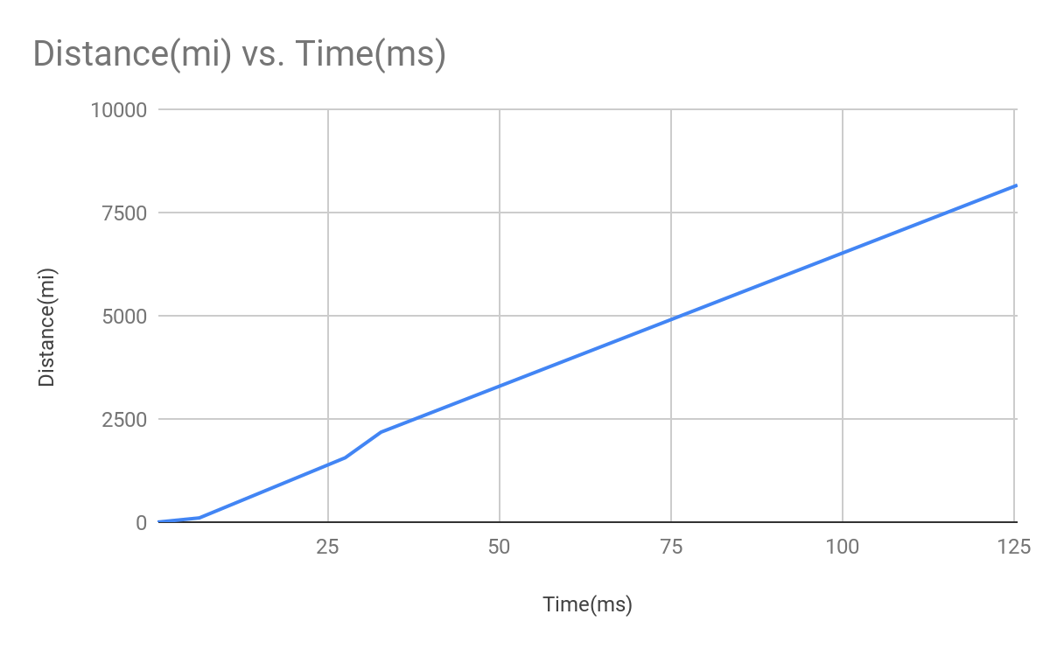

A graph that shows how long it takes to send a data packet from Auburn University to other Universities with relationship to the distance away from Auburn.

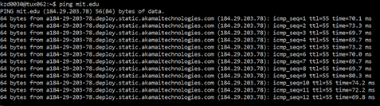

A screenshot of times for a round trip for a 64 byte packet to be sent from Auburn to MIT.

With Auburn I able to hit the server but this was most likely because I was logged into the tux machine, so I was able to bypass the ping protection. With Texas A&M I was unable to hit the server because of this ping protection just like other schools (i.e. Georgia Tech, CalTech, etc).

**Exercise 2 (30 points)**

a) (20 points) A system has an n-layer protocol hierarchy. Applications generate messages of length

M bytes. At each of the layers, an h-byte header is added. What fraction of the network bandwidth is filled with headers?

The total number of header bytes is *n * h*, so that’s the amount of layer space the headers take up.

The total message size is the total header bytes plus the application message bytes, so *M + (n * h).*

The fraction of the network bandwidth that is filled with headers is the total number of header bytes divided by the total message size.

b) (10 points). Consider a DNS request on the Internet. The DNS request (application layer) is a message of about 100 bytes. The UDP header is 8 bytes long. The IP header is in general 20 bytes long. An IEEE 802.3 Ethernet frame may have up to a 26 bytes header and a 16 bytes trailer. What fraction of the network bandwidth is filled with headers?

The total number of header bytes is the application layer headers plus the network layer headers plus the 8 + 20 + 26 = 54 bytes.

The total message size is the total header bytes plus the application message bytes plus the ethernet trailer, which is 100 + 54 + 16 = 170.

The fraction of the network bandwidth that is filled with headers is the total number of header bytes divided by the total message size.

**Exercise 3 (10 points)**

The performance of a client-server system is strongly influenced by two major network

characteristics: the bandwidth of the network (that is, how many bits/sec it can transport) and the latency (that is, how many seconds it takes for the first bit to get from the client to the server).

Give an example of a network that exhibits high bandwidth but also high latency. Then give an example of one that has both low bandwidth and low latency.

Bandwidth is used to represent the number of bits that can be transported over time. Latency is the measure of how many seconds it will take a network to transfer data from one device to another.

An example of a network that exhibits high bandwidth and high latency is Satellite Internet. Satellite Internet providers like Viasat can provide satellite internet that can transfer data with the speed up to 100 Mbps, but these satellites are tens of thousands of miles away in space. As a result, the latency can be as high as 500 ms.

An example of a network that exhibits low bandwidth and low latency is an Asymmetric digital subscriber line. An ADSL connection has the potential of reaching 24 Mbps, but on average it is around 8 Mbps. However, ADSLs have a basic encoding latency of around 10 ms.

What you need to turn in:

* Electronic copy of this file (including your answers) (standalone). Submit the file as a Microsoft Word or PDF file.
* Recall that answers must be well written, documented, justified, and presented to get full credit.
* How this assignment will be graded:
* A right answer will get full credit when:
* It is right (worth 25%)
* It is right AND neatly presented making it easy and pleasant to read. (worth 15%)
* There is an obvious and clear link between 1) the information provided in the exercise and in class and 2) the final answer. A clear link is built by properly writing, justifying, and documenting an answer (worth 60%).
* Calculation mistakes will be minimally penalized (2 to 5% of full credit) while errors on units will be more heavily penalized.
* You are welcome/encouraged to discuss exercises with other students or the instructor. But, ultimately, personal writing is expected.

**Appendix**: Grading: What is an OBVIOUS and CLEAR LINK?

Here is an example to explain what an **obvious and clear link** is and how we grade your work.

Consider the following problem:

*"(100 points) John travels from Auburn to Atlanta in his car at a speed of 50 mph. Leaving at 8am, at what time will John reach Atlanta".*

Here are the answers of three students and their scores:

**Student 1** answers: "10am". Student 1 will get 25 points.

**Student 2**answers : "John will reach Atlanta at 10am". Student 2 will get 25+15 = 40 points

**Student 3** answers: "The time t to travel a distance d at speed v is equal to d/v = d/50mph. The problem does not provide the distance d from Auburn to Atlanta. Based on Google, the distance from Auburn to Atlanta is approximately 100 miles (**document is here**). Therefore, the time t = 100 miles/50mph = 2 hours. Since John left at 8am, he will then reach Atlanta at 8am + 2 hours = 10 am".

**Student 3** will get 25 + 15 + 60 = 100 points

Do you see the **direct** **link** going from the data provided in the question to the final answer, using general knowledge/formula and documents?.... Can you now solve the following problem and get 100 points?

*"(100 points) Alice travels from Auburn to Atlanta in her car at a speed of 50 mph. Leaving at 8am, at what time will Alice reach Atlanta assuming that she had a flat tire that delayed her 30 minutes*".

1. See on the appendix what an obvious and clear link is.