**Questions and Exercises to work out and turn in:**

**Grading Guidelines:**

A right answer will get full credit when:

1. It is right (worth 25%)
2. It is right **AND** neatly presented making it easy and pleasant to read. (worth an **extra** 15%)
3. There is an **obvious and clear link** between 1) the information provided in the exercise and in class and 2) the final answer. A clear link is built by properly writing, justifying, and documenting an answer (worth an **extra** 60%).
4. Calculation mistakes will be minimally penalized (2 to 5% of full credit) while errors on units will be more heavily penalized.

**Late Submission** : as specified in the syllabus. Days counting starts one minute after the deadline.

You are welcome/encouraged to discuss exercises with other students or the instructor. But, ultimately, **personal** writing is expected.

* USE THIS FILE AS THE STARTING DOCUMENT YOU WILL TURN IN. **KEEP IN THE QUESTIONS** AND INSERT YOUR ANSWERS.
* IF USING HAND WRITING (STRONGLY DISCOURAGED), REWRITE THE QUESTIONS.
* FAILING TO FOLLOW TURN IN DIRECTIONS /GUIDELINES WILL COST A 30% PENALTY.

**Objectives of this assignment:**

* to implement programs that communicate over the Internet
* to implement such applications using socket programming.

**What you need to do:**

Answer the questions and/or solve the exercises described below.

**Exercise 1 (100 points)**

The objective of this exercise is to get you familiar with the types used in Java to handle IP addresses.

Consider the program ***InetAddressExample.java*** provided with this homework:

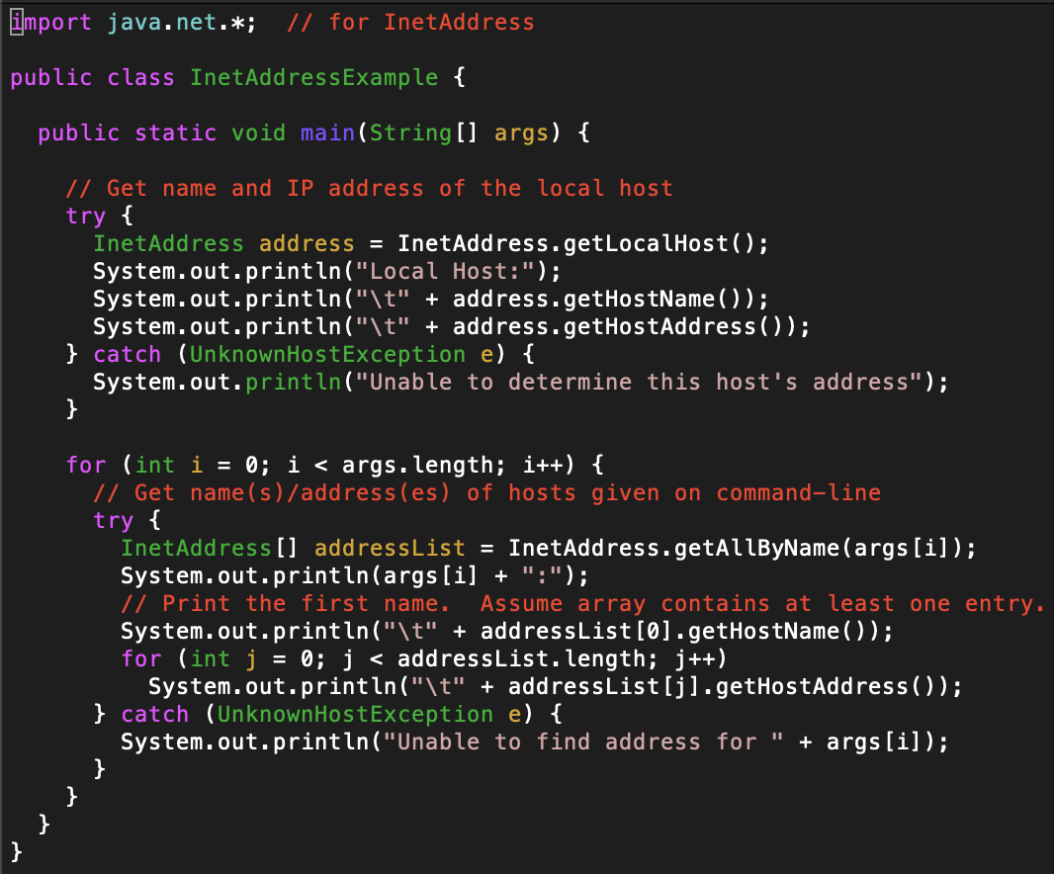

a) (20 points) Download, read, examine, compile, and run this program to understand this program. Execute the following commands and provide the screenshots of the response:

1) java InetAddressExample

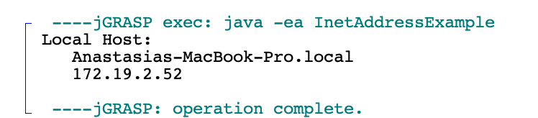

2) java InetAddressExample www.tamu.edu [www.mit.edu](http://www.mit.edu)

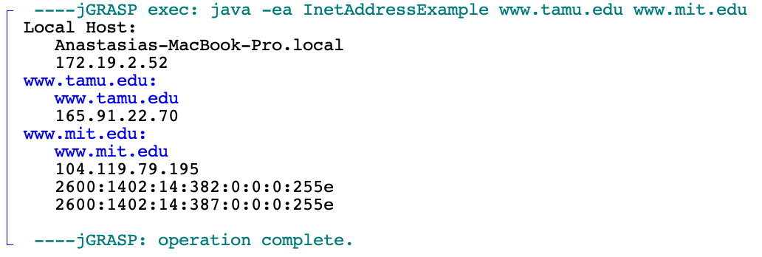

b) (80 points) Modify this program to create a program named MyInetAddressExample.java to perform the following tasks:

1) Prompt the user to enter a hostname (e.g., www.auburn.edu)

2) Display the IP addresses in binary, binary dotted-quad, and decimal dotted-quad formats. For example, if the user enters the hostname www.auburn.edu, then your program must display:

- binary format : 10000011110011001000101010101010

- binary dotted-quad format : 10000011.11001100.10001010.10101010

- decimal dotted-quad format : 131.204.138.170

3) Provide a screenshot of an execution of your program.

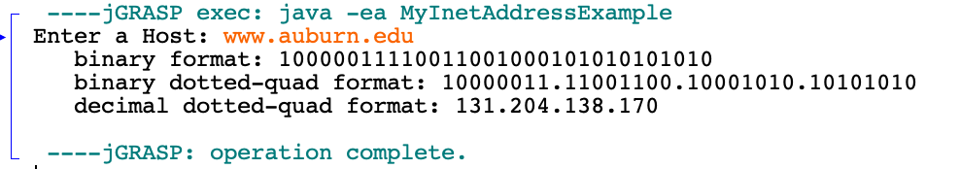

**What you need to turn in**:

* Electronic copy of this file (including your answers) (standalone) and the program source MyInetAddressExample.java (standalone) Submit this file as a Microsoft Word or PDF file.
* Recall that answers must be well written, documented, justified, and presented to get full credit.
* How this assignment will be graded:
* A right answer will get full credit when:
* It is right (worth 25%)
* It is right AND neatly presented making it easy and pleasant to read. (worth 15%)
* There is an obvious and clear link between 1) the information provided in the exercise and in class and 2) the final answer. A clear link is built by properly writing, justifying, and documenting an answer (worth 60%).
* Calculation mistakes will be minimally penalized (2 to 5% of full credit) while errors on units will be more heavily penalized.
* You are welcome/encouraged to discuss exercises with other students or the instructor. But, ultimately, personal writing is expected.