**Questions and Exercises to work out and turn in:**

**Grading Guidelines:**

A right answer will get full credit when:

1. It is right (worth 25%)
2. It is right **AND** neatly presented making it easy and pleasant to read. (worth an **extra** 15%)
3. There is an **obvious and clear link[1]** between 1) the information provided in the exercise and in class and 2) the final answer. A clear link is built by properly writing, justifying, and documenting an answer (worth an **extra** 60%).
4. Calculation mistakes will be minimally penalized (2 to 5% of full credit) while errors on units will be more heavily penalized.

**Late Submission** : as specified in the syllabus. Days counting starts one minute after the deadline.

You are welcome/encouraged to discuss exercises with other students or the instructor. But, ultimately, **personal** writing is expected.

* USE THIS FILE AS THE STARTING DOCUMENT YOU WILL TURN IN. **KEEP IN THE QUESTIONS** AND INSERT YOUR ANSWERS.
* IF USING HAND WRITING (STRONGLY DISCOURAGED), REWRITE THE QUESTIONS.
* FAILING TO FOLLOW TURN IN DIRECTIONS /GUIDELINES WILL COST A 30% PENALTY.

**Objectives of this assignment:**

* to compute the "Internet Checksum" on a stream of bits
* to evaluate the impact of the distance on the throughput and efficiency of stop-and-wait protocol.

**What you need to do:**

Answer the questions and/or solve the exercises described below.

**Logical Link Layer**

**Exercise 1 (30 points)**

#### Suppose that a message 1001 1101 1000 0111 is transmitted using Internet Checksum (4-bit word). What is the value of the checksum?

#### An n-bit Internet Checksum is computed as follows:

#### 1) Break the stream of bits in n-bit words w1, w2, ..., and wm.

2) Compute the n-bit word S = w1 + w2, if there is a carry then set S = S + 1

3) Compute S = S + w3, if there is a carry then set S = S + 1

........

n) Compute S = S + wn, if there is a carry then set S = S + 1

Finally, the Internet Checksum = ~S (one-complement of S)

* 1 1 1
* 1 0 0 1
* 1 1 0 1
* 1 0 0 0
* 0 1 1 1

----------------------

1 0 0 1 0 1

* 0 1 0 1
* 1 0

----------------------

0 1 1 1

checksum = one’s complement of 0111 = 1000

**Exercise 2 (70 points)**

#### **The objective of this exercise is to realize high distance and high bandwidth affect the performance of stop and wait.**

#### The distance from Earth to a distant planet is approximately 9 x 107 km. Assume that the frame size is 16 KB and the speed of light is 3 108 m/s. Assume that the bit rate is 20 Mbps.

1. (5 points) What is the efficiency (channel utilization) if a stop-and-wait protocol is used?

distance = 9 x 107 km = 9 x 1010 m

data rate = 20 Mbps = 20,000,000 bps

size = 16 KB = 128 Kbits = 128,000 bits

propagation speed = 3 x108 m/s

transmission delay = size / data rate = 128,000 / 20,000,000 = .0064 s

propagation delay = distance / propagation speed = 9 x 1010 / 3 x108 = 300 s

channel utilization = .0064 / (.0064 + 300) = 0.00002133 = 21.33 x 106

1. (15 points) Suppose we use a window protocol. What should be the window size in frames to achieve the maximal efficiency (channel utilization)?

To achieve efficiency of 100% window size should be equal to the number of packets that can be sent in one round trip time.

Round trip time = 2 * propagation delay = 2 * 300 = 600 s

The transmission time for 1 packet is .0064 s, so we can send 600/.0064 = 93,750 packets in one round trip time, thus the window size should be 93,750

1. (20 points) Plot the efficiency versus the distance when the bit rate is set to 20 Mbps. Discuss this plot.

efficiency = throughput / bit rate

throughput = Size / (2 * propagation time + transmission time) = size / ( 2 * distance / propagation speed + size / bit rate ))

efficiency = (Size / (2 * propagation time + transmission time) = (size / ( 2 * (distance / propagation speed) + (size / bit rate)))) / bit rate

= (128,000 bits / ( 2 * (distance / 3 x108 m/s) + 128,000 bits / 20,000,000 bps ))) / 20,000,000 bps

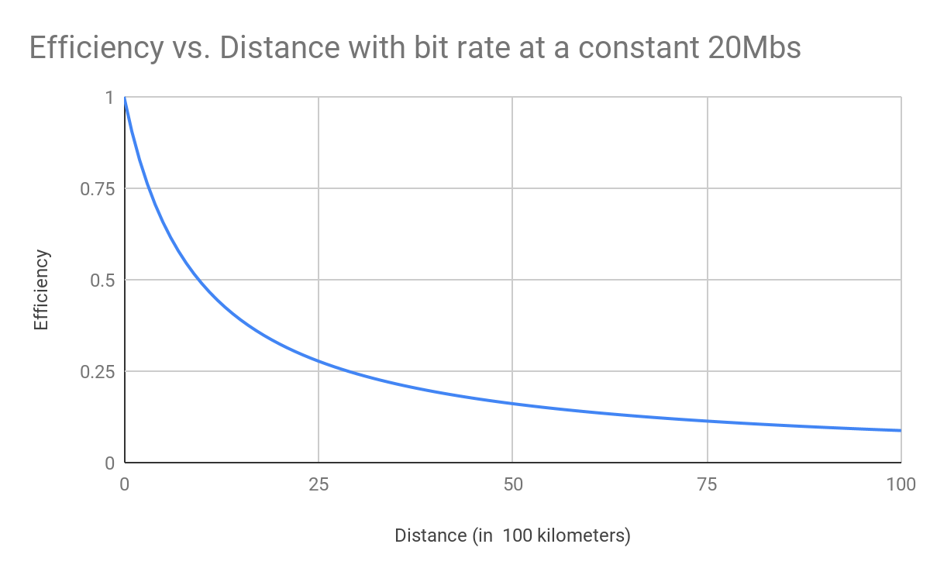As the distance increases the efficiency decreases meaning that distance and efficiency have an inverse relationship.

Points used

|  |  |
| --- | --- |
| 0 | 1 |
| 1 | 0.9056603774 |
| 2 | 0.8275862069 |
| 3 | 0.7619047619 |
| 4 | 0.7058823529 |
| 5 | 0.6575342466 |
| 6 | 0.6153846154 |
| 7 | 0.578313253 |
| 8 | 0.5454545455 |
| 9 | 0.5161290323 |
| 10 | 0.4897959184 |
| 11 | 0.4660194175 |
| 12 | 0.4444444444 |
| 13 | 0.4247787611 |
| 14 | 0.406779661 |
| 15 | 0.3902439024 |
| 16 | 0.375 |
| 17 | 0.3609022556 |
| 18 | 0.347826087 |
| 19 | 0.3356643357 |
| 20 | 0.3243243243 |
| 21 | 0.3137254902 |
| 22 | 0.3037974684 |
| 23 | 0.2944785276 |
| 24 | 0.2857142857 |
| 25 | 0.2774566474 |
| 26 | 0.2696629213 |
| 27 | 0.262295082 |
| 28 | 0.2553191489 |
| 29 | 0.2487046632 |
| 30 | 0.2424242424 |
| 31 | 0.236453202 |
| 32 | 0.2307692308 |
| 33 | 0.2253521127 |
| 34 | 0.2201834862 |
| 35 | 0.2152466368 |
| 36 | 0.2105263158 |
| 37 | 0.2060085837 |
| 38 | 0.2016806723 |
| 39 | 0.1975308642 |
| 40 | 0.1935483871 |
| 41 | 0.1897233202 |
| 42 | 0.1860465116 |
| 43 | 0.1825095057 |
| 44 | 0.1791044776 |
| 45 | 0.1758241758 |
| 46 | 0.1726618705 |
| 47 | 0.1696113074 |
| 48 | 0.1666666667 |
| 49 | 0.1638225256 |
| 50 | 0.1610738255 |
| 51 | 0.1584158416 |
| 52 | 0.1558441558 |
| 53 | 0.1533546326 |
| 54 | 0.1509433962 |
| 55 | 0.1486068111 |
| 56 | 0.1463414634 |
| 57 | 0.1441441441 |
| 58 | 0.1420118343 |
| 59 | 0.139941691 |
| 60 | 0.1379310345 |
| 61 | 0.1359773371 |
| 62 | 0.1340782123 |
| 63 | 0.132231405 |
| 64 | 0.1304347826 |
| 65 | 0.1286863271 |
| 66 | 0.126984127 |
| 67 | 0.1253263708 |
| 68 | 0.1237113402 |
| 69 | 0.1221374046 |
| 70 | 0.1206030151 |
| 71 | 0.1191066998 |
| 72 | 0.1176470588 |
| 73 | 0.1162227603 |
| 74 | 0.1148325359 |
| 75 | 0.1134751773 |
| 76 | 0.1121495327 |
| 77 | 0.1108545035 |
| 78 | 0.1095890411 |
| 79 | 0.1083521445 |
| 80 | 0.1071428571 |
| 81 | 0.1059602649 |
| 82 | 0.1048034934 |
| 83 | 0.1036717063 |
| 84 | 0.1025641026 |
| 85 | 0.1014799154 |
| 86 | 0.10041841 |
| 87 | 0.09937888199 |
| 88 | 0.09836065574 |
| 89 | 0.09736308316 |
| 90 | 0.09638554217 |
| 91 | 0.09542743539 |
| 92 | 0.09448818898 |
| 93 | 0.09356725146 |
| 94 | 0.09266409266 |
| 95 | 0.09177820268 |
| 96 | 0.09090909091 |
| 97 | 0.09005628518 |
| 98 | 0.08921933086 |
| 99 | 0.08839779006 |
| 100 | 0.08759124088 |

1. (20 points) Plot the efficiency versus the bit rate when distance is set to 9 x 107 km. Discuss this plot.

efficiency = throughput / bit rate

throughput = Size / (2 * propagation time + transmission time) = size / ( 2 * distance / propagation speed + size / bit rate ))

efficiency = (Size / (2 * propagation time + transmission time) = (size / ( 2 * (distance / propagation speed) + (size / bit rate)))) / bit rate

= (128,000 bits / ( 2 * (9 x 1010 m / 3 x108 m/s) + 128,000 bits / bit rate ))) / bit rate

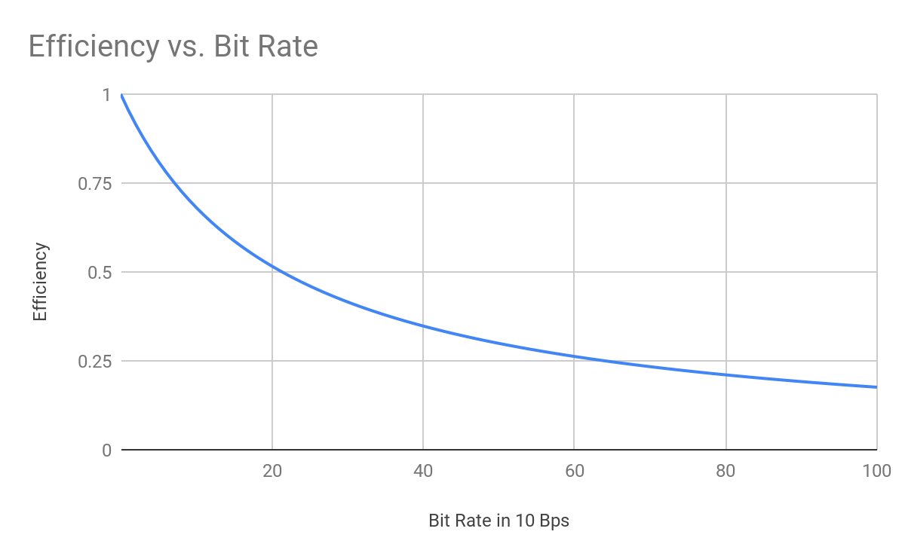

As the bit rates increases the efficiency decreases meaning that bit rate and efficiency have an inverse relationship.

Points used

|  |  |
| --- | --- |
| 0.000001 | 0.9999999531 |
| 1 | 0.9552238806 |
| 2 | 0.9142857143 |
| 3 | 0.8767123288 |
| 4 | 0.8421052632 |
| 5 | 0.8101265823 |
| 6 | 0.7804878049 |
| 7 | 0.7529411765 |
| 8 | 0.7272727273 |
| 9 | 0.7032967033 |
| 10 | 0.6808510638 |
| 11 | 0.6597938144 |
| 12 | 0.64 |
| 13 | 0.6213592233 |
| 14 | 0.6037735849 |
| 15 | 0.5871559633 |
| 16 | 0.5714285714 |
| 17 | 0.5565217391 |
| 18 | 0.5423728814 |
| 19 | 0.5289256198 |
| 20 | 0.5161290323 |
| 21 | 0.5039370079 |
| 22 | 0.4923076923 |
| 23 | 0.4812030075 |
| 24 | 0.4705882353 |
| 25 | 0.4604316547 |
| 26 | 0.4507042254 |
| 27 | 0.4413793103 |
| 28 | 0.4324324324 |
| 29 | 0.4238410596 |
| 30 | 0.4155844156 |
| 31 | 0.4076433121 |
| 32 | 0.4 |
| 33 | 0.3926380368 |
| 34 | 0.3855421687 |
| 35 | 0.3786982249 |
| 36 | 0.3720930233 |
| 37 | 0.3657142857 |
| 38 | 0.3595505618 |
| 39 | 0.3535911602 |
| 40 | 0.347826087 |
| 41 | 0.3422459893 |
| 42 | 0.3368421053 |
| 43 | 0.3316062176 |
| 44 | 0.3265306122 |
| 45 | 0.3216080402 |
| 46 | 0.3168316832 |
| 47 | 0.312195122 |
| 48 | 0.3076923077 |
| 49 | 0.3033175355 |
| 50 | 0.2990654206 |
| 51 | 0.2949308756 |
| 52 | 0.2909090909 |
| 53 | 0.2869955157 |
| 54 | 0.2831858407 |
| 55 | 0.2794759825 |
| 56 | 0.275862069 |
| 57 | 0.2723404255 |
| 58 | 0.268907563 |
| 59 | 0.265560166 |
| 60 | 0.262295082 |
| 61 | 0.2591093117 |
| 62 | 0.256 |
| 63 | 0.2529644269 |
| 64 | 0.25 |
| 65 | 0.2471042471 |
| 66 | 0.2442748092 |
| 67 | 0.241509434 |
| 68 | 0.2388059701 |
| 69 | 0.2361623616 |
| 70 | 0.2335766423 |
| 71 | 0.2310469314 |
| 72 | 0.2285714286 |
| 73 | 0.2261484099 |
| 74 | 0.2237762238 |
| 75 | 0.2214532872 |
| 76 | 0.2191780822 |
| 77 | 0.2169491525 |
| 78 | 0.2147651007 |
| 79 | 0.2126245847 |
| 80 | 0.2105263158 |
| 81 | 0.2084690554 |
| 82 | 0.2064516129 |
| 83 | 0.2044728435 |
| 84 | 0.2025316456 |
| 85 | 0.2006269592 |
| 86 | 0.198757764 |
| 87 | 0.1969230769 |
| 88 | 0.1951219512 |
| 89 | 0.1933534743 |
| 90 | 0.1916167665 |
| 91 | 0.1899109792 |
| 92 | 0.1882352941 |
| 93 | 0.1865889213 |
| 94 | 0.1849710983 |
| 95 | 0.1833810888 |
| 96 | 0.1818181818 |
| 97 | 0.1802816901 |
| 98 | 0.1787709497 |
| 99 | 0.1772853186 |
| 100 | 0.1758241758 |

**What you need to turn in**:

* Electronic copy of this file (including your answers) (standalone). Submit the file as a Microsoft Word or PDF file.
* Recall that answers must be well written, documented, justified, and presented to get full credit.
* How this assignment will be graded:
* A right answer will get full credit when:
* It is right (worth 25%)
* It is right AND neatly presented making it easy and pleasant to read. (worth 15%)
* There is an obvious and clear link between 1) the information provided in the exercise and in class and 2) the final answer. A clear link is built by properly writing, justifying, and documenting an answer (worth 60%).
* Calculation mistakes will be minimally penalized (2 to 5% of full credit) while errors on units will be more heavily penalized.
* You are welcome/encouraged to discuss exercises with other students or the instructor. But, ultimately, personal writing is expected.

**Appendix**: Grading: What is an OBVIOUS and CLEAR LINK?

Here is an example to explain what an **obvious and clear link** is and how we grade your work.

Consider the following problem:

*"(100 points) John travels from Auburn to Atlanta in his car at a speed of 50 mph. Leaving at 8am, at what time will John reach Atlanta".*

Here are the answers of three students and their scores:

**Student 1** answers: "10am". Student 1 will get 25 points.

**Student 2**answers : "John will reach Atlanta at 10am". Student 2 will get 25+15 = 40 points

**Student 3** answers: "The time t to travel a distance d at speed v is equal to d/v = d/50mph. The problem does not provide the distance d from Auburn to Atlanta. Based on Google, the distance from Auburn to Atlanta is approximately 100 miles (**document is here**). Therefore, the time t = 100 miles/50mph = 2 hours. Since John left at 8am, he will then reach Atlanta at 8am + 2 hours = 10 am".

**Student 3** will get 25 + 15 + 60 = 100 points

Do you see the **direct** **link** going from the data provided in the question to the final answer, using general knowledge/formula and documents?.... Can you now solve the following problem and get 100 points?

*"(100 points) Alice travels from Auburn to Atlanta in her car at a speed of 50 mph. Leaving at 8am, at what time will Alice reach Atlanta assuming that she had a flat tire that delayed her 30 minutes*".

1. Check the appendix about what an obvious and clear link is.