**Objective:** The objective of this assignment is to learn independently about *Network Address Translation* ***(NAT)***. You must research and read about NAT, and then answer the questions.

**Resources**:

1. **Textbook:** Tanenbaum, Andrew S. and David J. Wetherall. *Computer Networks*.
2. Module 5
3. Your instructor (Through Piazza)
4. RFC 3022
5. Wikipedia (complete, but may be confusing)
6. Internet

Note that the textbook, Module 2 material, and your instructor are sufficient to answer all questions in this homework as well as the related self-study questions.

**Questions**: (**hint**: fist read all questions before answering. This will avoid you repeating or overlapping answers).

**Generalities**

1) **(5 points)** Which problem does NAT address or solve?

The network address translation (NAT) helps link communication from a private network to the internet (outside of that network) by providing a group of public IPs that will connect to other routers that can reach the destination.

2) **(15 points)** Explain briefly what NAT is (about 5 to 10 lines). Feel free to refer to **Figure 5-55** below to help your explanations.

NAT is used to connect to the internet using an allocation table that reroutes the traffic to the internet. Each customer network is assigned a single IP address for internet traffic. Inside the customer network, each computer gets a unique IP address used for routing internal traffic. Within the customer network, every has a unique address listed in point A. Before a packet leaves the customer premises, it passes through the NAT box that converts the internal IP source address to the customer’s true shared public IP address. The NAT box device often contains a firewall that provides security by controlling what goes into the customer network and what comes out of it

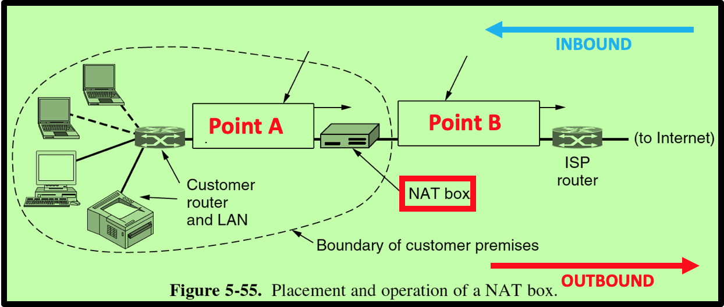

3) **(5 points)** Suppose you want to deploy NAT at your home. Do you need to contact some Internet organization/authority or your Internet provider to get assigned some range of IP addresses to use on your **internal** network?

You must get authorization from the internet provider because they have a predetermined set of public IP addresses that are connected to their routers

4) **(5 points)** What is (are) the range(s) of IP addresses you could use on your internal network?

internal networks can use the IP addresses in class A (0.X.X.X - 127.X.X.X), class B (128.X.X.X - 191.X.X.X), or class C (192.X.X.X - 223.X.X.X)

5) **(5 points)** Does your wireless network at home use NAT? What is the IP address of your desktop, laptop, or any device you use to access the Internet from home?

My apartment complex does use NAT to connect our routers to the internet.

my IP address is 100.64.7.187/20

6) **(5 points)** Suppose that you want to use NAT on your network at home. What is the smallest number of external (Internet) IP addresses you would need to acquire from your Internet provider?

one NAT address is the smallest number of external IP addresses needed from your internet provider

**NAT Operations**

First let us define a **flow**: *two packets belong to the same TCP (or UDP)* ***flow*** *if both packets carry a TCP segment (or a UDP datagram) that have the* ***same*** *source IP address, destination IP address, source port number, and destination port number.*

For all the following questions, we assume that the NAT box has the following available ports for translation for TCP and UDP. When the NAT box needs to translate a packet for a **new** flow, it will pick the next available port number from the table below. We assume that the next available port number for TCP (resp., UDP) is at Index 1. If the port number at Index 1 is already used, the next available will be the one at Index 2 and so on. **We assume that the NAT was just turned on**. Therefore, the next available port # for translation of a TCP (resp. UDP) flow is 6040 (resp. 7050).

|  |  |  |
| --- | --- | --- |
| Index | TCP | UDP |
| 1 | 6040 | 7050 |
| 2 | 8269 | 8201 |
| 3 | 6314 | 7100 |
| 4 | 7801 | 5325 |

As seen on Figure 5-55, a customer sets up a network with multiple machines. However, the Internet provider assigned only one IP address to the customer: this IP address is 128.194.20.56.

Consider a machine M on the customer's network "behind" a NAT box, i.e. on the premises of the customer (see Figure 5-55 above). The IP address of Machine M is 192.168.2.67. A TCP client socket is established at Port # 10100 to send an http query ***Q*** to the server at IP address 64.233.177.101.

1. **(10 points)** Consider Packet P1 carrying the http request ***Q.*** P1 **leaves** Machine M and reaches Point A (see Figure 5-55). Fill in the array below with the source IP address, destination IP address, source port number, destination port number of Packet P1 when it is at Point A. Tell whether this packet P1 carries a TCP segment or a UDP datagram.

|  |  |  |  |  |
| --- | --- | --- | --- | --- |
| TCP or UDP? | IP Source | IP Destination | Source Port # | Dest. Port # |
| TCP | 192.168.2.67 | 64.233.177.101 | 10100 | 80 |

2) **(10 points)** When the NAT box receives Packet P1, it translates it and outputs on Point B (see Figure 5-55) a translated packet. Fill in the array below with the source IP address, destination IP address, source port number, destination port number of the **translated** Packet P1. Highlight the information that will change (by the translation) and explain why.

|  |  |  |  |  |
| --- | --- | --- | --- | --- |
| TCP or UDP? | IP Source | IP Destination | Source Port # | Dest. Port # |
| TCP | 128.194.20.56 | 64.233.177.101 | 6040 | 80 |

Translating Packet P1 changes the source ip address as well as the source port number. The nat box translates the packet to give it the same IP address as other Packets that go through the nat box. The nat box also gives a unique port so all the computers on the network have the same IP.

3) **(10 points)** When Packet P1 reaches the server, the server will respond with a packet **P2**. Fill in the array below with the source IP address, destination IP address, source port number, destination port number of the Packet **P2**.

|  |  |  |  |  |
| --- | --- | --- | --- | --- |
| TCP or UDP? | IP Source | IP Destination | Source Port # | Dest. Port # |
| TCP | 64.233.177.101 | 128.194.20.56 | 80 | 6040 |

4) **(10 points)** When the inbound packet P2 reaches the NAT box, it will be translated. Fill in the array below with the source IP address, destination IP address, source port number, destination port number of the **translated** Packet P2 (Point A).

|  |  |  |  |  |
| --- | --- | --- | --- | --- |
| TCP or UDP? | IP Source | IP Destination | Source Port # | Dest. Port # |
| TCP | 64.233.177.101 | 192.168.2.67 | 80 | 10100 |

5) **(10 points)** Suppose now that the same machine M (IP address :192.168.2.67) makes a DNS request to the server at IP address 128.194.54.252. The DNS client is bound to Port # 10200. The DNS request will be carried by Packet P3. Fill in the array below with the source IP address, destination IP address, source port number, destination port number of Packet P3 (Point A).

|  |  |  |  |  |
| --- | --- | --- | --- | --- |
| TCP or UDP? | IP Source | IP Destination | Source Port # | Dest. Port # |
| UDP | 192.168.2.67 | 128.194.54.252 | 10200 | 53 |

6) **(10 points)** When the NAT box receives Packet P3, it translates it and outputs on Point B (see Figure 5-55) a translated packet. Fill in the array below with the source IP address, destination IP address, source port number, destination port number of the **translated** Packet P3. Highlight the information that will change (by the translation) and explain why.

|  |  |  |  |  |
| --- | --- | --- | --- | --- |
| TCP or UDP? | IP Source | IP Destination | Source Port # | Dest. Port # |
| UDP | 128.194.20.56 | 128.194.54.252 | 7050 | 53 |

Translating Packet P3 changes the source IP address as well as the source port number. The nat box translates the packet to give it the same IP address as other Packets that go through the nat box. The nat box also gives a unique port so all the computers on the network have the same IP.