Problem 1

V(G) = 4 + 1 =5

V(G) = 5

V(G) = |E| - |V| + p = 15 – 11 + 1 = 5

P\* = 2 \* 2 + 2 + 2 = 8

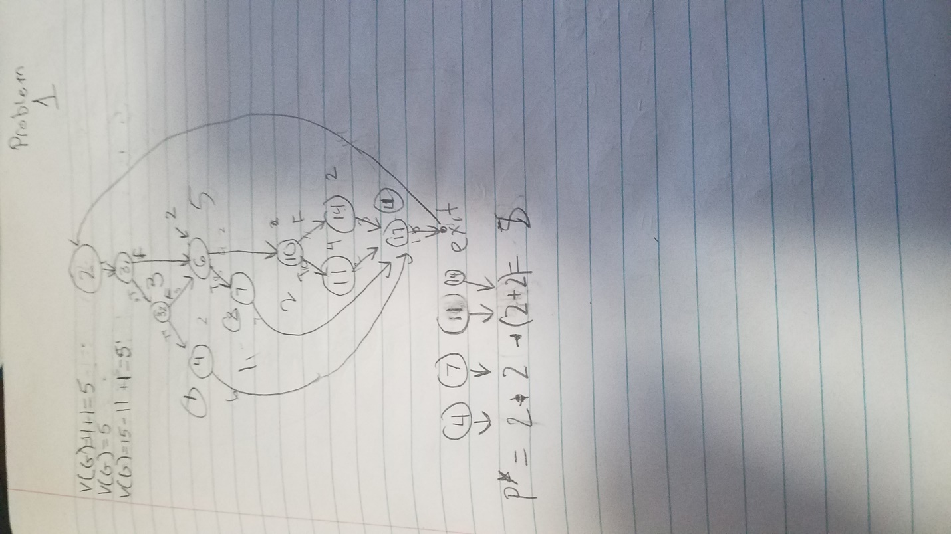

Problem 2

V(G) = 6 + 1 =7

V(G) = 7

V(G) = |E| - |V| + p = 20 – 14 + 1 = 7

P\* = 2 + 2 + 2 + 24 = 22

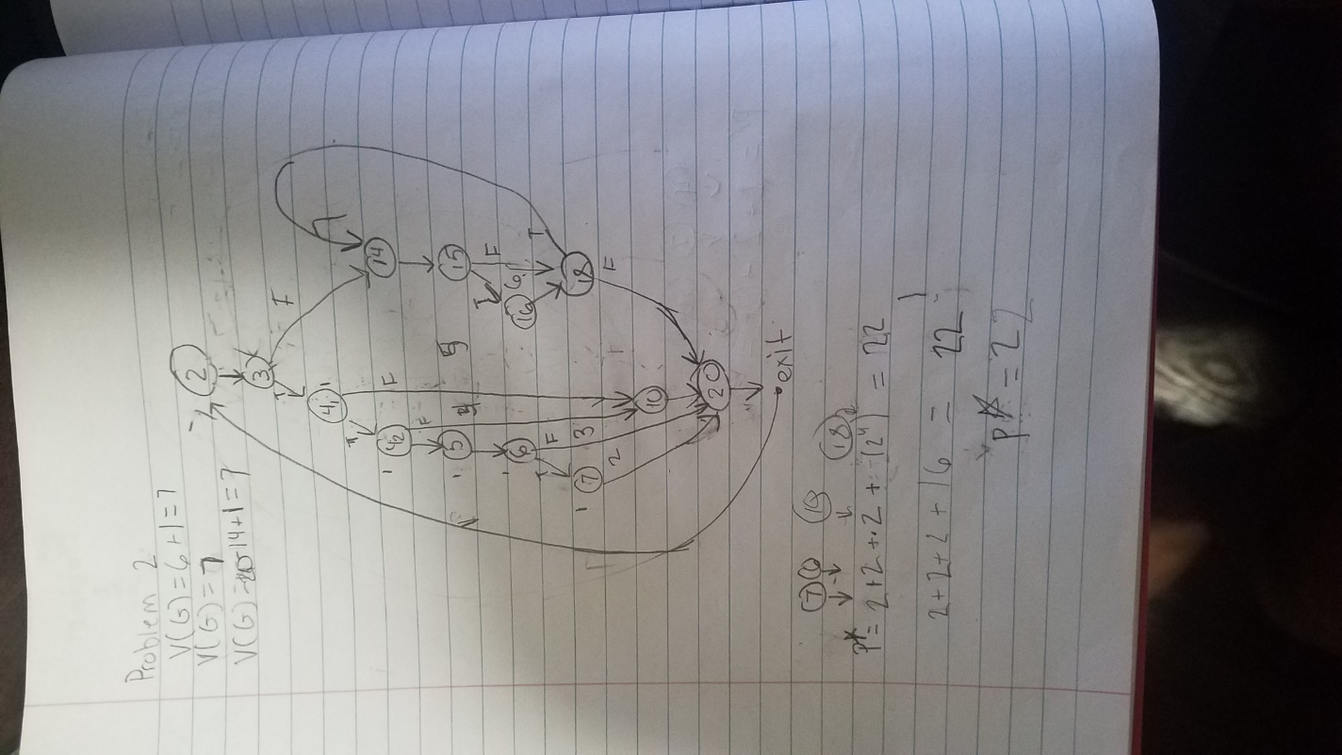

Problem 3

V(G) = 6 + 1 =7

V(G) = 7

V(G) = |E| - |V| + p = 24 – 18 + 1 = 7

P\* = (2 + 2 + (21 + 22 + 23) ) \* (1 + 13)= 36

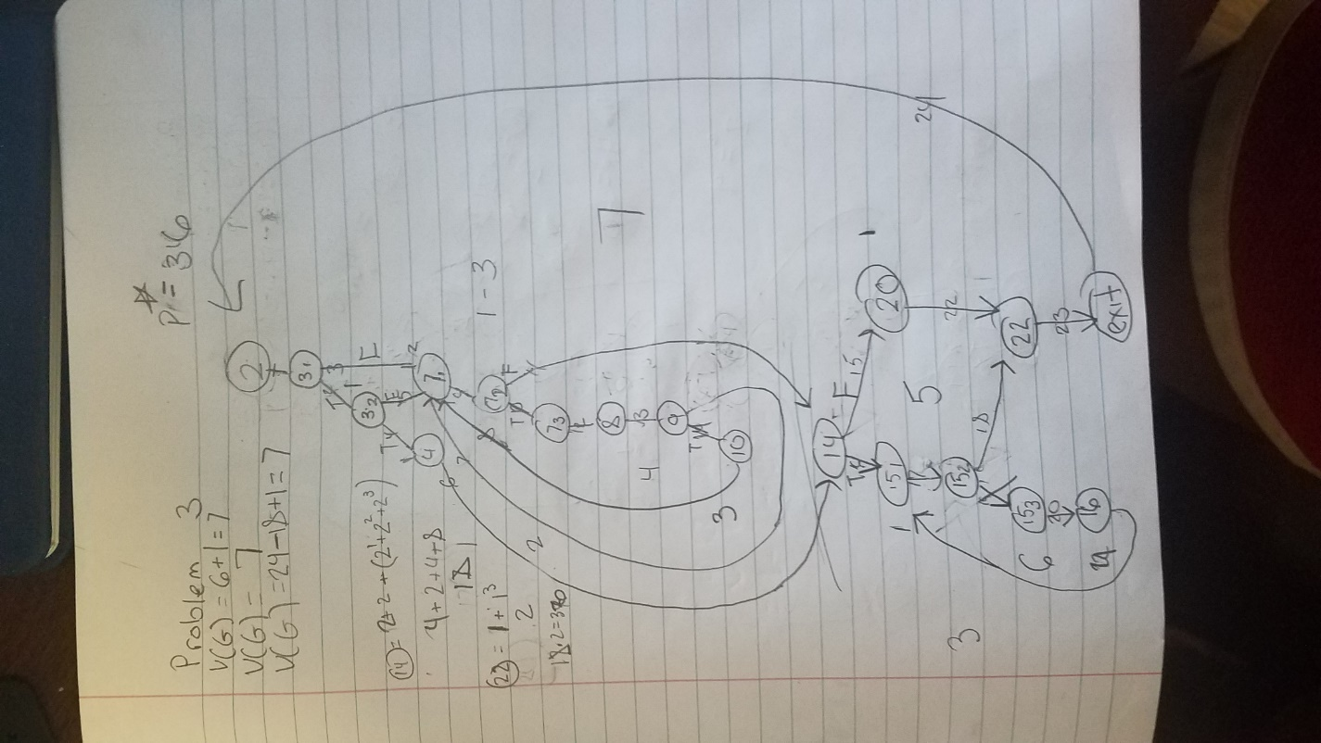

Problem 4

V(G) = 8 + 1 =9

V(G) = 9

V(G) = |E| - |V| + p = 25 – 17 + 1 = 9

P\* = ((2 + 2 \* (2+ 2))\* (1 + 13)2)2= 1600

