Comp 3350: Computer Organization & Assembly Language

HW # 10: Theme: Strings and Arrays
(All main questions carry equal weight. Credit awarded to only those answers for which work has been shown.)
- [Case Table] Write a program that asks the user to enter a score. It then adds 1 to the score, creating a final score and prints the letter grade based on the final score (see table below). The program should display your original score, final score as well as the letter grade. You should reference the section of the text that discusses Table Driven Selection. Use the following data as a guide for letter grade and score range association:

Score Range | Letter Grade
89 – 100 | A
79 – 88 | B
69 - 78 | C
59 – 68 | D
0 - 58 | F
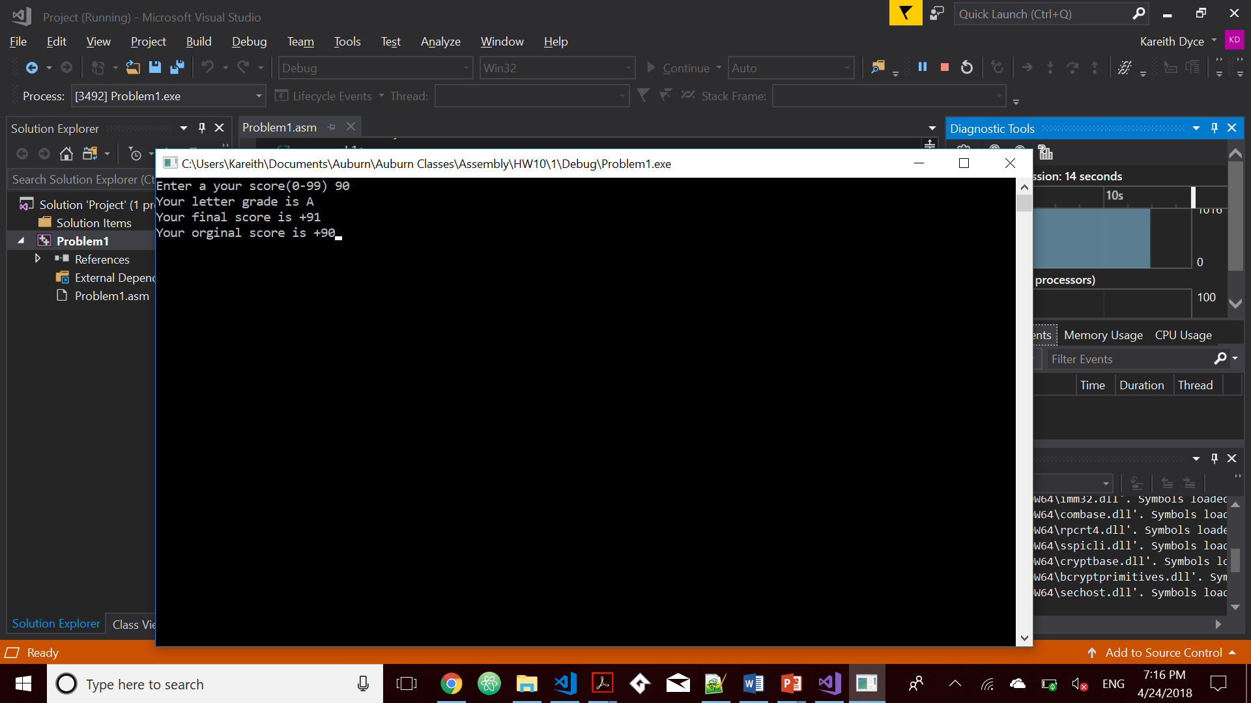
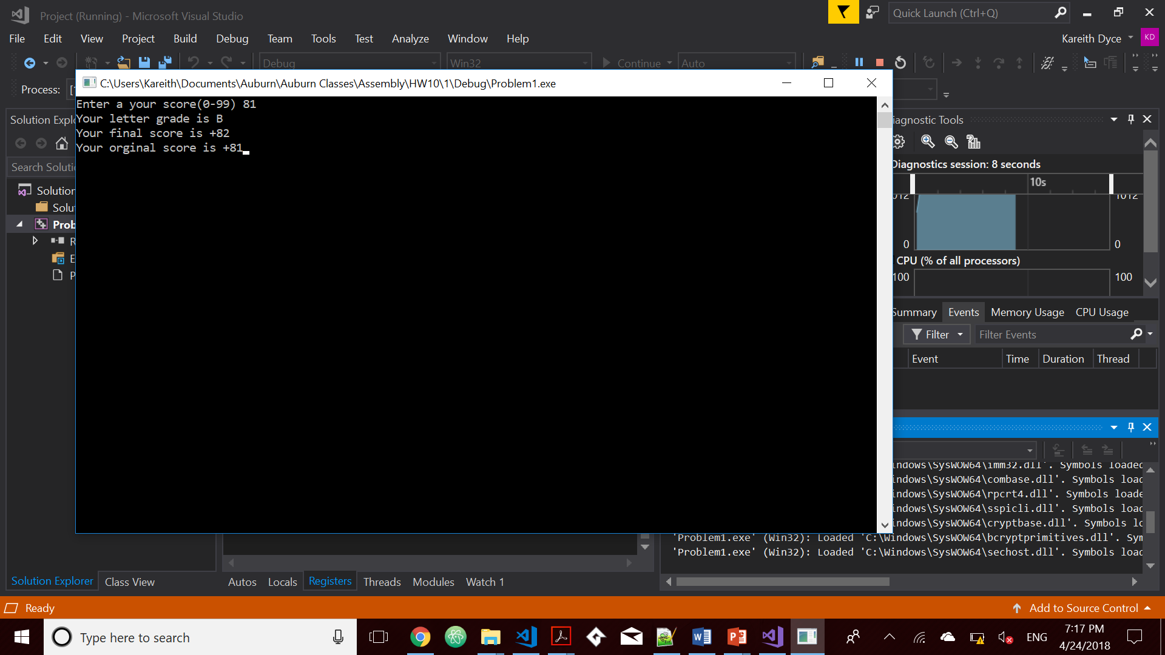
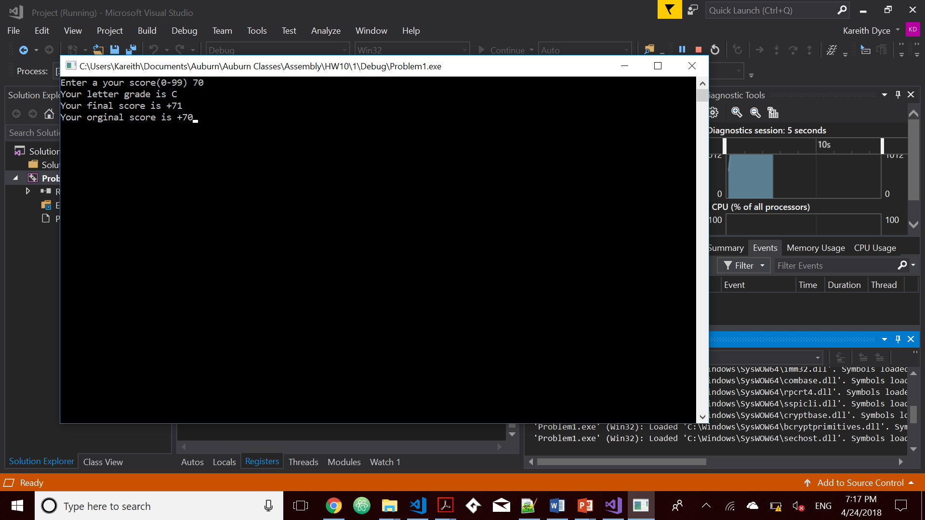

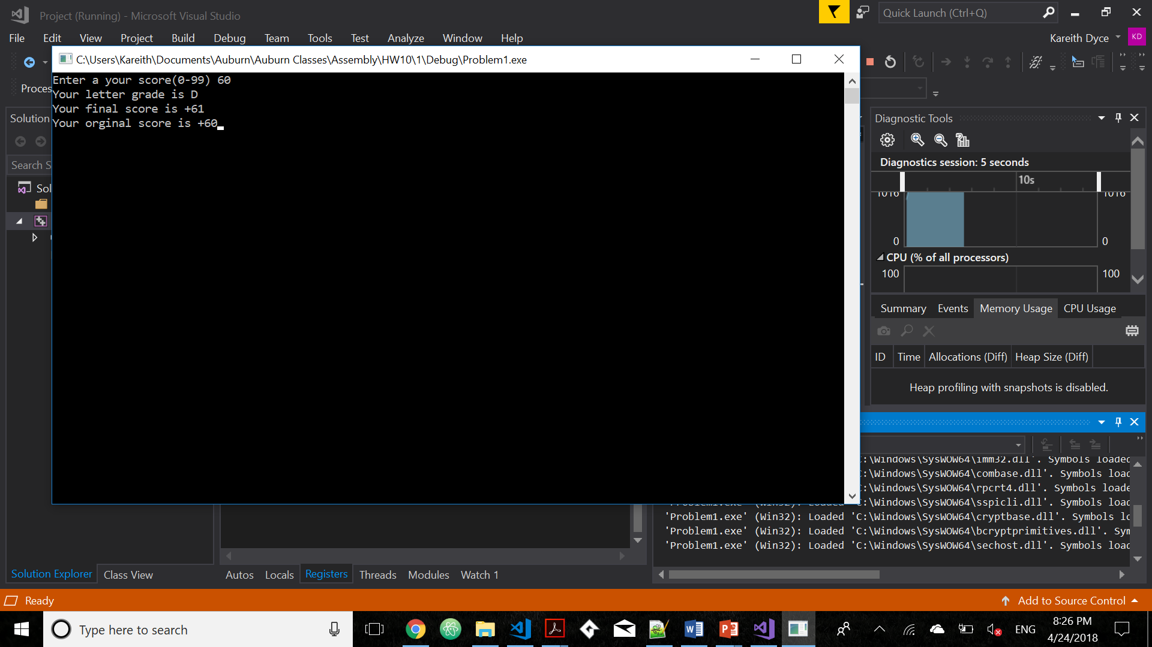
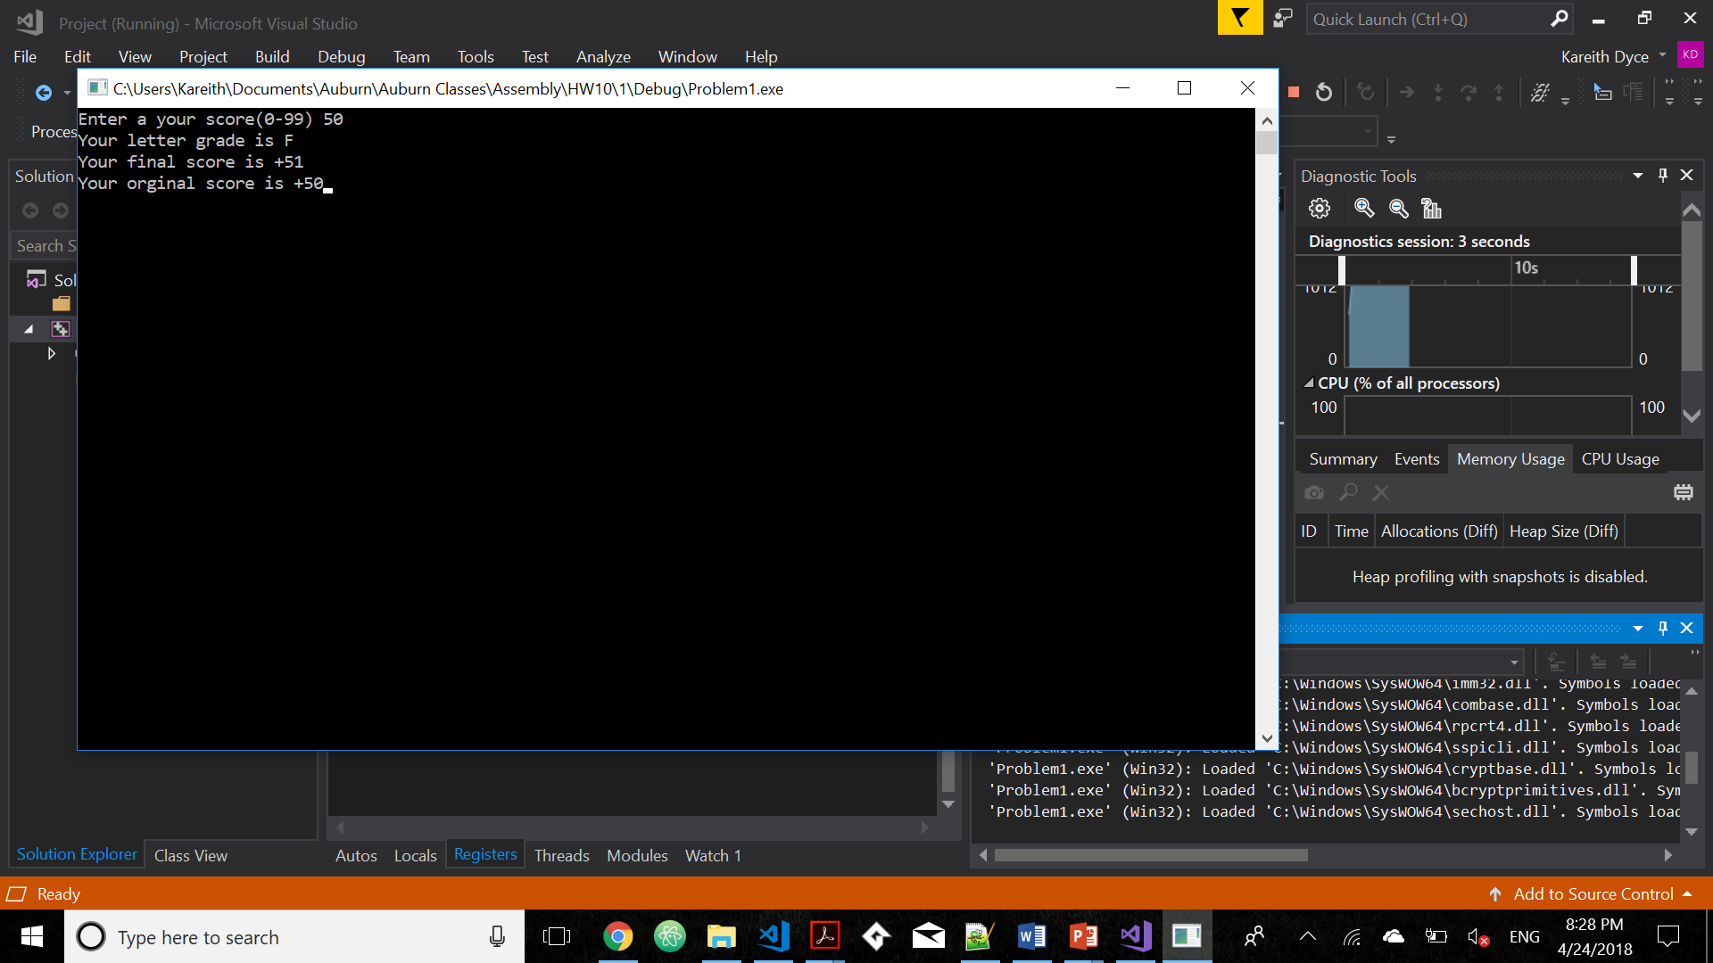
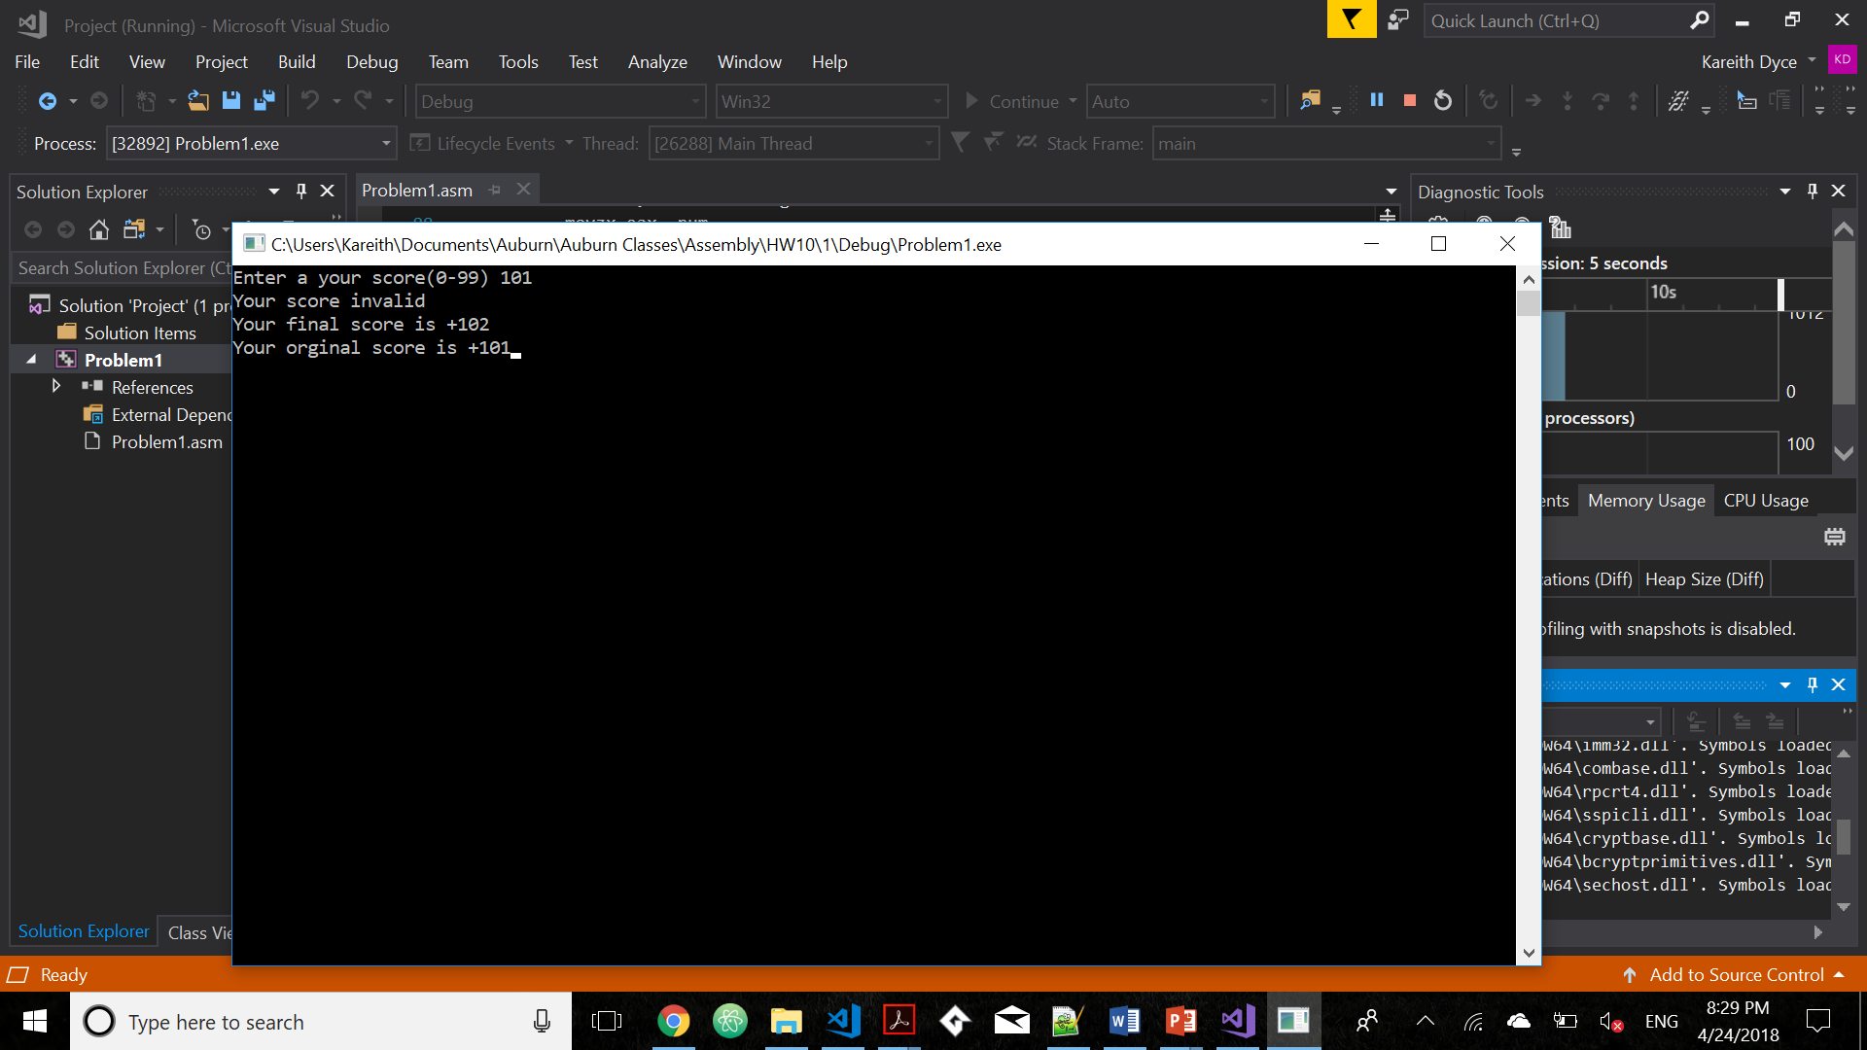
Please embed your code into your homework submission along with a screen shot post execution.
Include Irvine32.inc
.386
.stack 4096
ExitProcess proto,dwExitCode:dword

.data
CaseTable WORD 89
DWORD Process_A
EntrySize = ($ - CaseTable)
WORD 79
DWORD Process_B
WORD 69
DWORD Process_C
WORD 59
DWORD Process_D
WORD 0
DWORD Process_F
NumberOfEntries = ($ - CaseTable) / EntrySize
msgA BYTE "Your letter grade is A", 0
msgB BYTE "Your letter grade is B", 0
msgC BYTE "Your letter grade is C", 0
msgD BYTE "Your letter grade is D", 0
msgF BYTE "Your letter grade is F", 0

string1 Byte "Enter a your score(0-99) ", 0
string2 Byte "Your orginal score is ", 0
string3 Byte "Your final score is ", 0
string4 Byte "Your score invalid ", 0
num WORD ?

.code
Process_A PROC
mov edx,OFFSET msgA
ret
Process_A ENDP

Process_B PROC
mov edx,OFFSET msgB
ret
Process_B ENDP

Process_C PROC
mov edx,OFFSET msgC
ret
Process_C ENDP

Process_D PROC
mov edx,OFFSET msgD
ret
Process_D ENDP

Process_F PROC
mov edx,OFFSET msgF
ret
Process_F ENDP

main PROC
mov edx, offset string1
Call WriteString
Call ReadInt
mov num, ax
inc eax
cmp ax, 100
ja L3
mov ebx, OFFSET CaseTable
mov ecx, NumberOfEntries
L1:
cmp ax, [ebx]
jbe L2 ;
call NEAR PTR [ebx + 2]
call WriteString
call Crlf
jmp L4 ; exit the search
L2:
add ebx,EntrySize
loop L1
L3:
mov edx, OFFSET string4
call writestring
call Crlf
L4:
mov edx, offset string3
call Writestring
call Writeint
call Crlf

mov edx, offset string2
movzx eax, num
call Writestring
call Writeint
invoke ExitProcess,0
main endp
end main

- [Strings] Write a program that copies bytes from source to target. You must use string instructions to accomplish the job. Declare the source and target locations in the data segment. The source string should be your name.

- [General Programming] Write a program that converts the temperature in Celsius to F in Farenheit using F = C*9/5 + 32. For ease of programming you can display the result in fractions, i.e. 20 1/9 (no need to use floats, just display the quotient, the slash character and the digit 9). Show the runs for freezing, boiling point, room temperature and human body temperature. Provide screen shots of the runs along with your program. 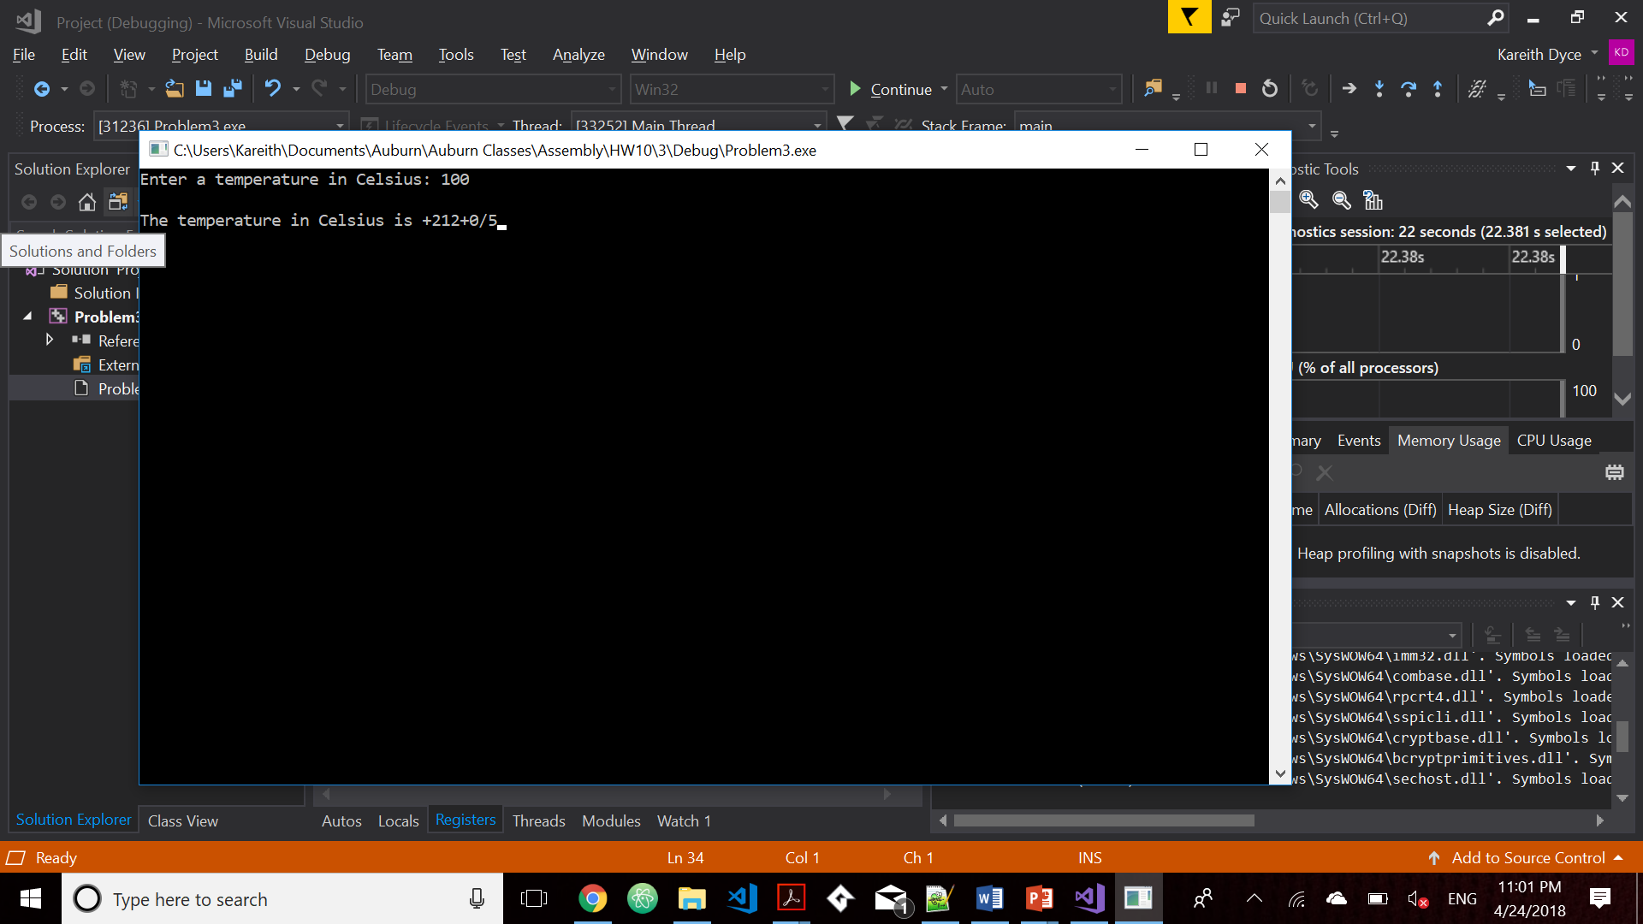 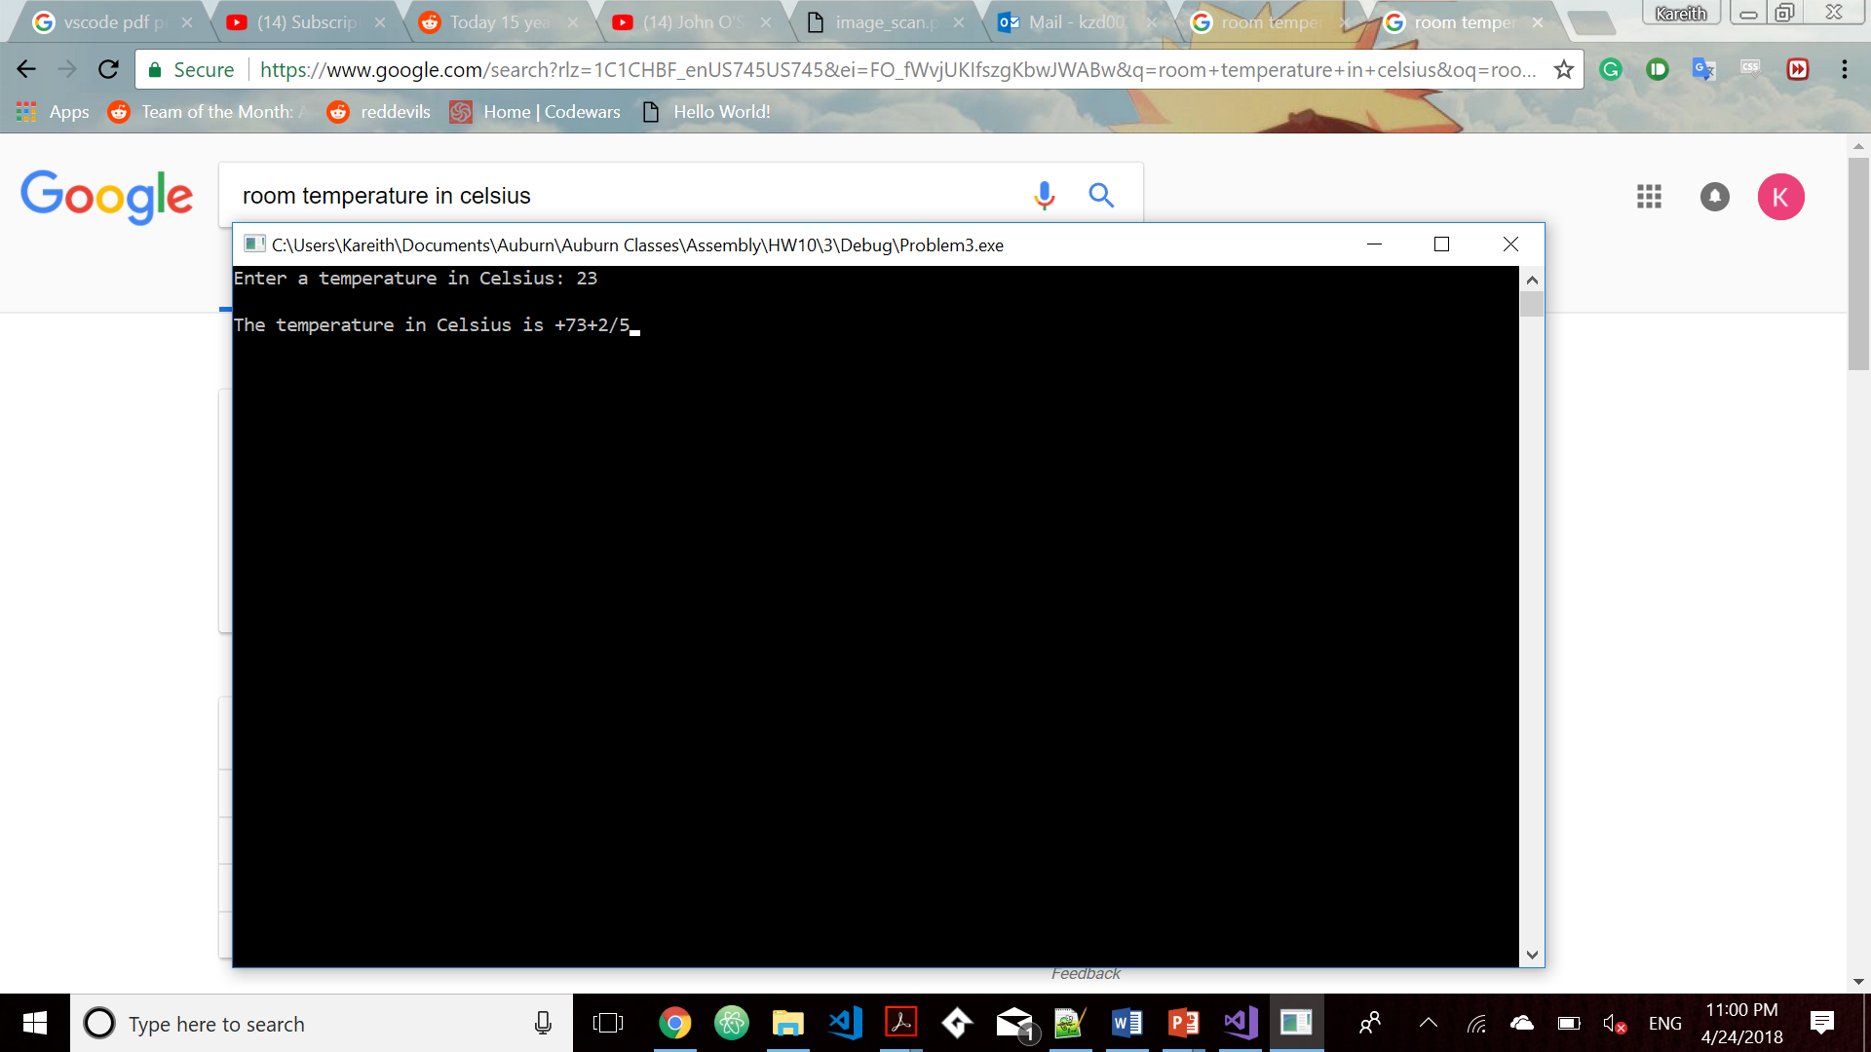
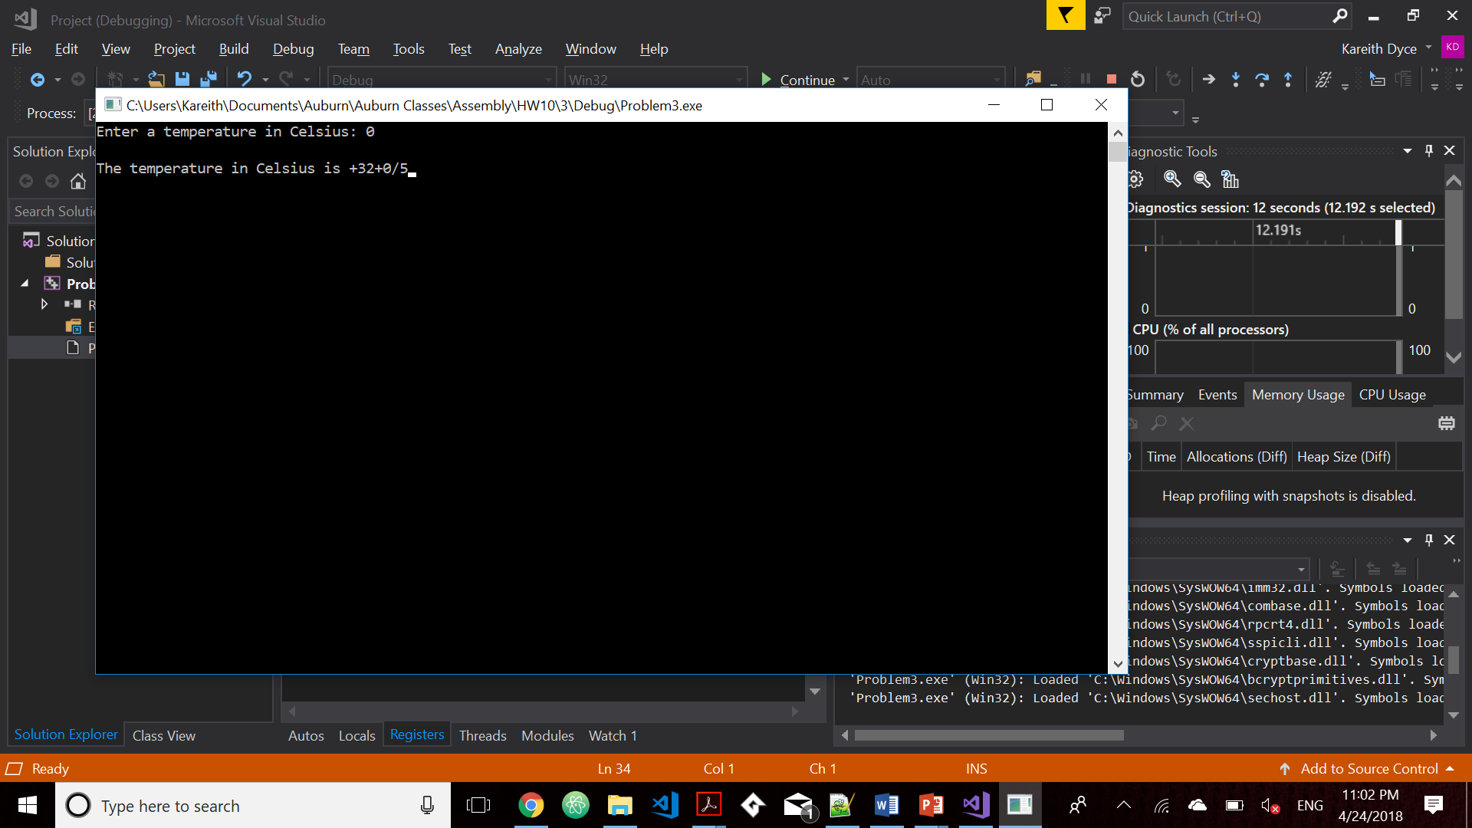
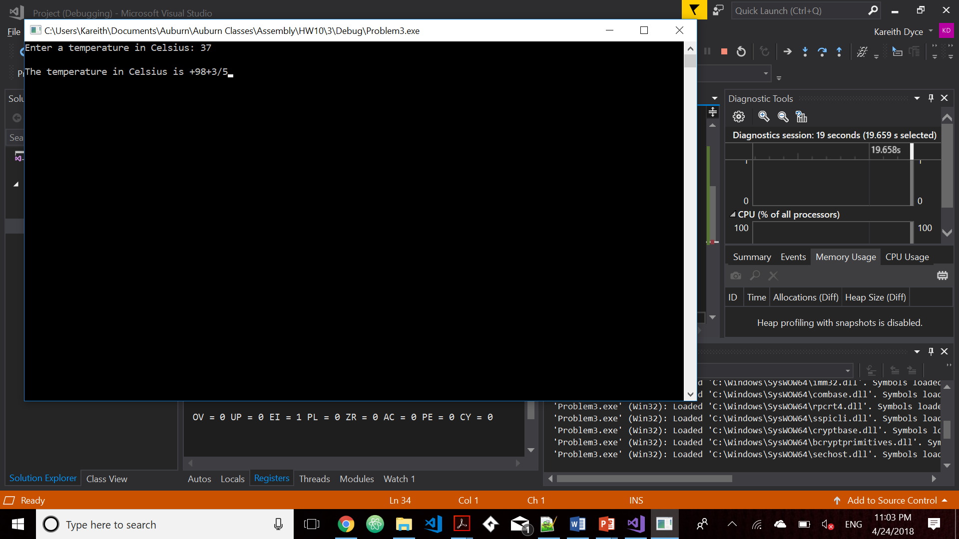
- [Strings] Write a program that searches for a character in a string. You should set the EDI pointer to point to the character found. Test the program thoroughly using various strings, including your name. Provide screen shots of the runs along with your program. You must use string instructions in your program. 