Comp 3350: Computer Organization & Assembly Language

HW # 9: Theme: Advanced Procedures, Stack Parameters, Locals and BCD
(All main questions carry equal weight. Credit awarded to only those answers for which work has been shown.)
- Write a procedure named ArraySeries that fills an array of ten (10) numbers with the Fibonacci series. The procedure receives two arguments: the first is the offset of an array, and the second is an integer that specifies the array length. The first argument is passed by value and the second is passed by reference. In the main program, you should set the parameters of the array and print the array values before and after call to the procedure.
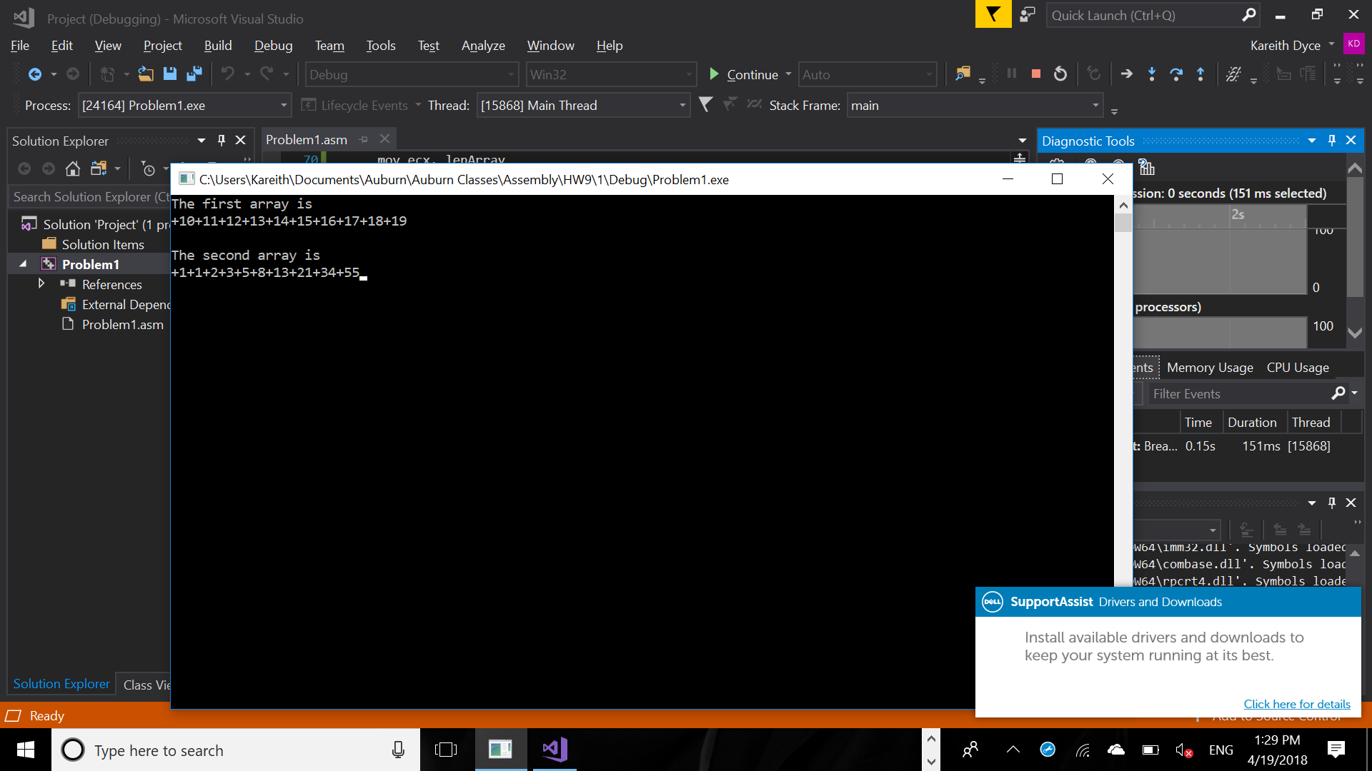
Please embed your code into your homework solution along with a screen shot of the run of the program.
Include Irvine32.inc
.386
.stack 4096
ExitProcess proto,dwExitCode:dword

.data
array DWORD 10,11,12,13,14,15,16,17,18,19
arraySize DWORD SIZE array
temp DWORD ?
lenArray DWORD LENGTHOF array
word1 BYTE "The first array is ", 0
word2 BYTE "The second array is ", 0

.code
ArraySeries PROC
push ebp
mov ebp,esp
mov ecx, [ebp+8]
mov esi, [ebp+12]

mov eax, 1
mov ebx, 0
mov temp, 0

mov [esi], eax
mov edx, 4

L1:
mov temp, eax
add eax, ebx
mov [esi+edx], eax
;call writeInt
add edx, 4
mov ebx, temp
loop L1

pop ebp
ret
ArraySeries endp

main PROC
mov edx, offset word1
call writestring
call crlf
mov ecx, lenArray
mov edx, 0

L1:
mov eax, array[edx]
Call WriteInt
add edx, 4
loop L1

mov eax, offset array
mov ebx, lenArray
call crlf
push eax
push ebx
call ArraySeries
pop ebx
pop eax

call crlf

mov edx, offset word2
call writestring
mov ecx, lenArray
mov edx, 0

mov ecx, lenArray
mov edx, 0
mov eax, 0

call crlf

L2:
mov eax, array[edx]
Call WriteInt
add edx, 4
loop L2

invoke ExitProcess,0
main endp
end main
- Draft a program that adds two BCD numbers (10-digits each). The first BCD number is stored in an array named myAuburnID, and the second in an array named myAurbunIdRev. The first number is your actual Auburn ID (with a prefix single zero digit and the remaining digits as the 9-digits of your Auburn ID); the second is the value of MyAuburnId written backwards. Your program should do the following:

- Use shifts/rotates using myAuburnID to fill the array myAuburnIdRev
- Display contents of the memory locations in question
- Add myAuburnID and myAurbunIdRev using BCD arithmetic
- Store the sum in a variable named Result, and
- Display contents of memory post execution.
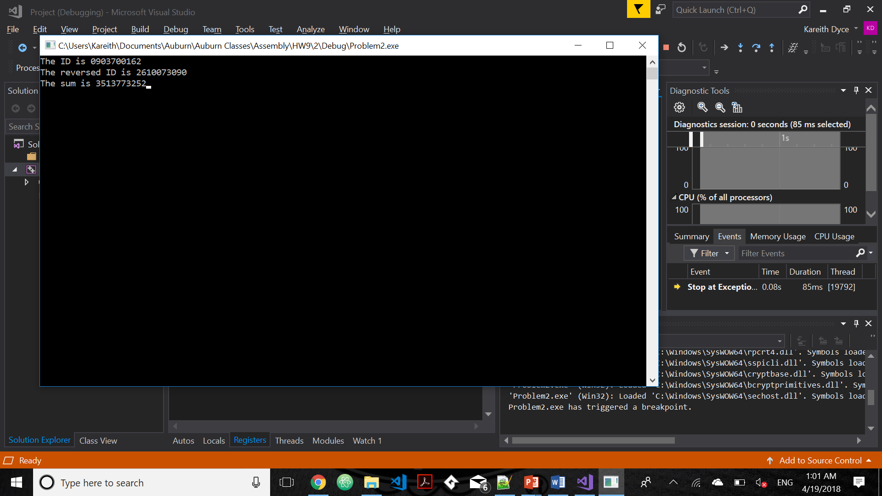

Include Irvine32.inc
.386
.stack 4096
ExitProcess proto,dwExitCode:dword

.data
ID BYTE "The ID is ",0
revId BYTE "The reversed ID is ",0
sum BYTE "The sum is ",0
myAuburnID BYTE 09h,03h,70h,01h,62h
myAuburnIDRev BYTE 5 DUP(?)
result BYTE 5 DUP(?)
len DWORD LENGTHOF myAuburnID

.code

main proc

mov edx, offset ID
call writestring
mov eax, 0
mov ecx, len
mov edx, 0
mov ebx, 1

L1:
mov al, myAuburnId[edx]
call writehexB
inc edx
loop L1

call crlf
mov edx, offset revID
call writestring

mov ecx, len
mov edx, 0

L2:
mov al, myAuburnId[ecx-1]
rol al, 4
mov myAuburnIdRev[edx], al
inc edx
loop L2

mov ecx, len
mov edx, 0

L3:
mov al, myAuburnIdRev[edx]
call writehexB
inc edx
loop L3

mov ecx, len
mov edx, 0

L4:
mov al, myAuburnIdRev[ecx-1]
add al, dl
mov dl, 0
add al, myAuburnId[ecx-1]
daa
mov result[ecx-1], al
jnc skip
mov dl, 1
skip:
loop L4

call crlf
mov edx, offset sum
call writestring
mov ecx, len
mov edx, 0

L5:
mov al, result[edx]
call writehexB
inc edx
loop L5

main ENDP
END main
Please embed your code into your homework solution along with a screen shot post execution.

- Consider an isosceles triangle A with base 12 and height 20. Consider another triangle B formed using vertices which are the center of the sides of triangle A. Consider another triangle C whose vertices are similarly formed from B. Repeat this process ad infinitum. Express the sum of the areas of all such triangles using a series and its closed form sum. Compute the areas (a) by using only the first two terms of the series and (b) by using the closed form of the series sum. Write a program to find the sums and use shifts to compute. What is the difference in the two computed sums?

Please embed your code into your homework solution along with a screen shot post execution.

Include Irvine32.inc
.386
.stack 4096
ExitProcess proto,dwExitCode:dword

.data
method1 BYTE "The sum using method 1 is ",0
method2 BYTE "The sum using method 2 is ",0
diff BYTE "The difference between the two methods is ",0

base WORD 12
height WORD 20
sum1 WORD ?
sum2 WORD ?

.code
main proc

movzx ebx, height
movzx ecx, base
mov eax, ecx
mul bx
shr ax, 1
add sum1, ax
shr ax, 2

add ax, sum1
mov sum1, ax
mov edx, offset method1
call writestring
call writeint
call crlf

movzx ebx, height
movzx ecx, base

L1:
mov eax, ecx
mul bx
shr ax, 1
jz next
add sum2, ax
shr bx, 1
shr cx, 1
jmp L1
next:
movzx eax, sum2
mov edx, offset method2
call writestring
call writeint
call crlf

mov ax, sum2
sub ax, sum1
mov edx, offset diff
call writestring
call writeint

main ENDP
END main

