12/02/2020
Todo lo que no está marcado con el modelo, pertenece al modelo 3

lr=0.01 bz=32, bn=True (pre-activation), drop=False, FF [4096, 128,10]

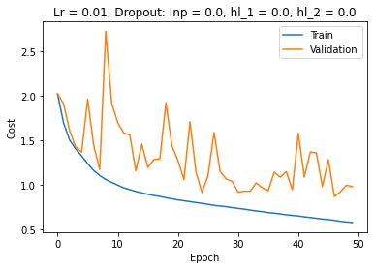
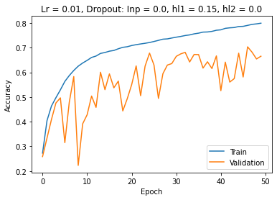

lr=0.01 bz=128, bn=True (pre-activation), drop=False, FF [4096, 50,50,10]
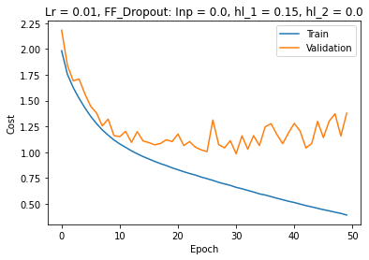
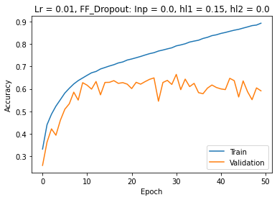

lr=0.01 bz=128, bn=True(pre-activation), FF_drop=True, FF [4096, 50,50,10]
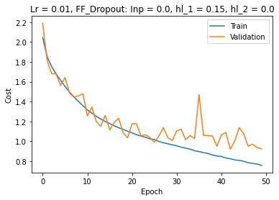
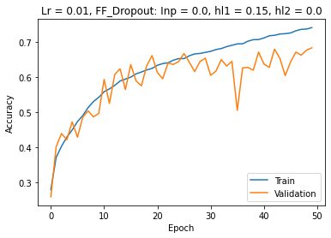

lr=0.01 bz=128, bn=True(pos-activation), FF_drop=True, FF [4096, 50,50,10]

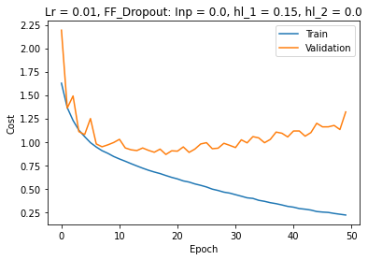
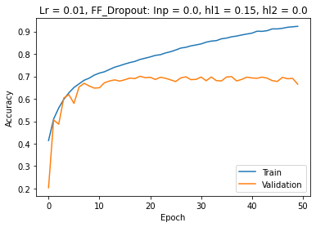

lr=0.01 bz=128, bn=True(pos-activation), drop=False, FF [4096, 50,50,10]

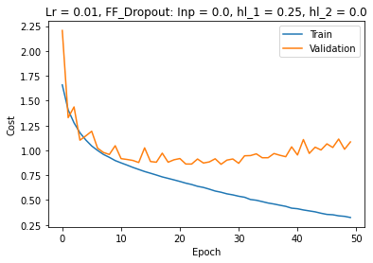
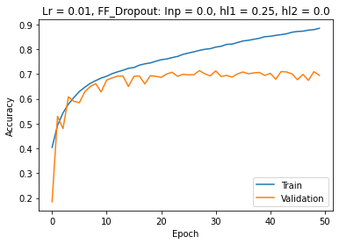

lr=0.01 bz=128, bn=True(pos-activation), drop=False, FF [4096, 50,50,10]

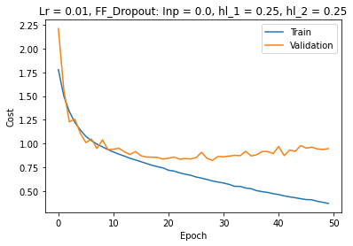
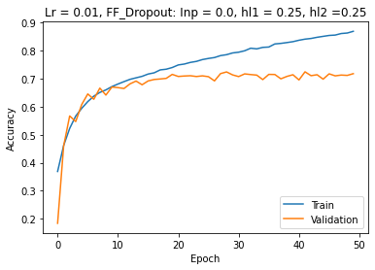

lr=0.01 bz=128, bn=True(pos-activation), drop=False, FF [4096, 50,50,10]

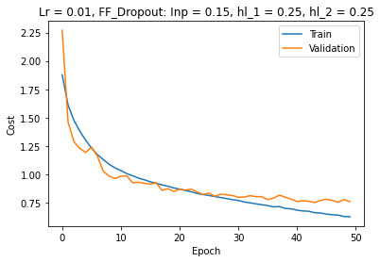
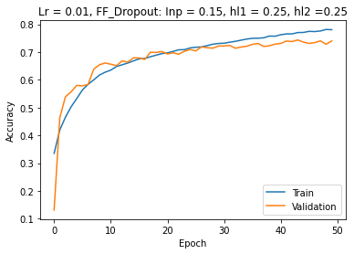

lr=0.01 bz=128, bn=True(pos-activation), drop=False, FF [4096, 50,50,10]

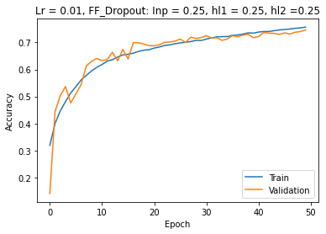
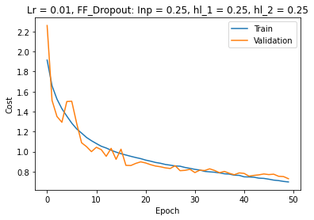

lr=0.01 bz=128, bn=True(pos-activation), drop=False, FF [4096, 50,50,10]

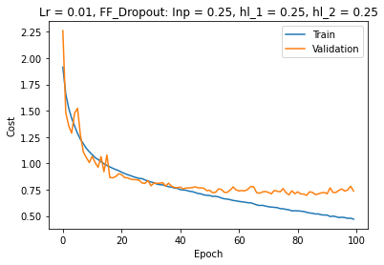
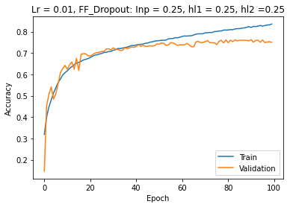

lr=0.01 bz=128, bn=True(pos-activation), drop=False, FF [4096, 50,50,10]
The kernel kernel_initializer was changed from he_uniform to random_uniform
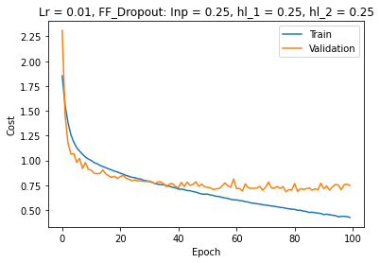
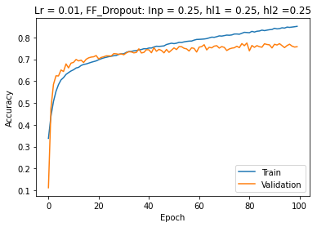

lr=0.01 bz=128, bn=True(pos-activation), drop=False, FF [4096, 50,50,10]
The kernel_initializer changed again from random_uniform to he_uniform
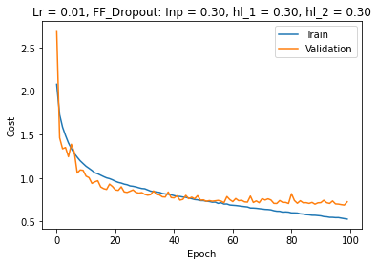
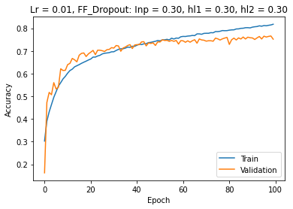

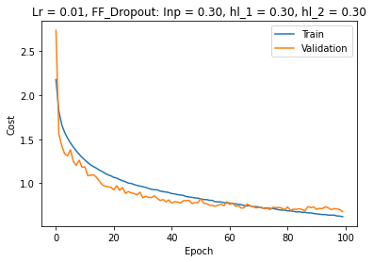
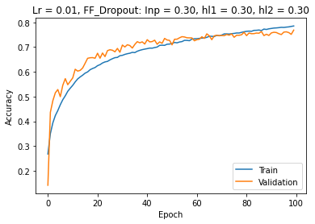
lr=0.01 bz=128, batch_normalization=True(pos-activation), drop=False, FF [4096, 50,50,10]

lr=0.01 bz=128, batch_normalization=True(pos-activation), drop=False, FF [4096, 50,50,10]
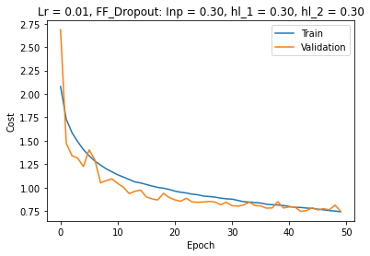
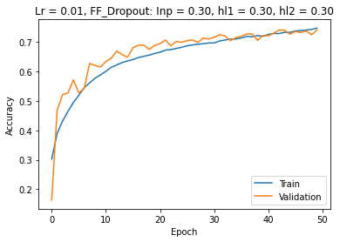

model.add(BatchNormalization(epsilon=0.001, center=False, scale=False))
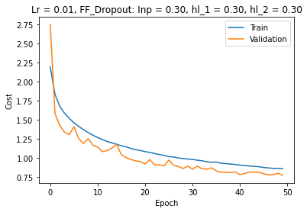
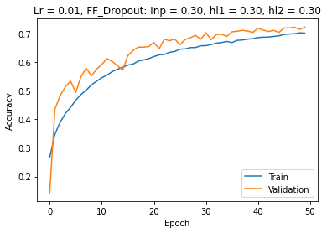

model.add(BatchNormalization(epsilon=0.001, center=True, scale=True))
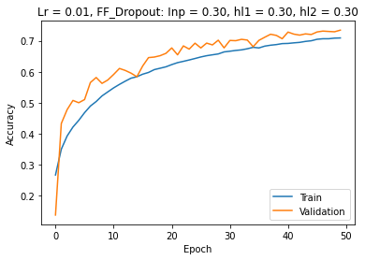
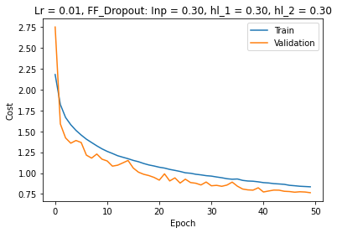

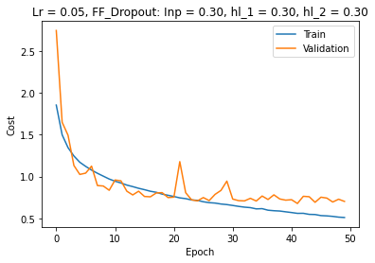
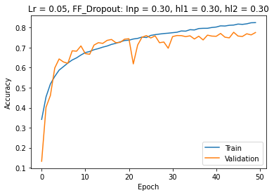
Model 000 – 1 FF-input 3,072 (32,32,3) nodes
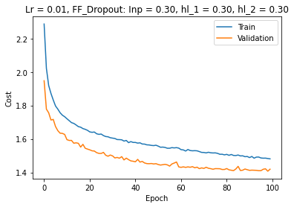
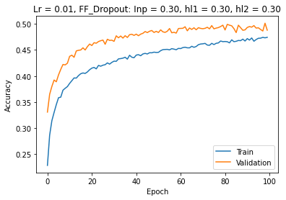

Model 000-1 – 1 FF-input 6,144 (32,32,6) nodes
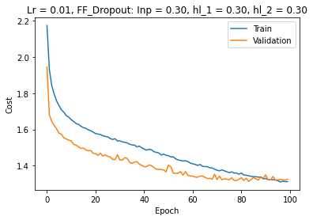
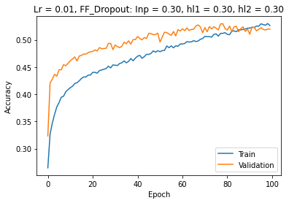

Model 000-2 – 1 FF-input 9,216 (32,32,9) nodes

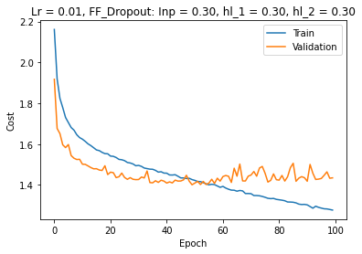
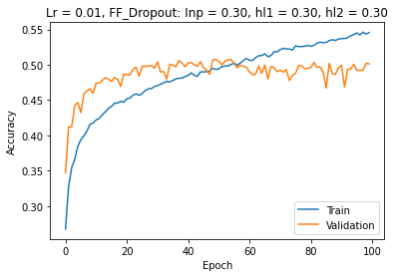

Model 000-3 – 1 FF-input 12,288 (32,32,12) nodes
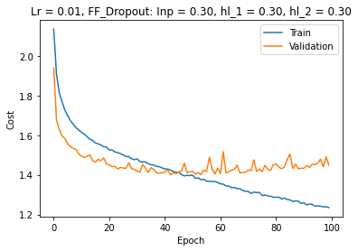
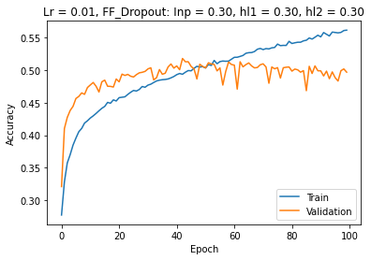

Model 000-4– 1 FF-input 12,288 (32,32,12) nodes. Two conv2 layers
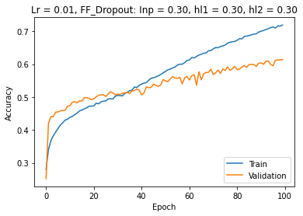
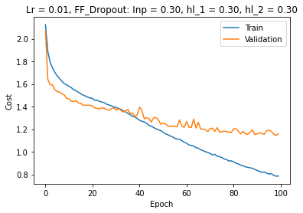

Model 000-5– 1 FF-input 3,072 (16,16,12) nodes. Two conv2 layers + MaxPooling2D
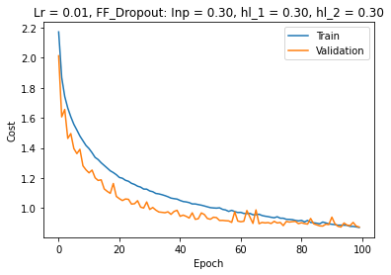
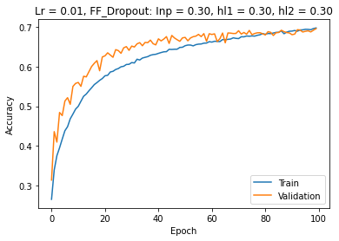

Model 000-6– 1 FF-input 3,072 (16,16,12) nodes. Two conv2 layers + MaxPooling2D + one conv2layer (12, 3)

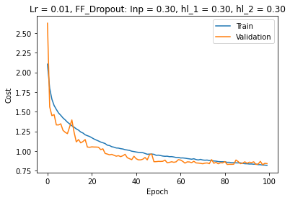
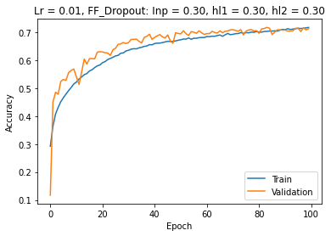

Model 000-7– 1 FF-input 3,072 (16,16,12) nodes. Two conv2 layers + MaxPooling2D + two conv2layers (12, 3)

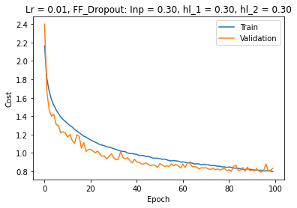
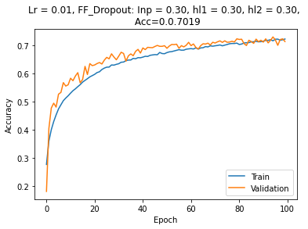
Model 000-8– 1 FF-input 768 (8,8,12) nodes. Two conv2 layers + MaxPooling2D + two conv2layers (12, 3) + MaxPooling2D
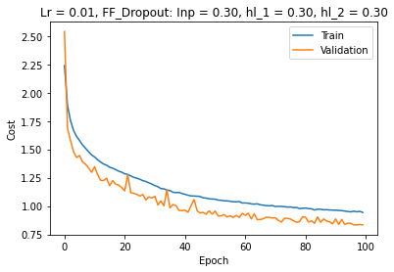
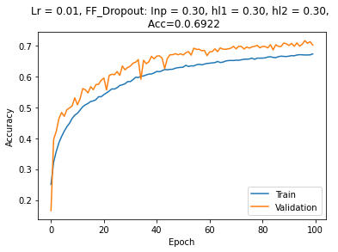

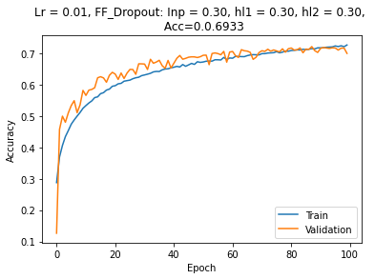
Model 000-8– 1 FF-input 3,072 (16,16,12) nodes. Two conv2 layers + MaxPooling2D + three conv2layers (12, 3)
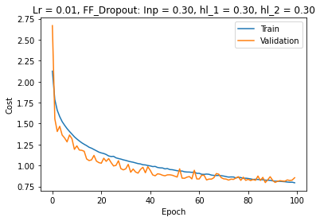

Model 3

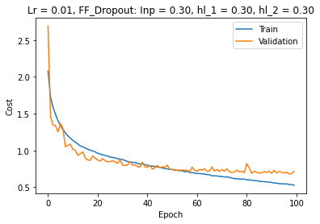
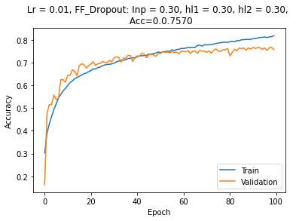
Model 00 – 1 FF-input 32,768 (32,32,32) nodes
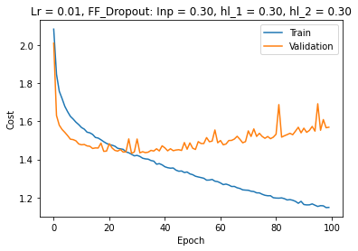
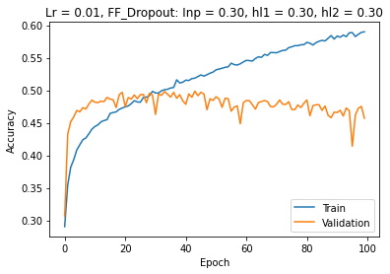

Model 0 – 1 FF-input 8,192 (16,16,32) nodes
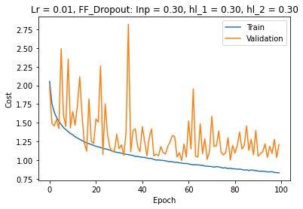
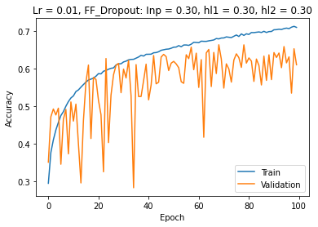

Model 1
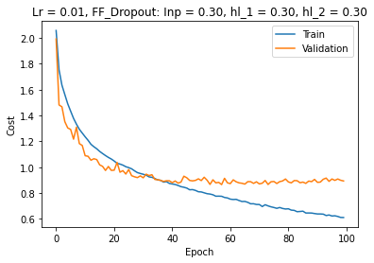
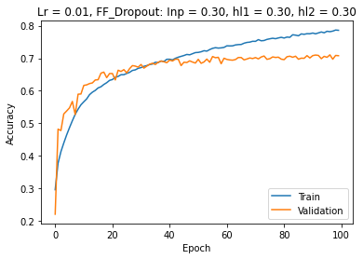

Model 1 – 1 FF-input 16,384 (16,16,64) nodes
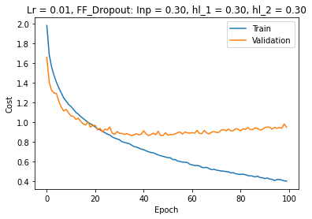
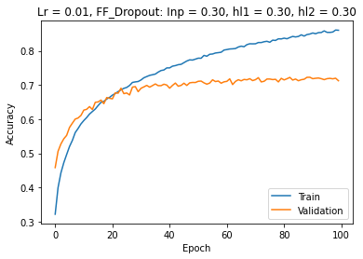

Model 2
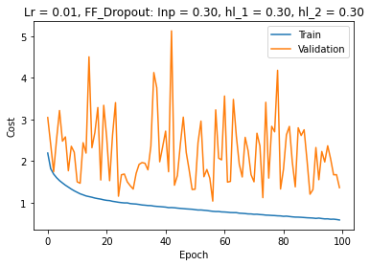
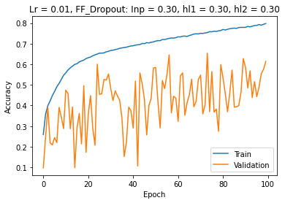

Model 3
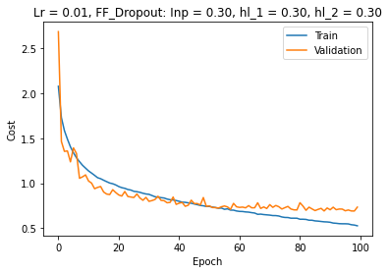
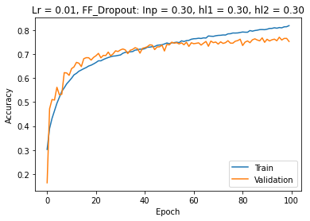

Model 4

