

ISLT 9471

Instructional Systems Design

Motivating Adult Learners in the Online Environment

Karen Ballengee William Duncan

Executive Summary
Many schools are businesses are turning to online courses to provide instruction and training. Online course delivery creates a unique set of challenges that must be addressed by instructional designers and online instructors. This professional development session will help the participants to recognize some of the challenges of creating an engaging online learning community.

This is a two-day, face-to face professional development session and will cover the following topics:

- Motivation Theory
- Adult Learning Theory
- The Role of the Online Teacher
- Ways to Engage Online Learners
- Articulate, SurveyMonkey, and YouTube

Intended Audience: This project was designed to for those who teach or intend to teach online learners. Audience members come from a variety of teaching situations including public school, colleges, and local businesses. Due to the limited availability of technology, the course will be limited to 30 participants. The course will be offered again at a future date so that more people can participate.

Team Responsibilities

Team Member Primary Role Responsibilities
Karen Ballengee Project Manager ✓ Project Manager
- Broad Goals and Big Ideas
- Learning Objectives (shared)
- Needs Analysis
- Task Analysis (review only)
- Learner Analysis (review only)
- Contextual Analysis (review only)
- Formative Evaluation (write text)
- Summative Evaluation (write text)
- Types of Learning Experiences
- Materials for Training Program
- Implementation Plan (Review Only)
- References (shared)
- Appendix A: Task Analysis
William Duncan Team Member ✓ Learning Objectives (shared)
- Needs Analysis (review)
- Task Analysis
- Learner Analysis
- Contextual Analysis
- Formative Evaluation (write surveys)
- Summative Evaluation (write surveys)
- Types of Learning Experiences (review)
- Materials (review)
- Implementation Plan, including Schedule and Logistics
- References (shared)

Contents
Executive Summary 1
Team Responsibilities 2
- Desired Results 4
1a. Broad Goals and Big Ideas 4
1b. Learning Objectives 5
1c. Needs Assessment 11
1d. Task Analysis 15
- Evidence of Acceptable Results 18
2a. Formative Evaluation 18
2b. Summative Evaluation 18
- Learner Experiences and/or Instruction 20
3a. Learner Analysis 20
3b. Contextual Analysis 23
3c. Types of Learning Experiences and Instruction 24
3d. Materials for the Training Program 24
3e. Implementation Plan 24
References 26
Appendices 27
Appendix 1. Needs Assessment Instruments and Evaluation Materials 27
Appendix 1a. Needs Assessment Survey 27
Appendix 1-a-i. Pre-Training Faculty Questionnaire 35
Appendix 1-b. Procedural Analysis Detailed Outline 36
Appendix 1-c. Formative Evaluation Materials 37
Appendix 1-d. Summative Evaluation Materials 39
Appendix 2. Materials, Schedules, Outlines, Etc. 41
Appendix 2-a. Table of Learning Experiences and Instructional Strategies 41
Appendix 2-b. Materials for the Training Program 47
Appendix 2-c. Implementation Schedule 62

1. Desired Results
1a. Broad Goals and Big Ideas
Adult learners come to the classroom with different needs and goals than younger learners. Instructors should consider the specific characteristics of adult learners when designing instruction. The use of technology is one way to engage adult learners. As more programs transition from face-to-face to online instruction learners come to the classroom with different needs and goals than younger learners. Instructors of adult learners, it is important to understand the motivations of adult learners and how motivation effects learner participation and retention. SurveyMonkey, YouTube and Articulate are examples of technologies that can support adult learning in an online community.
This training is a two-day, face-to-face professional development session for instructors and future instructors of online learners. The training will provide the learners with knowledge of adult learning and motivation principles. Participants will learn the skills needed to introduce SurveyMonkey, YouTube and Articulate in an online environment. Participants will be given examples of ways to use these technologies to engage their online adult learners.
This professional development training will take place in eight sessions over the course of two days. The first day will include introductions, a preview of learning objectives, a review of relevant learning and motivation theories, the characteristics of adult learners, and the instructor’s role in traditional and online learning. Participants will participate in an online attitude survey using SurveyMonkey. Day One will finish up with groups and individual participants providing feedback on using surveys to engage adult learners, their own attitudes toward instructional technology, and the course.
Day Two will include instruction and practice using YouTube, SurveyMonkey, and Articulate. The learners will select one of these technologies for their final presentation. Each project will be evaluated by the rest of the class using the checklist provided in the learner guide. There will also be a post- presentation survey at the end of the second day. Participants will be provided with copies of all instructional materials and references.
Goal 1: Learners will compare and contrast the role of the traditional teacher and the online teacher.
Goal 2: Learners will recognize ways to transfer face-to-face instruction to the online environment. Goal 3: Learners will relate learning and motivation theories to attitudes of adult learners toward technology use.
The Participants will pick one of the three technologies to complete a project
Goal 4: Learners will express their attitudes toward technology and create a survey with proficient use with SurveyMonkey.
or
Goal 5: Learners will access and examine three videos under 5 minutes in length they would use for instruction on YouTube.
or
Goal 6: Learners will access and create an online lesson and quiz with proficient use of Articulate.

1b. Learning Objectives
Goal 1: Learners will compare and contrast the role of the traditional teacher and the online teacher.

OBJECTIVE | ALIGNMENT | ASSESSMENT | EVIDENCE
1.1 Following the training, leaners will successfully discuss the role of the traditional teacher. | Discuss the role of the traditional teacher.  List the words and phrases.  Collaborate with peers  to create the list. | The learners in groups of 5, will write down as many words or phrases about the role of the traditional teacher in 2  minutes. | The learners have listed words and phrases about the role of the traditional teacher.
1.2 Following the training, learners will successfully recognize the role of the online teacher. | Recognize the role of the online teacher.  List the words and phrases.  Collaborate with peers  to create the list. | The learners in groups of 5 will write down as many words or phrases as they can about the online teacher in 2  minutes. | The learners have listed words and phrases about the traditional teacher.
1.3 Following the training, learners will successfully compare and contrast the roles of the online and traditional teacher. | Compare the traits of the traditional and online teacher.  Contrast the traits of the traditional and online teacher.  Diagram the similarities and differences with circles  and underlining. | The learners in groups of 5, will circle any phrases that are the same for traditional and online teachers and underline any phrases that are different. | The learners circled the similar phrases and underlined the differences.

Goal 2: Learners will recognize ways to transfer face-to-face instruction to the online environment.

OBJECTIVE | ALIGNMENT | ASSESSMENT | EVIDENCE
2.1 Following the training, learners will successfully recognize three ways to engage online learners. | List the ways to engage online learners.  Write the list in their learner guide.  Choose one engage- ment technique  Apply the engagement  technique to the online module. | List three ways to engage learners online. Use one of these in your online module | The learner used one engagement technique in the Articulate Module.
2.2 Following the training, learners will successfully discuss the challenges of teaching online learners. | List one challenge. Analyze the problem. Generate a solution. Discuss with peers. | List one challenge you could face as you transfer a lesson in your subject area from face-to-face to online. How would you mitigate the challenge? | The learner listed the challenge and mitigation in the workbook and discussed the challenge and solution with the class.
2.3 Following the training, learners will successfully identify one task or small block of instruction (5-10 minutes) that they can  transfer to an online learning module. | Identify the lesson to transfer online. | Think of a lesson or task you would transfer from face to face to online. This lesson should be 5-10 minutes | The learner identified one 5-10-minute lesson or task to transfer from face-to- face to online.

Goal 3: Learners will relate learning and motivation theories to attitudes of adult learners toward technology use.

OBJECTIVE | ALIGNMENT | ASSESSMENT | EVIDENCE
3.1 Following the training, learners will successfully relate the three domains of Bloom’s Taxonomy of Learning to KASI | Identify the three domains of Bloom’s Taxonomy of Learning. Compare the domains of Bloom’s Taxonomy with KASI (knowledge, attitude, skills,  interpersonal skills) | Recall the three domains of Bloom’s Taxonomy and relate them to a KASI (knowledge, attitude, skills, interpersonal skills) map in an  online quiz format. | Cognitive domain - knowledge  Affective domain -- attitude  Psychomotor domain -- skills & interpersonal skills
3.2 Following the training, learners will successfully relate the three psychological needs as discussed in Self- determination Theory to Maslow’s Hierarchy of Needs | Identify three psychological needs, as communicated in self- determination theory Relate three psychological needs of humans of SDT to Maslow’s Hierarchy of Needs | Construct a graphic organizer that relates the three basic needs of self-determination theory to aspects of Maslow’s Hierarchy | Autonomy -- Self- actualization Competence -- Esteem  Relatedness -- Belonging
3.3 Following the training, learners will successfully identify characteristics of adult learners. | Brainstorm some of the characteristics of adult learners  Self-identify three characteristics within yourself | As a class, construct a list of characteristics of adult learners Highlight characteristics of  individuals within the training | Readiness Relevance Agency Collaboration  Clearly defined Goals

Goal 4: Learners will express their attitudes toward technology and create a survey with proficient use with SurveyMonkey.

OBJECTIVE | ALIGNMENT | ASSESSMENT | EVIDENCE
4.1 Following the training, learners will demonstrate proficient use of SurveyMonkey by designing a 10 question quiz | Complete a survey using SurveyMonkey Create a 10 item content relevant quiz using SurveyMonkey | Complete an instructor generated survey on SurveyMonkey  Create a 10 item quiz using SurveyMonkey | Learner completed an instructor generated survey on SurveyMonkey Learner created a functioning content relevant quiz using  SurveyMonkey
4.2 Following the training learners will demonstrate proficient use of SurveyMonkey by collecting responses from all group members | Collect statistical data from a minimum of 5 individuals who take the quiz you created | Collect performance data from learner generated quiz | Learner enlisted a minimum of 5 individuals to take the quiz they created  Learner collected statistical data about performance on the quiz  they created
4.3 Following the training learners will demonstrate proficient use of SurveyMonkey  by analyzing data | Analyze the data you collected to revise the quiz you created. | Analyze performance data  Revise quiz | Learner analyzed performance data for the quiz they created Learner revised the quiz  in light of their analysis
4.4 Following the training learners will report to the large group attitudes of small group members to using SurveyMonkey as a learning tool | Discuss with the quiz takers their attitudes toward using SurveyMonkey as a learning tool  Report the attitudes of learners to the large group. | Discuss attitudes about the effectiveness and limitations of using SurveyMonkey as a learning tool Report results of discussion | Learner discussed and discussed with classmates their attitudes about the quiz they took using SurveyMonkey and their attitudes toward SurveyMonkey as a  learning tool.

Goal 5: Learners will access and examine three videos under 5 minutes in length they would use for instruction on YouTube.

OBJECTIVE | ALIGNMENT | ASSESSMENT | EVIDENCE
5.1 Following the training, learners will search YouTube and choose 3 videos under 5 minutes in duration that are relevant to their teaching  situations | View YouTube videos related to course content  Select 3 videos to use in teaching course content. | Preview and choose 3 instructional videos of under 5 minutes’ duration to use as learning tools. | Learners chose 10 videos relevant to their teaching objectives  Learners selected 3 videos under 5 minutes in duration to use for instructional purposes
5.2 Following the training, learners will create a reference list of the YouTube videos they have chosen (including time stamp) | Create a reference list of the YouTube videos, including URL and running time, you have chosen to use in teaching course content | Create a reference list for the three YouTube videos chosen. | Learners created a reference list of the 3 videos they chose to use in teaching course content
5.3 Following the training, learners will discuss their attitudes about using YouTube videos as a learning tool | Discuss the value of the videos chosen as learning tools.  Report the attitudes of learners to the large group. | Discuss the value of using YouTube videos for instructional materials | Learners discussed their attitudes about using videos from YouTube as instructional materials  Learners communicate their attitude to their classmates

Goal 6: Learners will access and create an online lesson and quiz with proficient use of Articulate.

OBJECTIVE | ALIGNMENT | ASSESSMENT | EVIDENCE
6.1 Following the training, learners will successfully build a module in articulate using 5-10 slides and 3- 5 quiz questions at the  end. | Learners create a lesson.  Learners explained a concept in the module. Learners built the slides. | Create one 5-10 slide module with 3-5 quiz questions. | The learner used 5-10 slides  The learner used 3-5 quiz questions.
6.2 Following the training, learners will successfully insert a photo or illustrated character into to their Articulate module. | Learners used the character to build the slide. | Insert one character in the module. The character will have one pose and one facial expression. | The learner used one photo or illustrated character in their articulate module. The learner created a pose and a facial expression for the character.
6.3 Following the training, learners will insert one photo into their articulate module, practicing proper copyright  etiquette. | Learners build the slide by adding a photo.  Learners evaluate the copyright status of the photos. | Insert one photo in the module. | The learner inserted one photo into Articulate. The photo was the learner’s original, was purchased, or met the  terms of Fair Use.
6.4 Following the training, learners will successfully add questions to their quiz, using one drag and drop and one hotspot type question. | Create quiz questions. Test the learners.  Discuss learner attitudes toward Articulate.  Report learner attitudes to the large group. | Create one drag and drop and one hotspot quiz question. | The learner had one drag and drop and one hotspot question in their quiz.

1c. Needs Assessment

Summary of the study’s purpose
The purpose of this study is to determine what instructional solutions should be provided to combat the high learner dropout rate in online courses. Initial research indicates a lack of engagement as the main reason learners drop online courses. This study will determine what instructor training, academic support, IT, and learner mentoring resources are needed.

Summary of the Process
- Interviews -- Administrators/Instructional Technologists
- Focus Groups -- Instructors/Learners
- Surveys -- Learners/Instructors
- School Data -- Dropout rates/Course evaluations/Instructor evaluations

Summary of the Results

WHAT IS
A high number of learners are dropping online courses. Course evaluations indicate a lack of learner engagement.

GAP=NEEDS
More training in engagement techniques and more Instructional Technology

WHAT SHOULD BE
Learner engagement should improve and the dropout rate should be close to that of the
face-to-face environment.

People to Ask | Things to Observe | Things to Study/Analyze
- Key stakeholders  - Instructors who teach online courses  - Instructors who do not teach online courses  - Instructors who will need to transition from traditional to the online classroom in the future  - Learners who take online courses  - Learners who have dropped out of online courses  - Instructional Designers and Technologists  - Administrators | - Instructors’ willingness to transfer face-to-face instruction online  - Instructor knowledge of engagement strategies for online learners  - Samples of online courses of the instructors  - Learner attitudes toward online instruction  - School resources such as instructional designers or technologists | - Literature, books and articles on online learner retention and engagement  - Instructor evaluations  - Learner data (online and f2f) such as drop -out rates.  - Experience, training, and resources for those who teach online courses  - Learner surveys and reasons for online course drop  - Online learner survey on learner engagement  - Adult learning and motivation theories

Problem or existing situation (what is) | Desired situation (what should be) | Individual or Group Questioned | Possible Causes or Indicators | Solution Alternatives
Online learners don’t feel a connection in the online classroom and have a high drop rate. | Learners should feel a sense of online learning community and retention rates should improve | Instructors of  face-to-face courses | Are not comfortable teaching online courses  Do not wish to teach online | Conduct professional development with the instructional technologist  Offer incentives such as merit pay or funds for professional  development
 |  | Online instructors | Some are not comfortable with  the technology | Provide a successful online instructor as a mentor
 |  | Administrators | Online dropout is high | Provide time for professional  development for improvement
 |  | Instructional technologists | No one requests their services | Hold professional development sessions. Go to the instructors and show  them strategies for online teaching
 |  | Online learners | Online is impersonal | Assign a peer mentor
 |  | Online learners | The instructor never answered my email or questions | Create a policy that the instructor must answer emails in 48 hours
 |  | Online learners | The subject was too  difficult for online | Offer online tutoring
 |  | Online learners | Technical difficulties | Set up am IT help desk with  convenient hours for the working learner
 |  | Online learners | Do not know where to go for technical or instructional  help | Create a learner orientation  Set up an IT helpdesk

Stakeholder | Expectations
Administrators | High learner success rate/low dropout rate
Instructors | Resources, training, and support to teach online
Online learners | Convenient education/academic support and accommodations for special needs/engaging  environment
Instructional designers and technologists | Instructor support and participation in professional development activities

Project Roles | Project Responsibilities
Project Manager | Responsible for determining deadlines, overall  content,
Team Members | Develop objectives Write content  Create needs assessment, learner analysis, contextual analysis, procedural analysis and implementation plan  Create instructional materials  Oversee formative and summative evaluations
Instructors | Set up the PowerPoint  Hand out materials Teach the content
Technology SME | During the technology portions, facilitate the use of Voice Thread, Articulate, and Video  Assist with the learner projects
Materials coordinator | Create printed materials, gather all materials, set up before the professional development
Instructional Technologists | Procure the laptops and set up before the  training
Recorder | Records all answers from interviews and focus groups. Puts the data in a word document, excel  spreadsheet, or chart.

 | Constraints | Resources
School | Some subjects are not easy to  teach online | Instructional Design Staff
IT | Budget | IT Staff
Teacher | Some are unwilling to transition to the online environment | There are several teachers identified as master online  teachers
Learner | Some are unwilling to seek help  in an online environment | Peer tutors and online  mentors

Final Report:
The information from the interviews, focus groups, and surveys indicates the following recommendations.

Results and Recommendations Non-instructional:
Instructor availability was one concern learners expressed in the focus groups. These learners suggested that instructors hold virtual office hours so that they might answer any learner questions. Learners also mentioned instructor response to email was slow. It is recommended that the school institute a policy that instructors of online courses must answer emails within 48 hours. An IT learner help desk with convenient hours would help to eliminate any learner IT issues. Peer tutors and mentors would help the learners in some of the more difficult online courses. Online orientation will help to acquaint the online learners with the online classroom and help them to navigate the resources available to them. Ideally, the learners would complete this orientation and be familiar with the online environment before classes start.

Instructional
Most instructors indicate a willingness to teach in the online environment, but few instructors feel that they have the resources necessary to effectively engage the learners. Professional development sessions and one-on-one help from the Instructional Technologist are recommended. There were several instructors recognized by the administration and learner evaluations as the masters of online instruction. These instructors can mentor those who are less experienced at online teaching.

Recommendations Summary Non-Instructional
- Offer library support for online learners
- Offer virtual office hours for instructors
- Create a 24-hour IT helpdesk
- Conduct online learner orientation

Instructional
- Use expert online instructors as mentors to novice online instructors
- More one-on-one time with Instructional Technologists
- Professional development sessions for online teaching. Topics should include information on adult learning and motivation, online learner engagement, and the use of specific technology tools.
Please refer to Appendix 1-a. for a list of interview questions and a copy of the pre-training faculty questionnaire.

1d. Task Analysis

Prerequisite Analysis:
A pre-training survey will be administered to participants to determine the level of experience and their attitudes regarding technology use in education, specifically, YouTube, SurveyMonkey and Articulate. Workshop participants will be divided into different learning groups based on their expressed level of experience and confidence in using these applications.

Topic Analysis
Goal 1: Learners will compare and contrast the role of the traditional teacher and the online teacher.
  - Review the role of the traditional teacher.
    - Discuss the role of the traditional teacher.
    - List the words and phrases.
    - Collaborate with peers to create the list.
  - Review the role of the online teacher.
    - Recognize the role of the online teacher.
    - List the words and phrases.
    - Collaborate with peers to create the list.
  - Compare and contrast the roles of the online and traditional teacher.
    - Compare the traits of the traditional teacher with the traits of the online teacher.
    - Contrast the traits of the traditional teacher with the traits of the online teacher.
    - Diagram the similarities and differences with circles and underlining.
Goal 2: Learners will recognize ways to transfer face-to-face instruction to the online environment.
  - Recognize three ways to engage online learners.
    - List ways to engage online learners.
    - Learners will write the list in the learner guide.
    - Choose one engagement technique.
    - Apply the engagement technique to the online module.
  - Discuss the challenges of teaching of teaching online learners.
    - List one challenge.
    - Analyze the problem.
    - Generate the solution.
    - Discuss the peers.
  - Identify a task or block of instruction to transfer to an online learning module.
    - Identify the lesson to transfer.

Goal 3: Learners will relate learning and motivation theories to attitudes of adult learners toward technology use.
  - Relate the three domains of Bloom’s Taxonomy of Learning to the terms that form the acronym K.A.S.I. (knowledge, attitude, skills, interpersonal skills).
    - Identify the domains of Bloom’s Taxonomy of Learning.
    - Compare the domains of Bloom’s Taxonomy of learning with K.A.S.I.
  - Relate the three psychological needs discussed in Self-Determination Theory to Maslow’s Hierarchy of Needs.
    - Identify three psychological needs communicated in Self-Determination Theory.
    - Relate the three psychological needs to Maslow’s Hierarchy of Needs.
  - Identify the characteristics of adult learners.
    - Brainstorm some of the characteristics of adult learners.
    - Self-identify three characteristics.
Goal 4: Learners will create a survey with proficient use with SurveyMonkey and express their attitudes toward the technology as a learning tool.
  - Demonstrate proficiency with SurveyMonkey by designing a 10 question quiz.
    - Complete a survey using SurveyMonkey.
    - Create a 10 item content relevant quiz using SurveyMonkey.
  - Collect responses to the quiz created using SurveyMonkey.
    - Collect responses from a minimum of five individuals who have taken the quiz.
  - Analyze collected quiz responses using SurveyMonkey.
    - Analyze data collected from those who took the quiz.
    - Revise the quiz based on data analysis.
  - Report learner attitudes about using SurveyMonkey to the large group.
    - Discuss with quiz takers their attitudes toward using SurveyMonkey as a learning tool.
    - Report attitudes of SurveyMonkey users to the large group.
or
Goal 5: Learners will access and examine three videos under 5 minutes in length they would use for instruction on YouTube and express their attitudes toward the technology as a learning tool.
  - Search YouTube and choose three content relevant videos under five minutes in duration.
    - View content relevant YouTube videos.
    - Select three videos under five minutes.
  - Create a reference list, including URL and time stamp, of the YouTube videos chosen.
  - Discuss with learners their attitudes toward using YouTube videos as a learning tool.
    - Discuss with learners their attitudes about using YouTube videos as a learning tool.
    - Report results of discussion with the large group.

or
Goal 6: Learners will access and create an online lesson and quiz with proficient use of Articulate and express their attitudes toward the technology as a learning tool.
  - Build a module of 5-10 slides and a quiz of 3-5 questions in length using Articulate.
    - Create a lesson using Articulate.
    - Explain the concept covered by the lesson.
    - Build a module of 5-10 slides using Articulate.
    - Build a quiz of 3-5 quiz questions.
  - Insert a photo or illustrated character into the Articulate module.
    - Create a new slide.
    - Choose a character from the Insert menu.
  - Insert a photo, paying attention to copyright issues, into the Articulate module.
    - Create a new slide.
    - Choose Photo from the Insert menu.
    - Select a photo and insert the photo into the slide.
  - Create a quiz containing at least one drag and drop question and one hotspot type question using Articulate.
    - Create a new slide.
    - Choose Graded Question in the New Slide menu.
    - Choose Matching Drag-and-drop question and insert into the slide.
    - Choose Hotspot question and insert into the slide.
    - Choose 1-3 other question forms and insert into the slide.
    - Fill in questions with content information.

Procedural Analysis:
Using the Goals and Learning Objectives described in Sections 1-a and 1-b, Learning Goals 1 and 2 have been detailed in a step-by-step procedural analysis. The analysis focused on determining the steps needed to achieve the observable and measurable goals for each application. These analyses are included in Appendix 1-b.

- Evidence of Acceptable Results 2a. Formative Evaluation
Before and during the training, the facilitators will conduct formative evaluations. These evaluations will determine if the content is relevant for the target audience. The instructors will conduct several electronic surveys to determine learner attitudes about technology use in the online classroom, learner knowledge on the principles of teaching online, adult learners, and presentation and content. The subject matter experts will be consulted throughout the training to determine if the technology training is realistic and appropriate for those who are new to such technologies.
Participant attitudes toward technology in the online classroom What experiences do these learners have with online teaching? Are they willing to use technology in an online environment?
Are they comfortable using technology in the online classroom? Do they know what technologies are available?
Do they know how to use these technologies?

Participant knowledge of the principles of teaching online learners
Do the participants have knowledge of adult learners? Do the participants know how to engage online learners?
Are the participants willing to teach learners in the online environment?

Presentation and content
Was the content engaging?
Were the instructional materials and visual aids useful
Was the professional development session too long, too short, or just right?
Did the participants learn enough to use the technology in the online environment? Was there enough technology for everyone to participate?
Can the participants apply the principles of teaching adult online learners to their online instruction?

Technology training
Is the training realistic for those who are new to the technologies? Can this training be accomplished in the amount of time?
To view the Formative Evaluation Materials, see Appendix 1-c. 2b. Summative Evaluation

Key questions
  - Are participants able to apply motivation theory and adult learning theory to their online courses?
  - Are participants able to create engaging content for their online courses?
  - Are participants able to use SurveyMonkey to make the online course more interactive and gauge the interest of the participants?
  - Are the participants able to select and use a You Tube video to engage participants?

  - Are the participants able to use Articulate to better explain topics?
  - Are participants able to use Articulate to create more interactive quizzes?
The Summative Evaluation will be conducted to determine if learning and transfer has occurred. This occur directly after learning and six months after the professional development session.

Instrument | Time Period
Technology checklist | Directly after the professional development  session
Participant focus groups | 3 and 6 months after the professional  development session
Administrator interviews | 3 and 6 months after the professional  development session
Learner engagement surveys | 3 and 6 months after the professional  development session.
Teacher evaluation surveys | After the next full semester

The technology checklist
This checklist will be used after the professional development session. This will determine if the participants were able to perform all of the tasks required to operate their particular technology. The learner participant guide will provide a place for the participants to brainstorm for ideas on how they can use technology in their subject area

Participant focus group
These focus groups will help determine the transfer and use of the information over a long period of time. Are the teachers using the technologies? If so, how?

Administrator Interviews
These interviews will capture the big picture from the administrator’s point-of-view. Questions will determine if, in the administrator’s opinion, any improvement has been made.

Learner Engagement Surveys
These surveys (along with the pre-training surveys) will determine if the participants feel any more engaged than before the training.

Teacher Evaluations

These evaluations can determine if the teachers are using technology more and in more engaging and meaningful ways.
To View Summative Evaluation Materials, see Appendix 1-d.

Learner Experiences and/or Instruction
3a. Learner Analysis
The “Motivating Adult Learners in an Online Environment” professional development presentation is designed for instructors of adult learners. As adult learners themselves, the participants in the presentation will be provided with some instruction, but predominantly tasks using technology that they will subsequently evaluate as to its utility in teaching adult learners like themselves. The presentation materials are designed to be effective and engaging and consistent with current theories of learning, motivation, and andragogy (teaching adult learners).
Pre-Instruction Learner Survey

1. Which of the following apply to your teaching experience (Check all that apply)?
□ Face to face only
□ Online only
□ Blended (face to face and online)
□ Face to face sections and online sections
□ Not currently teaching
2. How confident are you teaching in a face to face learning environment?
□ Not confident at all/I have not taught in a face to face learning environment
□ Slightly confident/I have limited experience teaching in a face to face learning environment
□ Confident/I teach in a face to face learning environment on a regular basis
□ Extremely confident/I teach exclusively in a face to face learning environment
3. How confident are you teaching in an online learning environment?
□ Not confident at all/I have not taught in an online learning environment
□ Slightly confident/I have limited experience teaching in an online learning environment
□ Confident/I teach in an online learning environment on a regular basis
□ Extremely confident/I teach exclusively in an online learning environment
4. How long have you been teaching?
□ Less than one year
□ 1-5 years
□ 6-10 years
□ 11-15 years
□ 16-20
□ More than 20 years
5. What grade level are the learners whom you teach? (check all that apply)?
□ K-5
□ 6-8
□ 9-12
□ 2-year post-secondary
□ 4-year post-secondary
□ graduate/professional
□ adult learner/enrichment/occupational/technical

6. Which of the following have you used in a learning context (check all that apply)?
□ Computer
□ Internet
□ Smart phone
□ Tablet
□ Other (specify)
7. In a learning context, how do you use technology (check all that apply)?
□ Creating instructional materials and assessments
□ Viewing online materials (e.g. YouTube, TED talks)
□ Multimedia learning sites (e.g. Articulate, Prezi)
□ Learning Management System (e.g. Canvas, Blackboard, Moodle)
□ Proofreading/editing/plagiarism check (e.g. Turn-it-in)
□ Asynchronous communication (e.g. email, personal messaging, discussion boards)
□ Synchronous communication (e.g. Skype, FaceTime)
□ Image editing software (e.g. Photoshop)
□ HTML editing software (e.g. Dreamweaver)
□ Software stored on the Cloud (e.g. Adobe Creative Cloud, Microsoft Office 365)
8. How confident are you creating instructional materials and assessments using technology?
□ Not confident at all/I have not created instructional materials/assessments using tech
□ Slightly confident/I have limited experience creating instructional materials using tech
□ Confident/I create instructional materials for learning using technology on a regular basis
□ Extremely confident/I create all instructional materials and assessments using technology
9. How confident are you using a learning management system?
□ Not confident at all/I have not used a learning management system
□ Slightly confident/I have limited experience using a learning management system
□ Confident/I use a learning management system on a regular basis
10. If you teach online courses, how many years have you been teaching online courses?
□ I have never taught online courses
□ I have taught online course for 1-2 years
□ I have taught online courses for 3-5
□ I have taught online courses for 6-10 years
□ I have taught online courses for more than 10 years
11. What aspect of teaching online courses is most interesting to you?
□ Technology
□ Course organization
□ Time management
□ Bookkeeping
12. What aspect of teaching online courses is most challenging to you?
□ Technology
□ Course organization
□ Time management
□ Bookkeeping

13. To which of the following instructional technologies do you have access in your workplace?
(check all that apply)
□ Computer for instructor use
□ Computer stations for shared use by learners
□ Computer stations for individual learner use in the library/media center
□ Tablets/laptop computers for shared use within your department
□ Tablet/laptop computer for individual learners
□ Internet access for group/individual learner use in the library/media center
□ Wireless internet access for group/individual learner use in the library/media center
□ Wireless internet access for group/individual learner use in the classroom
□ Whiteboard/Smartboard in classroom
□ I clicker/REEF polling in classroom
□ instructor/course web presence with learner access
□ word processing/spreadsheet/presentation software for learner access

A variety of learner characteristics are embedded in surveys, interviews, focus groups and school data found online.

3b. Contextual Analysis
Contextual analysis was developed for participants in the Motivating Adult Learners in the Online Environment program and divided between the learning environment and applied environment. In addition to the Pre-Instruction Learner Survey, data analysis will include:

Learning Context Performance Context
1. Facility
 | □ Optimal -- classroom with room for small groups to work | □ Optimal -- classroom/meeting room with room for small groups  to work
 | □ Adequate -- library/m.c. | □ Adequate -- library/m.c.
 | □ Minimal -- computer cart/laptops | □ Minimal -- computer cart/laptops
2. Hardware
 | □ Optimal -- tablet/laptop for individual  learner use | □ Optimal -- tablet/laptop for  individual learner use
 | □ Adequate -- tablet/laptop for small  group use | □ Adequate -- tablet/laptop for small  group use
 | □ Minimal -- desktop for instructor with Smartboard/projector and white  board | □ Minimal -- desktop with Smartboard/projector and white  board
3. Connectivity
 | □ Optimal -- Wireless high speed  internet connection in classroom | □ Optimal -- Wireless high speed  internet connection in classroom
 | □ Adequate -- Wireless high speed internet connection in library/media  center | □ Adequate -- Wireless high speed internet connection in  library/media center
 | □ Minimal -- Wired in router for direct connection to instructor computer and smartboard/white board and  projector | □ Minimal -- Wired in router for direct connection to computer and smartboard/white board and  projector
4. Software
 | □ Word processing | □ Word processing
 | □ Spreadsheet | □ Spreadsheet
 | □ Presentation | □ Presentation
 | □ Web browser | □ Web browser

The contextual analysis allows the trainer to set up the learning context as closely to the performance context as possible, thus lowering the affective filters of participants. As the presentation proceeds, participants will be invited to provide input about adapting use of the technology to their individual requirements.

3c. Types of Learning Experiences and Instruction
This learning experience is a professional development session occurring during two consecutive days. This learning experience has a combination of approaches. The training consists of direct instruction, small group discussion, and break-out groups. The direct instruction will be used for the Motivation Theory and Adult Learner portion of the training. Small group discussion will be used for the Role of the Online Teacher and Ways to Engage Online Learners modules. The participants will break out into three groups, based on the technology they choose. Each technology group will have a Subject Matter Expert to facilitate the training. The subject matter expert will go over the technology step-by-step and then be available to assist the participants while they are working on their final presentation.

See Appendix 2a for the Table of Learning Experiences and Instructional Strategies

3d. Materials for the Training Program
Materials for the training program are found include the table of learning experiences and instructional strategies, which describes the role of the facilitator/trainer, and the participant syllabus, activity sheets, and case studies (i.e. student materials), the MS PowerPoint presentation and technology use handouts, from which the participants will develop their online projects.

See Appendix 2b for materials for the training program.

3e. Implementation Plan
The implementation plan includes a detailed schedule of the two-day (16 hour) training presentation. The schedule is found in Appendix 2-c. The implementation plan also includes logistical information on the physical aspects of the presentation. That information is found in section 3b, Contextual analysis, wherein is found information regarding the facilities (room number, size, and configuration), equipment (computer type and number, network connection), and software (word processor, spreadsheet, presentation, web browser) available in the learning environment and the performance environment. Because there will be participants whose responsibilities involve working with adult learners in educational settings and in business settings, it will be necessary to solicit solutions to logistical problems from participants during the training sessions.

Logistics
Pre-Survey
Students have signed up for one of the three technologies and placed in groups Students have a ten-minute lesson for technology use
3 rooms are reserved
Internet connectivity is established Computers are available
There are three instructor computers with projectors Articulate is installed on the computers
Students have registered for SurveyMonkey Handouts are printed and distributed

PDFs are available for handouts
Flip charts with sharpies are available.

See Appendix 2c for the Implementation Schedule.

References
Alessi, S. & Trollip, S. (2001). Multimedia for Learning: Methods and Development. (3rd ed).
Massachussetts: Allyn & Bacon.
Bender, T. (2012). Discussion-Based Online Teaching to Enhance Student Learning: Theory, Practice, and Assessment. (2nd ed). Virginia: Stylus.
Bloom, B. S., Englehart, M. D., Furst, E. J., Hill, W. H., & Krathwohl, D. R. (1956). Taxonomy
of Educational Objectives: The Classification of Educational Goals. Handbook I: Cognitive domain. New York: David McKay Company. [video -- Learning Domains https://youtu.be/NPBZQ4J46GI ]

Conrad, R., & Donaldson, J.A. (2011). Engaging the Online Learner: Activities and Resources for Creative Instruction. California: Wiley and Sons.
Keillor, C., & Littlefield, J. (2012). Engaging adult learners with technology. (unpublished presentation agenda). Winona, MN: Saint Mary’s University of Minnesota. Retrieved from http://digitalcommons.macalester.edu/cgi/viewcontent.cgi?article=1236&context=libtech_conf

Maslow, A.H. (1943). A theory of human motivation. Psychological Review 50(4) 370-396.
Retrieved from http://psychclassics.yorku.ca/Maslow/motivation.htm [video -- Up and the Hierarchy of Needs https://youtu.be/Iucf76E-R2s 6:25 ]

Patterson, R. Rubelke, C., Llinas, M., Channell, H., Frisz, A., & Pope, D. (2013). Google Apps for Education. (unpublished manuscript).
Ryan, R. M., and Deci, E. L. (2000). Self-determination theory and the facilitation of intrinsic motivation, social development, and well-being. American Psychologist 55(54) 68-78 [video -- Self-Determination Theory’s Three Psychological Needs https://www.youtube.com/watch?v=3sRBBNkSXpY 1:50]

Seligman, M. E. P., & Csikszentmihalyi, M. (2000). Positive psychology: an introduction.
American Psychologist 55(1) 5-14 retrieved from https://msu.edu/~dwong/CEP991/ CEP991Resources/Seligman-PositivePsych.doc [video -- Flow https://youtu.be/lOg6HmB6-Uc 3:46]
Talab, R.S. (1999). Commonsense Copyright: A Guide for Educators and Librarians.
(2nd ed.). North Carolina: McFarland and Company Inc.

Appendices
Appendix 1. Needs Assessment Instruments and Evaluation Materials Appendix 1a. Needs Assessment Survey

Interviews
Administrators

What online classes are offered at your school? What is the dropout rate for all classes?
What type of support is offered to online learners?
What do you perceive to be the problem with online retention?

Instructional Technologists/Designers
How many people are on your team?
What types of support do you offer for online classes?
Do you offer any additional training for online instructors? Do instructors take advantage of the training?

Successful Online Instructor
What subject do you teach?
How many learners per course drop the class? What do you do to reach learners with problems? What materials do you use to teach online?
Have you worked with the Instructional Technologist/Designer? Is there any additional support you’d like to have?
What advice would you give to instructors who are new to online teaching?

Online Learners Who Have Dropped a Course
What course did you drop?
Would the course have been better to take face-to-face? What type of IT support did you receive?
Did you get an online orientation?
Did you have access to library materials?
Did the instructor have convenient virtual office hours? Would you do better with a peer mentor or tutor?

Focus Groups
Instructors of Online Courses (all)
What does it take to be a successful online instructor? How do you identify struggling learners?
What types of support do you offer to struggling learners? Do you hold virtual office hours?
What kind of IT support do you receive?
Why do you think learners drop online courses?

Online Learners(all)
Why do learners take online courses?
What types of problems do learners encounter in online courses? What types of support do learners have?
What types of support do they need?
Are the instructors available if there is a problem? What would the ideal online course look like?
How do you as an online learner balance school and your jobs, family, etc.?

Surveys
Instructor Survey

1. Which of the following apply to your teaching experience (Check all that apply)?
□ Face to face only
□ Online only
□ Blended (face to face and online)
□ Face to face sections and online sections
□ Not currently teaching
2. How confident are you teaching in a face to face learning environment?
□ Not confident at all/I have not taught in a face to face learning environment
□ Slightly confident/I have limited experience teaching in a face to face learning environment
□ Confident/I teach in a face to face learning environment on a regular basis
□ Extremely confident/I teach exclusively in a face to face learning environment
3. How confident are you teaching in an online learning environment?
□ Not confident at all/I have not taught in an online learning environment
□ Slightly confident/I have limited experience teaching in an online learning environment
□ Confident/I teach in an online learning environment on a regular basis
□ Extremely confident/I teach exclusively in an online learning environment
4. How long have you been teaching?
□ Less than one year
□ 1-5 years
□ 6-10 years
□ 11-15 years
□ 16-20
□ More than 20 years
5. What grade level are the learners whom you teach? (check all that apply)?
□ K-5
□ 6-8
□ 9-12
□ 2-year post-secondary
□ 4-year post-secondary
□ graduate/professional
□ adult learner/enrichment/occupational/technical
6. Which of the following have you used in a learning context (check all that apply)?
□ Computer
□ Internet
□ Smart phone
□ Tablet
□ Other (specify)

7. In a learning context, how do you use technology (check all that apply)?
□ Creating instructional materials and assessments
□ Viewing online materials (e.g. YouTube, TED talks)
□ Multimedia learning sites (e.g. Articulate, Prezi)
□ Learning Management System (e.g. Canvas, Blackboard, Moodle)
□ Proofreading/editing/plagiarism check (e.g. Turn-it-in)
□ Asynchronous communication (e.g. email, personal messaging, discussion boards)
□ Synchronous communication (e.g. Skype, FaceTime)
□ Image editing software (e.g. Photoshop)
□ HTML editing software (e.g. Dreamweaver)
□ Software stored on the Cloud (e.g. Adobe Creative Cloud, Microsoft Office 365)
8. How confident are you creating instructional materials and assessments using technology?
□ Not confident at all/I have not created instructional materials/assessments using tech
□ Slightly confident/I have limited experience creating instructional materials using tech
□ Confident/I create instructional materials for learning using technology on a regular basis
□ Extremely confident/I create all instructional materials and assessments using technology
□ 9. How confident are you using a learning management system?
□ Not confident at all/I have not used a learning management system
□ Slightly confident/I have limited experience using a learning management system
□ Confident/I use a learning management system on a regular basis
□ Extremely confident/I have used a variety of learning management systems for some time
9. How confident are you using a learning management system?
□ Not confident at all/I have not used a learning management system
□ Slightly confident/I have limited experience using a learning management system
□ Confident/I use a learning management system on a regular basis
□ Extremely confident/I have used a variety of learning management systems for some time
10. Have you used YouTube videos as a learning tool?
□ I have never used YouTube as a learning tool
□ I have occasionally used YouTube as a learning tool
□ I regularly use YouTube as a learning tool
□ I integrate YouTube videos into instruction on a weekly basis
11. How effective do you think YouTube is as a learning tool?
□ Very ineffective
□ Ineffective
□ No opinion
□ Effective
□ Very Effective
12. Have you ever used SurveyMonkey as a learning tool (to create quizzes or surveys)?
□ I have never used SurveyMonkey as a learning tool
□ I have used SurveyMonkey once or twice to create a quiz or survey
□ I regularly use SurveyMonkey to create quizzes and/or surveys
□ I use SurveyMonkey to create Warm Ups, short quizzes, and/or surveys weekly.

13. How effective do you think SurveyMonkey is as a learning tool?
□ Very ineffective
□ Ineffective
□ No opinion
□ Effective
□ Very Effective
14. Have you ever used Articulate as a learning tool?
□ I have never used Articulate as a learning tool
□ I have used Articulate once or twice as a learning tool
□ I use Articulate as a learning tool on a regular basis
□ I use Articulate exclusively to present instruction and assess learning
15. How effective is Articulate as a learning tool?
□ Very ineffective
□ Ineffective
□ No opinion
□ Effective
□ Very Effective
16. For which of the following would you like to receive training to enhance learning
□ SurveyMonkey
□ YouTube
□ Articulate
□ Other (specify)
17. For which of the following would you like to receive training to enhance learning?
□ SurveyMonkey
□ YouTube
□ Articulate
□ Other (specify)
18. If you teach online courses, how many years have you been teaching online courses?
□ I have never taught online courses
□ I have taught online course for 1-2 years
□ I have taught online courses for 3-5
□ I have taught online courses for 6-10 years
□ I have taught online courses for more than 10 years
19. What aspect of teaching online courses is most interesting to you?
□ Technology
□ Course organization
□ Time management
□ Bookkeeping
20. What aspect of teaching online courses is most challenging to you?
□ Technology
□ Course organization
□ Time management
□ Bookkeeping

Learner Survey

1. Have you taken online classes?
□ I have never taken online classes
□ I have taken one or two online classes
□ I have taken three to five online classes
□ All of my classes are online classes.
2. Have you taken blended classes? (part online/part face-to-face)
□ I have never taken blended classes
□ I have taken one or two blended classes
□ I have taken three to five blended classes
□ All of my classes are blended class.
3. Have you withdrawn from an online/blended class?
□ I have never withdrawn from an online/blended class
□ I have withdrawn from one online/blended class
□ I have withdrawn from two online/blended classes
□ I have withdrawn from more than two online/blended classes
4. How satisfied were you with your online course?
□ Very satisfied
□ Satisfied
□ Neutral
□ Dissatisfied
□ Very dissatisfied
5. Did you withdraw from an online or blended class?
□ I have never withdrawn from an online/blended class
□ I have withdrawn from a blended class
□ I have withdrawn from an online class
□ I have withdrawn from both a blended and an online class
5. If you withdrew from a blended class, was your reason related to the online part, the face-to-face part,
or something else?
□ The face-to-face part
□ The online part
□ Something else (please specify)
6. If you withdrew from an online class, was your reason related to how the class was administered, the
class content, or something else?
□ How the class was administered
□ Class content
□ Technology problem
□ Something else (please specify)
7.Were you satisfied with how the class was administered?
□ Very satisfied
□ Satisfied
□ Neutral
□ Dissatisfied
□ Very dissatisfied

8. Were you satisfied with the technology you used”
□ Very satisfied
□ Satisfied
□ Neutral
□ Dissatisfied
□ Very dissatisfied
9. Were you satisfied with how the course content was presented?
□ Very satisfied
□ Satisfied
□ Neutral
□ Dissatisfied
□ Very dissatisfied
10. What tasks did you complete for your class online?
□ Submit assignments
□ Participate in discussions
□ Take quizzes
□ Take exams
□ Read an online textbook
□ Check grades
11. Which of the following best describes your primary motivation for taking an online class?
□ Online course allows me to work from home
□ Scheduling courses is convenient
□ On-campus sections were not available that would fit my schedule
□ Online courses are more convenient for me based on disabilities
12. In terms of the difficulty of coursework, how do you compare an online course to face-to-face class?
□ More difficult
□ Same difficulty
□ Less difficult
□ N.A.
13. In terms of the amount of coursework, how do you compare an online course to face-to-face class?
□ More work
□ Same amount of work
□ Less work
□ N.A.
14. How would you rate the amount of interaction with other learners in your online class?
□ Far too much interaction
□ Too much interaction
□ About the right amount of interaction
□ Not enough interaction
□ Not nearly enough interaction

15. How would you rate the amount of interaction with the instructor in your online class?
□ Far too much interaction
□ Too much interaction
□ About the right amount of interaction
□ Not enough interaction
□ Not nearly enough interaction
16. Were assignment grades posted in a timely fashion?
□ In a timely fashion
□ Could have been returned quicker
□ Not at all
17. Have you used SurveyMonkey as a learning tool?
□ I have never used SurveyMonkey as a learning tool
□ I have used SurveyMonkey once or twice as a learning tool
□ I use SurveyMonkey on a regular basis as a learning tool
18. Have you used YouTube videos as a learning tool?
□ I have never used YouTube videos as a learning tool
□ I have used YouTube videos as a learning tool once or twice
□ I often use YouTube videos as learning tool
19. Have you ever used Articulate as a learning tool?
□ I have never used Articulate as a learning tool
□ I have used Articulate as a learning tool once or twice
□ I use Articulate as a learning tool regularly
20. Based on your prior experience, would you enroll in another online course?
□ No. I would not take another online course
□ I would take another online course if I had more input in the type of learning activities
□ I would take another online course if there were more interactions among learners
□ I would take another online course if graded assignments were returned in a timely manner.
□ Yes. I would take another online course.

Appendix 1-a-i. Pre-Training Faculty Questionnaire

1. Which of the following have you used in a learning context (Check all that apply).
□ Computer
□ Internet
□ Tablet
□ Smart phone
2. Indicate how confident you feel using each of the following in an educational context.
 | Not confident |  | Slightly confident |  |  | Confident | Very confident
Computer | □ |  | □ |  |  | □ | □
Internet | □ |  | □ |  |  | □ | □
Tablet | □ |  | □ |  |  | □ | □
Smart phone | □ |  | □ |  |  | □ | □
3. In a learning context, I use technology to… (Check all that apply)
□ View instructional videos
□ Write assignments and papers with a word processor
□ Communicate via discussion boards or personal messaging
□ Communicate using real time video (e.g. Skype or FaceTime).
□ Teleconference (using GoToMeeting, VoiceStream, or Collaborate Ultra)
□ Multimedia learning sites (e.g. Articulate or Prezi)
□ Other (please specify)
4. Have you ever watched YouTube videos to help you learn?
□ I have never watched YouTube videos to help me learn.
□ I have occasionally watched YouTube videos to help me learn.
□ I regularly watch YouTube videos to help me learn.
□ I weekly watch YouTube videos to watch me learn.
5. How effective do you think YouTube is as a learning tool?
□ Very Ineffective |  | □ Ineffective |  |  | □ N.A. | □ Effective | □ Very Effective
6. Before today, have you used SurveyMonkey in your experience as a learner?
□ I have never used SurveyMonkey in my experience as a learner.
□ I have used SurveyMonkey once or twice in my experience as a learner.
□ I often use SurveyMonkey in my experience as a learner.
□ All of my instructors use SurveyMonkey for assessments and learner feedback.
7. How effective is SurveyMonkey as a learning tool?
□ Very ineffective |  | □ Ineffective |  |  | □ N.A. | □ Effective | □ Very effective
8. Have you ever used Articulate in your experience as a learner?
□ I have never used Articulate in my experience as a learner.
□ I have used Articulate once or twice in my experience as a learner.
□ I regularly use Articulate in my experience as a learner.
□ All of my instruction use Articulate for instruction and assessment.
9. How effective is Articulate as a learning tool?
□ Very ineffective |  | □ Ineffective |  | □ N.A. |  | □ Effective | □ Very effective
10. For which of the following would you like training for use in a learning environment? (Check all that apply)
□ SurveyMonkey
□ YouTube
□ Articulate
□ I do not need or want training in any of the above.

Appendix 1-a-ii. Questions for Interviews and Focus Groups Appendix 1-b. Procedural Analysis Detailed Outline
Goal 1: Learners will compare and contrast the role of the traditional teacher and the online teacher.
Procedural Analysis
  - Review the role of the traditional teacher.
    - Discuss the role of the traditional teacher.
    - List words and phrases that describe the role of the traditional teacher.
    - Collaborate with peers to create the list.
Procedural Analysis
  - Review the role of the online teacher.
    - Recognize the role of the online teacher.
    - List the words and phrases.
    - Collaborate with peers to create the list.
Procedural Analysis
  - Compare and contrast the roles of the online and traditional teacher.
    - Compare the traits of the traditional teacher with the traits of the online teacher.
    - Contrast the traits of the traditional teacher with the traits of the online teacher.
    - Diagram the similarities and differences with circles and underlining.
Goal 2: Learners will recognize ways to transfer face-to-face instruction to the online environment.
Procedural Analysis
  - Recognize three ways to engage online learners.
    - List ways to engage online learners.
    - Learners will write the list in the learner guide.
    - Choose one engagement technique.
    - Apply the engagement technique to the online module.

Procedural Analysis
  - Discuss the challenges of teaching of teaching online learners.
    - List one challenge.
    - Analyze the problem.
    - Generate the solution.
    - Discuss with peers.

Procedural Analysis
  - Identify a task or block of instruction to transfer to an online learning module.
    - Identify the lesson to transfer.

Appendix 1-c. Formative Evaluation Materials
We are always looking improve our instruction. Would you help us by answering some questions about your experience with learning with technology? Your responses will be anonymous. Thanks.
- What experience do you have teaching online classes?
□ I have never taught an online class.
□ I have taught an online class once before.
□ I teach an online class once a year.
□ I teach only online classes.
- If you have not taught an online class, are you willing to use technology and teach a class online?
□ I am not interested in teaching a class online.
□ I would be interested in teaching an online class if I first receive adequate training.
□ I would be interested in teaching an online class if I work with people I know.
□ I would be interested in teaching an online class if the content were relevant to my job or life.
- Do you have knowledge of how adults learn?
□ I do not have knowledge of how adults learn.
□ I have worked with adult learners before.
□ I have been an adult learner and I work with adult learners regularly.
- Do you know how to engage adult learners in online learning?
□ I have no background in working with adult online learners.
□ I have experienced success engaging learners in an online learning environments.
□ My learners have consistently commented that I make online learning interesting.
- Are you confident using technology to teach an online class?
□ I am not confident teaching an online class.
□ I am fairly confident using technology to teach an online class.
□ I am confident using technology to teach an online class.
□ I am experienced in using technology to teach online classes.
- Have you used YouTube videos as a teaching tool before now?
□ Yes
□ No
- If you have used YouTube videos to learn before, how confident are you in teaching that way?
□ I’ve used YouTube videos in teaching once or twice.
□ I use YouTube videos in teaching on a regular basis.
□ I could show others how to select YouTube videos for their online classes.
- If you currently use YouTube videos to learn, how long have you been using it?
□ Less than one year
□ 1-2 years
□ 3-5 years
□ over 5 years

- Will using YouTube videos help your learners to learn together?
□ I think it will help.
□ It might help them.
□ I don’t know if it will help.
□ I don’t think it will help.
□ I think it won’t help.
- Have you ever used SurveyMonkey before now to give a survey or quiz?
□ Yes
□ No
- If you have used Survey to teach before, how confident are you in teaching that way?
□ I’ve used SurveyMonkey in my teaching once or twice.
□ I use SurveyMonkey in my teaching on a regular basis.
□ I could show others how to use SurveyMonkey in their teaching.
- If you currently use SurveyMonkey in your teaching, how long have you been using it?
□ Less than one year
□ 1-2 years
□ 3-5 years
□ over 5 years
- Will using SurveyMonkey help your learners to learn together?
□ I think it will help.
□ It might help them.
□ I don’t know if it will help.
□ I don’t think it will help.
□ I think it won’t help.

Questions for the Technology Subject Matter Experts?
Are the objectives realistic for the first-time user?
Can the tasks be accomplished in our two-day training?
Are the learning objectives appropriate for a first-time user? How can the training be improved?
Is there anything in the training that isn’t necessary? Is there any task that could be added to the training?

Appendix 1-d. Summative Evaluation Materials

Technology Checklist Participant Focus Groups
Have you used any of the three technologies?
If so, how?
What are the learners’ reactions? What are some good points?
What can be improved?

Administrator interviews
Have you noticed instructors using technology more? Can you give specific examples?
What is going well?
What can be improved?

Teacher Evaluation Surveys
Name:
Lesson
Engagement Technique:
 | Did Not Meet  Standard | Met Standard | Exceeded Standard
Lesson contained 5-10 slides of instruction
Lesson contained 3-5 quiz questions
Lesson contained a results slide
Quiz contained one drag and drop and one
hotspot question
Photo contained in module
Audio contained in module
Photo and audio follow copyright (either user- created, purchased, falls under Fair Use)
Photo and audio properly attributed
Engagement technique supported the lesson
Comments:

Appendix 2. Materials, Schedules, Outlines, Etc.
Appendix 2-a. Table of Learning Experiences and Instructional Strategies

Goal 1: Learners will compare and contrast the role of the traditional teacher and the online teacher.
Objective | Type of Learning | Instructional  Strategy | Rationale
1.1 Following the training, leaners will successfully discuss the role of the traditional teacher. | Facts/Recall | Discuss/Explain | The participants will need to understand the role of a teacher.
1.2 Following the training, learners will successfully recognize the role of the online  teacher. | Facts/Recall | Discuss/Explain | The participants will need to understand the role of the online teacher.
1.3 Following the training, learners will successfully compare and contrast the roles of the online and traditional teacher. | Facts/Recall/Identification | Discuss/Explain/ Compare/Contrast | The participants will need to understand how the roles of the online and traditional teacher are similar and  different.
Motivational | Tell the participants that, although online teaching is different than teaching in the traditional classroom, there are many similarities.
Initial Presentation | First the participants will break into groups of five and write as many phrases as they can think about the traditional instructors in two minutes. Then the class will discuss the role of the traditional teacher. The participants will then get into their groups and write as many phrases as they can about online instructors  in two minutes. The class will discuss the role of the online teacher.
Generative  Strategy | The groups will then compare and contrast the role of the online teacher by  circling the similarities and underlining the differences.

Goal 2: Learners will recognize ways to transfer face-to-face instruction to the online environment.
Objective | Type of Learning | Instructional Strategy | Rationale
2.1 Following the training, learners will successfully recognize three ways to engage  online learners. | Facts/Recall/Identification | Discuss/Explain/Apply | The participants will need to know how to engage online  learners.
2.2 Following the training, learners will successfully discuss the challenges of teaching online learners. | Facts/Recall/Identification | Discuss/Explain | The participants will need to know the challenges of teaching online learners.
2.3 Following the training, learners will successfully identify one task or small block of instruction (5-10 minutes) that they can transfer  to an online learning module. | Facts/Recall/Identification/Application | Plan | The participants will need to transfer one of their lessons to an online environment.
Motivational | The online instructor creates an inviting environment much like the classroom teacher creates an inviting classroom environment. There are a few ways you can welcome your learners into the online classroom and engage them in  learning.
Initial Presentation | The instructor will take examples of activities from the traditional classroom and convert them to the online environment. Examples are introductions, discussions, office hours. The class will then discuss the challenges of the online classroom.
Generative Strategy | The learners will list in their participant guide three ways they can engage online learners They will come to the training with a short lesson that they want to transfer online. They will list their technology choice and how this technology can be used in the lesson to engage learners. They will also list one challenge  and a solution to the challenge.

Goal 3: Learners will relate learning and motivation theories to attitudes of adult learners toward
technology use.
Objective | Type of Learning | Instructional  Strategy | Rationale
3.1 Following the training, learners will successfully relate the three domains of Bloom’s Taxonomy of Learning to KASI | Facts/Recall/Identification | Observe slide presentation  Connect Bloom’s cognitive domain with K - knowledge; affective domain with A - attitudes; Psychomotor (skills, interpersonal skills) | Participants will recognize that learning involves skills and attitudes as well as knowledge
 |  | Relate learning theory to practical learning
3.2 Following the training, learners will successfully relate the three psychological needs as discussed in Self- determination Theory to Maslow’s  Hierarchy | Facts/Recall/Identification | Observe slide presentation  Relate autonomy, competence, and connectedness to Maslow’s hierarchy of needs -- basic needs, psychological needs, self-fulfillment  needs | Participants will connect motivation theory to the needs of adult learners
3.3 Following the training, learners will successfully identify characteristics of  adult learners. | Facts Recall/Identification | Identify that adult learners expect agency, collaboration, and relevance | Learners will connect to felt needs of adult learners
Motivational | Instructor uses visual presentation to make learning and motivation theory  relevant to adult learners
Initial  Presentation | Instructor will guide learners connect relevant points of learning theory and  motivation theory to the characteristics of adult learners
Generative  Strategy | Learners will connect their needs as adult learners to common points of  learning and motivation theory

Goal 4: Learners will express their attitudes toward technology and create a survey with proficient
use with SurveyMonkey.
Objective | Type of Learning | Instructional  Strategy | Rationale
4.1 Following the training, learners will demonstrate proficient use of SurveyMonkey by designing a 10  question quiz | Procedural | Follow steps to take SurveyMonkey online survey  Complete online survey/quiz | Learners will experience online quiz survey using SurveyMonkey
4.2 Following the training learners will demonstrate proficient use of SurveyMonkey by collecting  responses from all group members | Procedural | Create 10 question quiz  Collect responses from small group members | Learners will practice using SurveyMonkey to create an online quiz and collect quiz  data for analysis
4.3 Following the training learners will demonstrate proficient use of SurveyMonkey by  analyzing data | Identification | Review quiz responses of small group members Analyze responses Discuss apparent  effectiveness of quiz | Learners will analyze data to evaluate the effectiveness of the quiz they  created
4.4 Following the training learners will report to the large group attitudes of small group members to using Survey Monkey as a  learning tool | Identification | Discuss attitudes of small group members about the value of using SurveyMonkey as an effective instructional tool.  Report attitudes to the large group. | Learners will verbalize attitudes about the use of SurveyMonkey as an effective instructional tool for  assessments
Motivational | Instructor shifts center of learning experience to learners.
Initial  Presentation | Instructor will guide learners through logging on and taking quiz before turning  the technology over to learners to create their own product.
Generative  Strategy | Learners will choose the technology, create the quiz, analyze the data, and  report their attitudes about using SurveyMonkey to their peers.

Goal 5: Learners will access and examine three videos under 5 minutes in length they would use for instruction on YouTube.
Objective | Type of Learning | Instructional  Strategy | Rationale
5.1 Following the training, learners will search YouTube and choose 3 videos under 5 minutes in duration that are relevant to their teaching  situations | Identification/Procedural | View content relevant videos on YouTube  Select 3 videos under 5 minutes duration | Learners will evaluate the value of videos on YouTube.  Learners will select three videos to use in their instruction
5.2 Following the training, learners will create a reference list of the YouTube videos they have chosen (including  time stamp) | Procedural | Create a reference list of content relevant videos for use in instruction | Learners will produce a list of YouTube videos, with URLs, to use in their instruction
5.3 Following the training, learners will discuss their attitudes about using YouTube videos as a  learning tool | Identification | Discuss the value of YouTube videos and the attitude of small group members toward using videos in instruction | Evaluate the advantages and disadvantages of using YouTube videos in instruction

Goal 6: Learners will access and create an online lesson and quiz with proficient use of Articulate.
Objective | Type of Learning | Instructional Strategy | Rationale
6.1 Following the training, learners will successfully build a module in articulate using 5- 10 slides and 3-5 quiz questions at  the end. | Procedural/Application | Explain/Demonstrate Model/Practice | The participants will need to know how to add slides and quiz questions.
6.2 Following the training, learners will successfully insert an illustrated character into to their Articulate  module. | Procedural/Application | Explain/Demonstrate Model/Practice | The participants will need to know how to insert an illustrated character into Articulate.
6.3 Following the training, learners will insert one photo into their articulate module, practicing proper copyright etiquette.
6.4Following the training, learners will successfully add questions to their quiz, using one drag and drop and one  hotspot type question. | Procedural/Application | Explain/Demonstrate Model/Practice | The participants will need to know how to add quiz questions in articulate.
Motivational | Explain that Articulate helps to create more engaging instruction. With Articulate, you can add images, sounds, and animations. You can even quiz  learners to see what they know.
Initial Presentation | This instruction will be done in break out groups. Each participant will have a written guide as the instructor demonstrates the procedures step-by-step. The learners will practice by making their own lesson.

The learners will get hands-on practice and create an engaging lesson using articulate.
Generative Strategy
Appendix 2-b. Materials for the Training Program

Professional Development Workshop
Engaging the Online Learner

Syllabus

Welcome to the Online Instructor Professional Development. This syllabus has everything you need to be successful.

Administrative Details

Technology

Since we are working with technology, there will be no eating or drinking in the classroom.
We have a limited number of computers for each technology so you will need to sign up for your preferred technology at the beginning of the course. You will be given opportunities in subsequent professional development sessions to try all three technologies.

Restrooms

The restrooms are located by the front door.

Smoking

This is a smoke free campus

Day 1

Introduction

Introduce yourself.
Where do you teach?
Do you teach online?
What are your hobbies?
What do you hope to get out of this professional development session?

The Role of the Online Instructor Activity Sheet Materials: One piece of flip chart paper for each group.

Instructions:
- In groups of five, take 2 minutes to write down as many words or phrases as you can to describe the role traditional teacher.
- One group spokesman will discuss the results with the class
- In groups of five, write down as many words or phrases as you can about the role of the online instructor.
- One group spokesman will discuss the results with the class.
- In two minutes, take the list and circle the words and phrases that are similar and underline the phrases that are different.
- One group spokesman will discuss the results with the class.
Online

Examples: Distant Caring
Traditional

Examples: Lectures Caring

Transfer and Engagement Activity
List three ways to engage online learners.
1.

2.

3.

Think of the technology you have chosen and the lesson you would like to teach. Choose one of these engagement technology techniques to apply to your online lesson.
Technology Used:

Lesson:

Engagement Technique:

Challenge | Solution

Learner Engagement Case Studies

Case Study 1:
Dave is a 43-year-old male who is switching careers. In order to make the switch, Dave has to take an online introduction to Math class online through the local community college. Dave hasn’t been to school since the early 1990s and he has never “attended” school online. It’s three weeks into the class and Dave is already frustrated. Math has never been his subject and he feels alone in his struggle.
- What can the school to do to help learners like Dave?
- What can Dave do to help himself?
- What can the instructor do if he or she realizes that Dave is struggling?
- What are some ways that this Math course can be personalized?
Case Study #2
Martha is a highly-rated classroom teacher. She recently transitioned to the online classroom and has become frustrated. She feels that she has a grasp on technology, after all, she posts You Tube videos.
  - What questions need to be asked to determine if Martha is using the videos effectively?
  - What other suggestions could you make for Martha?

Articulate Instructions

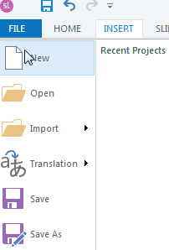Create a New File
1
2
  - Go to the File Menu
  - Select New

Insert a New Slide
  - Right Click
  - Select New Slide
  - Select Basic Layout
  - Select Blank

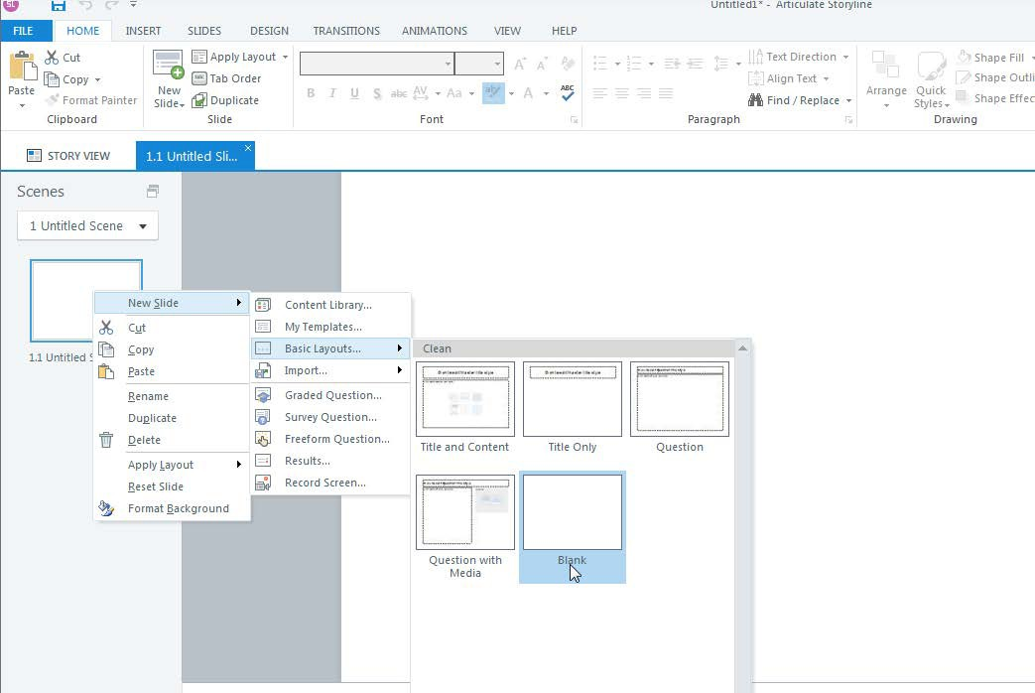
3
2
4

Insert a Character
  - Click the Insert tab
  - Select Character
  - Select the style, gender, clothing, and industry, and age of the character.
  - Pick the character on the right
  - 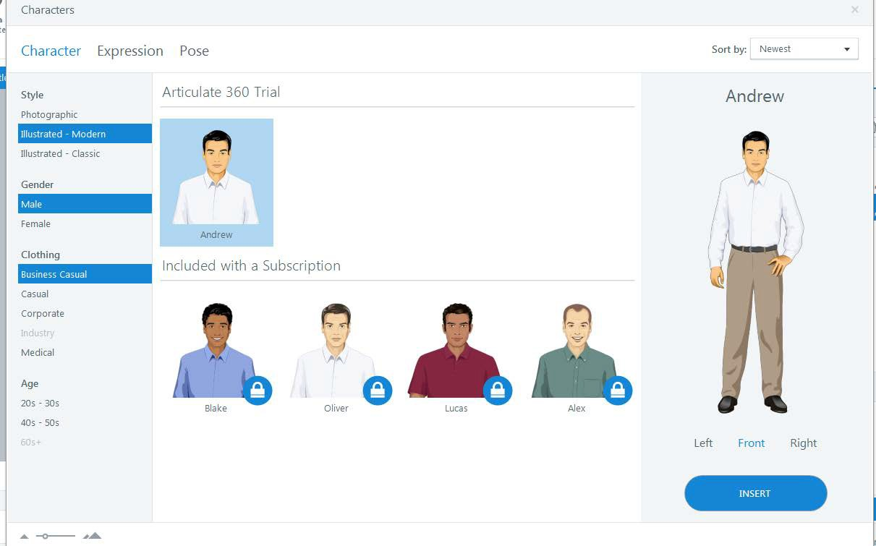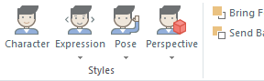Click Insert
1
6. Chose the expression, pose or perspective of the character.
2
6
3
4
5

Insert Photos or Illustrations
  - Click Insert
  - Select Photos
1
2

  - Select the
3 Photo
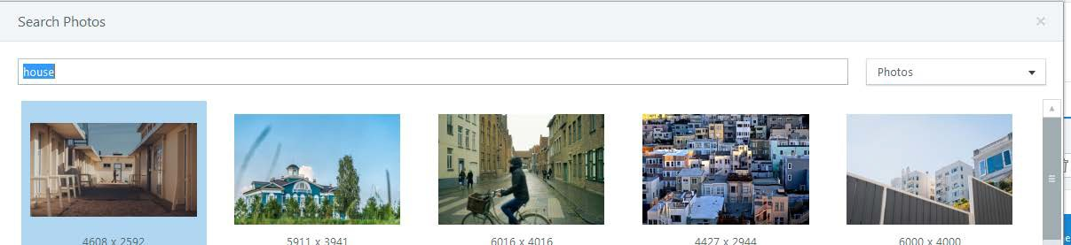

Insert a Photo From a File
  - Click Insert
  - Select a Picture from File
1


2

  - Select a photo from your computer


3

Insert a Drag and Drop Quiz Question
  - Right Click
  - Select New Slide
  - Select Graded Quiz Question

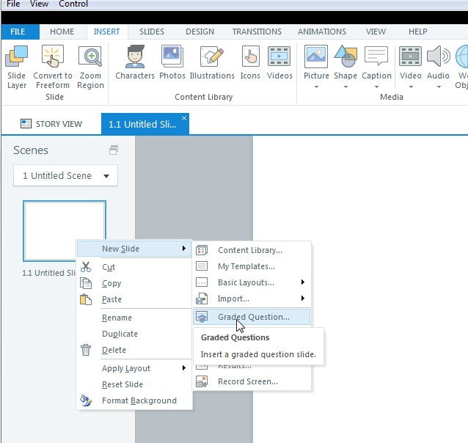
2
3

  - Select Matching Drag and Drop

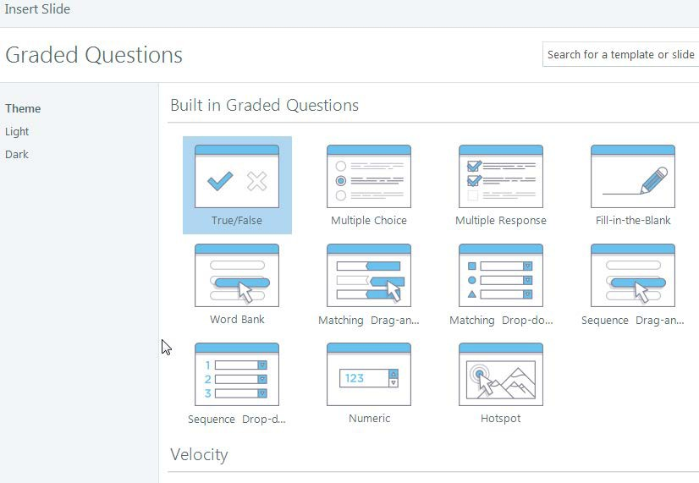
4

  - 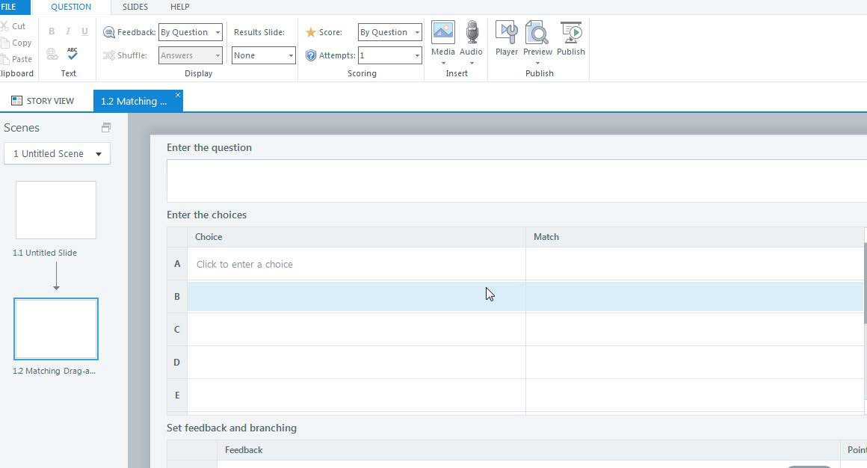Enter the information with choice and match
5

8
. Insert a Hotspot Question
1. Right Click

- Select New Slide
- Select Graded Quiz Question
2
3

- Select Hotspot
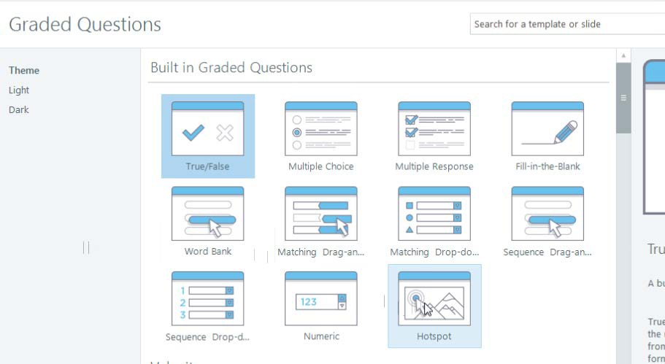
4

- Select a photo from your computer.

5

- Insert Hotspot
6

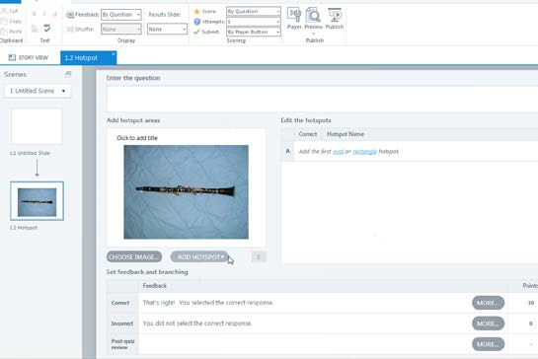
6

- Adjust the shape over the hotspot.
- Enter the question information.
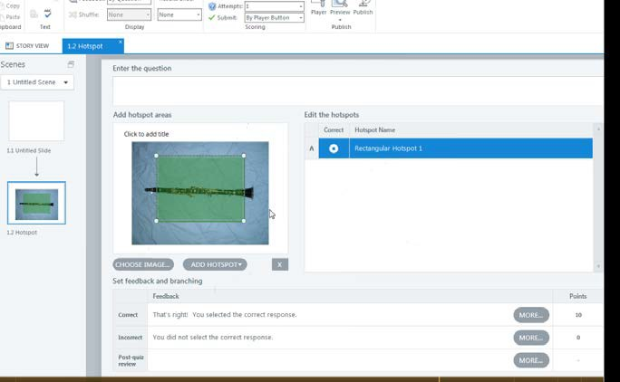
7
8

Examples of Engagement using Quiz Questions
Before (Multiple Choice)
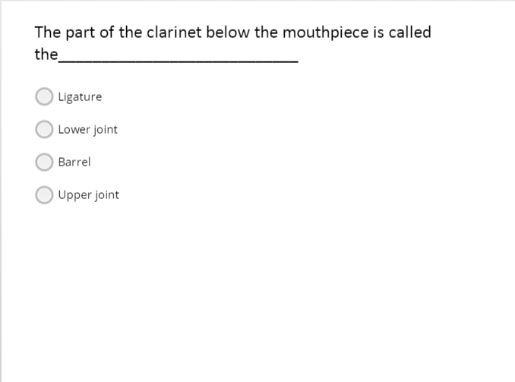

After (using a Hotspot question)
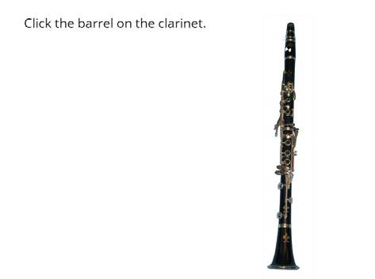

Before (Multiple Choice with multiple response)
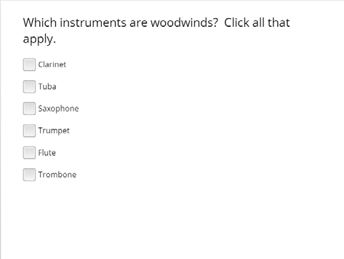

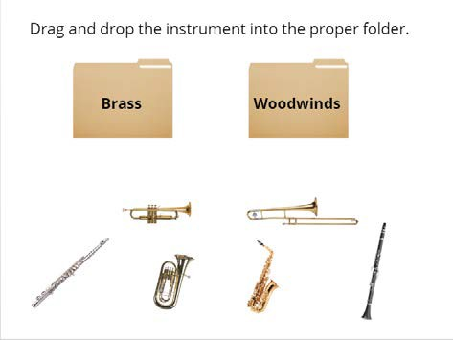After (Drag and Drop)

Resources
E Learning Uncovered: Articulate Storyline 360 By Diane Elkins and Desiree Pinder

Articulate Storyline 360: The Essentials By Kevin Siegel and Kal Hodi

Articulate E-Learning Heroes https://community.articulate.com/

Appendix 2-c. Implementation Schedule

Professional Development Schedule

Day 1
Time | Activity
9:00-9:30 | Introductions/Administrative Details/Technology Sign-Up
9:30-10:00 | Motivation Theory
10:00-10:45 | Adult Learning Theory
10:45-11:00 | Break
11:00-11:30 | The Role of the Online Teacher
11:30-12:00 | Ways to Engage Online Learners
12:00-1:00 | Lunch
1:00-2:00 | Break Out Groups/How to Use Articulate/SurveyMonkey/You Tube (Technical  Training)
2:00-2:45 | Break Out Groups/How to Use Articulate/SurveyMonkey/You Tube (Specific Ways to Use in Online Teaching)
2:45-3:00 | Break
3:00-3:30 | Break Out Groups/How to Use Articulate/SurveyMonkey/You Tube  (Brainstorm/Sketch Out Your Idea)
3:30-4:30 | Break Out Groups/How to Use Articulate/SurveyMonkey/You Tube (Get  Started on Project)

Day 2
Time | Activity
9:00-12:00 | Work on Lesson Projects
12:00-1:00 | Lunch
1:00-4:00 | Project Presentation and Critique
4:00-4:30 | End of Course Survey



Motivating Adult Learners in an Online Environment

A Presentation for Educators of Adult Learners

Presenters: Karen Ballengee & William Duncan

Agenda – Day One

- Session 1 – Admin details/Introductions/Preview of Learning Objectives
- Break
- Session 2 – Overview of Learning Theories and Motivation Theories
- Lunch
- Session 3 –SurveyMonkey
- Break
- Session 4 – Summing Up -- Group and Individual Feedback;
- Role of the Online Teacher; Ways to Engage the Online Learner;
- Break out Groups (Technology Demonstration)
- Break out Groups (Technology Practice)
- Project Presentations
- End of Course Survey

Agenda – Day Two

- Session 5 – Reflections on Day One; YouTube Video Use with Adult Learners
- Break
- Session 6 -- Introduction to Articulate
- Break
- Session 7 -- Articulate, Part Two
- Break
- Session 8 – Summing Up -- Small Group Presentations and Evaluation Survey; Takeaways



Introductions
Karen Ballengee
Education
M.Ed. Instructional Technology North Carolina State University
B.A. Music Education Shepherd University

Certificates
Graphic Design Technology Hagerstown Community College

Experience – 20 years as a military musician and woodwind instructor/Master Resilience Trainer
Hobbies –Road cycling

Introductions

Bill Duncan Education

B.S. Biology
M.A. Linguistics; M.A. Asian Studies M.Ed. Positive Coaching (2017)

Certificates (Missouri Dept of Elem & Sec Ed)

Biology, Chemistry, General Science, Chinese, TESOL, Online Educator (2017)

Experience
over 20 years of experience in classroom teaching, Homeschooling and Mentoring

Hobbies
Powerlifting

Goals

Goal 1: Learners will compare and contrast the role of the traditional teacher and the online teacher.
Goal 2: Learners will recognize ways to transfer face-to-face instruction to the online environment.
Goal 3: Learners will relate learning and motivation theories to attitudes of adult learners toward technology use.
Goal 4: Learners will express their attitudes toward technology and create a survey with proficient use with Survey Monkey.
Goal 5: Learners will access and examine three videos under 5 minutes in length they would use for instruction on Youtube
Goal 6: Learners will access and create an online lesson and quiz with proficient use of Articulate.

Cognitive

Characterizatio ,
1b-)I Vllue Set Organization
Psychomotor

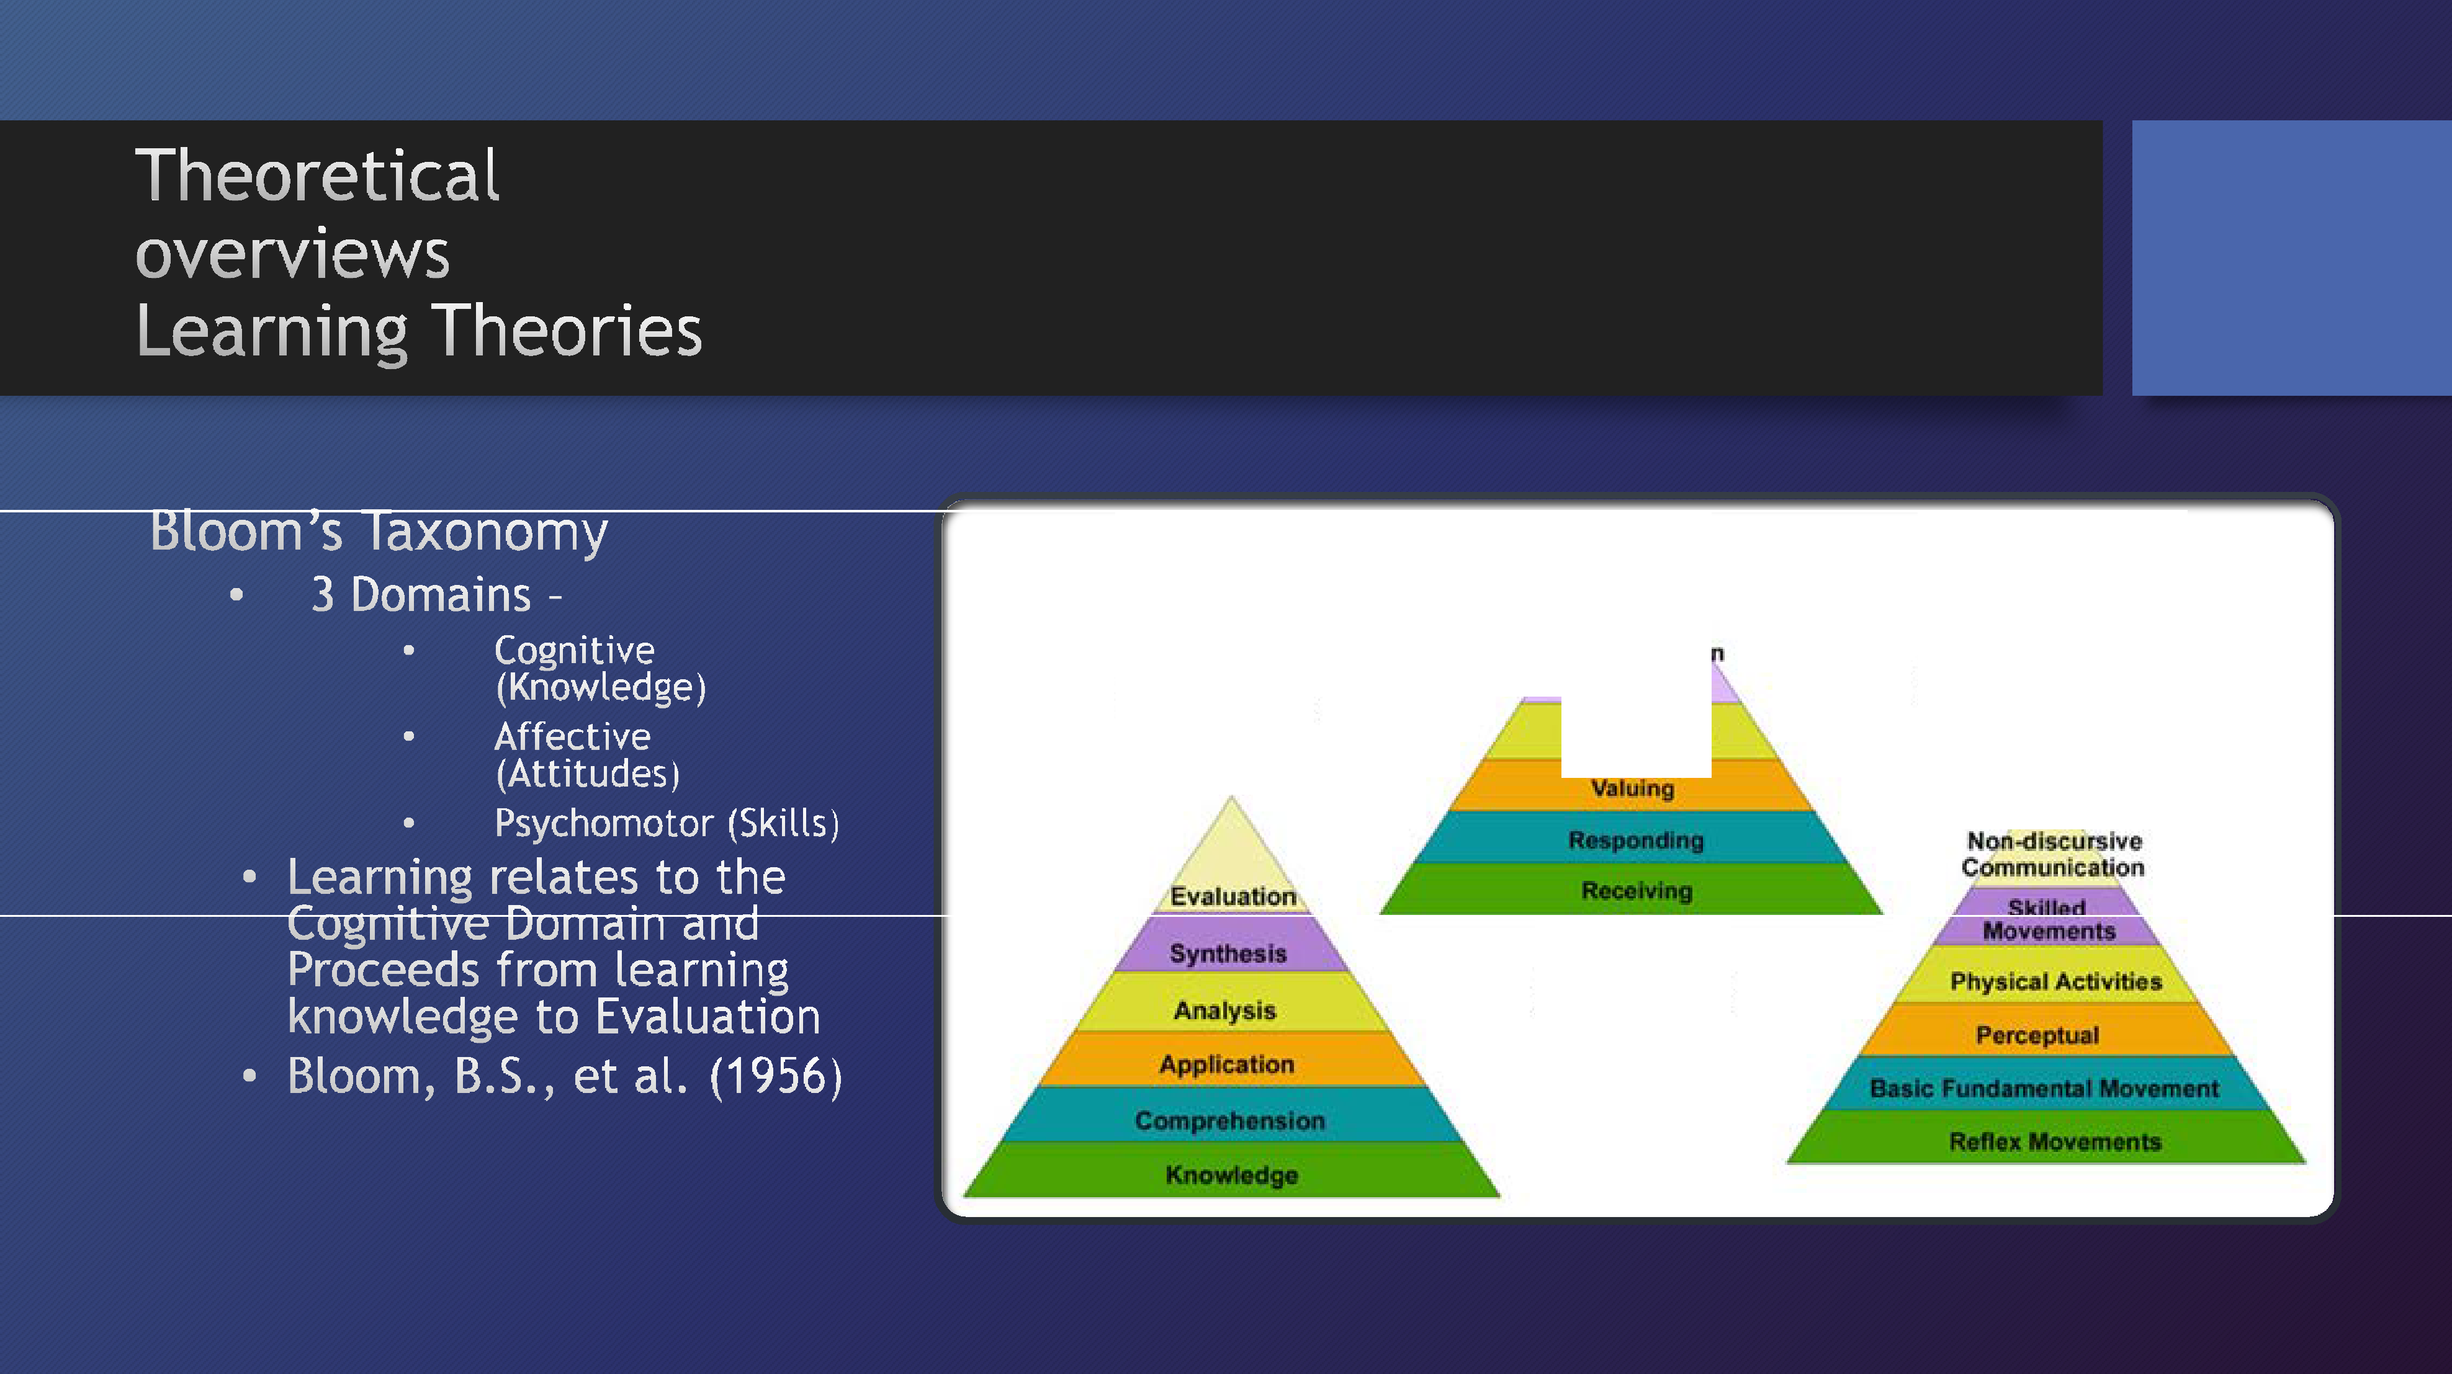

Affective

Theoretical Overviews

- Behaviorism – “Most human behavior is learned observationally through modeling: from observing others, one forms an idea of how new behaviors are performed, and on latter occasions this coded information serves as a guide for action.” (Social Learning Theory, Bandura, 1986)
- Constructionism – “Every function in the child’s cultural development appears twice: first, on the social level, and later, on the individual level; first, between people and then inside the child.” (Social Development Theory, Vygotsky, 1980)

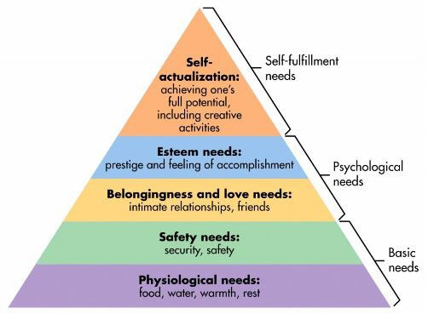

Motivation Theories

- Hierarchy of Needs
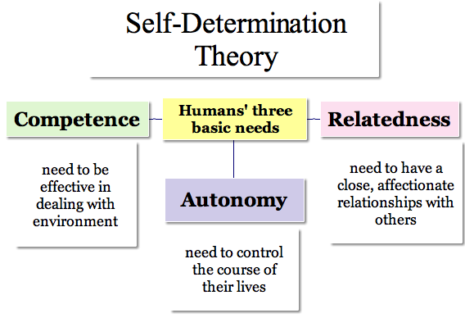
  - Humans act to meet their basic needs, their Psychological needs, then their self- fulfillment needs (Maslow, A.H. 1943)
- Self-Determination Theory
  - Humans act to meet basic motivational needs of competence (need to do something well), Autonomy (Need to control one’s own life), and Relatedness (need to interact with others with shared experience)
(Ryan & Deci, 2000)

How Adults Learn

- Adults need to be ready to learn
- Adults need to see the relevance of learning technology to the task they need to complete
- Adults need to be agents in their learning
- Adults need to work in a collaborative learning environment to construct meaning
- Collaborate with adult learners to determine learner needs
- Collaborate with adult learners on developing learning objectives
- Ensure that learning activities are practical.
- Ensure an approachable, authentic, empathetic, and respectful Learning environment.

Literature Review

  - Johnson, M. (2011)
    - Adult learners expect content that directly applicable to their lives.
    - Adult learners expect expert advice and feedback when handling technical issues.
    - When confident in their ability to use technology, adult learners have more positive attitudes toward using technology as a means of self-improvement
  - McLeod, J. K. (2007)
    - Prior experience is a strong correlating factor with positive attitudes for teachers and learners.
    - Field of study (relevance) found to correlate with positive attitudes.
    - Students seek more guidance in using technology-based resources when pedagogical and technical issues arise

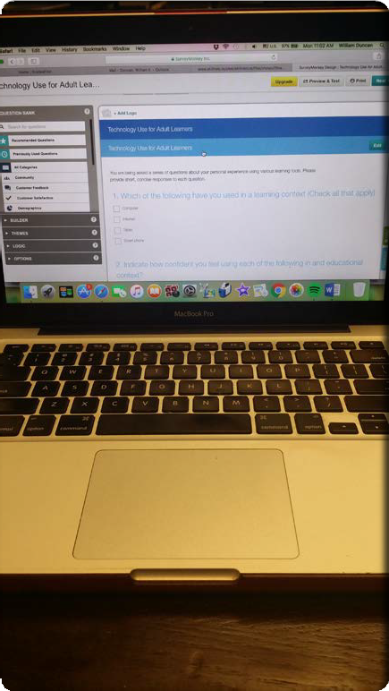

Surveymonkey

- Survey Monkey is an online survey builder that allows users to create surveys and quizzes that function on computers and mobile devices.
- https://youtu.be/yoDTZuDk5pU?list=PLiTGWc0Er5wf wZeH8ek9-LUvqImcCAy3x
- For our purposes, we want to know our learners attitudes toward learning with technology.
- Copy this link into the location box on your browser and take the sample survey. https://www.surveymonkey.com/r/5J897NX
- Since you have taken a seen an instructional video and have taken a survey using Survey monkey, we want you to take some time and make a survey about how adult learners feel about learning with technology.
- https://www.surveymonkey.com

The Distance Factor

Physical Distance
Being separated in time and place

Transactional Distance
Michael Moore (1984) “There is now a distance between learner and teacher which is not merely geographic, but educational and psychological as well.”


Wegeriff (1998) discovered that the degree of students’ success or failure was closely related to whether each student felt like an insider or an outsider.

The Optimal Role of the Online Teacher

Six Teaching Roles
  - Facilitator
  - Expert
  - Formal Authority
  - Socializing Agent
  - Ego ideal
  - Person who demonstrates compassion and understanding

Student Characteristics
- Independence and Responsibility
- Authoritarianism
- Anxiety

McKeachie (1978)

Copyright

Ask Yourself
  - Did you create the work yourself?
  - Did you pay to use it?
  - Can you claim Fair Use?



Copyright

Fair Use
Under the Fair Use doctrine, portions of copyrighted materials may be used without permission of the copyright owner provided
  - the use is fair and reasonable
  - does not substantially impair the value of the materials
  - does not curtail the profits reasonably expected by the owner.

You may use the materials for teaching, research, scholarship, and criticism. You may not post any of the materials or graphics on your own website.

Copyright

Attribution
Even though the terms of fair use apply under certain conditions, the user is still required to acknowledge the copyright holder. Proper attribution includes the author’s name and the date of the work.

Sources of Free Photos

Creative Commons
https://creativecommons.org/

Pixabay
https://pixabay.com/

Phases of Engagement

Learner Role | Instructor Role | Examples
Newcomer | Social Negotiator | Ice Breaker
Cooperator | Structural Engineer | Peer Reviews
Collaborator | Community Member | Role Play
Initiator/Partner | Challenger | Group Presentation

Conrad & Donaldson (2011)

Adapting Classroom-Based Activities

    - Will the activity help learners use the online tools?
    - Does it assist in the social process needed to establish community?
    - What type of interaction or collaboration with peers occurs?
    - Is reflection required?
    - Will a particular problem be resolved?

Conrad & Donaldson (2011)

Measuring Online Engaged Learning

  - Rubrics

Conrad & Donaldson (2011)
  - Team Assessments
  - Reflective Self- Assessments

Activities

  - Online Icebreakers

Conrad & Donaldson (2011)
  - Reflective Activities
  - Authentic Activities
  - Games and Simulations
  - Learner-Led Activities

References

Bender, T. (2012). Discussion-Based Online Teaching to Enhance Student Learning: Theory, Practice, and Assessment. (2nd ed). Virginia: Stylus.
Conrad, R., & Donaldson, J.A. (2011). Engaging the Online Learner: Activities and Resources for Creative Instruction. California: Wiley and Sons.
Talab, R.S. (1999). Commonsense Copyright: A Guide for Educators and Librarians. (2nd ed.). North Carolina: McFarland and Company Inc.

