**CSC1022 Architecture and Networks**

**PRACTICE CLASS TEST on ARCHITECTURE TOPICS**

**9.00 am – 11.00 pm (Belfast UK time zone)**

**Instructions to Candidates**

Please read all sections of the instructions before you start answering questions.

**These are provided so that you can prepare for the actual class test. This PRACTICE TEST has been left open for one and a half days on Canvas, so that you may do it at your leisure.**

**Please PAY ATTENTION to the process of ZIPPING a directory of answers and UPLOADING it to Canvas. You may upload you answers to this practice test in order to become familiar with the system. These are not marked as such but discussed in lectures.**

1. **Format of the test**

This is an OPEN BOOK test. You may use your own lecture notes, the recommended texts for this module, and other material presented during the lectures on architecture for CSC1022. You do NOT NEED to reference these materials.

You cannot cut and paste anything whatsoever from any OTHER source whatsoever unless you reference such work in your answer.

This resit test is worth 50% of the marks for the CSC1022 module.

The time available is 2 hours minutes for most students. This is 1 hour 15 minutes for the test plus a 45 minute extension for remote working.

The examiners will allow some extra minutes for upload to compensate for problems with Internet connections. Please note that we have a record of time of upload. You do not need to contact Dr. Gillan or Mr Sah to inform them of delays unless these become excessively long.

If you have an ISSA approved by QUB, you may add the allowance to the 1 hour 15 minutes for the test. For example, if you have a +25% allowance, you can take an EXTRA 19 minutes (25% of 1 hour 15 mins) to complete the test. That means your total allocation is 2 hours 19 minutes. Some students have an absolute additional time allowance instead of a percentage allowance. In that case just add the required allowance to the total time of 2 hours.

You must present all working out steps in mathematical questions. If no working is shown, no marks will be awarded. You may give the answer first and attach the working out, or you may show the working out and present the answer at the end. In either case, PLEASE MARK clearly what you are presenting. You may wish to write on paper and scan in JPEG files of your working out, or you can type it in Word.

1. **Upload instructions**

You download this file from Canvas to your local computer. You should create a folder for your answers and place all answers in it. You must NAME THE folder with your student number and NOTHING else. For example

123456789

All files in the folder should also begin with your student number and name.

12345678_John_Doe

You may enter your answers below each question in the Word documents, or you may split the documents into separate questions. Clearly mark the point where your answer begins. We recommend use of Courier font for mathematical information if you are using a Word processor to prepare your answers.

If you use separate files then name them appropriately for the question which the answer, for example

12345678_John_Doe_Question_1_part_i.docx

Some students may wish to handwrite all their answers. In that case, you may wish to prepare one or more PDFs or a set of screen shots in JPG or GIF format.

When you have completed answering the questions, you must ZIP the folder and then you must upload the ZIPPED file to Canvas. There is a button under the Canvas QUIZ Question 1, for you to perform the upload.

1. **Submission of the work**

Please not the following declaration.

By submitting the work, I declare that:

1. I have read and understood the University regulations relating to academic offences, including collusion and plagiarism:

<http://www.qub.ac.uk/directorates/AcademicStudentAffairs/AcademicAffairs/GeneralRegulations/Procedures/ProceduresforDealingwithAcademicOffences/>

1. The submission is my own original work and no part of it has been submitted for any other assignments either by me or by anyone else, except as otherwise permitted.
2. All sources used, published or unpublished, have been acknowledged if appropriate;
3. I give my consent for the work to be scanned using a plagiarism detection software
4. **Issues arising during the test**

If you need to raise an issue during the test, you should e-mail [c.gillan@qub.ac.uk](mailto:c.gillan@qub.ac.uk) at that time or as soon as possible afterwards.

**[ End instructions ]**

**Networking Questions – Answer ALL questions**

**All questions, Q1 to Q5, carry equal total marks.**

**The allocation of marks to parts of each question is shown for each part of each question.**

***Q1***. Write a reflection on the sections of the textbook,

Organization and Design ARM Edition: The Hardware Software Interface (The Morgan Kaufmann Series in Computer Architecture and Design) 1st Edition

Authors: David A Patterson and John L Hennessey

that you have studied alongside lectures in the architecture section of CSC1022. Compare and contrast the presentation in the above textbook with three other sources that you have used during your studies in CSC1022. You may cite up to two other textbooks before citing other types of resource (e.g. YouTube, Web site). These resources do NOT include you lectures notes or lab practicals. You answer should be no longer than 600 words. Which sources did you find best for your own style of learning.

**[Marks 10]**

**Q2**. Write ARM assembler code to perform the following steps.

1. Defines two 32 bit integers in RAM giving each a value

[Marks 2]

1. Loads the integers in (i) into registers 3 and 4 respectively

[Marks 2]

1. Multiplies the values in registers 3 and 6 and then adds the value 63 (decimal) to the result of the multiplication storing the answer in register 7

[Marks 4]

1. Stores the value in register 7 to a 32 bit location in RAM

[Marks 2]

**[ Total Marks 10 ]**

**Q3.** How does a programmer used the ARM assembler instruction BNE. Include an example. Which feature(s) of the CPU does this exploit.

**[ Marks 10 ]**

**Q4.** Explain the process of binary subtraction of two 8 bit signed integers that is implemented in a CPU using the example

8510 - 4210

**[Marks 10]**

**Q5.** You have been given table 1, see below, which is taken from the documentation

ARM7TDMI-S Data Sheet 4-1 ARM DDI 0084D.

Use the information in table 1 to construct the 32-bit instruction (machine code)

that corresponds to the assembly language instruction

SUB R7, R5, R6

You may assume that this instruction will ALWAYS be executed so that the

CONDITION field in bits 31 … 28 is 1110.

**Table 1: Format of the machine language instructions for data processing used in question 5.**

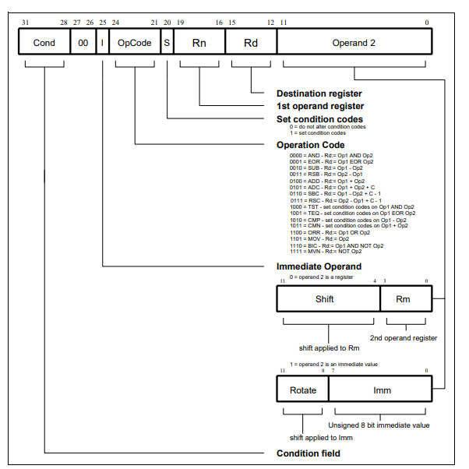

**[ Marks 10 ]**

**[ End of Test ]**