# CSC1023 Databases

**Practical 4 – Physical database design & SQL-1**

## Exercise A. Physical database design

**Instruction**

* Exercise A of this practical is about Physical database design and it can be done without additional software.
* Although you would need to have the **answers** to B3, C3 and D3 of **Practical 3** to help you with A3, A4 and A5 in this Practical 4.

|  |  |
| --- | --- |
|  |  |
| ***A1.*** | What is main objective of physical design for RDBMS? |
| ***A2.*** | For the following fields (hopefully obvious what they are) in the table Customer build a data dictionary (by hand, or using the template that is available on CSC1023 CANVAS Modules page, under ‘Practical – Resources’ section).  Make sure you include the data type, length, if it’s required/indexed/unique, and identify the keys.     * CustomerNo * Firstname * Surname * BillingAddress * Notes * ShippingAddress * CreditLimit * AccountBalance |
| ***A3.*** | Using the 3NF schema: Question **B3 of Practical 3**, create the necessary data dictionary form(s) for each table and field. |
| ***A4.*** | Using the 3NF schema: Question **C3 of Practical 3**, create the necessary data dictionary form(s) for each table and field. |
| ***A5.*** | Using the 3NF schema **D3 of Practical 3**, create the necessary data dictionary form(s) for each table and field. |
|  |  |

## Exercises B to F. SQL-1

**Instruction**

* Exercises B to F are about Structured Query Language (SQL), and they require you to make use of the EEECS MySQL hosting account.

If you have not yet set up a MySQL hosting account, then please follow the instructions in the “MySQL_Account_Installation” to set up a EEES MySQL hosting account.

(**Note**: this is the same instruction available on CSC1023 CANVAS Modules page,

under ‘Practical – Resources’ section with the file name of MySQL_Accout_Installation_Guide.pdf.

Alternatively, you may choose to have MySQL hosted on your own PC (although we can only support the EEECS hosted account).

* You will need to record your SQL statements and the output screens obtained on SQLphpMyAdmin.

* + To capture the SQL statements used, simply copy and paste from SQL-phpMyAdmin.

* + To obtain screen captures of your MySQL-phpMyAdmin output screen (the Entity tables, rows or columns of attributes, etc), you can use the “Snipping Tool (for Windows OS)” or ‘control-shift-Command-4’ (for Mac OS)” to capture your output screen. To paste your screen captures into this document, use ‘Control-V’ (for Windows OS) or ‘Command-V’ (for Mac OS).

**Task**:

* You must have created a EEECS LAMP hosting account and be able to connect and login to phpMyAdmin on that (or your own installation).
* Login to phpMyAdmin and select your database (on the left pane).
* Download the northwind-complete.sql file to the PC that you are working on. If the link doesn’t work, go to CSC1023 CANVAS Modules page, under ‘Practical – Resources’ section, to download the same file.
* Import northwind-complete.sql file to your phpMyAdmin, by following this video guide. If the link doesn’t work, go to CSC1023 CANVAS Modules page, under ‘Practical – Resources’ section, to watch the video.
* Alternatively, follow the instructions written below:
  + - Invoke/open a text editor software of your choice (Notepad++ , Textedit, etc) o Open the northwind-complete.sql file through your text editor.
    - Copy the entire file → Highlight everything in the file, apply (Control+A) and copy into the clipboard (Control+C)
    - In phpMyAdmin, open the phpMyAdmin’s MySQL code editor, accessible via the ‘SQL’ tab along the top menu (on the pane), and paste the content of the clipboard (Control+V) onto the blank space (the input area of the SQL tab) on the screen.
    - Click Go (bottom right) o This should load the example tables in – click again on your database on the left to see if it has loaded them, you should see something like the following:

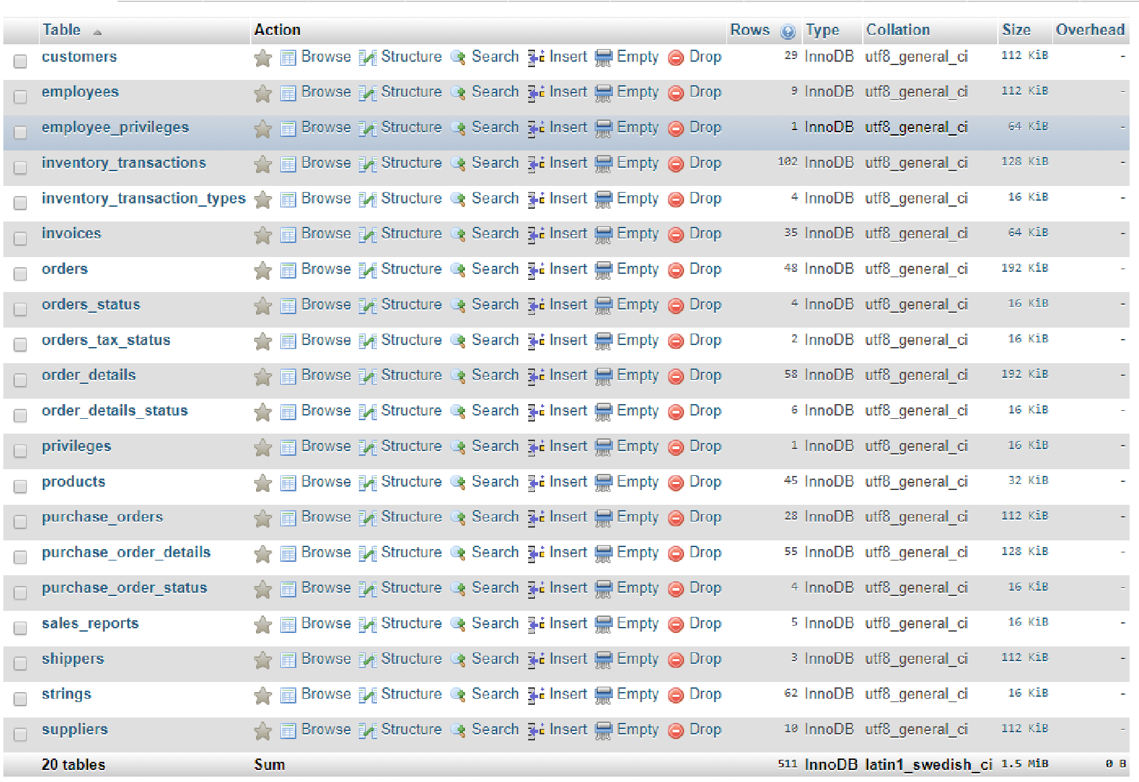

Note that you can see the tables (20 here) created and also how many rows (records) are contained in each one, for example there are 29 customers and 9 employees.

* **Executing SQL Queries**

Within phpMyAdmin when we want to perform an SQL query, the easiest option is to click on the **SQL tab** and **type** in the **query** then press **Go**.

Once you’ve performed a query and are seeing the results you can change the query as needed without going back by clicking “edit inline” and clicking Go to update.

Remember to paste your SQL and your result into this document.

## Section B. Exploring the Northwind Database

Perform the following tasks for all the questions listed in this section:

* **Be familiar with the with the structure (schema) and contents (data) of the Northwind database.**
* **Learn your way around phpMyAdmin**
* **Some answers can be found by clicking through the interface in phpMyAdmin**
* **Other answers may require the use of Google (or ask a demonstrator)** • **Paste your answers into this document**

|  |  |
| --- | --- |
|  |  |
| ***B1.*** | How many tables are in the Northwind schema? |
| ***B2.*** | How many rows are in the suppliers table? |
| ***B3.*** | For the first supplier (id 1) what is the company name? |
| ***B4.*** | What data type is the city column in the suppliers table? |
| ***B5.*** | What is the table type of the orders_status table? |
| ***B6.*** | What is the size (storage size – KiB) of the order_details table? |
| ***B7.*** | How many columns are there in the employees table? |
| ***B8.*** | What is the data type of the attachments column in the employees table? |
| ***B9.*** | What’s the definition of the data found in question 8? |
| ***B10.*** What column is the primary key of the employees table?    ***B11.*** What extra attributes does the id column of the products table have?    ***B12.*** What does the attribute you found in question 11 mean? | |

***B13.*** What are the two tax status names stored in the orders_tax_status table?

***B14.*** In the orders table how many different countries are contained within the ship_country_region column throughout all 48 rows?

## Section C. SQL query using the SELECT statement

Perform the following tasks for all the questions listed in this section:

* **write** an **SQL query**,
* **execute** the query,
* **Check** your output **table** gives the expected result,
* **paste** the SQL **query** statement into this document.

|  |  |
| --- | --- |
|  |  |
| ***C1.*** | List all the columns for all the rows in the **customers** table.  SELECT * FROM CUSTOMERS |
| ***C2.*** | List the **id**and **company** columns for all the rows in the **customers** table.  SELECT ID, COMAPANY FROM CUSTOMERS |
| ***C3.*** | List all the columns for all the rows in the **products** table.  SELECT * FROM PRODUCTS |
| ***C4.*** | List the **product_code,** **product_name** and **standard_cost** for all the rows in the **products** table.  SLECT PRODUCT_CODE, PRODUCT_NAME, STANDARD_COST FROM PRODUCTS |
| ***C5.*** | List the **company** column for all the row(s) in the **customers** table with an **id**of 12.  SELECT COMPANY FROM CUSTOMER WHERE ID = ‘12’ |
| ***C6.*** | List the **product_code** and **product_name** for all products with a **standard_cost** greater than 10 in the **products** table.  SELEECT PRODUCT_CODES, PRODUCT_NAME FROM PRODUCTS WHERE STANDARD_COST > 10 |
| ***C7.*** | List the **product_code** for a product with the **product_name** of “Northwind Traders Scones” in the **products** table.  SELECT PRODUCT_CODE FROM PRODUCTS WHERE PRODUCT_NAME = ‘Northwind Traders Scones’ |
| ***C8.*** | List the **company**, **last_name** and **first_name** of all customers whose **job_title** starts with the word “purchasing” in the **customers** table.  SELECT COMPANY, LAST_NAME, FIRST_NAME FROM CUSTOMERS WHERE JOB_TITLE LIKE ‘PURCHASING%’ |
| ***C9.*** | List the **company** and **business_phone** of all customers whose **job_title** contains the word “Manager” in the **customers** table.  SELECT COMPANY, BUSINESS_PHONE FROM CUSTOMERS WHERE JOB_TITLE LIKE ‘%MANAGER%’ |

***C10.*** List the **company** of all customers who are based in California (the state_province is CA) in the **customers** table.  
SELECT COMPANT FROM CUSTOMERS WHERE STATE_PROVINCE = ‘CA’

**More challenging questions:**

***C11.*** List the **product_code** and **product_name** for all very profitable products (very profitable is if the profit per item is more than 5 i.e. the list_price minus the standard_cost is more than five) in the **products** table.  
SELEVCT PRODUCT_CODE, PRODUCT_NAME FROM PRODUCTS WHERE (LIST_PRICE-STANDARD_COST)>5

***C12.*** List the **product_code** and **product_name** for all products that have a standard_cost between 10 and 20 inclusive in the **products** table.  
SELECT PRODUCT_CODE, PRODUCT_NAME FROM PRODUCTS WHERE STANDARDCOST >= 10 && STANDARD_COST <=20

See the next few pages for Exercises D to F.

### D SQL Query using Built-in Aggregate Functions

Perform the following tasks for all the questions listed in this section:

* **write** an **SQL query**,
* **execute** the query,
* **Check** your output **table** gives the expected result, • **paste** the SQL **query** statement into this document.

|  |  |
| --- | --- |
|  |  |
| ***D1.*** | Output the average (mean) **standard_cost** of all products from the **products** table, and name the output column as “Average Cost”.  SELECT AVG(standard_cost) AS 'Average Cost' FROM products |
| ***D2.*** | Output the average (mean) **list_price** of all products from the **products** table, and give the output column the name of “Average List Price”.  SELECT AVG(LIST_PRICE) AS ‘Average List Price’ FROM PRODUCTS |
| ***D3.*** | Output the number of product rows which have the category “Sauces” from the **products** table, and give the output column the name of “Sauce Count”.  SELECT COUNT(*) AS 'Sauce Count' FROM products WHERE category = 'Sauces' |
| ***D4.*** | Output the highest **standard_cost** of any item from the **products** table, and give the output column the name of “Highest Standard Cost”.  SELECT MAX(standard_cost) AS 'Highest Standard Cost' FROM products |
| ***D5.*** | From the **products** table, output the total number of **employees** in a column with the header “Number Of Employees”.  SELECT COUNT(*) AS 'Number Of Employees' FROM `employees` |

**More challenging questions:**

***D6.*** From the **products** table, output the average profit for all the products.

Note: Profit can be calculated by finding the difference between the **list_price** and the **standard_cost**.

SELECT AVG(list_price-standard_cost) FROM `products`

***D7.*** From the **products** table, output the highest profit for any product.  
SELECT MAX(list_price-standard_cost) FROM `products`

# E SQL query using more complex WHERE statements

Perform the following tasks for all the questions listed in this section:

* **write** an **SQL query**,
* **execute** the query,
* **Check** your output **table** gives the expected result,
* **paste** the SQL **query** statement into this document.

|  |  |
| --- | --- |
|  |  |
| ***E1.*** | Use two different methods, output the **product_code**  of all products, From the **products** table, that are in the “Sauces” category that also have a **standard_cost** between 10 and 20 inclusive.  SELECT product_code FROM products WHERE category = 'Sauces' AND standard_cost >=10 && standard_cost <= 20  SELECT product_code FROM products WHERE (category = 'Sauces') AND (standard_cost >=10 && standard_cost <= 20) |
| ***E2.*** | We need German native speakers at our head office in the USA. Output the particulars of the employees, from the **employees** table, who currently live in the USA and have the word “German” contained within their notes or have a country_region of “Germany”.  SELECT * FROM `employees` WHERE country_region = 'USA' AND notes LIKE '%German%'OR country_region = 'Germany' |
| ***E3.*** | Use two different methods, Output the **id** and **order_id**, from the **invoices** table, for the invoices that are dated in the month of March in the year 2006.  SELECT id, order_id FROM `invoices` WHERE invoice_date LIKE '2006-03-%%'  SELECT id, order_id FROM `invoices` WHERE invoice_date NOT LIKE '2006-04-%%' |
| ***E4.*** | From the **inventory_transactions** table, output the **id** and the **transaction_type** of the transactions that were either:   * created in the month of March in 2006 and had a quantity above 100, or * created in the month of April in 2006 and had a quantity above 50. SELECT id, transaction_type FROM `inventory_transactions` WHERE transaction_created_date LIKE '2006-03-%%' && quantity > 100 OR transaction_created_date LIKE '2006-04-%%' && quantity > 50 |
| ***E5.*** | Find the relevant Entity table and output the **id** and **comments** of any  **inventory_transactions** that contains a comment (i.e., it is neither NULL nor an empty string).  SELECT inventory_transactions.id, comments FROM inventory_transactions, inventory_transaction_types WHERE comments NOT LIKE 'null' |
| ***E6.*** | Find the relevant Entity table and output the full list of **order_details** that either: • Have a quantity greater than 20 and a **unit_price** greater than 10, or  • Have a **status_id** of 1.  SELECT * FROM `order_details`, order_details_status WHERE (quantity > 20 && unit_price >10) OR status_id = '1' |
|  |  |

# F SQL query using ORDER BY and LIMIT statements

Perform the following tasks for all the questions listed in this section:

* **write** an **SQL query**,
* **execute** the query,
* **Check** your output **table** gives the expected result,
* **paste** the SQL **query** statement into this document.

**Note**:

**Although the questions may ask for a number (output X), there may not be enough records in which case less than X will be output – but the query should be correct.**

|  |  |
| --- | --- |
|  |  |
| ***F1.*** | Find the relevant Entity table, output the top 10 **order_details** in terms of highest quantity.  SELECT * FROM `order_details`, order_details_status order by quantity LIMIT 0,10 |
| ***F2.*** | Find the relevant Entity table, output the 2nd, 3rd and 4th **order_details** in terms of highest unit_price. |
| ***F3.*** | Find the relevant Entity table, output a list of all customers sorted alphabetically by (most important to least important): company, last_name, first_name. |
| ***F4.*** | Find the relevant Entity table, output a list of the first five customers who are based (city) in Miami. |
| ***F5.*** | Output from the **order_details** table, the **product_id** that has an **order_id** value of 30 and has the lowest quantity. |
| ***F6.*** | Find the relevant Entity table and sort the **customers** alphabetically by **company**, andoutput all details of the 5th to 10th customers on the list. |
| ***F7.*** | Output from the **products** table, the details of the five highest **standard_cost** products. |