a)

SELECT AVG(Amount) AS Average

FROM Budget, Activity

WHERE Budget.BuID = Activity.BuID

AND (Activity.Title='Coding Competition' OR Activity.Title='Welcome Party');

b)

SELECT StaffID, FirstName, LastName, Campus.Address

FROM Staff, Campus

WHERE Staff.CaID = Campus.CaID

AND LeftD LIKE '2019-%%-%%'

c)

INSERT INTO Campus (Address, GmName, Country, Status)

VALUES ('122, Pineapple Avenue, New York', 'Michael Carlos', 'USA', 'Open Soon' )

d)

SELECT Title, FirstName, LastName

FROM Staff, Department

WHERE Staff.DeptID = Department.DeptID

AND Department.DeptName = 'EEECS'

e)

SELECT \*

FROM Staff

ORDER BY LastName ASC LIMIT 10

f)

SELECT FirstName, LastName, COUNT(\*)

FROM Staff, Allocation

WHERE Staff.StaffID = Allocation.StaffID

GROUP BY Staff.StaffID

g)

SELECT StudentName, Address, Enrolment.Score

FROM Student, Enrolment, Moudle

WHERE Student.StudentID = Enrolment.StudentID AND Enrolment.MoudleID = Moudle.MoudleID

AND Moudle.MoudleName = 'Java Programming'

ORDER BY Enrolment.Score DESC

h)

SELECT SUM(Amount) AS 'Lisa’s Spend'

FROM Budget

WHERE Approver = 'Lisa Amy' AND Status = 'Approved'

i)

SELECT Staff.\*

FROM Staff, Campus

WHERE LastName LIKE 'C%' AND Staff.CaID = Campus.CaID AND Campus.Address LIKE '%London%'

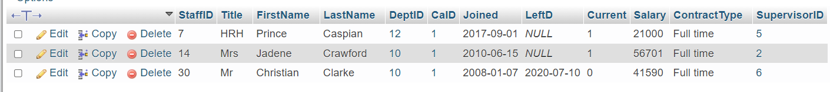

j)

SELECT StudentName, Moudle.MoudleName, Enrolment.Semester

FROM Student, Moudle, Enrolment

WHERE Enrolment.Year = '2020' AND Student.StudentID = Enrolment.StudentID AND Enrolment.MoudleID = Moudle.MoudleID

ORDER BY Enrolment.Score DESC

LIMIT 1,1

