Ocean currents and other factors leading to plastic accumulation – Stuart Watt

Due to the Coriolis effect, systems of large circulating ocean currents called *gyres* are formed. There are 5 major gyres in total. Gyres are known to collect pollutants, and as such regions of high-density plastic in the ocean are produced over time, such as the “North Atlantic garbage patch”.

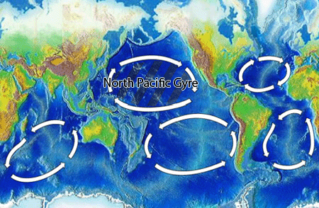

Figure : taken from <https://en.wikipedia.org/wiki/Ocean_gyre>

Surface currents are tracked by tracking buoys by the Global Drifter Program. This data is publicly available in various forms at <https://www.aoml.noaa.gov/phod/gdp/data.php>.

A simulation has been built using surface current data to successfully model and predict plastic accumulations. Details are in the following highly cited paper: <https://www.researchgate.net/publication/234002610_Origin_dynamics_and_evolution_of_ocean_garbage_patches_from_observed_surface_drifters>

The simulation code is available as open source software at <http://oceanparcels.org>. Also, at <http://plasticadrift.org>, a simulation of plastic dispersion from an initial single point can be performed and the results extracted as a .csv file.

Things of note:

* ‘leaking’ of debris from gyres is predicted. Escaping plastic is then likely recaptured into another gyre. For long simulations most plastic ends up in the North Pacific Gyre.
* An ocean clean-up organisation has began efforts to capture plastic in the North Pacific Gyre. Details, related research and criticism may be found in the Wikipedia page: <https://en.wikipedia.org/wiki/The_Ocean_Cleanup#cite_ref-58>. One thing of note: according to experts, less than 5% of ocean plastic makes its way into the garbage patches, and a large portion of this may be below the surface layer.