# Predicting Non-Attendance of Healthcare Appointments

## Project Summary

This project assessed 110,000 appointments information obtained in Brazil, over a 5 week period in May 2016, where 20% of the appointments were not attended.

A predictive model was built on a sample of 5,000 appointments, but generally it could not be proved to be predicted with real accuracy. What is resultant of the project is identifying which factors are not significant to appointment attendance and identifying potential future research.

## Key Findings

1. The most likely predictor of appointment attendance is in the length of time between when an appointment is requested and when it is held. Specifically, same-day appointments are the best indicators of attendance.
2. The remaining variables of day of the week of the appointment; patient age, gender or access to welfare air; patient diagnosis of Alcoholism, Diabetes, Hypertension or handicap; and whether the patient received a SMS reminder, appear to be insignificant.

## Future Research Potential

1. If the time of an appointment impacts attendance.
2. If when an SMS reminder is sent impacts attendance.
3. If groups of ages (infants, children, teenagers, adults, seniors) tend to impact appointment attendance.

## Predictor Model Performance

The Gradient Boosting Model (GBM) was the best performing model of 5 models assessed, however accuracy of the model is 67%.

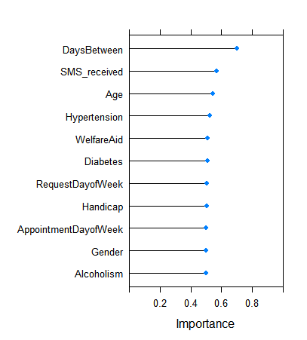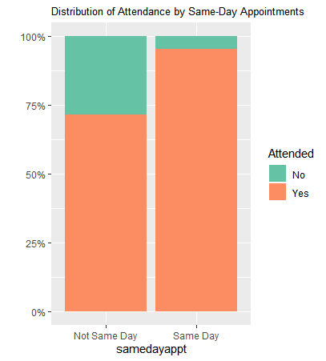

Figure (Left) Variables in Order of Importance Figure (Right) Attendance by Same-Day Appointments