Test report

Scenario | Status
Scenario: The navigate in Word Counter  Given a user navigates in Word Counter  When a user write Hello Hello Hello Hello how are you? in the text field  Then a user see text 7 words 36 characters | APPROVED
Scenario: Validate total repeat words  Given a user click in Keyword Density  When a user validate total repeat word is hello  Then the total de repeat word 4 (80%) | APPROVED
Scenario: Validate characters without spaces  Given a user write HelloHelloHello in the text field  Then a user see text 1 words 15 characters  When a user click in Keyword Density  Then a user validate total repeat word is hellohellohello  And the total de repeat word 1 (100%) | APPROVED
Scenario: Validate characters only spaces  Given a user write " " in the text field  Then a user see text 0 words 7 characters | APPROVED
Scenario: Validate specifics characters  Given a user write #%?¡-+)/('!"°#$&%/ in the text field  Then a user see text 1 words 18 characters | APPROVED
Scenario: Validate specifics characters without spaces  Given a user write #%?¡-+)/ ('!"°# $&%/ in the text field  Then a user see text 3 words 20 characters | APPROVED

Failure report

Caso de prueba 1.
Scenario: Refresh the page
Given a user navigate in https://wordcounter.net/
When a user write words in the text field
And a user refresh the page
Then written words must be removed

Evidencia
video = Caso1.mkv

Caso de prueba 2.
Scenario Outline: Show all equal options
Given a user navigate in https://wordcounter.net/
When a user click on the button CASE
Then case options <options> are displayed
And they should not show some glued and some separated
Examples:
| options |
| Sentence case |
| Tittle Case |
| UPPER CASE |
| lower case |

Evidencia
imagen: Caso2.png

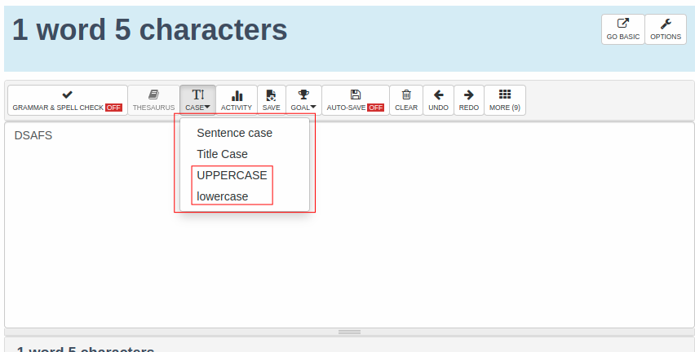

Caso de prueba 3.

Scenario: Accordion cards are not displayed when minimized
Given a user navigate in https://wordcounter.net/
When a user minimize the cards Details, Keyword Density and Activities
Then the cards must be minimized and show the name of each one
And cards name is not displayed

Evidencia
video = Caso3.mkv

UX MATTERS

1. Fondo nacional del ahorro (https://www.fna.gov.co/)

Al momento de refrescar la pagina algunos elementos se muestran fuera de sitio. Solucionar el problema de estilos

Evidencia
video = Refresh.mkv
imagen: Refresh.png

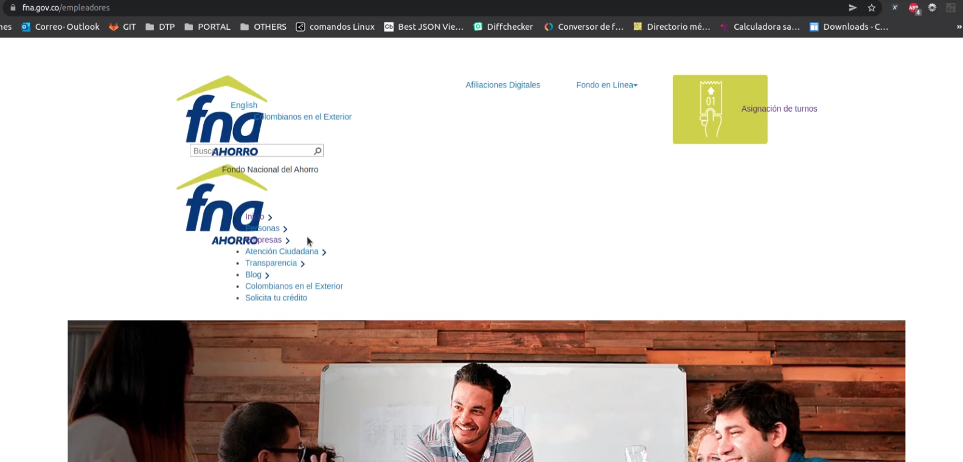
2. Al momento de seleccionar un item en el menú no debe mostrarse un borde de color. No se debe mostrar ya que para eso esta el enlace y ya se selecciono el elemento

Evidencia
video = SelectItem.png

