INSERT INTO pais VALUES ( 'MX', 'MEXICO');

INSERT INTO CUIDAD VALUES (‘TJ’,’TIJUANA’);

[Create](http://localhost/phpmyadmin/url.php?url=https://dev.mysql.com/doc/refman/5.5/en/create-table.html) [table](http://localhost/phpmyadmin/url.php?url=https://dev.mysql.com/doc/refman/5.5/en/create-table.html) TipoUsuario (id\_TipoUsuario [int](http://localhost/phpmyadmin/url.php?url=https://dev.mysql.com/doc/refman/5.5/en/numeric-types.html) [NOT](http://localhost/phpmyadmin/url.php?url=https://dev.mysql.com/doc/refman/5.5/en/logical-operators.html#operator_not) NULL AUTO\_INCREMENT PRIMARY key ,Tipo [varchar](http://localhost/phpmyadmin/url.php?url=https://dev.mysql.com/doc/refman/5.5/en/string-types.html" \t "mysql_doc)(50));

[insert](http://localhost/phpmyadmin/url.php?url=https://dev.mysql.com/doc/refman/5.5/en/insert.html) into tipousuario(tipo) [VALUES](http://localhost/phpmyadmin/url.php?url=https://dev.mysql.com/doc/refman/5.5/en/miscellaneous-functions.html#function_values)('Gimnasta');

[insert](http://localhost/phpmyadmin/url.php?url=https://dev.mysql.com/doc/refman/5.5/en/insert.html) into tipousuario(tipo) [VALUES](http://localhost/phpmyadmin/url.php?url=https://dev.mysql.com/doc/refman/5.5/en/miscellaneous-functions.html#function_values)('Entrenador');

Alter table usuario add id\_TipoUsuario int ;

Modulo:

INSERT into Modulo VALUES (1,'Modulo 1');

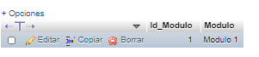

Evaluación:

insert into Evaluacion values (1, 'prueba 1 : Historia','Test', 1);

insert into Evaluacion values (2, 'prueba 2 : Historia de la gimnasia en México','Test', 1);

insert into Evaluacion values (3, 'prueba 3 : Pioneros del movimiento de gimnasia','Test', 1);

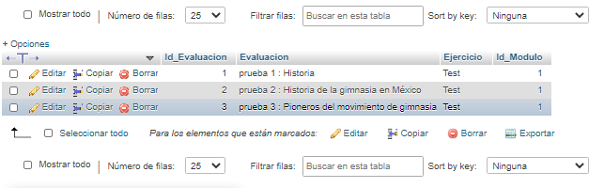

Entrenador:

insert into entrenador values (1,'Maryuri01','Maryuri','Chavez','Duarte','17/12/1995','TJ',1,'6642008983','maryuri@tectijuana.edu.mx','Rosarito #2268')



[CREATE](http://localhost/phpmyadmin/url.php?url=https://dev.mysql.com/doc/refman/5.5/en/create-table.html) [TABLE](http://localhost/phpmyadmin/url.php?url=https://dev.mysql.com/doc/refman/5.5/en/create-table.html) entrenador\_suarios( Id\_Entrenador [INT](http://localhost/phpmyadmin/url.php?url=https://dev.mysql.com/doc/refman/5.5/en/numeric-types.html) [NOT](http://localhost/phpmyadmin/url.php?url=https://dev.mysql.com/doc/refman/5.5/en/logical-operators.html#operator_not) NULL, ID\_Usuario [INT](http://localhost/phpmyadmin/url.php?url=https://dev.mysql.com/doc/refman/5.5/en/numeric-types.html) [NOT](http://localhost/phpmyadmin/url.php?url=https://dev.mysql.com/doc/refman/5.5/en/logical-operators.html#operator_not) NULL, PRIMARY KEY (Id\_Entrenador,ID\_Usuario), FOREIGN KEY (Id\_Entrenador) REFERENCES entrenador(Id\_Entrenador), FOREIGN KEY (ID\_Usuario) REFERENCES usuario(ID\_Usuario))

[ALTER](http://localhost/phpmyadmin/url.php?url=https://dev.mysql.com/doc/refman/5.5/en/alter-table.html) [TABLE](http://localhost/phpmyadmin/url.php?url=https://dev.mysql.com/doc/refman/5.5/en/alter-table.html) entrenador\_suarios RENAME entrenador\_usuarios

[insert](http://localhost/phpmyadmin/url.php?url=https://dev.mysql.com/doc/refman/5.5/en/insert.html) into entrenador\_usuarios [values](http://localhost/phpmyadmin/url.php?url=https://dev.mysql.com/doc/refman/5.5/en/miscellaneous-functions.html" \l "function_values" \t "mysql_doc)(1,340)

[insert](http://localhost/phpmyadmin/url.php?url=https://dev.mysql.com/doc/refman/5.5/en/insert.html) into entrenador\_usuarios [values](http://localhost/phpmyadmin/url.php?url=https://dev.mysql.com/doc/refman/5.5/en/miscellaneous-functions.html" \l "function_values" \t "mysql_doc)(1,341)

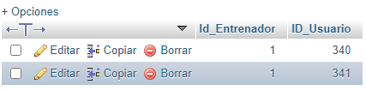

SELECT \* FROM `evaluacion`

