**BLOCK DIAGRAM OF A DIGITAL COMPUTER**

**Introduction**

The computers have evolved over time as per the cost, performance and usage. From the Mainframe. Minicomputers, Supercomputers, Microcomputer (i.e., on physical dimensions)

Basically, the general functions that a computer can perform are mainly,

1. Data processing
2. Data storage
3. Data movement
4. Control

There are various types of diagram show how the above functions are related. Some of are as follows

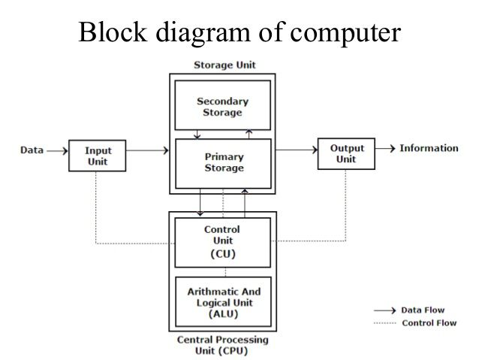

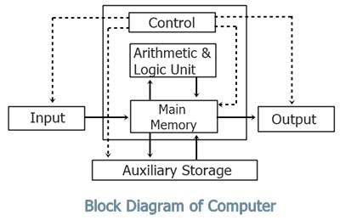

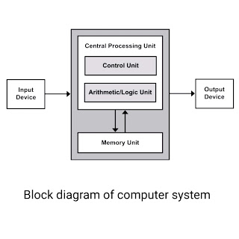

**Computer Block Diagram System**:

Mainly computer system consists of three parts, that are central processing unit (CPU), Input Devices, and Output Devices. The Central Processing Unit (CPU) is divided into two parts again: arithmetic logic unit (ALU) and the control unit (CU). The set of instruction is in the form of raw data.

A large amount of data is stored in the computer memory with the help of primary and secondary storage devices. The CPU is like the heart/brain of the computer. The user does not get the desired output, without the necessary option taken by the CPU.  The Central processing unit (CPU) is responsible for the processing of all the instructions which are given by the user to the computer system.

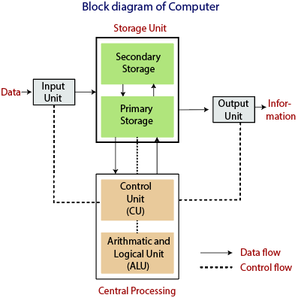

The data is entered through input devices such as the keyboard, mouse, etc. This set of instruction is processed by the CPU after getting the input by the user, and then the computer system produces the output. The computer can show the output with the help of output devices to the user, such as monitor, printer, etc.

* CPU (Central Processing Unit)
* Storage Unit
* ALU (Arithmetic Logic Unit)
* Control Unit

**Central Processing Unit (CPU)**

The computer system is nothing without the Central processing Unit so, it is also known as the brain or heat of computer. The CPU is an electronic hardware device which can perform different types of operations such as arithmetic and logical operation.

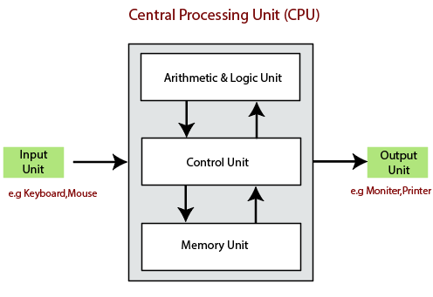

The CPU contains two parts: the arithmetic logic unit and control unit. We have discussed briefly the arithmetic unit, logical unit, and control unit which are given below:

**Control Unit**

The control unit (CU) controls all the activities or operations which are performed inside the computer system. It receives instructions or information directly from the main memory of the computer.

When the control unit receives an instruction set or information, it converts the instruction set to control signals then; these signals are sent to the central processor for further processing. The control unit understands which operation to execute, accurately, and in which order.

**Arithmetic and Logical Unit**

The arithmetic and logical unit is the combinational digital electronic circuit that can perform arithmetic operations on integer binary numbers. It presents the arithmetic and logical operation. The outputs of ALU will change asynchronously in response to the input. The basic arithmetic and bitwise logic functions are supported by ALU.

**Storage Unit**

The information or set of guidelines are stored in the storage unit of the computer system. The storage unit provides the space to store the data or instruction of processed data. The information or data is saved or hold in computer memory or storage device. The data storage is the core function and fundamental of the computer components.

**Primary Memory**

The Random-Access Memory is the main memory of the computer system, which is known as RAM.  The main memory can store the operating system software, application software, and other information.  The Ram is one of the fastest memories, and it allows the data to be readable and writeable.

**Secondary memory**

 We can store the data and programs on a long-term basis in the secondary memory. The hard disks and the optical disks are the common secondary devices. It is slow and cheap memory as compare to primary memory. This memory is not connected to the processor directly.

It has a large capacity to store the data. The hard disk has a capacity of 500 gigabytes. The data and programs on the hard disk are organized into files, and the file is the collection of data on the disk. The secondary storage is direct access by the CPU; that’s why it is different from the primary storage.

The hard disk is about 100 times the capacity of the main memory. The main difference between primary and secondary storage is speed and capacity. There are several large blocks of data which are copied from the hard disk into the main memory.