Zhihua Shang

06/18/2020

Fundations of Programming(python)

Assignment08

GitHubURL:

Class of Python

# Introduction

Python has the function of class. The classes enable the data and functions to be grouped together. In this script, the use of classes and the connection with the main body will be shown as follows.

# Create a folder and Open the downloaded file

Open file via PyCharm. Click create new project, name it as Assignment08, and save it under _PythonClass in C: drive (Figure 1).

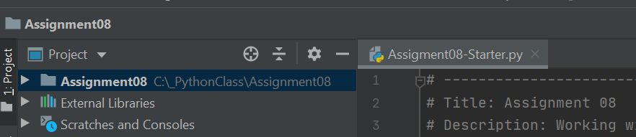

*Figure 1: Showing the location of Assginment08.py*

# Coding

This is the main and most important part of the whole process. After checking the Assignment08-Starter, the header, the main body of the script, and three classes need to be added codes.

## Update the changelog in the header

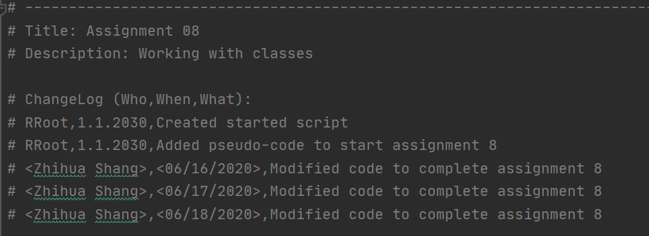

*Figure 2: Showing the updated changelog of file.*

## Class of Product

This part focuses on the class of Product. Before working on the codes, it is necessary to finish the pseudo-code. It helps both the creator and users an understanding of the codes (Figure 3)

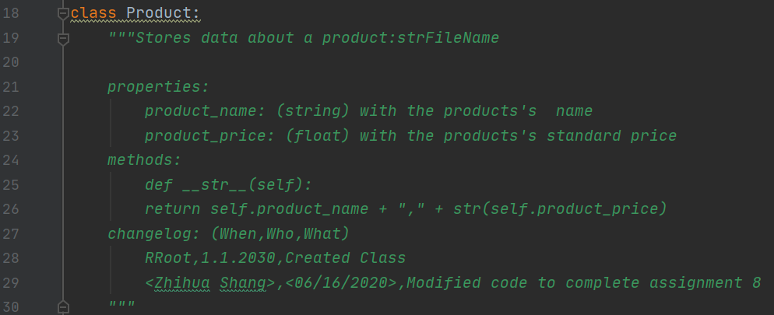

*Figure 3:* *Showing the pseudo code of class Product*

The second step is to follow the five components of classes and fill the codes (Figure 4).

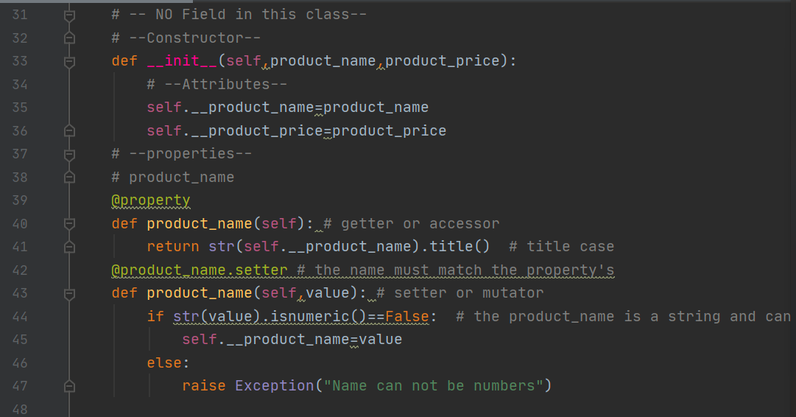

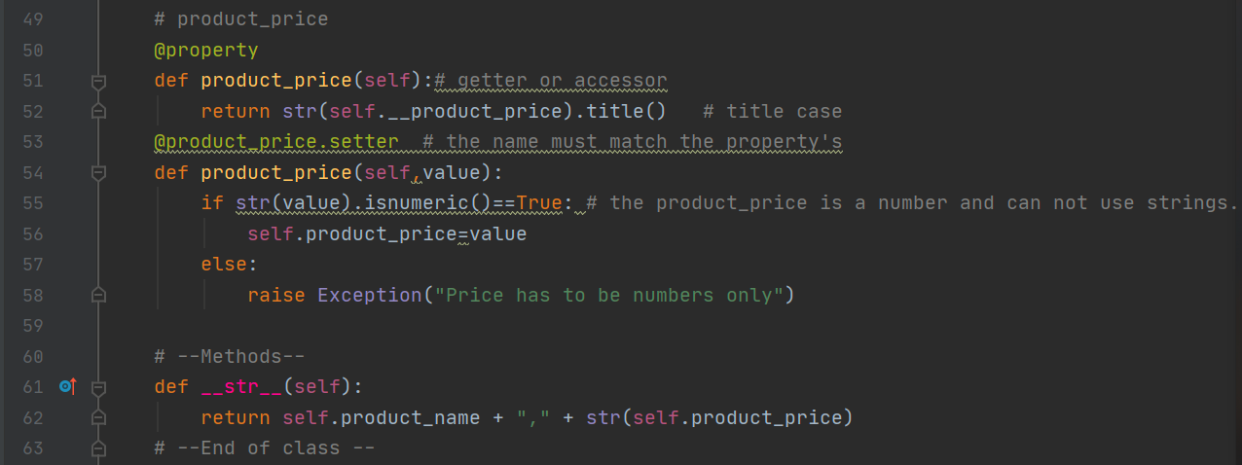

*Figure 4: Showing the components of class Product*

## Class of FileProcessor

This part focuses on the class of FileProcessor which includes two static methods.

When the data is stored as static method, the methods can be called directly from the class. The one named save_data_to_file is to perform the function that save or not the data to a file. Try function is used to detect errors (Figure 5). When doing this part, the previous homework could be referred.

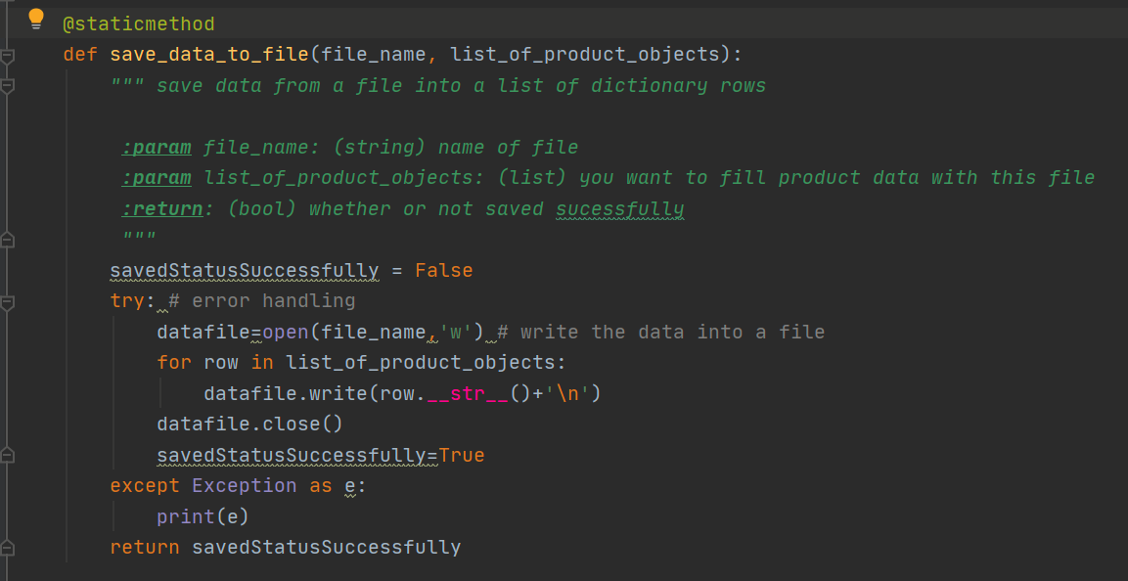

*Figure 5:* *Showing the* *staticmethod of save_data_to_file()*

Another static method is class read_data_from_file which is a file that read data from the file into a list. Error handling also must be included in this method due the assignment requirement (Figure 6).

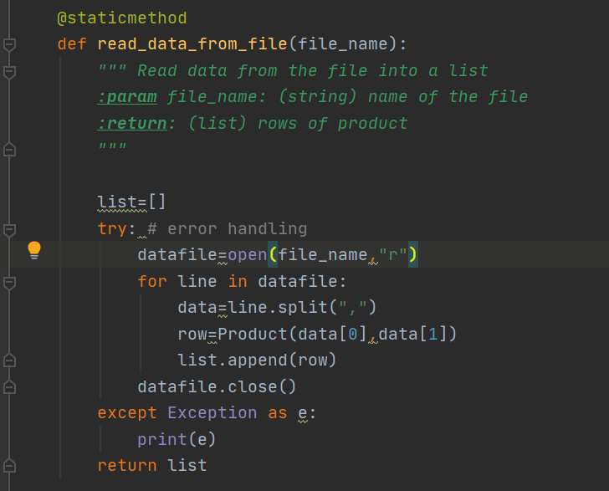

*Figure 6: Showing the staticmethod of read_data_from_file()*

## Class of IO (input and output)

When working this part, it is important to check what the assignment asked for. According to the requirement, several methods can be made and then be recalled at the main body. This part includes five static methods. The first one is to show the menu of options. It is named print_menu. It provides several options for the users (Figure 7).

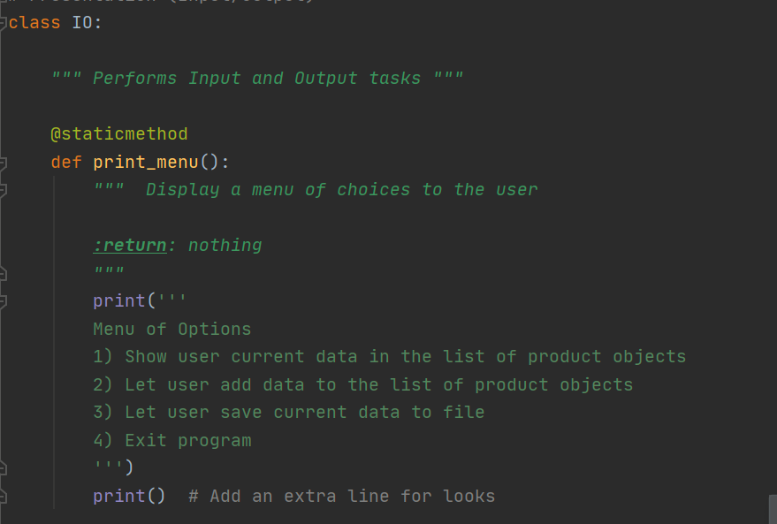*Figure 6: Showing the staticmethod of print_menu()*

When users see the menu, they are asked to make a choice to choose one of the options. This method can be named as input_menu_choice (Figure 7).

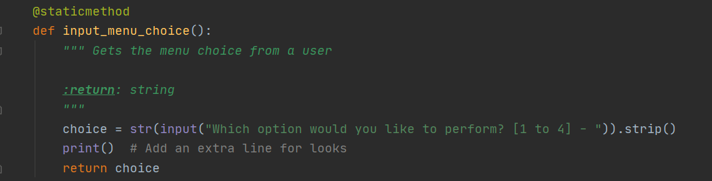*Figure 7: Showing the staticmethod of input_menu_choice()*

Another static method called input_press_to_continue is defined and will be used in main body to pause program and show a message before continuing (Figure 8).

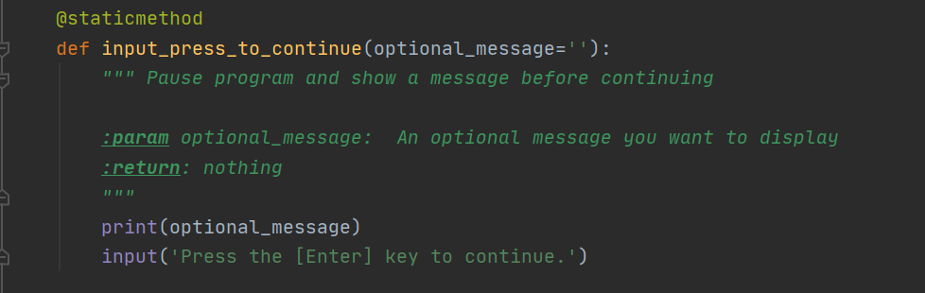*Figure 8: Showing the staticmethod of input_press_to_continue()*

The next static method is to ask users to provide product name and product price. It is called input_new_product_and_price (Figure 9).

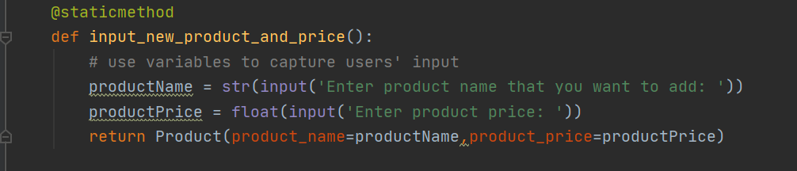*Figure 9: Showing the staticmethod of input_new_product_and_price ()*

The last static method in this class is to print the current data in the list (Figure 10).

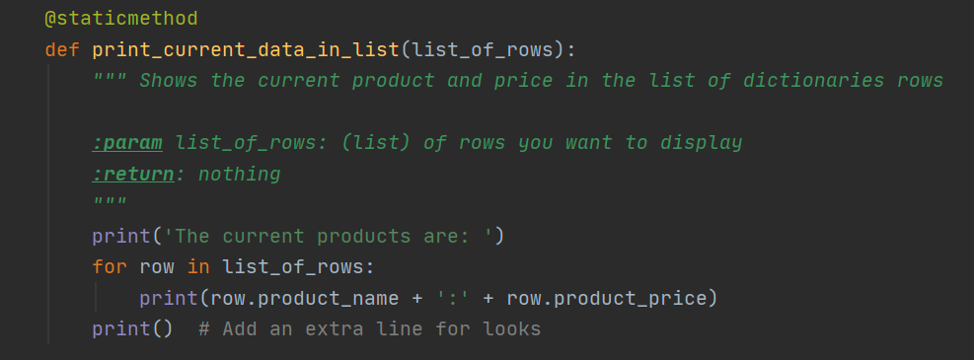*Figure 10: Showing the staticmethod of print_current_data_in_list()*

## Main body of the script

This part is to organize the methods that were made in different classes and make them to work together by using while loop and if method. Error handing is also required, so try function is used (Figure 11).

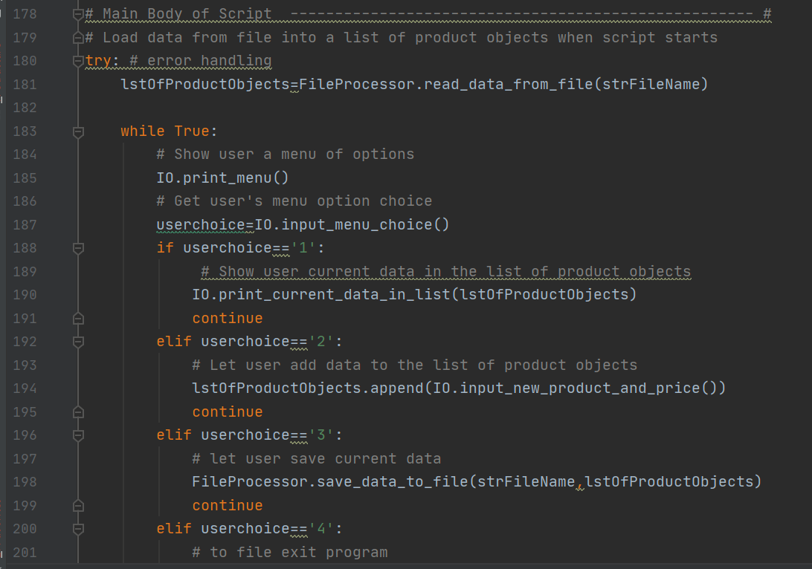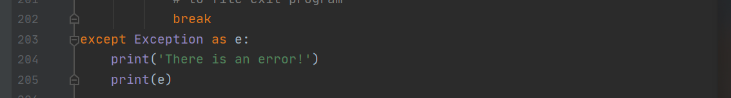*Figure11: Showing the main body of scrip*

## Demonstrate in PyCharm

This is the result that showing in PyCharm (Figure 12).

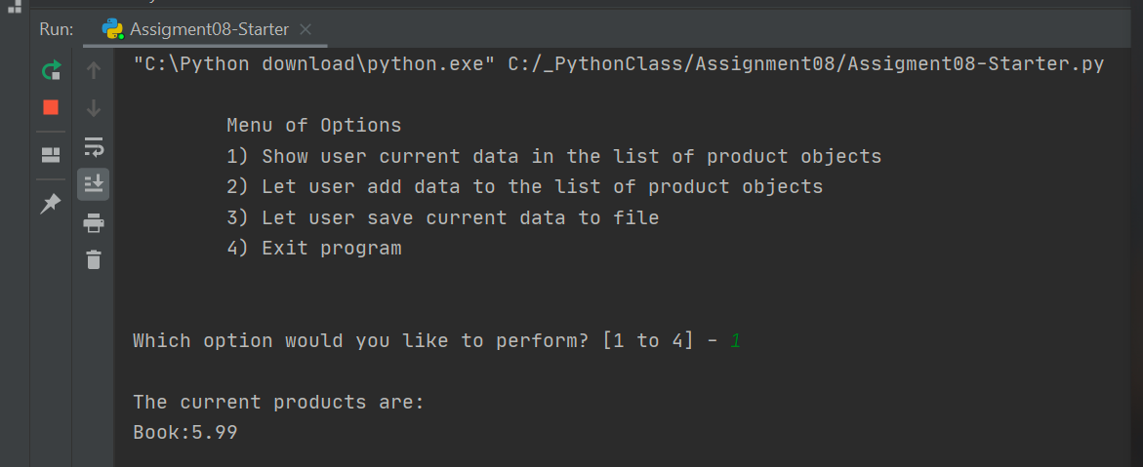

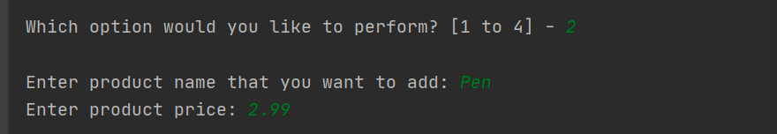

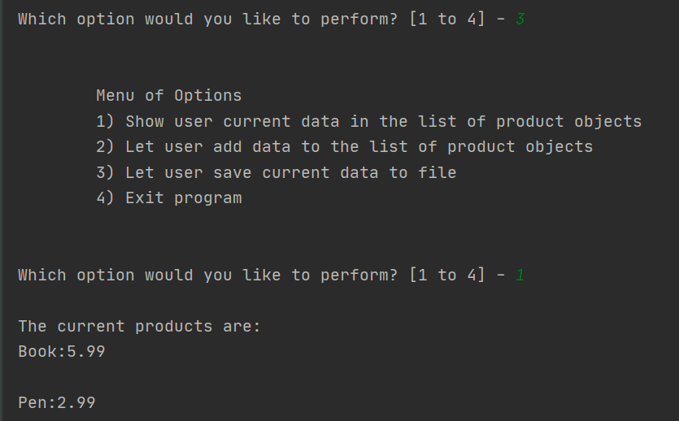

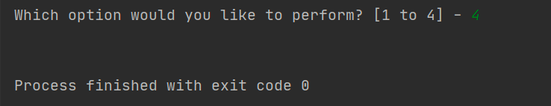

*Figure12: Showing the result in PyCharm.*

## Demonstrate in Command Window

Beside working in PyCharm, the python file can also work in a command window. The first step is to go to start, search and click CMD. The Command Prompt window shows up. Typing ‘python’ and pasting the path of the BasicMath.py file, then the information shows up (Figure 13).

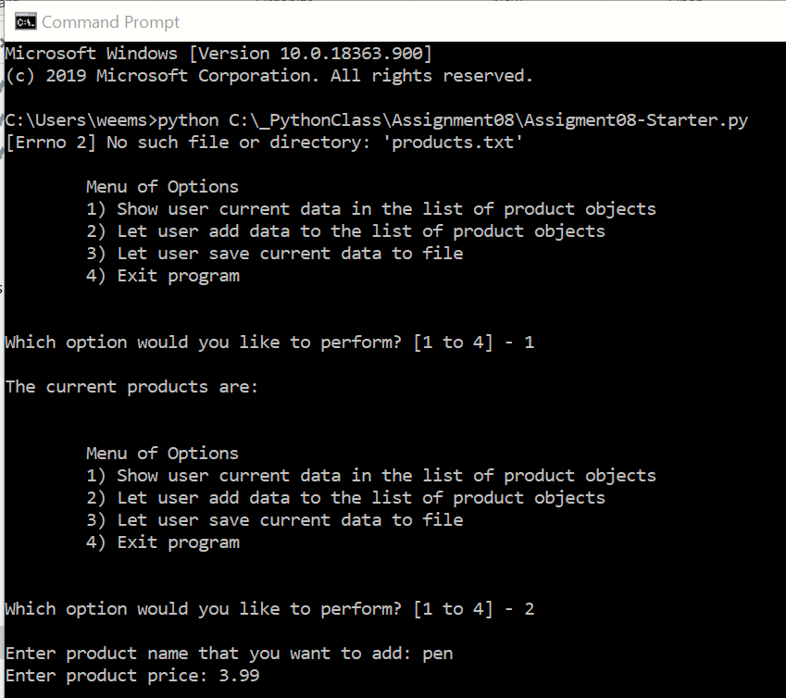

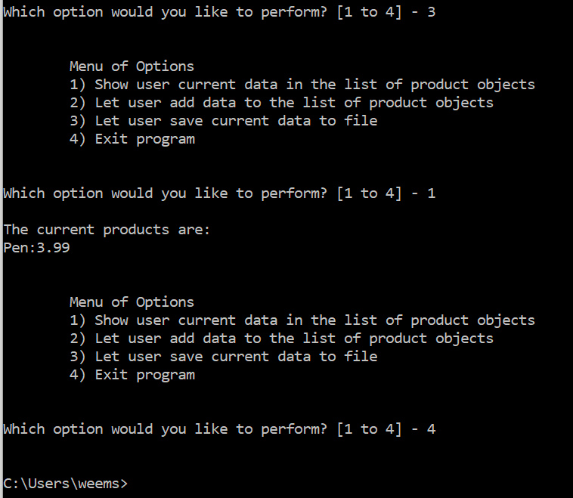

*Figure 13: script running from command.*

## Demonstrate in Shell window

The same script could also be demonstrated in IDE shell. Go to start, search and click IDE. The shell window shows up. Find file and open from the Assignment07 which is under_PythonClass in C drive. Run it, and the same result will be shown (Figure 14).

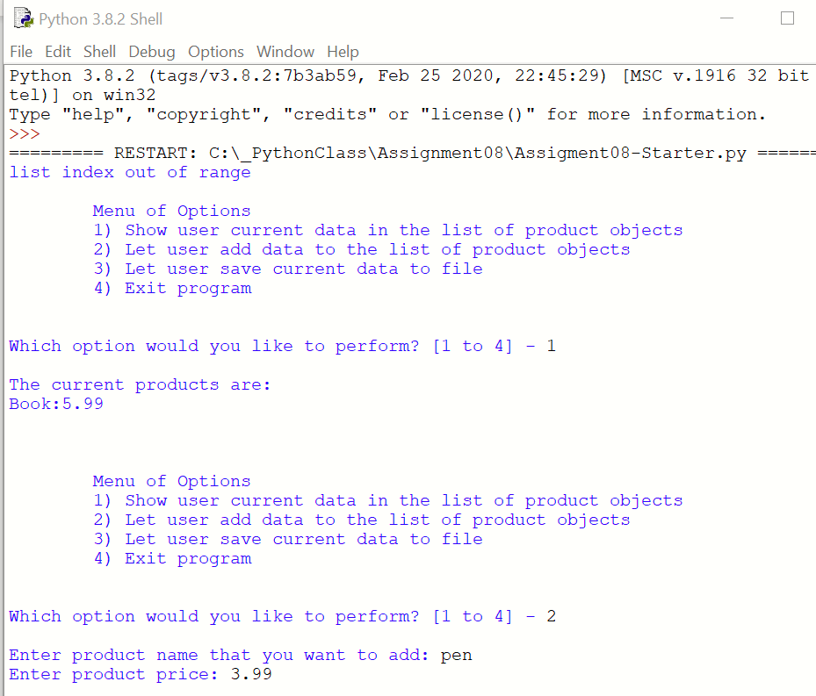

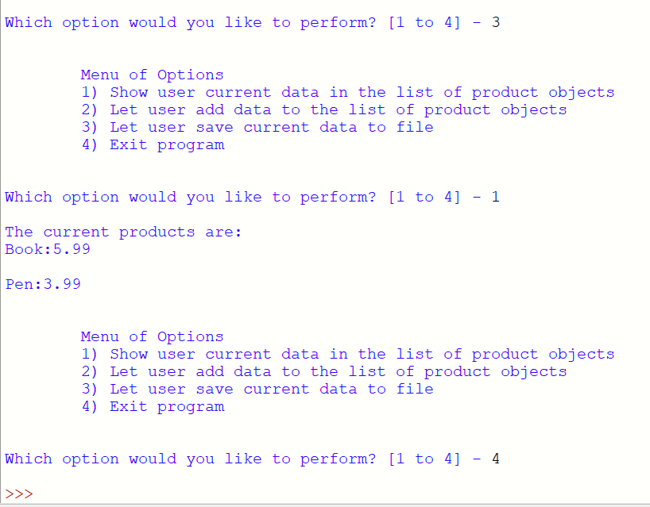

*Figure 14: script running from Shell window*

# Summary

Classes enable data to be grouped and gathered separately. When the data is only useful in the specific class, the variables can be defined as field which only works in that filed. Because of the limitation of the field, classes enable the data to be stored more safely. If the variable can be used beyond different classes, the global variables can be used in the main body. It means that the classes can be used in different scripts without repetition when the users have other purposes. This is greatly reduced manual errors and improve the work efficiency in the real workplace.