# **LAB 1 - TASK 4**

In this task, you will evaluate the performance of the slotted ALOHA protocol by investigating the effect of changing the transmission probability **p** on the system efficiency by both simuation and analytically.

**INSTRUCTIONS**

The initial MATLAB code in the window below is similar to code in Task 1. Some changes were made to speed up the simulation. In particular, each user always sends the same the frame. These frames are now stored in a matrix that will be used to create the slots. The variable **slot** is still computed by the logical OR of all transmitted frames, although the code is slightly different.

The goal of this task is to study the performance of the ALOHA system as a function of the probability **p**. For that purpose, we created a list of probabilities, called **p_list**, and we added a for loop to test the system with these probabilities. For each value of **p_list**, we will store the efficiency of the system (variable **eff_v**), the expected (theoretical) efficiency obtained by the equation studied in the lecture (variable **expeff_v**), the fraction of the total number of slots in the simulation (**n_slots**) that are empty (variable **empty_v**) and that contain collisions (variable **coll_v**). These fractions should vary between 0 and 1.

If you run the code, Fig. 1 will show the efficiency (simulated and analytical), the normalized number of empty slots, and the normalized number of collision as a function of the probability **p**. In the initial code, these values are always zero, but if you revise the code correctly, they will change with **p** and Fig.1 will illustrate how probability **p** affects the performance of the ALOHA protocol. For example, when **p** is set to 1, we expect the fraction of collisions to be 1 and the fraction of empty slots to be zero because every user always transmits. On the other hand, when **p** is set to 0, we expect there to be no collisions because all slots are empty.

Your task is to revise the code to compute the correct values of **eff_v**, **expeff_v**, **empty_v** and **n_slots**. Be reminded that these variables are column vectors with lengths equal to length of **p_list**. Refer to the lecture slides for the formula to calculate **expeff_v**.

Please revise the code between the lines

% % % % Revise the following code % % % %

and

% % % % Do not change the code below % % % %

Do not change other parts of the code.

**Output**

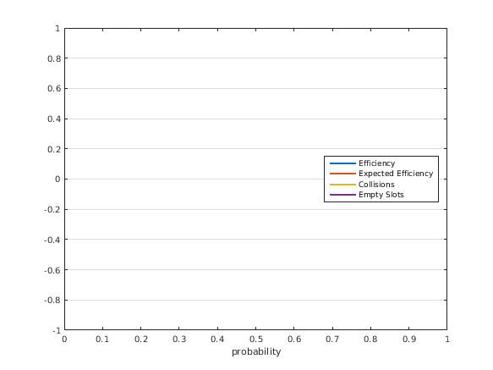

**Assessment Tests**

Is problem setup unmodified?

Is the efficiency correct?

Is the normalized number of empty slots correct?

Is the normalized number of collisions correct?

Is the expected (theoretical) efficiency correct?