## Concept Map: GitHub, Push, Pull, Remote

We’ve introduced a few new concepts since we last revisited our concept map.

* GitHub
* git push
* git pull
* remote

### Previous Version

Here’s what the map looked like the last time we added new concepts.

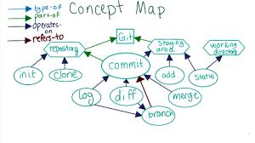

### Where Do the New Concepts Go?

There's wasn't a lot of screen real estate left, so we pruned off some of the concepts from last lesson that aren't tightly entwined with the new ones that will come up this lesson, and added in nodes for the new concepts.

Which concept belongs where? 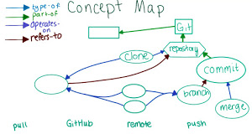

In the following quiz, write in the concept that you think belongs in each new empty node.

Remember that this map is subjective, so what we have here may not fit your mental model exactly; feel free to draw out the connections you see between the concepts and share your version on the forums!