## Concept Map: branch, merge

Here's where we left off with the concept map: 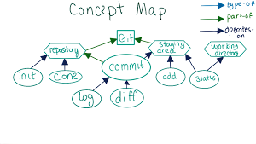

### New ideas

Since then, we've talked about a few new ideas. The biggest ones are the ideas of branching and merging.

Where do branching and merging fit best in the Concept Map? Continue to the quiz to add them.

