## Concept Map: init, add, staging area

We’ve introduced a few new concepts since we last revisited our concept map.

* git init
* git add
* git status
* staging area
* working directory

### Previous Version

Remember our concept map from last lesson? Here’s what it looked like the last time we added a new concept.

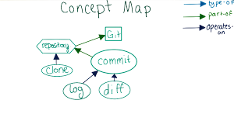

### Where Do the New Concepts Go?

Here’s the structure we’ve come up with for how to add these new concepts in to the map. Which concept belongs where?

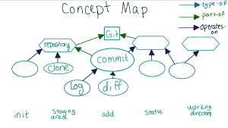

In the following quiz, write in the concept that you think belongs in each new empty node.