## Concept Map: Fork, Fetch, Pull Request, Fast-Forward Merge

Here are the big new concepts we’ve introduced since we last revisited our concept map:

* fork
* fetch
* pull request
* fast-forward merge

### Previous Version

Here’s what the map looked like the last time we added new concepts.

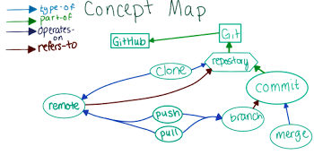

### Where Do the New Concepts Go?

Here's how we fit the new concepts in to the map. Which new concept belongs where? 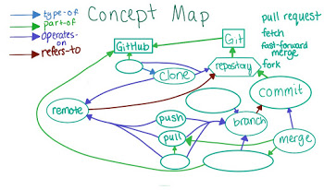

In the following quiz, write in the concept that you think belongs in each new empty node.

Remember that this map is subjective, so what we have here may not fit your mental model exactly; feel free to draw out the connections you see between the concepts and share your version on the forums!