## Update Easy Mode

### Motivation

Master has updated since the easy-mode branch was created. In this case, it has the addition of coins, which you might like to include in the easy-mode branch. In general, it’s very common that if you make a branch, either an experimental branch or to work on a new feature, you want to periodically merge master into that branch. This is because master usually contains the official version of the code, and it’s common to want experimental changes to include all of the changes to master.

### Previous version of the diagram

Here’s what the history looks like right now.   
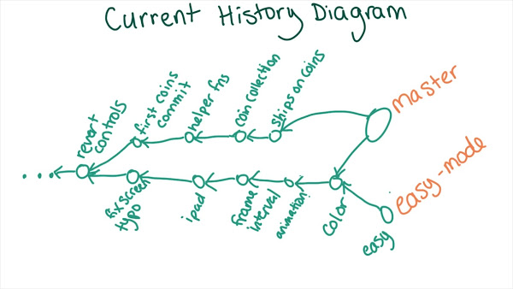

### Draw an updated diagram

If you merge master into the easy-mode branch, what will the history look like afterward? Take a minute to draw the new history using whatever method you like best. You might want to use pencil and paper, or create a text file with stars and dashes similar to the output of git log --graph, or maybe use an online diagramming tool like [gliffy](https://www.gliffy.com/) or [yUML](http://yuml.me/diagram/activity/draw). Once you’re finished, watch the solution to compare your diagram to Sarah’s.