24 responses

# Summary

### Would you like to use FicRec, an entertainment recommendation site, if it exists?

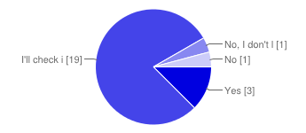

|  |  |  |
| --- | --- | --- |
| Yes | 3 | 13% |
| I'll check it out once, and use it if it's good | 19 | 79% |
| No, I don't like fictional entertainment. But I may recommend it to friends who do if it's good | 1 | 4% |
| No | 1 | 4% |

### If you answered "No" for question 1, please tell us why not.

From the video I didn't understand what it is about, I can just do the search in google.

Demo was not interesting enough. Is there sound on the demo? I couldn't hear it.

### What proposed features in FicRec do you like the most?

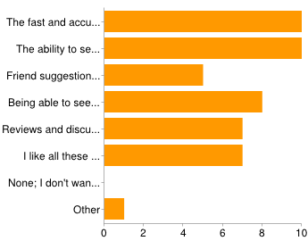

|  |  |  |
| --- | --- | --- |
| The fast and accurate fictional entertainment recommender | 10 | 42% |
| The ability to search for titles by plot/character elements, ex. "Evil Protagonist" or "Happy Ending" | 10 | 42% |
| Friend suggestions: people you most likely don't know but like the same titles you do | 5 | 21% |
| Being able to see the most recent updates of the titles and people you follow | 8 | 33% |
| Reviews and discussions associated with each title | 7 | 29% |
| I like all these features | 7 | 29% |
| None; I don't want to use this site | 0 | 0% |
| Other | 1 | 4% |

### What other features would you like to see in FicRec?

That people may upload files (video for instances if the recommendation is for a movie)

What other people are reading (personalized, based on what I read).

- Instant messaging with friends - Like/Dislike bar - Promotion, contests for items - Preview, trailer - Block user, anti-spam system - Medals for frequent users - Users can create playlist and share with other - Ranking for most popular fiction, top viewed fiction - Share on Facebook, Twitter, etc - Able to Like comment or dicussion - Mobile friendly - Search recommendation

I just want the recommendations to actually be good.

Search by rating, name of author, writer

Weekly Top Recommendations

ability to download a publication onto a tablet or app like ibooks

review score aggregation (like Rotten Tomatoes)

I think they are enough

All suggestions on product features are great. May I also suggest that the user be allowed to create a personal list of things used and aiming to use. I would really appreciate that.

### Is there another site you use that is similar to FicRec? If so, please specify and tell us why you like it.

imdb?

no, this is the first I've seen for this type of site

No

Similar to social networks in general, taking the most important from each one.

No I do not use any other site as of now.

1. http://www.goodreads.com/list/tag/fiction 2. http://www.harvard.com/shelves/staff/fiction_suggestions/ 3. http://www.barnesandnoble.com/u/Books-We-Recommend/379003220/ 4. http://www.wattpad.com/story/2351131-teen-fiction-recommendations 5. http://www.bestsfbooks.com/

No not exactly.

I am the kind of person that go and browse in a whole purpose site for pictures (I don't like movies very much and have no preference for a specific plot)

anime-planet: user recommendations, "if you like this, then you'd like this feature"

Not sure

## Number of daily responses

