Lab 03: One-Way ANOVA

Zhuqian (Karen) Zhou

Teachers College, Columbia University

**Task 1 & 2: The Omnibus Test**

Table 1

*One-Way Analysis of Variance in CES-D Gain*

|  |  |  |  |  |
| --- | --- | --- | --- | --- |
| Source | Sum of Squares | *df* | Mean Square | *F* Ratio |
| Treatment | 96 | 3 | 32 | 0.40 |
| Error | 10765.6 | 135 | 79.7 |  |
| Total | 10861.6 | 138 |  |  |

The p-value associated with the intervention factor is .75 so for α = .05, we fail to reject the null hypothesis. There is no sufficient evidence to conclude that the average change in depression, as measured by the CES-D, from the pretest to one-month follow-up differs across any of the four intervention groups.

**Task 3: The Pairwise Test**

Table 2

*Summary of Regression Analysis for Variables Predicting Change in Depression (*N=139*)*

|  |  |  |  |  |
| --- | --- | --- | --- | --- |
| Variables | *β* | *SD* | *t(*135*)* | *p* |
| Treatments |  |  |  |  |
| REM | -2.14 | 1.47 | -1.454 | 0.148 |
| SS | -0.66 | 2.21 | -0.297 | 0.767 |
| TGT | -0.89 | 2.00 | -0.444 | 0.658 |
| GV | -2.36 | 2.19 | -1.078 | 0.283 |

Although all treatments led to the decrease of depression with the three experimental conditions (i.e. SS, TGT, and GV) to a higher extent than the control condition (i.e. REM), there was no significantly different effect of SS, TGT, or GV on depression compared to the placebo group, REM. Even if we divided the p-value in the table by two to test the one-tail significance, there were still no p-values smaller than the alpha level, 0.05, which meant none of the three experimental interventions were more effective on reducing depression than the control condition.

**Task 4: Marginal/Adjusted Means & Pairwise Differences**

Table 3

*Marginal Means of Changes in Depression*

|  |  |  |  |  |  |
| --- | --- | --- | --- | --- | --- |
|  |  |  |  | 95% C.I. | |
| Variables | *M* | *SD* | *df* | *LL* | *UL* |
| Treatments |  |  |  |  |  |
| REM | -2.14 | 1.47 | 135 | -5.04 | 0.768 |
| SS | -2.79 | 1.66 | 135 | -6.07 | 0.486 |
| TGT | -3.02 | 1.36 | 135 | -5.72 | -0.330 |
| GV | -4.50 | 1.63 | 135 | -7.72 | -1.276 |

Table 4

*Pairwise Differences of Changes in Depression*

|  |  |  |  |  |
| --- | --- | --- | --- | --- |
| Variables | *M* | *SD* | *t(*135*)* | *p* |
| Treatments |  |  |  |  |
| REM – SS | 0.658 | 2.21 | 0.297 | 0.7669 |
| REM – TGT | 0.888 | 2.00 | 0.444 | 0.6581 |
| REM – GV | 2.365 | 2.19 | 1.078 | 0.2830 |
| SS – TGT | 0.230 | 2.15 | 0.107 | 0.9147 |
| SS – GV | 1.707 | 2.33 | 0.734 | 0.4642 |
| TGT – GV | 1.477 | 2.12 | 0.695 | 0.4881 |

The marginal mean of REM is -2.14, which means that writing down early mREMories each night for a week resulted in 2.14 decrease in the average depression score measured by the CES-D.

The pairwise difference between REM and SS is 0.658, which means that compared to writing down early mREMories, using signature strengths for a week resulted in 0.685 more decrease in the average depression score measured by the CES-D.

**Task 5: The Plot of Estimated Marginal Means with 95% C.I.**

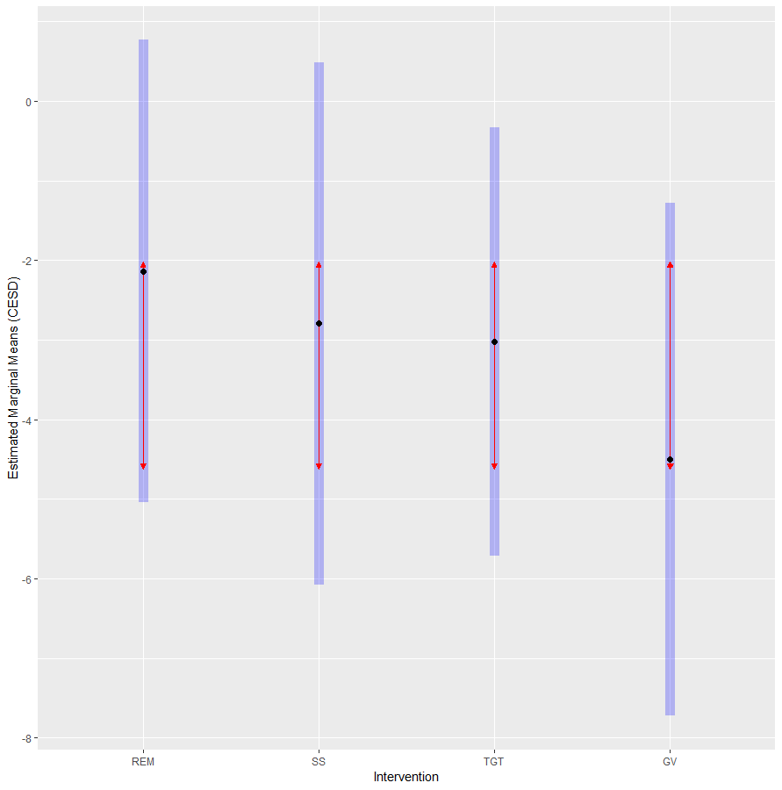

*Figure 1.* Estimated Marginal Means of Changes in Depression Across Different Groups with 95% Confidence Intervals and Comparison Arrows

The black dots in Figure 1 show the marginal means of changes in depression across all four intervention groups. The blue bars represent the 95% confidence intervals of the means for different groups. Since all of the comparison arrows of SS, TGT, and GV overlap greatly with the arrow of REM, there is no significant difference between any of the three experimental conditions and the control condition on the effect of depression reduction.

**Task 6: An APA Table for CES-D output**

Table 5

*Differences of Changes from the Control Group in Depression measured by CES-D*

|  |  |  |  |  |  |  |
| --- | --- | --- | --- | --- | --- | --- |
|  |  |  |  |  | 95% C.I. | |
| Variables | *M* | *SD* | *t(*135*)* | *p* | *LL* | *UL* |
| Treatments |  |  |  |  |  |  |
| REM – SS | 0.658 | 2.21 | 0.297 | 0.7669 | -3.72 | 5.04 |
| REM – TGT | 0.888 | 2.00 | 0.444 | 0.6581 | -3.07 | 4.85 |
| REM – GV | 2.365 | 2.19 | 1.078 | 0.2830 | -1.97 | 6.70 |

Application #1: ANOVA

Put the research question here. Use one or two sentences. Information comes from slide #7 of the handout.

**Methods**

**Participants**

Indicate the number of participants in the study. The information comes from slide #23.

**Instruments**

Indicate the variables and instruments used. Provide a description with whatever is provided in the handout from slide #20 and #23.

**Procedure**

Indicate that the data were provided by Tabachnick & Fidell (2007). Indicate what analyses were done using information from the handout. Please make sure you indicate the procedures used to evaluate the requirREMents of the analysis. No results are indicated here; just the criteria for evaluating the analyses. Indicate that IBM SPSS v.25 was used for the analysis.

**Results**

This is where you indicate the results. Start with the descriptive statistics in the first paragraph. Refer to Table 1 (which comes from slide #23) and offer some comments. Copy the descriptive statistics table from the SPSS output or the handout (slide #23) and paste into Table 1 located at the end of this paper. In the narrative, please include an overview of what the reader should notice about the sample sizes, means, and standard deviations.

Put here the results of evaluating the statistical requirREMents for the ANOVA here. Do not go into a narrative of each step – just present the results. Information comes from slides #25, #26 & 28.

The next paragraph presents the overall findings of the ANOVA. This means cutting-and-pasting the ANOVA source table from slide #31 of the presentation to Table 2. Make sure you interpret and comment on the statistical information presented. Additionally, cut-and-paste the graph showing the interaction results from slide #32 to Figure 1. Please make sure the figure is placed above the figure caption as required by APA format.

The next paragraph presents the follow-up results of the ANOVA represented by the follow-up analyses done and shown on slides #45, #48, and #49. Cut-and-paste the tables from these slides to Table 3. Make sure that you interpret and comment on the components of the analysis.

**Discussion**

Provide a recap of the results in a couple of sentences using a narrative.

Indicate what you have learned with by this assignment.

Provide any feedback and/or questions to the instructor.

References

Tabachnick, B. G. & Fidell, L. S. (2007). *Using multivariate statistics* (5th Ed.). Boston, MA: Pearson, Allyn & Bacon.

Table 1

*Descriptive Statistics*

[Add table from slide #23 from the ppt here]Table 2

*ANOVA Source Table*

[Add the table from slide #31 from ppt]

Table 3

*Source Tables of Simple Effects*

[Add table from slides #45, #48, & #49 from ppt]

[Add figure from slide #32 of ppt]

*Figure 1.* Interaction of Religious Affiliation and REMployment Status on Attitude toward Use of Drugs