Lab 06: Two-way ANOVA

Zhuqian (Karen) Zhou

Teachers College, Columbia University

**Task 1: Two-way ANOVA Source Tables**

Table 1

*Two-Way Analysis of Variance in the post-treatment Depression score measure by MMPI in thp1*

|  |  |  |  |  |  |
| --- | --- | --- | --- | --- | --- |
| Source | Sum of Squares | *df* | Mean Square | *F* Ratio | *p* |
| Severity | 1181 | 2 | 590.500 | 21.14 | 8.4e-07** |
| Therapy | 205 | 2 | 102.500 | 3.67 | .036* |
| Severity × Therapy | 14 | 4 | 3.500 | 0.13 | .972 |
| Error | 1005 | 36 | 27.917 |  |  |

\**p < .05. **p < .01.*

Table 2

*Two-Way Analysis of Variance in the post-treatment Depression score measure by MMPI in thp2*

|  |  |  |  |  |  |
| --- | --- | --- | --- | --- | --- |
| Source | Sum of Squares | *df* | Mean Square | *F* Ratio | *p* |
| Severity | 357 | 2 | 148.500 | 6.67 | .003** |
| Therapy | 46 | 2 | 23.000 | 0.82 | .446 |
| Severity × Therapy | 523 | 4 | 130.750 | 4.66 | .004** |
| Error | 1011 | 36 | 28.083 |  |  |

\**p < .05. **p < .01.*

According to Table 1 and Table 2 above, there is no evidence of significant interaction between the baseline depression severity and types of therapy in the *thp1* dataset while such an interaction is significant in the *thp2* dataset. Interaction plots will be shown below to further demonstrate it.

**Task 2: Interaction Plots**

Figure 1 and 2 show how baseline depression severity and types of therapy interact on the participants’ post-treatment depression scores.

In Figure 1, the effectiveness of different therapies on reducing depression is relatively consistent across baseline depression severity levels. Given the same baseline severity level, the average post-treatment depression scores in the CBT group are the lowest among the three types of therapy while the mean depression scores in the Rogerian group are the highest or very closed to the highest among the three. Therefore, the interaction plot shows no significant interaction between the baseline depression severity and types of therapy in the *thp1* dataset, which aligns with the result in Table 1.

In Figure 2, we can tell that CBT is most effective for people with severe baseline depression while assertiveness training is most effective for people with mild baseline depression. When participants have moderate baseline depression, CBT and assertiveness training are almost equally effective. As such, the interaction between baseline depression severity and types of therapy on the post-treatment depression scores is quite significant in the *thp2* dataset.

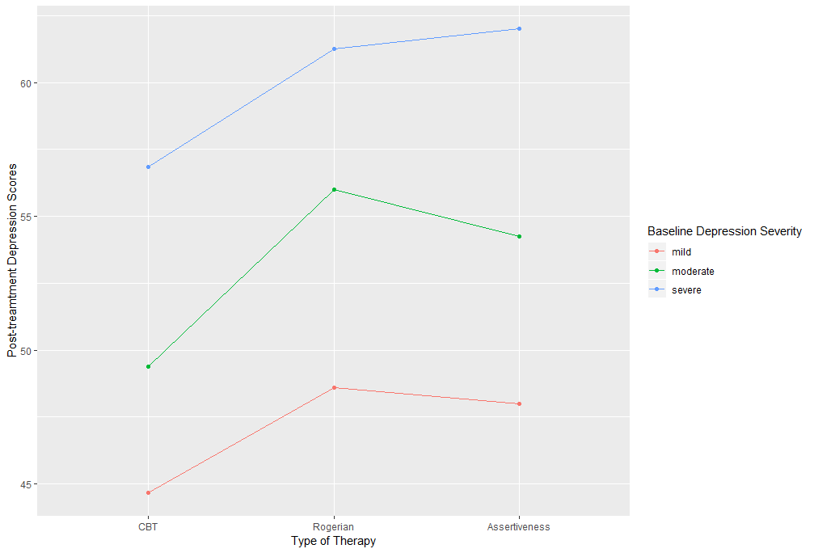

*Figure 1.* Interaction Plot for *thp1*

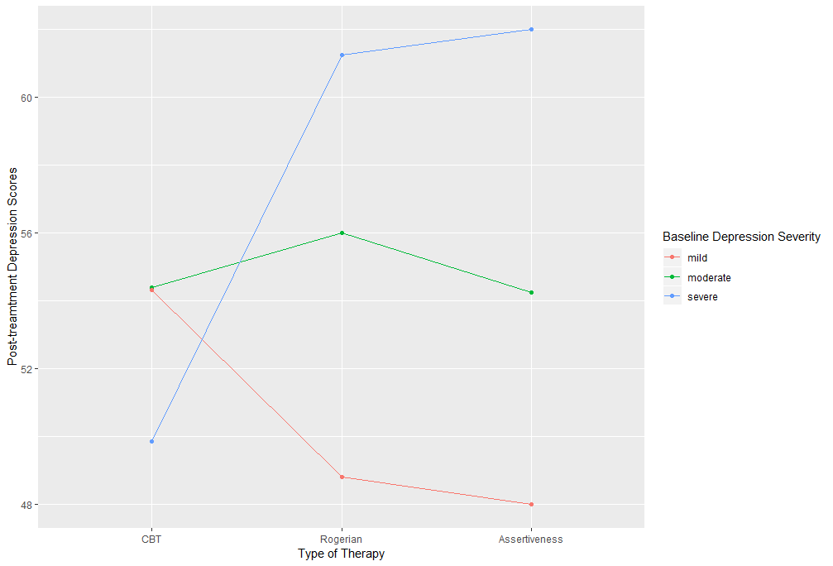

*Figure 2.* Interaction Plot for *thp2*

**Task 3 & 4: Simple or Main Effects and Pairwise Comparisons**

Since there is no significant interaction in *thp1* but in *thp2*, we will calculate main effects of therapy in the former dataset and simple effects of therapy in the latter dataset to quantify their impacts on depression respectively and conduct the pairwise comparisons on this basis.

In the *thp1* dataset, test if the average post-treatment depression scores differs among the three treatment groups across different baseline depression severities.

*H0: µ1 = µ2 = µ3*

*H1: µ1 ≠ µ2 or µ1 ≠ µ3 or µ2 ≠ µ3*

Statistics in Table 1 has shown that the effect of therapy on post-treatment depression scores was significant, *F*(2,36) = 3.67, *p =* .036. Therefore, pairwise comparisons need to be conducted to locate the exact between-group differences.

Test which pair(s) had different post-treatment depression scores among the three treatment groups.

*H0a: µ1 = µ2 H0b: µ1 = µ3 H0a: µ2 = µ3*

*H1a: µ1 ≠ µ2 H1b: µ1 ≠ µ3 H1a: µ2 ≠ µ3*

Table 3

*Pairwise Differences of the Main Effects of Three Types of Therapies on Post-treatment Depression score*

|  |  |  |  |  |
| --- | --- | --- | --- | --- |
| Contrasts | *M* | *SE* | *t(*36*)* | *p* |
| Treatments |  |  |  |  |
| CBT – Rogerian | -4.975 | 2.00 | -2.484 | .018* |
| CBT – Assertiveness | -4.442 | 2.00 | -2.218 | .033* |
| Rogerian – Assertiveness | 0.533 | 1.96 | 0.273 | .767 |

\**p < .05. **p < .01.*

Table 3 shows that the average post-treatment depression score of those who received the CBT therapy was significantly lower than the other two groups which received the Rogerian therapy, *t*(36) = -2.484, *p* = .018, or assertiveness training, *t*(36) = -2.218, *p* = .033, while there was no significant difference between the Rogerian therapy and the assertiveness training, *t*(36) = 0.273, *p* = .767.

In the *thp2* dataset, test if the average post-treatment depression scores differs among the three treatment groups at each level of baseline depression severity.

*Severity = mild Severity = moderate Severity = severe*

*H0a: µ1 = µ2 = µ3 H0b: µ1 = µ2 = µ3  H0c: µ1 = µ2 = µ3*

*H1a: µ1 ≠ µ2 H1b: µ1 ≠ µ2 H1c: µ1 ≠ µ2*

*or µ1 ≠ µ3 or µ1 ≠ µ3 or µ1 ≠ µ3*

*or µ2 ≠ µ3 or µ2 ≠ µ3 or µ2 ≠ µ3*

F-tests showed that the effect of therapy on post-treatment depression scores was significant when the baseline depression is severe, *F*(2,36) = 10.306, *p <* .001, while there were no significant treatment effects when the baseline depression is mild, *F*(2,36) = 1.475, *p =* .242, or moderate, *F*(2,36) = 0.179, *p =* .837. Therefore, pairwise comparisons need to be conducted on the condition of severe baseline depression.

Test which pair(s) had different post-treatment depression scores among the three treatment groups when the baseline depression is severe.

*H0a: µ1 = µ2 H0b: µ1 = µ3 H0a: µ2 = µ3*

*H1a: µ1 ≠ µ2 H1b: µ1 ≠ µ3 H1a: µ2 ≠ µ3*

Table 4

*Pairwise Differences of the Simple Effects of Three Types of Therapies on Post-treatment Depression Score on the Condition of Severe Baseline Depression*

|  |  |  |  |  |
| --- | --- | --- | --- | --- |
| Contrasts | *M* | *SE* | *t(*36*)* | *p* |
| Treatments |  |  |  |  |
| CBT – Rogerian | -11.39 | 3.32 | -3.430 | .0015** |
| CBT – Assertiveness | -12.14 | 2.95 | -4.119 | .0002** |
| Rogerian – Assertiveness | -0.75 | 3.42 | -0.219 | .8277 |

\**p < .05. **p < .01.*

Table 4 shows that when the baseline depression is severe, the average post-treatment depression score of those who received the CBT therapy was significantly lower than the other two groups which received the Rogerian therapy, *t*(36) = -3.430, *p* < .01, or assertiveness training, *t*(36) = -4.119, *p* < .01, while there was no significant difference between the Rogerian therapy and the assertiveness training, *t*(36) = -0.219, *p* = .8277.

**Task 5: Summary**

To summarize, in the *thp1* dataset, the CBT treatment led to significantly lower depression level after the intervention compared to the Rogerian therapy and the assertiveness training across all baseline depression levels. Besides, in the *thp2* dataset, the significant effect of the CBT treatment compared to the other two therapies was only found in the group with severe baseline depression. No other significant differences were found between treatments in either dataset.

**Appendix**

*R codes for Lab 06*

load("Lab_06_therapy.Rdata")

options(contrasts=c("contr.sum", "contr.poly"))

thp1$Severity_fac <- factor(x=thp1$Severity,

levels=1:3,

labels=c("mild","moderate","severe"))

thp1$Therapy_fac <- factor(x=thp1$Therapy,

levels=1:3,

labels=c("CBT","Rogerian","Assertiveness"))

thp2$Severity_fac <- factor(x=thp2$Severity,

levels=1:3,

labels=c("mild","moderate","severe"))

thp2$Therapy_fac <- factor(x=thp2$Therapy,

levels=1:3,

labels=c("CBT","Rogerian","Assertiveness"))

lm1 <- lm(formula = MMPI_Depression ~ Severity_fac*Therapy_fac, data = thp1)

lm2 <- lm(formula = MMPI_Depression ~ Severity_fac*Therapy_fac, data = thp2)

#Task 1: Two-way ANOVA Source Tables

library(car)

Anova(lm1, type = 3)

Anova(lm2, type = 3)

#Task 2: Interaction Plots

library(emmeans)

emm1<-emmeans(object = lm1, spec=~Severity_fac*Therapy_fac)

ip1<-emmip(object=emm1, formula = Severity_fac ~ Therapy_fac, xlab=c("Type of Therapy"), ylab=c("Post-treamtment Depression Scores"))

ip1$labels$colour <- "Baseline Depression Severity"

print(ip1)

emm2<-emmeans(object = lm2, spec=~Severity_fac*Therapy_fac)

ip2<-emmip(object=emm2, formula = Severity_fac ~ Therapy_fac, xlab=c("Type of Therapy"), ylab=c("Post-treamtment Depression Scores"))

ip2$labels$colour <- "Baseline Depression Severity"

print(ip2)

#Task 3&4: Simple or Main Effects and Pairwise Comparisons

emm1.m<-emmeans(object = lm1, spec=~Therapy_fac) # main effects of therapy

joint_tests(emm1.m) # similar as Anova(lm1, type = 3) above

pairs(emm1.m, adjust="none")

joint_tests(emm2,by="Severity_fac")

emm2.s<-emmeans(object = lm2, spec=~Therapy_fac|Severity_fac) # simple effects of therapy

pairs(emm2.s, adjust="none")