Ex. No. 7

# DEVELOP A SIMPLE EMAIL AUTOMATION SERVICE USING SALESFORCE

**AIM:**

To develop a simple email automation service using Salesforce.

# PROCEDURE:

1. Log in to Salesforce:

* Open your browser and go to Salesforce and log in with your credentials.

1. Go to Setup:

* Click the Setup gear icon at the top-right of the Salesforce interface and select Setup.

1. Open Flow Builder:

* In the left-hand menu, search for Flow using the Quick Find box.
* Click on Flows under Process Automation.

1. Create a New Flow:

* Click on New Flow.
* You will be prompted to choose the flow type. Select Record-Triggered Flow to start the automation when a record is created or updated.
* Click Create.

1. Configure Trigger:

* Select the Object you want to trigger the flow for (e.g., Lead, Account, Contact, etc.).
* Choose whether to trigger the flow when a record is created, updated, or created or updated.
* Set the condition that triggers the email (e.g., when a lead's status is set to "Qualified").

1. Add an Action (Send Email):

* In the Flow Builder, click the + icon to add an element.
* From the menu, select Action.
* In the Action type, search for Send Email.
* You will need to configure:
* Recipient: Choose the email field from the record (e.g., Lead's email). o Email Template: Select an existing template or create a new one.
* From Address: Choose an appropriate "From" email address (either system email or a user’s email). If Send Email is not directly available, you'll need to create an Email Alert first.

1. (Optional) Create an Email Alert:

* If Send Email doesn't appear in the action list, go to Setup > Email Alerts.
* Click New Email Alert, give it a name, and select:
* Object: The same object as in the Flow (e.g., Lead).
* Email Template: Choose a predefined template or create a new one.
* Recipient: Add who will receive the email (e.g., the Lead’s email).
* After creating, go back to your Flow and choose Send Email using this Email Alert.

1. Activate and Save the Flow:

* Once you've configured the email sending action, click Save.
* Click Activate to make the flow live.

1. Test Your Automation:

* To ensure your automation works, create a new lead or update an existing record based on the criteria you've set in the flow.
* Check the recipient’s inbox to confirm the email is sent.

# OUTPUT:

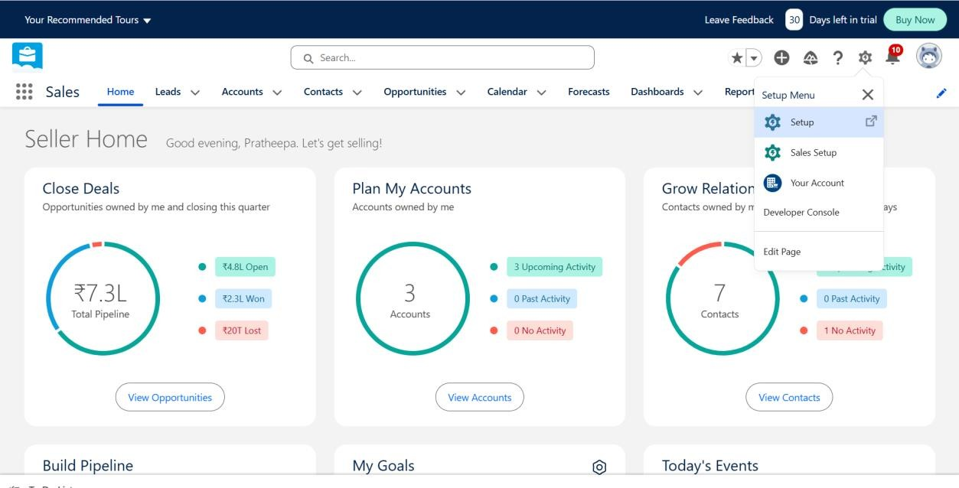

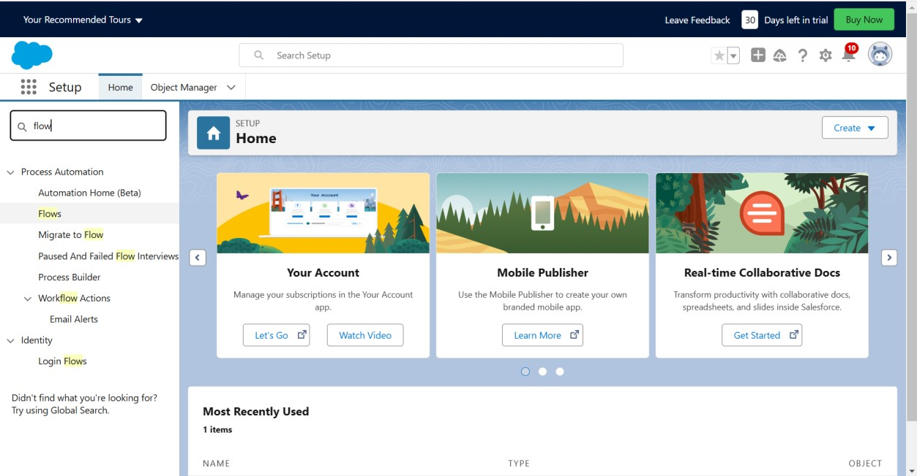

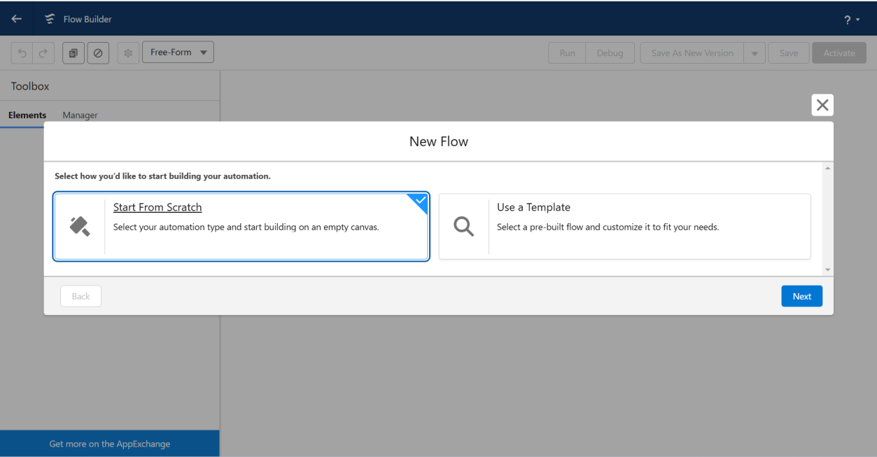

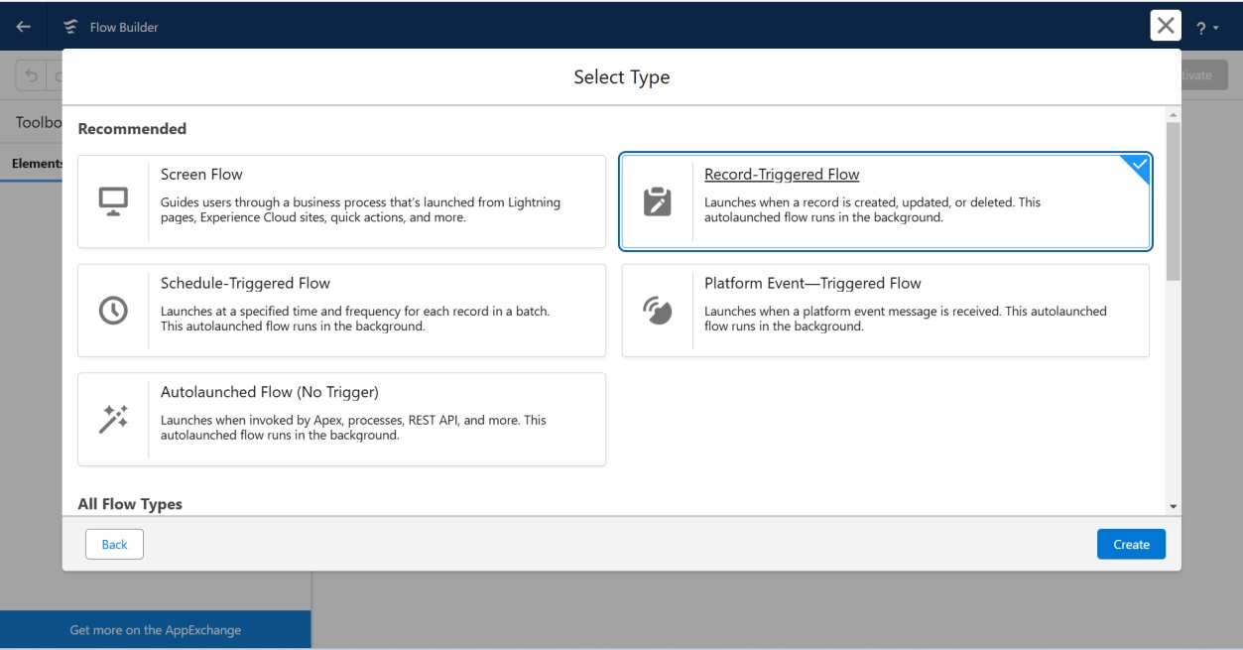

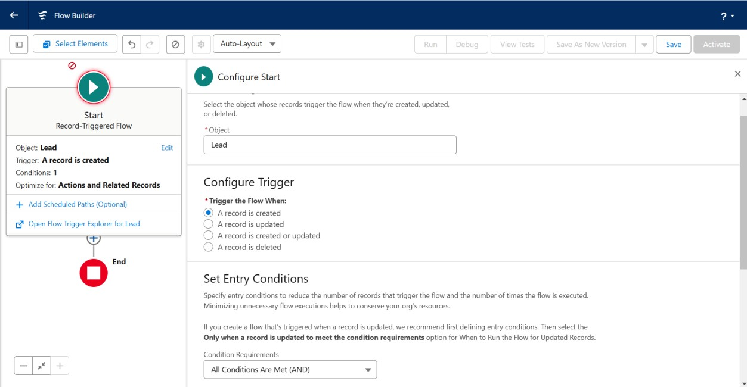

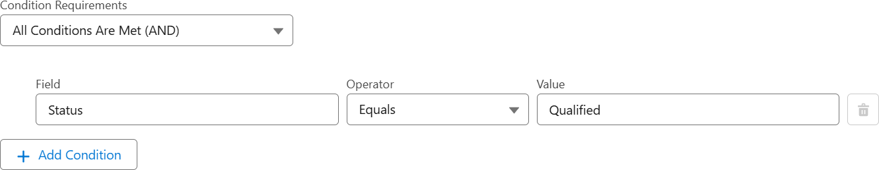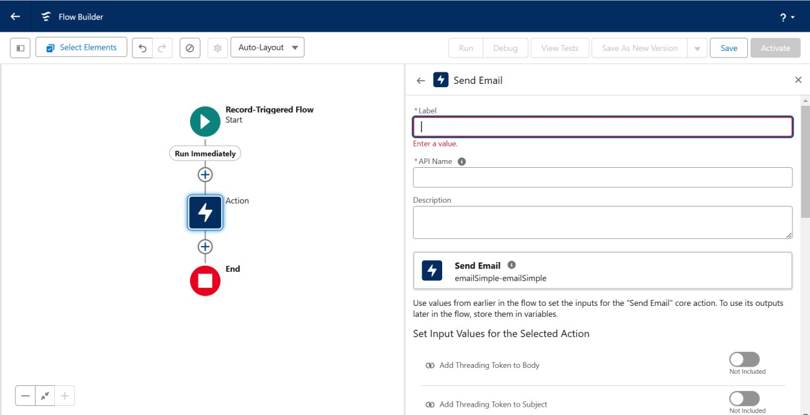

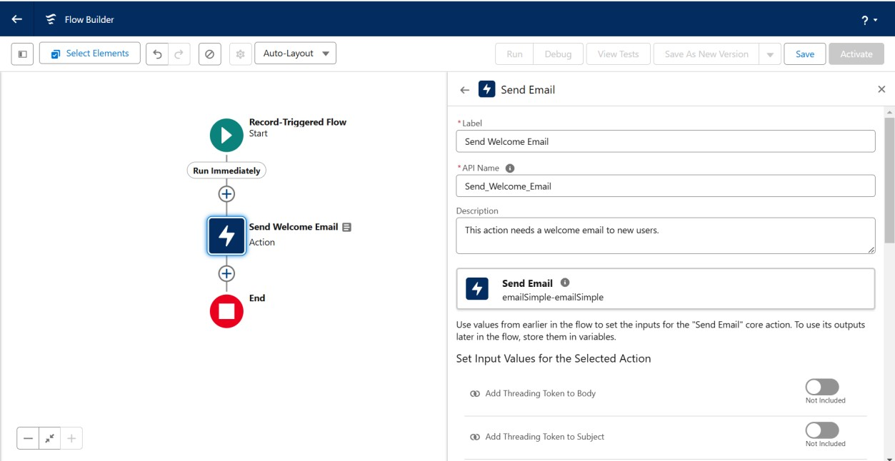

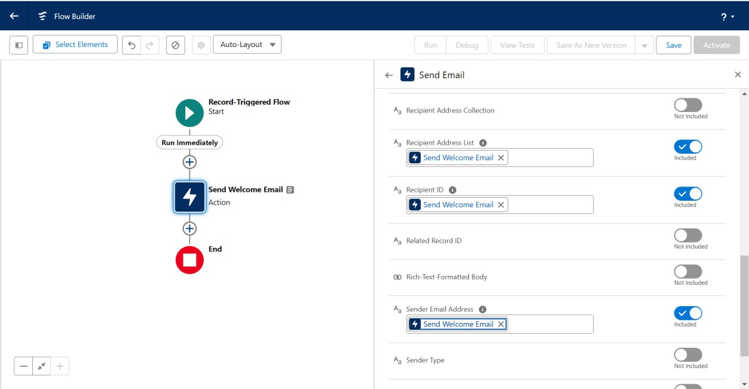

**RESULT:**

Thus, to develop a simple email automation service using Salesforce was completed successfully.