Ex.No.9

# DEMONSTRATE THE MAP REDUCE PROGRAMMING MODEL BY COUNTING THE NUMBER OF WORDS IN A FILE

**AIM:**

To demonstrate the MAP REDUCE programming model for counting the number of words in a file.

# PROCEDURE:

Open command prompt and run as administrator

Start Hadoop services by typing in the following commands:

* start-dfs.cmd
* start-yarn.cmd

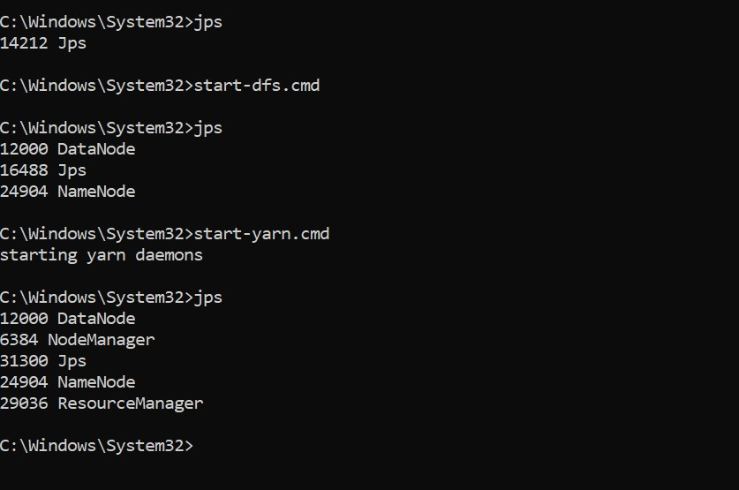

Open the browser and go to the URL localhost:9870

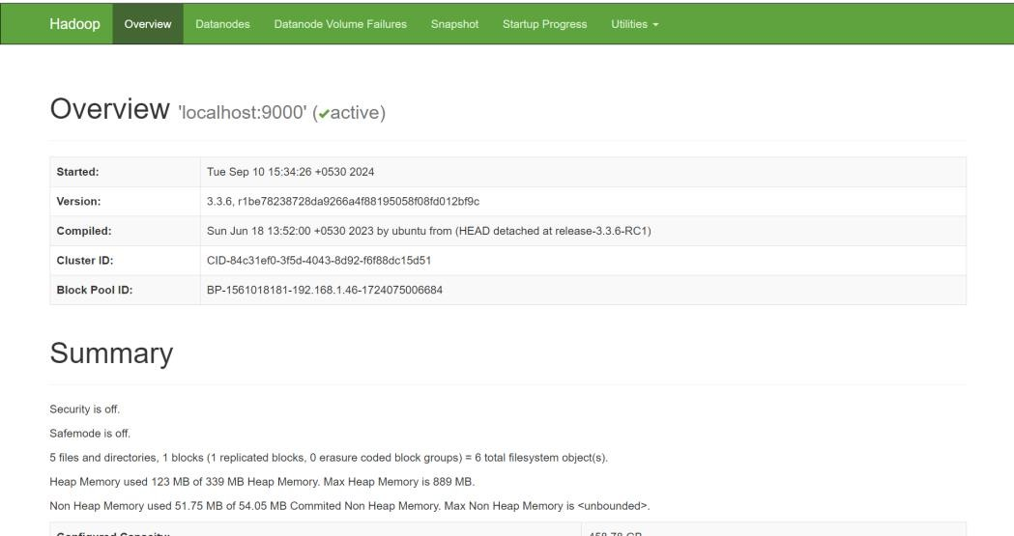

Create a directory in HDFS using the command: hdfs dfs -mkdir -p /user/hadoop/input

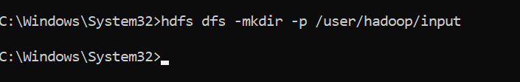

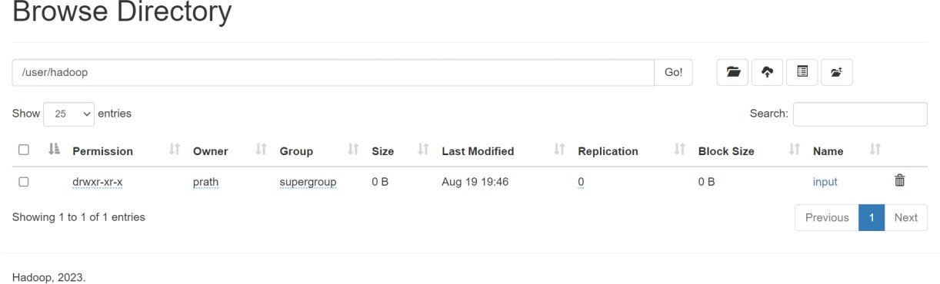

Copy the input file to HDFS using the command:

hdfs dfs -put C:/Semester7/DataAnalytics/Lab/input.txt /user/hadoop/input



Display the contents of the file using this command: hdfs dfs -cat /user/hadoop/input/input.txt



Create mapper.py and reducer.py files mapper.py

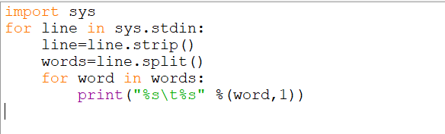

reducer.py

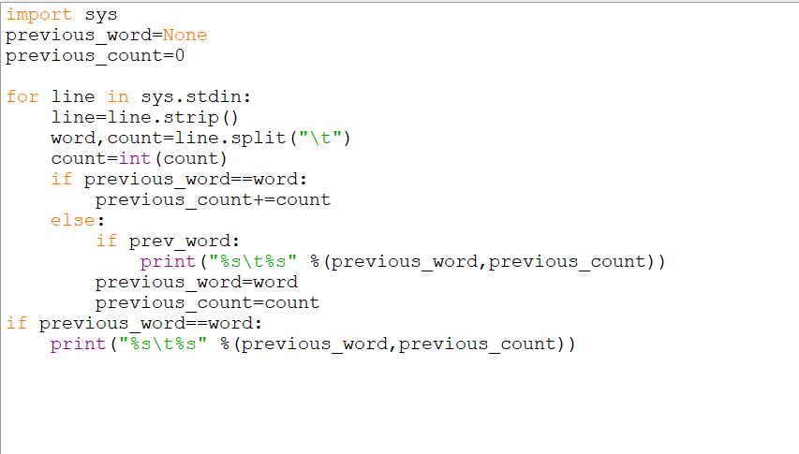

Run the Hadoop Streaming Job and give the file paths to the input, mapper and reducer using the following command:

hadoop jar %HADOOP_HOME%\share\hadoop\tools\lib\hadoop-streaming-

*.jar^

-mapper "python C:\Semester7\DataAnalytics\Lab\Ex.2\mapper.py" -reducer "python C:\Semester7\DataAnalytics\Lab\Ex.2\reducer.py"^

-input /user/hadoop/input/input.txt -output /user/hadoop/output

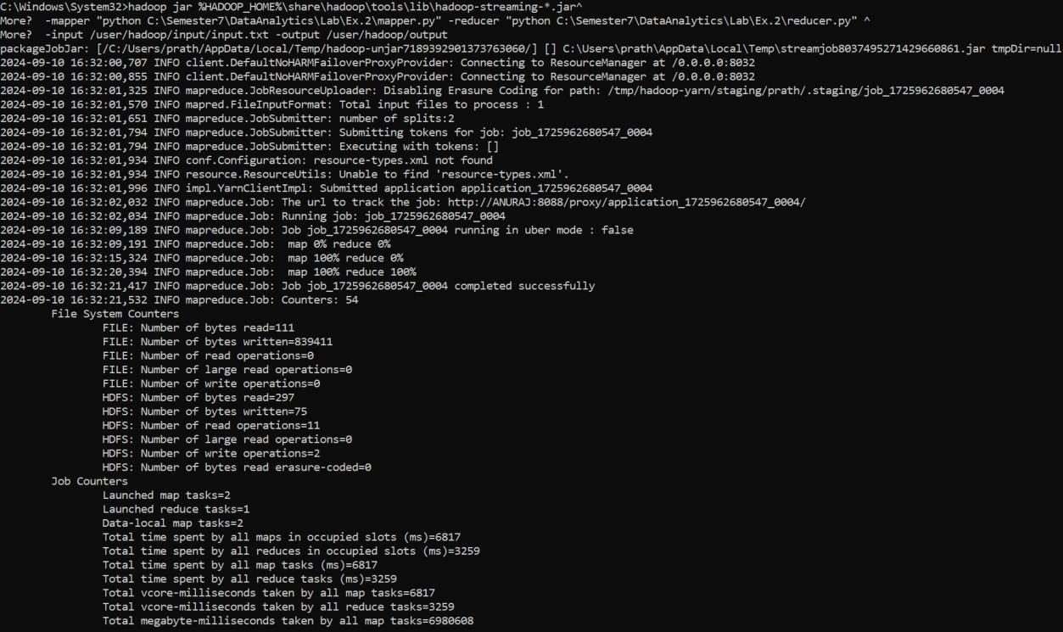

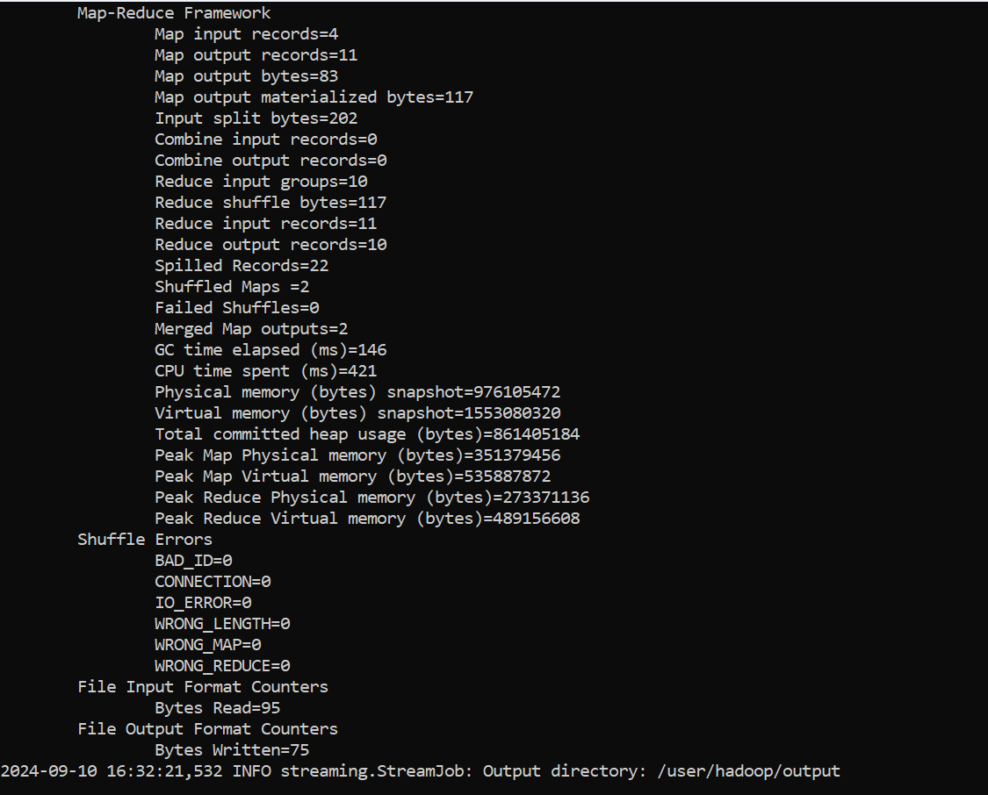

View the output using the command:

hdfs dfs -cat /user/hadoop/output/part-00000

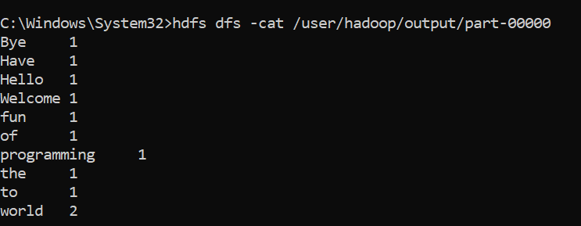

Check the output on the file system in the browser

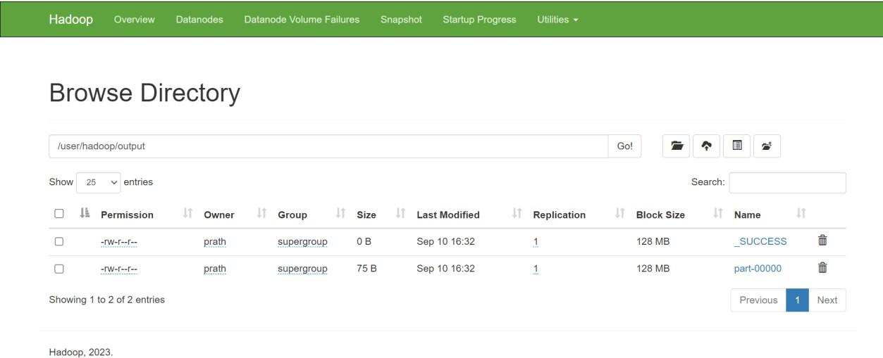

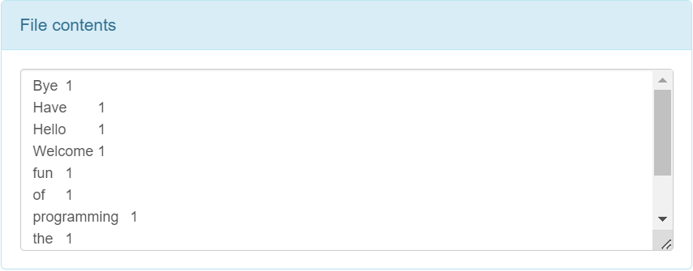

# RESULT:

Thus, to demonstrate the MAP REDUCE programming model for counting the number of words in a file was completed successfully.