Ex.No.10

# IMPLEMENT THE MAPREDUCE PROGRAM TO PERFORM PROCESSING ON TEMPERATURE DATA COLLECTED FROM SENSORS

**AIM:**

To implement a Map Reduce program to perform processing on the temperature data collected from sensors

# PROCEDURE:

Open command prompt and run as administrator

Start Hadoop services by typing in the following commands:

* start-dfs.cmd
* start-yarn.cmd

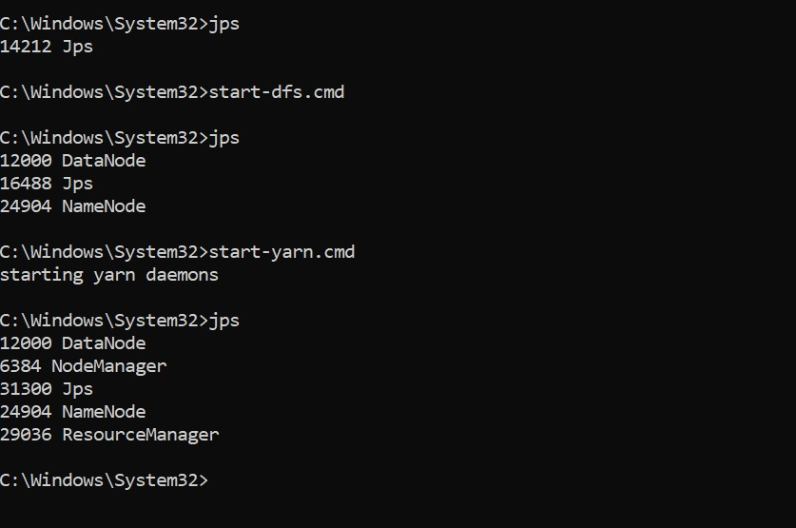

Open the browser and go to the URL localhost:9870

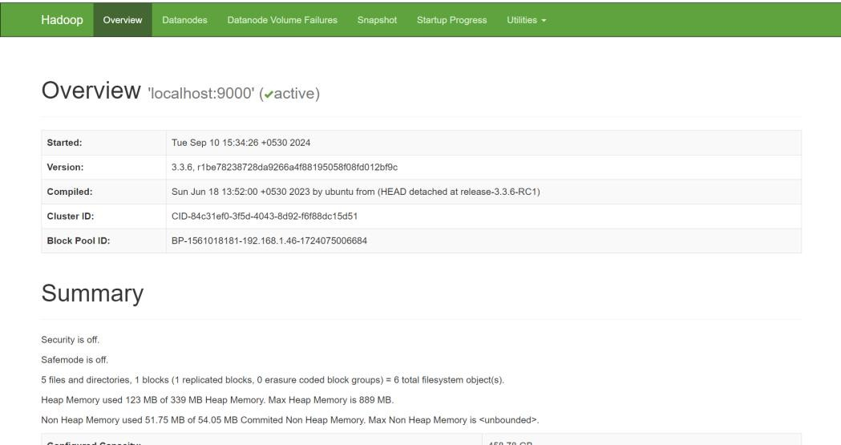

Create a directory in HDFS using the command:

hdfs dfs -mkdir -p /weather/hadoop/input

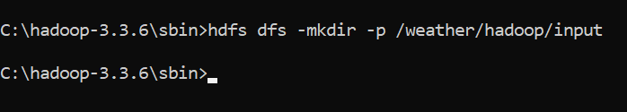

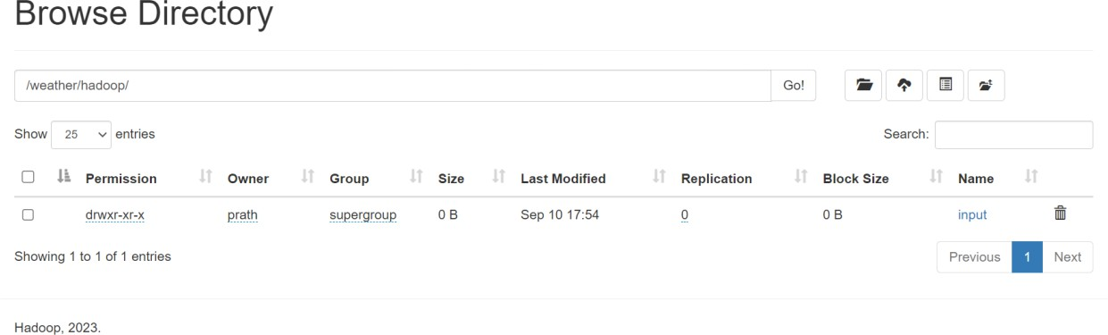

Copy the input file to HDFS using the command:

hdfs dfs -put C:/Semester7/DataAnalytics/Lab/Ex3/sample_weather.txt

/weather/hadoop/input



Display the contents of the file using this command: hdfs dfs -cat /weather/hadoop/input/sample_weather.txt

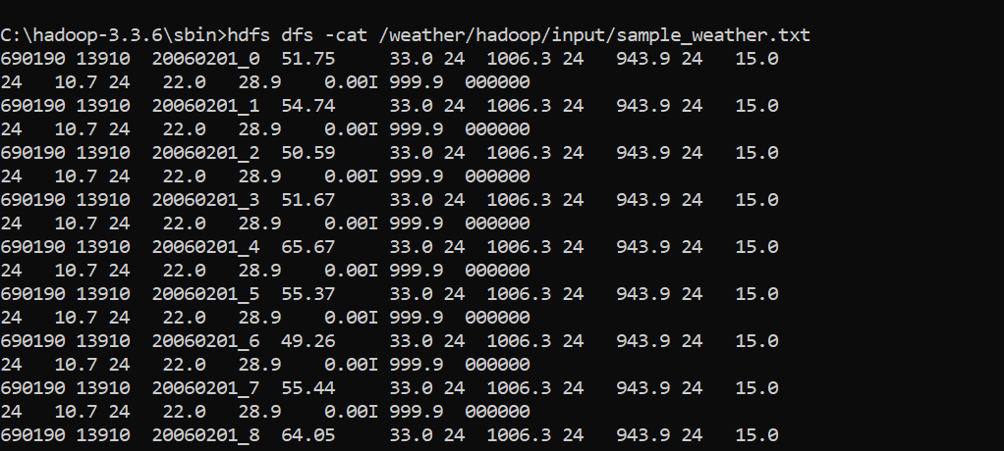

Create mapper.py and reducer.py files mapper.py

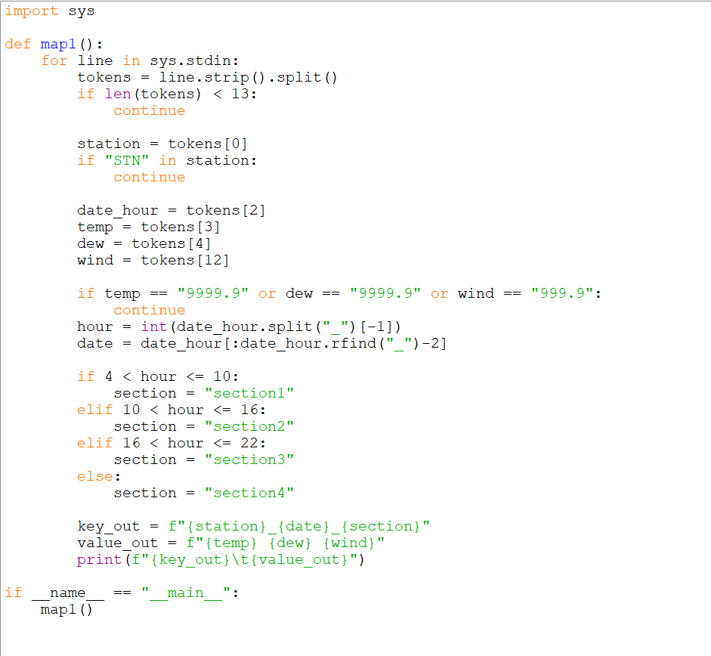

reducer.py

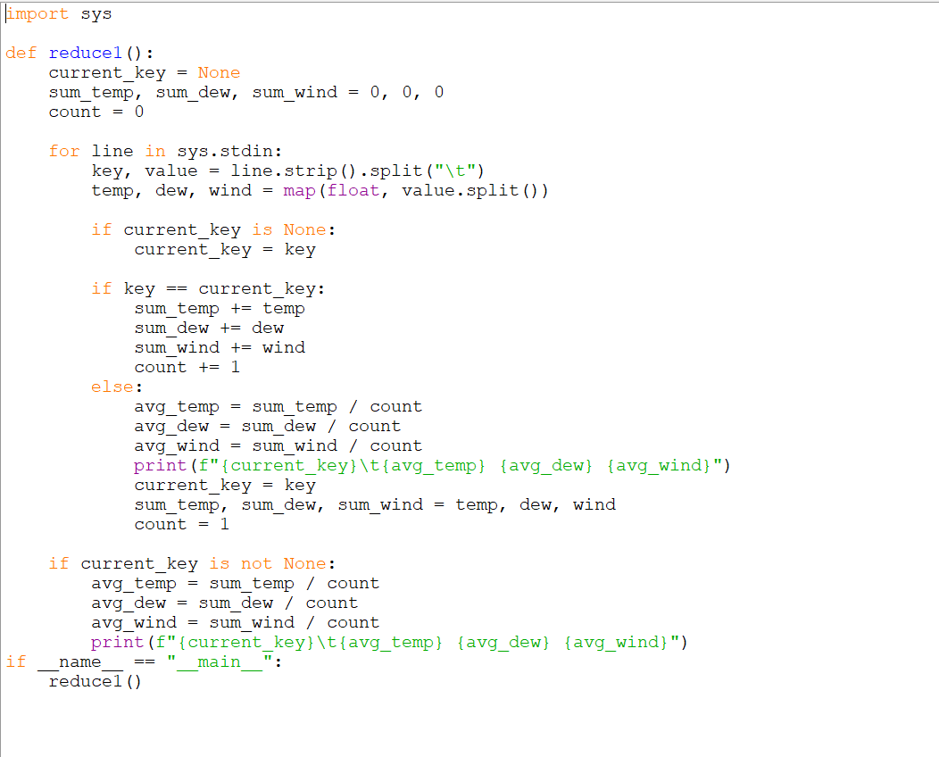

Run the Hadoop Streaming Job and give the file paths to the input, mapper and reducer using the following command:

hadoop jar %HADOOP_HOME%\share\hadoop\tools\lib\hadoop-streaming-

*.jar^

-mapper "python C:\Semester7\DataAnalytics\Lab\Ex3\mapper.py" -reducer "python C:\Semester7\DataAnalytics\Lab\Ex3\reducer.py"^

-input/weather/hadoop/input/sample_weather.txt -output /weather/hadoop/output

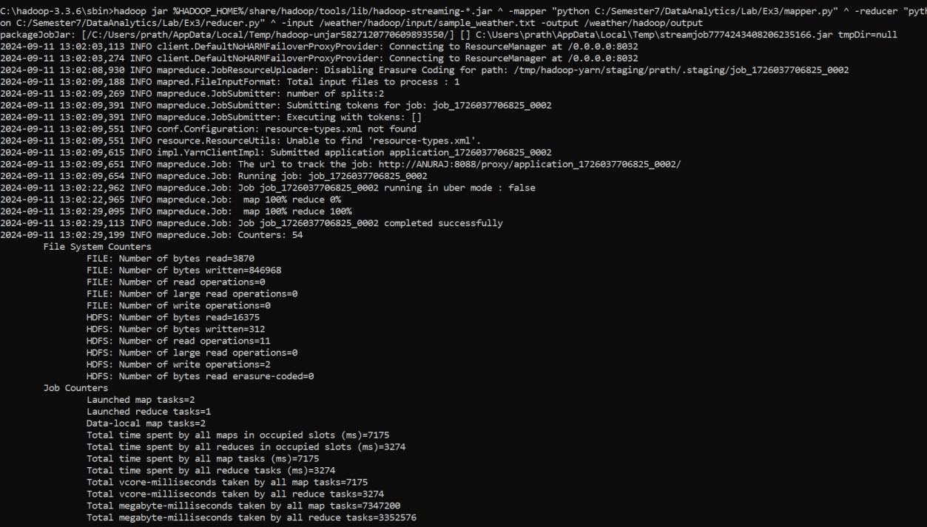

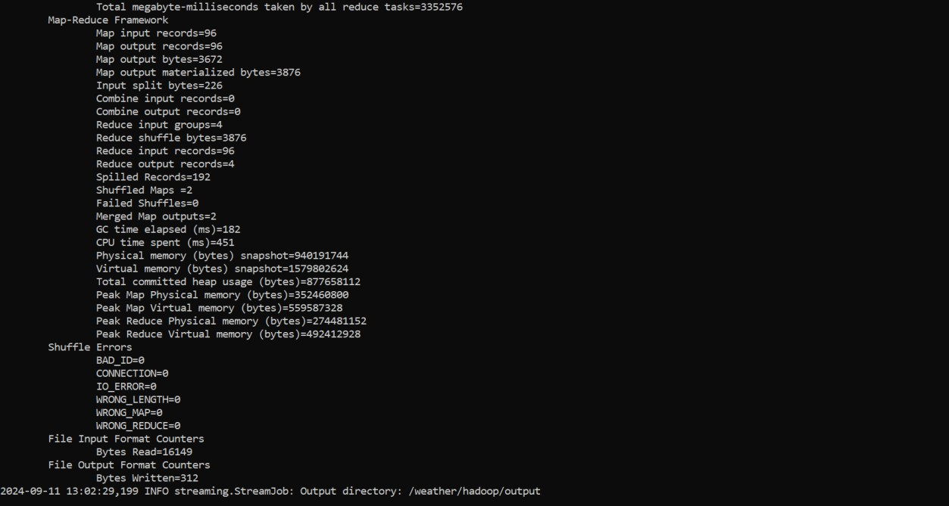

View the output using the command:

hdfs dfs -cat /weather/hadoop/output/part-00000

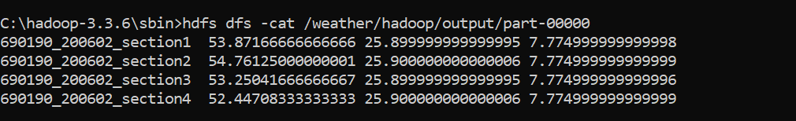

View the output on the file system in browser

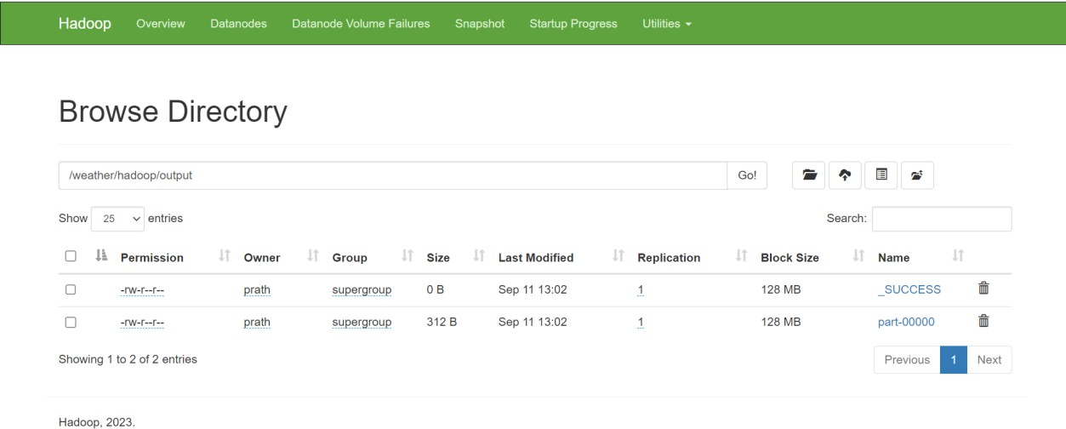

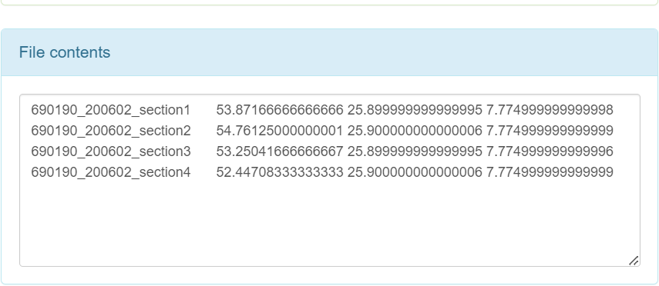

# RESULT:

Thus, to implement the Map Reduce program to perform processing on the temperature data collected from sensors was completed successfully.