**ONLINE BUS TICKET MANAGEMENT**

**Contents Page No:**

1) Introduction …………………………………………………………………………….01

2) Project Management……………………………………………………………………01

3) System Development Life Cycle………………………………………………………01

4) Use case:

a. Home…………………………………………………………………………….02

b. Login Page………………………………………………………………………02

c. Booking Page……………………………………………………………………03

d. Contact Page…………………………………………………………………….05

e. Offers Page……………………………………………………………………....05

e. Safety Page………………………………………………………………………06

f. Services Page…………………………………………………………………….06

5) Admin Page………………………………………………………………………………04

1) **Introduction**

In our country traveling from one place to another is quite a hassle. One has to go through a lot of trouble to book a ticket especially during occasion or vacations. Every one need to lineup to book a ticket in order to travel. Even waiting all night is not considered during these times. To remove these problems we need a better and efficient way to book tickets. Our online booking system is built specifically to conquer these problem. Anyone can book ticket through our software at the ease of their home. They can book when they want, see what time the bus travels, the schedule & the routes. It is also made user friendly so anyone can adapt to this system easily.

2) **Project management**

Project management skills are put to good use for this project. Having gone through project Management modules in Time Series Analysis, Optimization with proper planning and executing the project went very smoothly. Project management focuses on achieving the objectives by applying five processes presented in Figure below.



Figure 2.1: Project development phase

**System Development Life Cycle**

Systems Development Life Cycle (SDLC) is the most common process adopted to develop a project and not surprisingly, this project is following this model too. To be precise, waterfall model is being applied. Waterfall model is a sequential model process where the input of a phase actually results from the previous phase.

Phase4: Developing

Phase2: Analyzing

Phase1: Planning

Phase5: Testing

Phase3: Designing

**HOME PAGE:**

The general use case of the software is given bellow

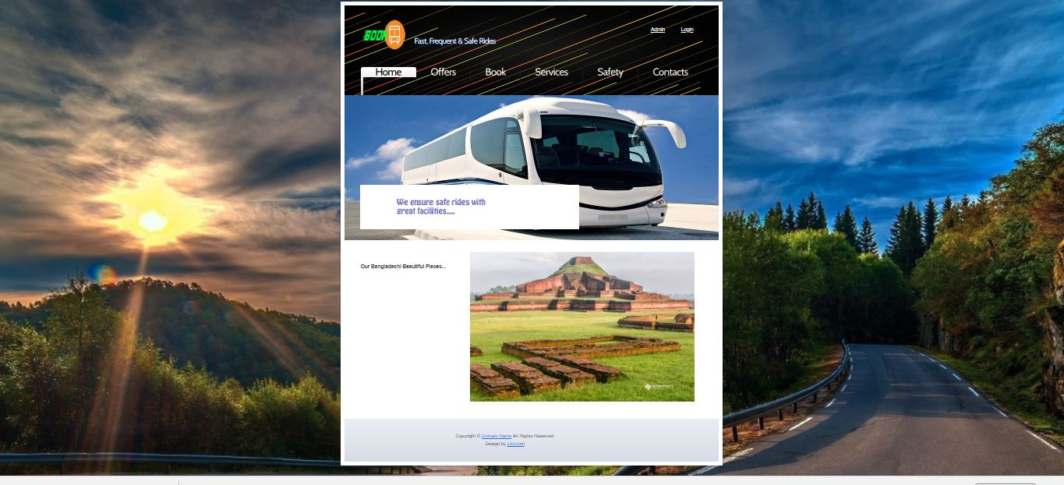

When a user Enters our software they first comes to the Home page. From here the user can navigate through the menu bar to other pages

**LOGIN PAGE:**

On the top right corner the on the top right corner the login option is available. The user simply has to provide some basic information in order to register .Any registered user can also login from this login option is available. The user simply has to provide some basic information in order to register . Any registered user can also login from this page.

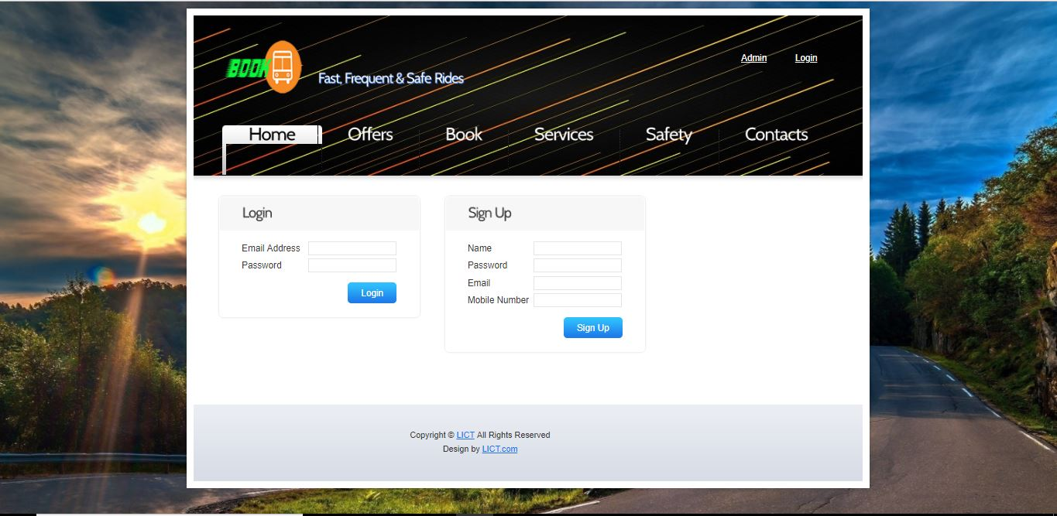

**BOOKING PAGE:**

Once the user has logged in they are applicable for booking tickets for available busses. They simply has to go to the booking option and fill in the information on the right side of the page.

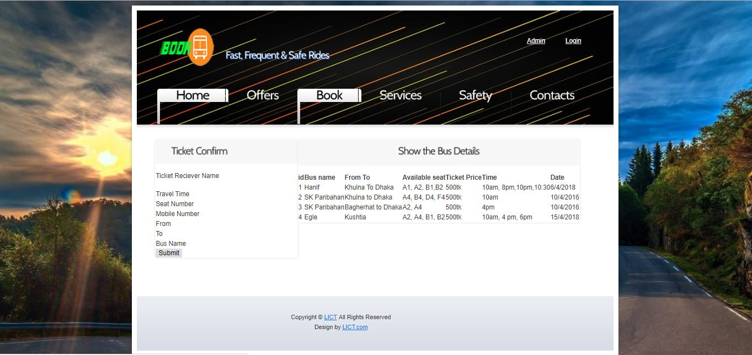

After booking for tickets a message will show the user that their request has been recorded.

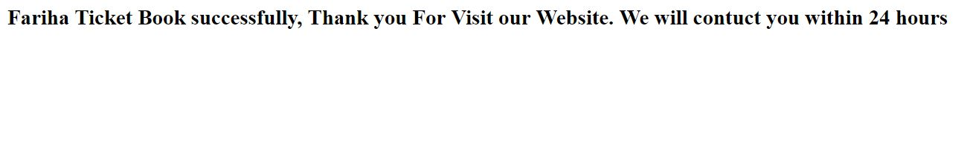

**ADMIN PAGE**:

This recorded requests can only be accessed by the Admin

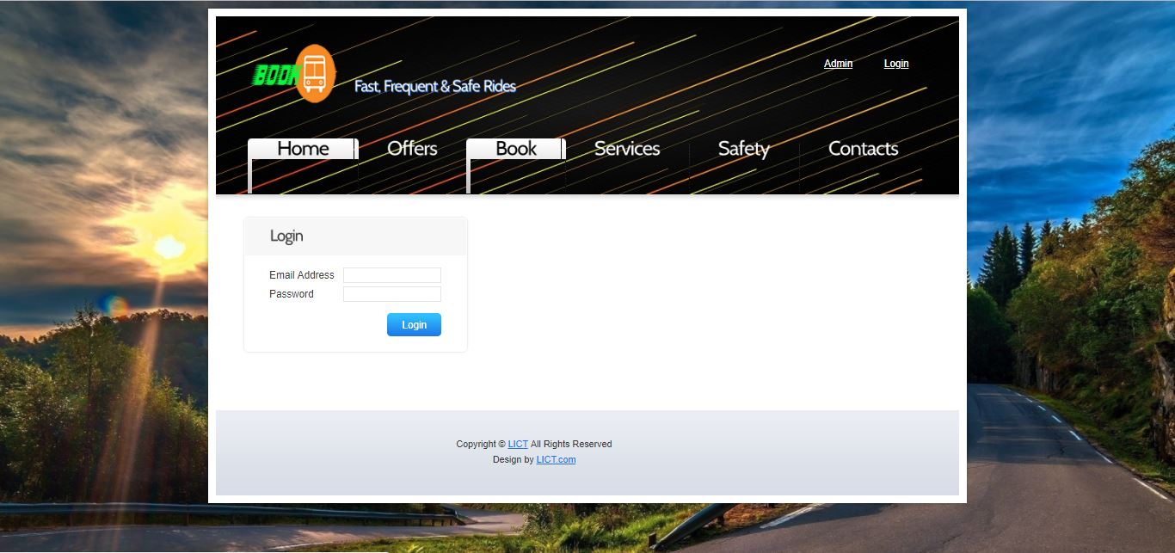

The admin will contact the requester to confirm booking and money transaction. If the user does not wish to proceed to confirming the ticket the admin can delete the request for booking.

Email Address: Admin, Password:123456

We have fixed Admin Email and Password. Because we think if we make signup option for Admin, Anyone will try to get Access in Admin Page.

Any changes on the booked ticket can only be done through the admin

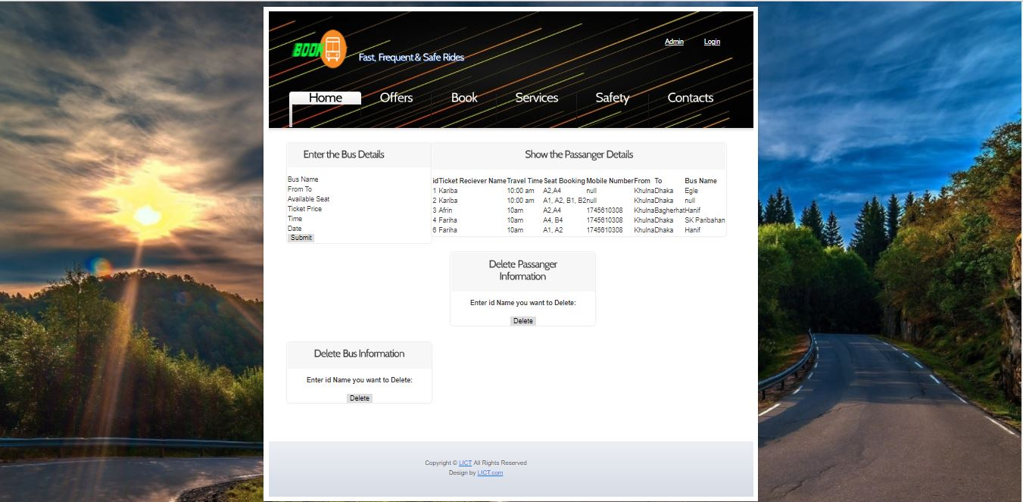

The admin will contact the requester to confirm booking and money transaction. If the user does not wish to proceed to confirming the ticket the admin can delete the request for booking.

**CONTANTS PAGE:**

The users can also file complain r suggestion through the contact page.

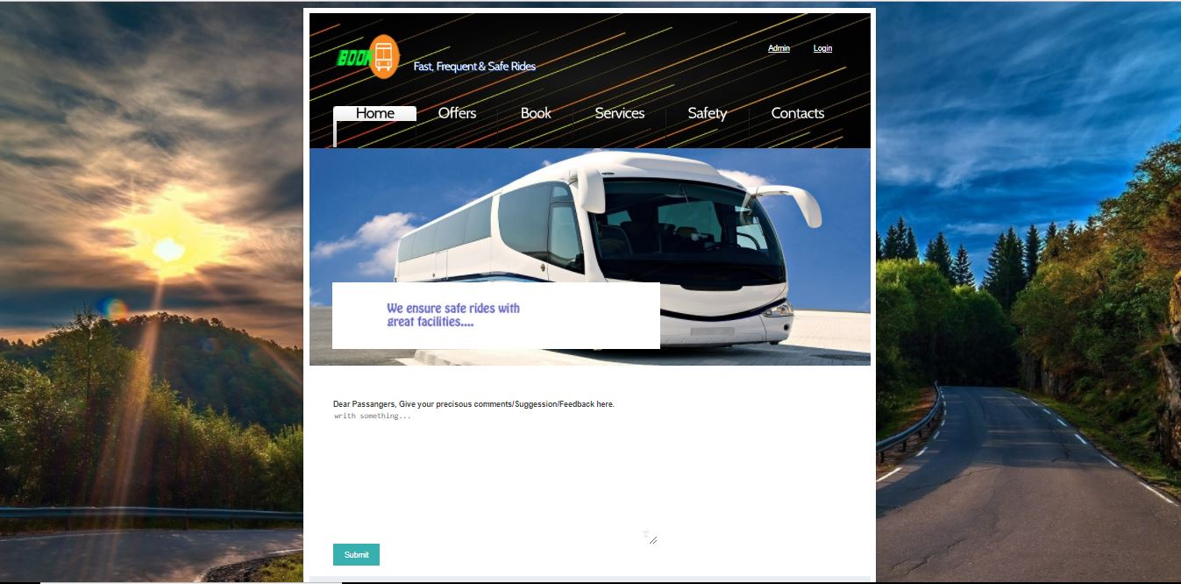

These are recorded for only the admin to see so they can improve their service and fix any error on their end through users feedback.

**OFFRES PAGE**:

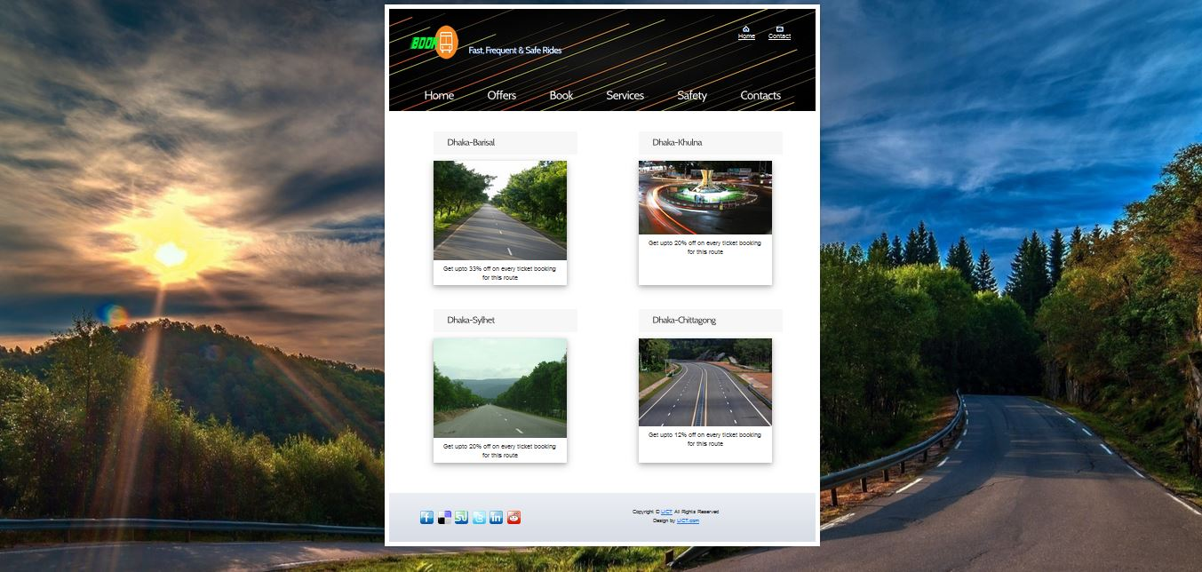

clicking on "offer" Option in the menu bar the user will see this page where they will be shown different offers available from different bus company ,s. Special services and travel packages will also be available here.

**SAFTY PAGE:**

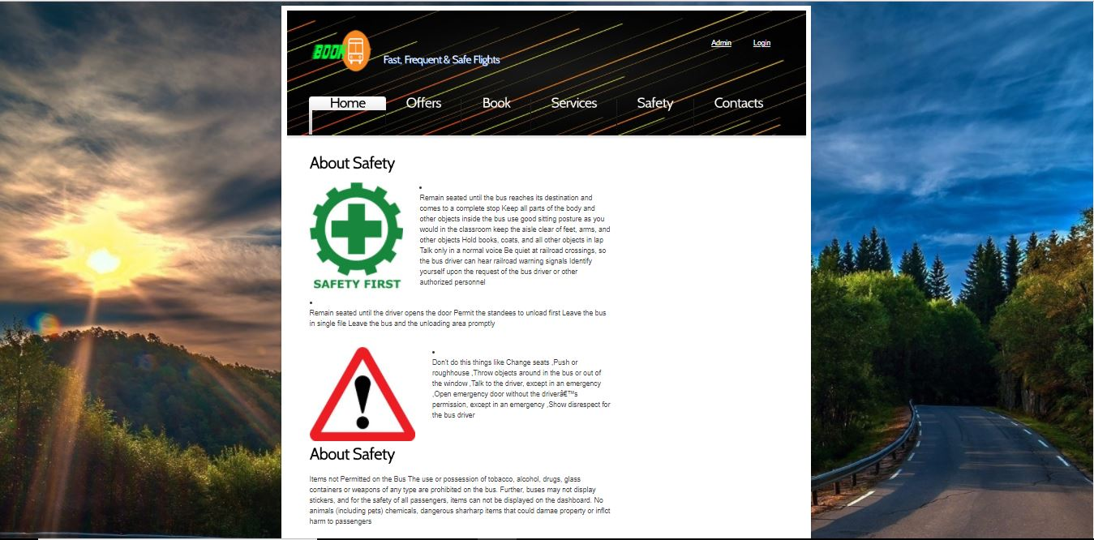

Here user can see all the safety precautions taken in the bus to prevent accidents and what not.

**SERVICES PAGE:**

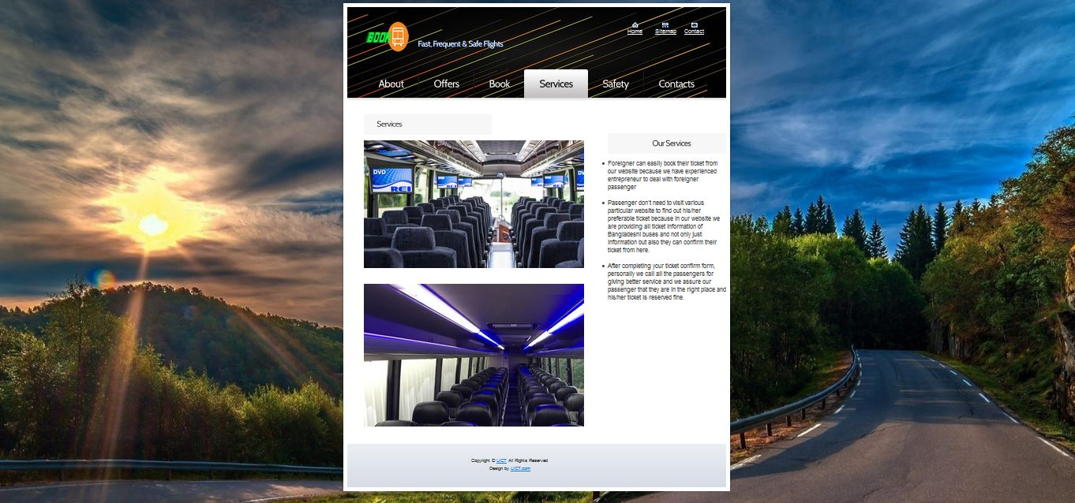

Lots of services here like- food and ,pure drinking water servicing any time. Every bus carries some big box so that bags or other things are safely reached on destination.