 IHG HOSPITALITY
DEPLOYMENT AND OPERATIONS
Deployment Guide

How the Enterprise Hospitality, Restaurant & Food Delivery Management Platform is hosted, configured, released and kept running.

VERSION  1.0 | DATE  4 October 2026
PREPARED FOR  International Hospitality Group | PREPARED BY  Karimul Islam  Batch 26/5  AI-Powered Software Engineering, ICT Bangladesh
LIVE WEBSITE  ihg-hospitality.netlify.app | STATUS  Issued for acceptance review

DOCUMENT CONTROL

About this document
This guide explains how the Enterprise Hospitality, Restaurant & Food Delivery Management Platform is hosted, configured, released and kept running. It is written for the person who takes over the platform after hand-over: someone comfortable with a web dashboard and a terminal, but with no prior experience of these particular services.
Item | Detail
Title | Deployment & Operations Guide
Version | 1.0
Date | 4 October 2026
Status | Issued for acceptance review
Applies to | The release deployed from branch master; database migration e5f1c92b4d73
Companion document | User Manual (guest and staff instructions)

Version | Date | Change
1.0 | 4 October 2026 | First release, covering the live deployment.

How to read this guide
You will see | It means
Note | Background that helps you understand a step.
Tip | A time-saver, or a way to avoid a delay.
Caution | A step where a small mistake is easy to make.
Important | Something that can cause harm or loss if ignored.
Dark code blocks | Commands to type exactly as shown. Text in capitals, such as PASTE_THE_FULL_NEON_CONNECTION_STRING_HERE, is a placeholder you replace.
Dashed screenshot frames | Marked spaces for screenshots, each saying which screen to capture. Hide any secret before saving an image.

Contents
01 | Introduction  What is deployed, where it lives, and who should read what.
02 | Architecture  The five services, how they connect, and why each was chosen.
03 | Before you begin  Accounts, tools and the layout of the repository.
04 | Configuration reference  Every setting the platform reads, and where it is set.
05 | Step-by-step deployment  Database, email, backend and website, in the order to build them.
06 | Verification checklist  Fourteen checks that prove the deployment works end to end.
07 | Operating the platform  Releasing changes, migrations, backups, rollback and key rotation.
08 | Free-plan behaviour  What to expect from free hosting, and how Alice degrades gracefully.
09 | Security and data protection  Secrets, access control, transport security and a launch checklist.
10 | Troubleshooting  Symptoms seen during this project, their causes and fixes.
11 | Limitations and next steps  What is deliberately a demo, and what to change before real use.
A–C | Appendices  Command reference, release checklist and glossary.
CHAPTER 01

Introduction
The platform joins three businesses that normally run separately: a hotel, a restaurant and a food-delivery service. It keeps their records in one place, so a booking, a table, an order and a delivery are all connected to the same guest account. This guide covers the technical side: how that system is put on the internet and looked after.
5  hosted services working together | $0  monthly cost on the free plans used | 1  git push releases a change | HTTPS  on every connection

1.1 Live addresses
Purpose | Address
Public website (guests and staff) | https://ihg-hospitality.netlify.app
Backend API | https://ihg-management-platform.onrender.com
API documentation (interactive) | https://ihg-management-platform.onrender.com/docs
Health check | https://ihg-management-platform.onrender.com/health
Source code | https://github.com/Karim-1211/ihg-management-platform

The first visit can be slow
The free backend sleeps after about 15 minutes without traffic, and the first request after that takes roughly 30 to 60 seconds. Open the website a minute before a demonstration.

1.2 Where to start
Choose by role
Reviewing the deployment: Chapters 2, 6 and 11.
Taking over the code: Chapters 3, 4, 5 and 7.
Running it day to day: Chapters 7, 8 and 10, and Appendix B.
Responsible for data protection: Chapter 9.

CHAPTER 02

Architecture
The platform is made of five hosted services. The website is a static application served by Netlify. It talks to an API running on Render, which keeps its data in a PostgreSQL database on Neon, sends email through Brevo, and calls AI providers for Alice, the concierge. GitHub holds the code and triggers both builds.
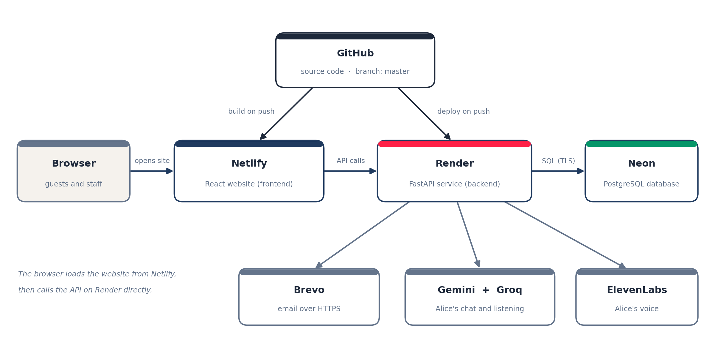
Figure 1 How the hosted services connect

2.1 Components
Component | Technology | Hosted on | Responsibility
Website | React, Vite, Tailwind CSS | Netlify | Everything guests and staff see. Calls the API from the browser.
API | FastAPI (Python 3.12), SQLAlchemy, Alembic | Render web service | Sign-in, roles, bookings, orders, billing, inventory, notifications, business rules and AI orchestration.
Database | PostgreSQL | Neon | All records: users, rooms, bookings, orders, invoices, stock, rules, audit trail.
Email | Brevo transactional API | Brevo | Confirmations, invoices (with PDF attached), welcome emails.
Alice: chat and listening | Gemini, Groq (Whisper) | Provider APIs | Answers questions, and turns speech into text.
Alice: voice | ElevenLabs, then the browser voice | Provider API / browser | Speaks Alice’s replies.
Source and release trigger | Git | GitHub | Single source of truth. A push to master starts both builds.

2.2 How one request travels
- The guest opens the website. Netlify serves the pre-built pages.
- The page asks the API for data, using the address stored in VITE_API_URL at build time.
- The API checks the guest’s login token, applies the business rules, and reads or writes the database on Neon.
- If an email is needed, a background worker sends it through Brevo without delaying the guest.
- If the guest talks to Alice, the API calls Gemini or Groq for the answer and ElevenLabs for the voice.

2.3 Why these services were chosen
Decision | Reason
Database on Neon rather than on Render | Render’s free PostgreSQL database expires after 30 days. Neon’s free database does not, so records survive.
Email through Brevo’s web API | Render’s free web services block the standard outbound mail ports (25, 465 and 587), so ordinary SMTP cannot be used. Brevo works over HTTPS, which is never blocked.
Website on Netlify | The site carries heavy static files (photographs, Alice’s audio clips). Serving them from Netlify keeps that traffic off the API server.
Local voice engine excluded from production | The engine used on the developer machine needs far more memory than a free server has. Production uses ElevenLabs, with the browser’s own voice as the final fallback.

Accurate at the time of writing
Free-plan terms change. The reasons above reflect each provider’s published terms in October 2026; re-check them before relying on a free plan for a real business.

CHAPTER 03

Before you begin

3.1 Accounts
Account | Used for | Plan
GitHub | Stores the source code and triggers deployments | Free
Neon | The production database | Free
Render | Runs the backend API | Free
Netlify | Hosts the website | Free
Brevo | Sends email | Free
Google AI Studio | Gemini keys for Alice’s chat | Free
Groq | Chat fallback and speech-to-text for Alice | Free
ElevenLabs | Alice’s spoken voice | Free monthly credits

3.2 Tools on the developer computer
- Git, to commit and push changes.
- Python 3.12, to run the backend and the maintenance scripts.
- Node.js 22, to run and build the website locally.
- PostgreSQL client tools (pg_dump and psql), to copy and back up the database.
- A code editor, and a password manager for the secrets listed in Chapter 4.

3.3 Repository layout
Path | Contains
backend/ | The FastAPI application (app/), database migrations (alembic/), requirements.txt, and the seed and maintenance scripts.
frontend/ | The React application (src/) and public files: images, Alice’s audio clips and the brand logo.
netlify.toml | Build settings for the website, and the rule that makes page refreshes work.
.gitignore | Keeps secrets, database backups and local files out of Git.

Secrets never go into Git
The .env file and any *.sql backup are listed in .gitignore. Before every commit, run git status and confirm neither appears. A leaked key or database password must be treated as compromised and replaced (see Chapter 7).

CHAPTER 04

Configuration reference
The platform has no settings in its source code. Everything is read from environment variables: named values set in each service’s dashboard. This chapter lists them by name and purpose. Values marked secret must be created and stored by the administrator and never written into a document, a chat or a commit.

4.1 Backend (set on Render)
Variable | Required | Purpose
PYTHON_VERSION | Yes | Python version Render uses. Currently 3.12.10.
APP_ENV | Yes | Set to production to switch on the startup safety checks.
DEBUG | Yes | Must be false in production.
DATABASE_URL | Yes, secret | The Neon connection string, copied exactly as Neon shows it.
JWT_SECRET_KEY | Yes, secret | Signs login tokens. A long random value, different from the one used locally.
ACCESS_TOKEN_EXPIRE_MINUTES | Optional | How long a login lasts. Default 30.
CORS_ALLOWED_ORIGINS | Yes | The website address allowed to call the API: the Netlify address with no trailing slash.
EMAIL_MODE | Yes | SMTP sends real email; DEMO only logs it.
BREVO_API_KEY | For email, secret | Lets the API send through Brevo.
SMTP_FROM_EMAIL | For email | The sender address, which must be verified in Brevo.
SMTP_FROM_NAME | Optional | Sender display name, e.g. IHG Grand Dhaka.
GEMINI_API_KEY_1, GEMINI_API_KEY_2 | Yes, secret | Alice’s chat. Two keys give a fallback if one runs out.
GROQ_API_KEY | Yes, secret | Chat fallback, and speech-to-text for Alice’s microphone.
ELEVENLABS_API_KEY | Recommended, secret | Alice’s spoken voice. Without it she uses the browser voice.
ELEVENLABS_VOICE_ID | Optional | Chooses which ElevenLabs voice speaks.
TTS_PROVIDER_ORDER | Optional | Order in which voice providers are tried. Default kokoro,elevenlabs,gemini,groq.
GROQ_STT_MODEL | Optional | Speech-to-text model. Default whisper-large-v3-turbo.
AI_MODEL_NAME_GEMINI, AI_MODEL_NAME_GROQ | Optional | Override the chat model names if a provider renames them.

4.2 Website (set in netlify.toml)
Variable | Purpose
VITE_API_URL | The API address with /api/v1 on the end. Baked into the website when it is built.
VITE_ALICE_USE_CLIPS | Set to false so Alice speaks every line in one hosted voice instead of mixing recorded clips with live speech.
NODE_VERSION | Node.js version used for the build: 22.

Website settings need a rebuild
Because these values are built into the site, changing one means pushing a commit or choosing “Clear cache and deploy site” in Netlify. Backend variables take effect when Render restarts, which happens automatically when you save them.

4.3 Local development only
The developer’s own backend/.env points at a local database and, optionally, sends mail through a Gmail account using SMTP_HOST, SMTP_PORT, SMTP_USERNAME, SMTP_PASSWORD and SMTP_USE_TLS. It must not contain BREVO_API_KEY, which is what keeps local email on Gmail. Use different secrets locally and in production so a laptop mishap cannot expose the live site.

4.4 The startup safety check
When APP_ENV is production, the API checks its own settings at startup and writes a Production readiness warning to the log for each problem: debug left on, a placeholder secret, CORS still pointing at the local address, email in demo mode, or email selected without a sender. After a clean deployment the log shows none of these.
CHAPTER 05

Step-by-step deployment
Build the services in this order: database first, then email, then the backend, then the website, then connect them. Each section ends with a check, so a mistake is caught where it happens.

5.1 What makes the code deployable
- requirements.txt lists only what the application imports. Heavy local-only libraries (the local voice engine and its machine-learning stack) are deliberately absent, so the install is small enough for a free server.
- The settings loader converts Neon’s postgresql:// address into the form the database driver needs, so the string can be pasted exactly as Neon provides it.
- Email goes through Brevo’s web API whenever BREVO_API_KEY is present, and through Gmail SMTP otherwise.
- The local voice engine is imported only if it is installed, so the API starts normally without it.
- netlify.toml holds the website build settings and the page-refresh rule.

5.2 Create the database on Neon
- Sign up at neon.tech with the GitHub account.
- Create a project:
  - Name ihg-platform.
  - Region AWS Europe (Frankfurt), close to the backend.
  - The newest PostgreSQL version offered.
- Choose Connect. Turn Connection pooling off, then copy the connection string into the password manager.
- Export the existing database from the developer computer (see below).
- Import it into Neon (see below), then run the check.

# 1. export (the file is saved outside the project folder)
pg_dump -U postgres -h localhost -d ihg_management --no-owner --no-privileges -f "$HOME\Desktop\ihg_backup.sql"

# 2. import into Neon
psql "PASTE_THE_FULL_NEON_CONNECTION_STRING_HERE" -f "$HOME\Desktop\ihg_backup.sql"

# 3. check the copy arrived
psql "PASTE_THE_FULL_NEON_CONNECTION_STRING_HERE" -c "SELECT (SELECT count(*) FROM users) AS users, (SELECT count(*) FROM rooms) AS rooms, (SELECT version_num FROM alembic_version) AS migration;"

SCREENSHOT
Neon: the Connect dialog with pooling switched off
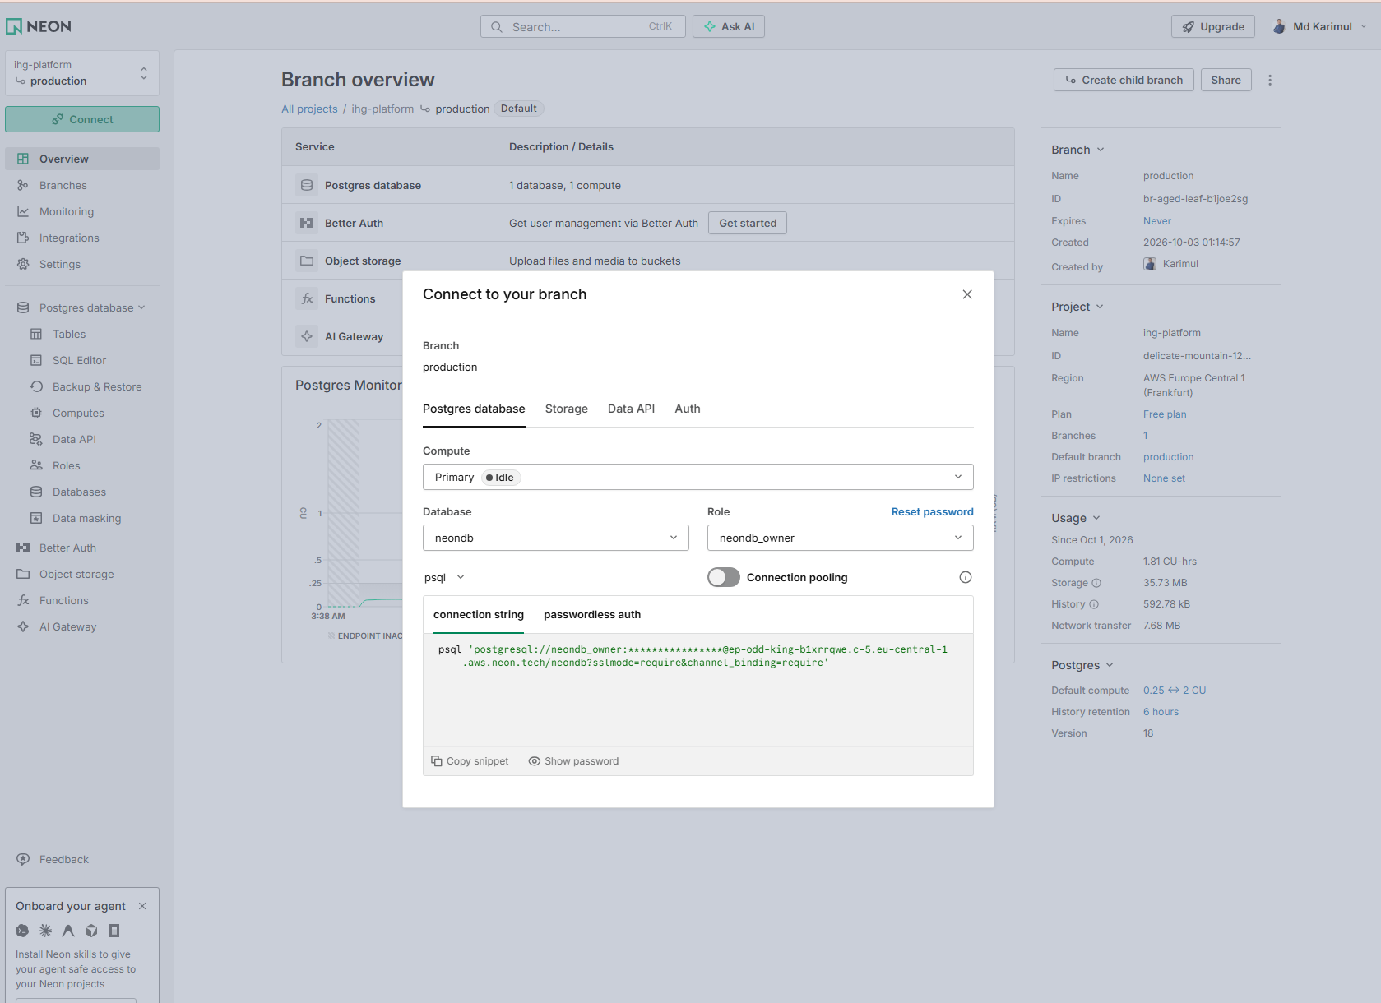
Figure 2 Neon: the Connect dialog with pooling switched off
Handle the backup like a password
The export contains password hashes and guest details. Keep it outside the project folder (the *.sql rule in .gitignore is a safety net, not a plan), and delete it when it is no longer needed.

5.3 Set up email on Brevo
- Create a free account at brevo.com.
- Add and verify a sender: the address that will appear as the “From” address. Brevo emails a confirmation link to it.
- Create an API key under the SMTP & API section and store it in the password manager.
- Under Security, make sure authorised IP restrictions are off. Render’s free servers have no fixed address, so an allow-list would block every send.

5.4 Create the backend on Render
- In Render choose New → Web Service, then connect GitHub and pick the repository.
- Fill in the settings below.
- Add the environment variables from section 4.1.
- Under Advanced, set the Health Check Path to /health, then choose Create Web Service.
- Wait for the build (three to five minutes) to end with “Your service is live”.

Setting | Value
Name | Any name; it becomes part of the address
Region | Frankfurt (EU Central)
Branch | master
Root Directory | backend
Language | Python 3
Build Command | pip install -r requirements.txt
Start Command | uvicorn app.main:app --host 0.0.0.0 --port $PORT
Instance Type | Free
Health Check Path | /health

SCREENSHOT
Render: service settings (Root Directory, commands, health check)
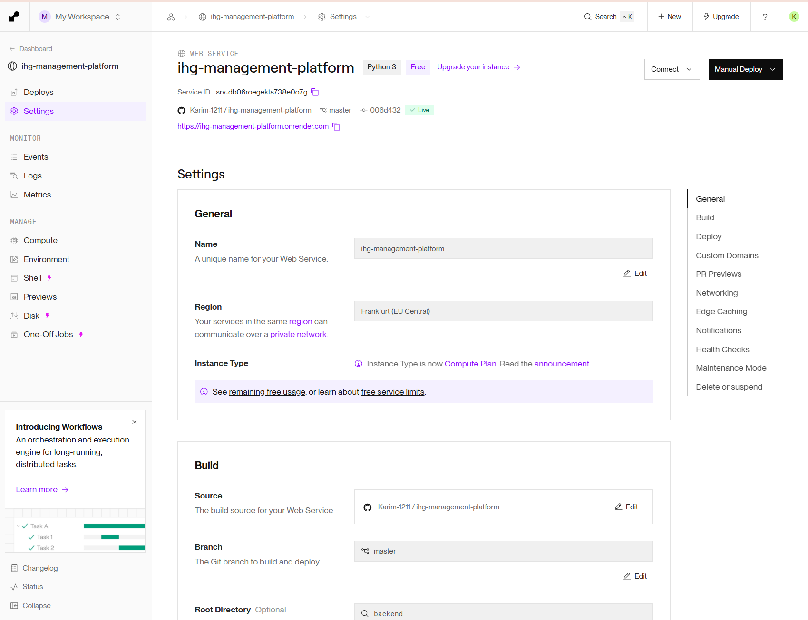
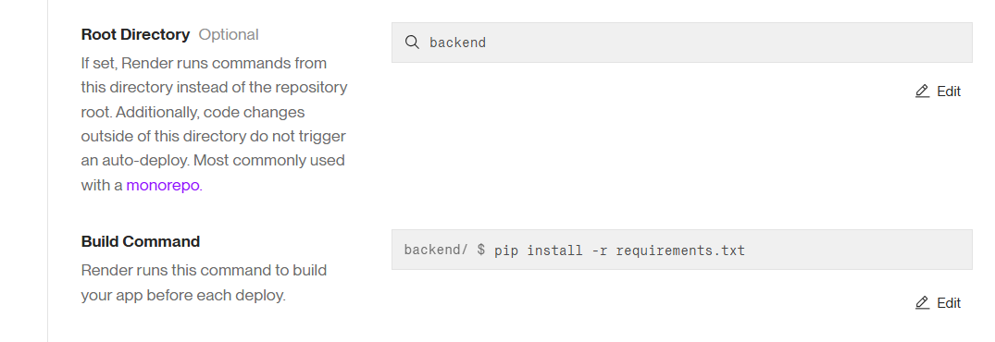
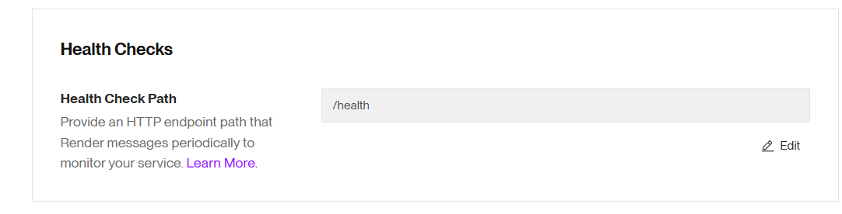
Figure 3 Render: service settings (Root Directory, commands, health check)
The most common first-build failure
If the build stops with “Could not open requirements file”, the Root Directory is empty. Set it to backend, save, and redeploy. Without it Render looks for requirements.txt in the wrong folder.

Why the start command does not migrate the database
The Neon database was copied from a database already at the latest migration, so nothing needs migrating at startup. Future migrations are applied deliberately, as described in section 7.2.

Check: open /health on the new address. It should show "status":"healthy" and "database":"up".

5.5 Create the website on Netlify
The repository already contains netlify.toml at its root. It tells Netlify how to build the site and which API to talk to:
[build]
base = "frontend"
command = "npm run build"
publish = "dist"

[build.environment]
NODE_VERSION = "22"
VITE_API_URL = "https://<your-api-address>/api/v1"
VITE_ALICE_USE_CLIPS = "false"

[[redirects]]
from = "/*"
to = "/index.html"
status = 200

- In Netlify choose Add new site → Import an existing project → GitHub and pick the repository.
- Confirm Netlify shows base frontend, build command npm run build and publish directory frontend/dist, then choose Deploy.
- When it finishes, open Site configuration → Change site name and choose a readable name. Copy the final address.

What the redirect rule is for
The website is a single-page application. Without the rule, refreshing a page such as /hotels/… makes Netlify look for a file that does not exist and show its own 404 page.

5.6 Connect the website to the API
The API only accepts requests from addresses it has been told to trust. Until this step, the browser blocks every call from the live website.
- In Render open the service → Environment.
- Set CORS_ALLOWED_ORIGINS to the Netlify address, exactly, with no slash at the end.
- Save. Render redeploys in about two minutes. Wait for “Live”.

CHAPTER 06

Verification checklist
Work through these in order on the live website. The first load may take up to a minute while the backend wakes. Stop at the first failure and use Chapter 10.
# | Check | Expected result | Pass
1 | Open /health on the API address | "status":"healthy" and "database":"up" | ☐
2 | Open /docs on the API address | The interactive API documentation loads | ☐
3 | Open the website at /hotels | Hotel page with photographs; nine rooms, numbered 101 to 402 | ☐
4 | Open a room, then refresh the browser | The page reloads normally (no Netlify 404) | ☐
5 | Sign in with a guest account | Signed in; My Account opens | ☐
6 | Ask Alice a question | She replies in text and in a spoken voice | ☐
7 | Book a room for future dates | Confirmation and invoice; booking appears in My Account | ☐
8 | Check the booking email | Branded confirmation arrives (check spam on the first send) | ☐
9 | Download the invoice as PDF | PDF opens with correct totals | ☐
10 | Sign in as staff and open Bookings | The new booking is listed | ☐
11 | Open Staff → Email Log | The confirmation shows as sent | ☐
12 | Place a delivery order and open the tracker | Tracker shows the order; the kitchen sees a ticket | ☐
13 | Subscribe through the popup or footer | A welcome code is shown and an email arrives | ☐
14 | Read the Render log after startup | No “Production readiness” warnings | ☐

Before any demonstration
Run checks 1, 3 and 6 a few minutes beforehand. They wake the backend and confirm the database, the website and Alice are all responding.

CHAPTER 07

Operating the platform

7.1 Releasing a change
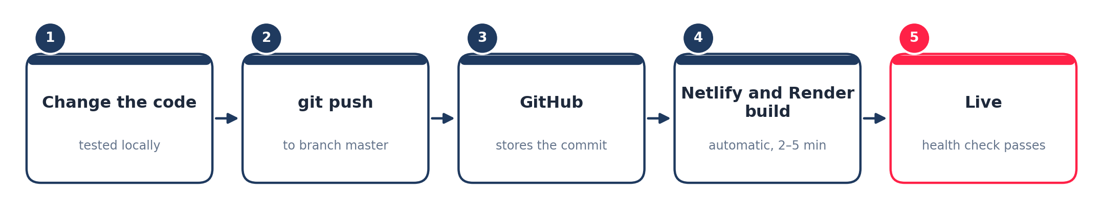
Figure 4 From a code change to the live site
- Make and test the change locally.
- Run git status. Confirm that no .env file and no .sql file is listed.
- Commit and push to master.
- Wait for Render to show Live and Netlify to show Published.
- Check /health, then reload the website with Ctrl + Shift + R so the browser drops its cached copy.

git status
git add -A
git commit -m "Describe the change"
git push

7.2 Changing the database structure (migrations)
Database structure is managed with Alembic. Render does not apply migrations when it starts, so they are applied deliberately, against Neon, from a developer computer:
- Back up first (section 7.4).
- In PowerShell, in the backend folder, point the session at Neon for this window only.
- Run the migration, then clear the setting.

$env:DATABASE_URL = 'PASTE_THE_FULL_NEON_CONNECTION_STRING_HERE'
alembic upgrade head
Remove-Item Env:DATABASE_URL

Always clear the variable afterwards
While DATABASE_URL is set in a window, every Python command in that window uses Neon. Clearing it (or closing the window) returns you to the local database.

7.3 Seed and maintenance scripts
These scripts live in backend/. Each is safe to run more than once. To run one against the live database, set DATABASE_URL as in section 7.2 first.
Script | What it does
seed_inventory_and_recipes.py | Creates the ingredients and the recipe for each menu dish, so orders deduct stock.
seed_tables_and_drivers.py | Adds restaurant tables and delivery riders, and links riders to the restaurant.
seed_room_details.py | Fills room descriptions, views, beds and amenities, and the hotel’s facilities list.
seed_room_character.py | Writes the per-room headline file used by the room detail panel.
seed_promo_rule.py | Creates the subscriber-discount business rule (default 10%).
seed_delivery_rules.py | Creates the kitchen-preparation and rider-travel minutes behind delivery estimates.
fix_roomtype_images.py, fix_roomtype_primary.py | Make sure every room type has an active, primary photograph.
update_user_email.py | Lists accounts and changes a user’s login and notification email.
cleanup_test_orders.py | Removes test orders. Shows what it would do unless run with --delete.

7.4 Backups and restoring
# back up the live database
pg_dump "PASTE_THE_FULL_NEON_CONNECTION_STRING_HERE" --no-owner --no-privileges -f ihg_live_backup.sql

# restore into an EMPTY database
psql "PASTE_CONNECTION_STRING_OF_THE_EMPTY_DATABASE_HERE" -f ihg_live_backup.sql

- Back up before every migration and before every demonstration.
- Store backups outside the repository, and treat them as personal data (Chapter 9).
- Test a restore into a spare database at least once, so the procedure is known to work.

7.5 Rolling back
What went wrong | Rollback
A code change broke the site | Undo it with git revert <commit> and push. Or redeploy an earlier successful deploy from the Render Events page and the Netlify Deploys page.
A migration or script damaged data | Restore from the backup taken beforehand (section 7.4).
A setting was changed by mistake | Set the variable back in the dashboard and save; the service restarts by itself.

7.6 Changing a secret
- Create the new value (a new API key, or a new database password in Neon).
- Put it in the matching variable on Render and save. The service restarts.
- Confirm /health is healthy, then revoke the old value at its source.

- Changing JWT_SECRET_KEY signs every user out. This is expected.
- Changing the Neon password means updating DATABASE_URL immediately afterwards, or the API loses its database.

7.7 Where to look when watching the system
Place | Shows
Render → Logs | Startup warnings, errors, and Alice’s speech-to-text decisions (STT segment kept/dropped).
/health | Whether the API and the database are up.
Staff → Email Log | Every email, its status and the reason for any failure.
Staff → Audit Log | Who changed what: rules, service requests and other sensitive actions.

CHAPTER 08

Free-plan behaviour
Every service is on a free plan, which is right for a demonstration and for early use. These are the behaviours to expect, and none of them is a fault.
Service | Behaviour | What it means in practice
Render (API) | Sleeps after about 15 minutes idle; wakes on the next request in roughly 30 to 60 seconds | Open the site a minute early for a demo. The first click after a quiet spell is slow.
Render (API) | Blocks outbound mail ports | Email must use Brevo’s web API, which is already configured.
Neon (database) | May pause when idle and resume on the next connection | The first query after a long quiet spell can be slower. The API reconnects automatically.
Brevo (email) | A daily sending allowance on the free plan | Plenty for a demo; check the current figure on Brevo before heavy use.
Groq (Whisper) | A free daily allowance of transcriptions, of the order of two thousand a day at the time of writing | Far more than a demonstration needs.
ElevenLabs (voice) | Monthly credits | When they run out, Alice switches to the browser’s voice for the rest of that visit and returns to ElevenLabs automatically once credits are available again.
Gemini (chat) | Free quota per key | Two keys, then Groq, are tried in turn before Alice says she is busy.
Netlify (website) | Monthly build and bandwidth allowances | Ample for this scale.

8.1 How Alice degrades gracefully
Alice never depends on a single provider. Her voice uses the first one that answers, and her listening is handled by the platform itself rather than the visitor’s browser:
- Voice: ElevenLabs, then (if configured) Gemini or Groq, then the browser’s built-in voice. Once a provider fails during a visit, the whole visit stays on the next one, so a conversation never alternates between two different voices.
- Listening: the visitor’s voice is recorded in the page and transcribed on the API by Whisper, so it works in any modern browser. Text produced from silence is filtered out using Whisper’s own confidence scores.
- Chat: Gemini key 1, Gemini key 2, then Groq.
- Everything else: if all voice or listening services fail, Alice invites the visitor to type, and the rest of the platform is unaffected.
CHAPTER 09

Security and data protection
The proposal requires that guest and customer data stay confidential and that each person sees only what their job needs. This chapter records how the platform meets that, and what the administrator must keep doing.

9.1 What the platform already does
Area | Measure
Passwords | Stored only as Argon2 hashes, never in readable form.
Sign-in | Signed login tokens that expire (30 minutes by default) and are signed with a secret known only to the server.
Permissions | Every staff screen and API route checks the user’s role. A kitchen user cannot open the bookings board; a receptionist cannot change business rules.
Transport | The website and API are served over HTTPS; the database connection requires TLS.
Cross-site access | The API accepts calls only from the configured website address.
Audit trail | Sensitive actions (such as changing a business rule) are written to the Audit Log with who and when.
Payments | Demonstration mode only: no real card or PayPal details are collected or stored.
Repository | .env files and database backups are excluded from Git.

9.2 What the administrator must do
- Keep every secret in a password manager. Never paste a key, token or connection string into a chat, an email or a ticket. When asking for help, remove the secret first.
- Use a different JWT_SECRET_KEY and different database credentials in production than on the developer computer.
- Rotate any secret that has been exposed, following section 7.6.
- Treat database backups as personal data: encrypt or store them securely, and delete old ones.
- Give staff accounts only the role they need, and deactivate accounts when people leave.

9.3 Points to know before real use
Alice’s voice and listening are open to visitors
So that people can use Alice before they have an account, the speech and transcription endpoints do not require a login. This is deliberate, but it means anyone who finds the API address can use the free voice and transcription allowance. Add rate limiting before any public launch.

Demo accounts and demo policies
The database contains demonstration accounts with simple passwords, and business policies (tax rate, check-in times, cancellation window, discount percentage) that are assumed values. Change every demo password, and replace the policies with the real ones in Staff → Business Rules, before the system holds real data.

9.4 Launch checklist
Item | Done
All demo account passwords changed or the accounts removed | ☐
Production secrets differ from local secrets | ☐
git status clean of .env and .sql files, and no secret in the Git history | ☐
Real business policies entered in Staff → Business Rules | ☐
Rate limiting added to the public voice and transcription endpoints | ☐
Backups scheduled and one restore tested | ☐
Real payment provider integrated in place of demonstration payments | ☐
Email sender is a verified company domain rather than a personal address | ☐

CHAPTER 10

Troubleshooting
Each row below was met during this project’s own deployment. Start with the symptom, check the likely cause, apply the fix.
Symptom | Likely cause | Fix
Render build stops: “Could not open requirements file” | Root Directory not set | Settings → Root Directory = backend, then redeploy.
The API will not start: “cannot import name …” | A file was pushed into the wrong folder, or not pushed at all | Check the file sits in the same folder as its neighbours, commit and push again.
/health shows "database":"down" | Wrong or outdated DATABASE_URL; Neon paused or password reset | Re-copy the string from Neon’s Connect dialog and save it on Render.
The site loads but shows “Network Error”; the browser console mentions CORS | CORS_ALLOWED_ORIGINS missing, mistyped or ends with a slash | Set it to the exact website address, no trailing slash, and save.
Refreshing a page gives a Netlify 404 | The redirect rule is missing | Confirm netlify.toml has the [[redirects]] block and redeploy.
Emails do not arrive | Sender not verified; SMTP_FROM_EMAIL does not match it; IP restriction on in Brevo; message in spam | Open Staff → Email Log for the exact reason, then correct the matching setting.
Alice has no spoken voice | ElevenLabs credits used up or key missing | She falls back to the browser voice automatically. Check ELEVENLABS_API_KEY and the credit balance.
Alice’s microphone never hears anything | Microphone permission blocked; GROQ_API_KEY missing | Allow the microphone for the site; confirm the key; look for STT segment lines in the Render log.
Alice answers things nobody said | An older backend version is still running | Confirm the latest Render deploy is Live and shows the newest commit; check the STT segment log lines.
A change is not visible after a push | Deploy still running, or the browser cached the old site | Wait for Live and Published, then press Ctrl + Shift + R.
A promo code says “That code isn’t recognised” | The code was issued by a different database (local versus live) | Codes belong to one database. Subscribe again on the live site to get a live code.
A room-type card shows “No image available” on the live site only | The photograph fix was applied to the local database, not Neon | Run the two image scripts from section 7.3 against Neon.

CHAPTER 11

Limitations and next steps
The platform meets the proposal’s functional scope, and the deployment is complete and repeatable. These items are deliberately left as demonstration choices, and are the natural next steps toward real use.
Area | Current state | Recommended next step
Hosting | Free plans, with a sleeping backend | A paid always-on backend plan removes the 30 to 60 second wake-up.
Payments | Demonstration mode only | Integrate a real payment provider behind the existing payment layer.
Business policies | Assumed values, editable in Business Rules | Replace with the real tax, cancellation, stay-length and discount policies.
Public voice endpoints | Open to all visitors | Add per-address rate limiting.
Email sender | A single verified address | Verify a company domain for better delivery and branding.
Custom address | Provider-generated web addresses | Attach a company domain to Netlify and Render.
Monitoring | Logs and the health endpoint | Add an uptime monitor and error alerts.
Data migration | Records start from the copied database | Use the planned import path (validate, preview, import) for historical paper records.

APPENDICES

Appendices

Appendix A. Command reference
Task | Command
See what has changed | git status
Release a change | git add -A, then git commit -m "message", then git push
Undo a released change | git revert <commit>, then git push
Apply database migrations | alembic upgrade head (with DATABASE_URL set, section 7.2)
Start the API locally | uvicorn app.main:app --reload (from backend)
Start the website locally | npm run dev (from frontend)
Back up a database | pg_dump "<connection string>" --no-owner --no-privileges -f file.sql
Point a PowerShell window at Neon | $env:DATABASE_URL = '<connection string>'
Clear that setting | Remove-Item Env:DATABASE_URL

Appendix B. Release checklist
Before pushing | Done
Change tested locally in the browser | ☐
git status shows no .env and no .sql file | ☐
Database migration written and tested, if the structure changed | ☐
Backup of the live database taken, if a migration is included | ☐

After pushing | Done
Render shows Live and Netlify shows Published | ☐
/health is healthy | ☐
Verification checks 3, 5, 6 and 7 pass (Chapter 6) | ☐
No new “Production readiness” warning in the Render log | ☐

Appendix C. Glossary
Term | Meaning
API | The server program the website talks to. It holds the business rules and the only access to the database.
Cold start | The delay when a sleeping free server wakes for the first visitor.
CORS | A browser safety rule. The API lists which website addresses may call it.
Environment variable | A named setting held in a service’s dashboard rather than in the code.
Health check | A small address (/health) that reports whether the API and database are working.
JWT | The signed token a user receives when they sign in; it proves who they are on each request.
Migration | A scripted change to the database’s structure, applied in order and recorded.
Seed script | A script that fills the database with starting data.
Whisper | The speech-recognition model Alice uses to turn a recorded voice into text.

