 IHG HOSPITALITY
GUESTS · STAFF · MANAGERS
User Manual

Step-by-step guidance for guests, and for every role on the team, in the Enterprise Hospitality, Restaurant & Food Delivery Management Platform.

VERSION  1.0 | DATE  4 October 2026
PREPARED FOR  International Hospitality Group | PREPARED BY  Karimul Islam  Batch 26/5  AI-Powered Software Engineering, ICT Bangladesh
LIVE WEBSITE  ihg-hospitality.netlify.app | STATUS  Issued for acceptance review

DOCUMENT CONTROL

About this manual
This manual shows guests how to book rooms, reserve tables and order food, and shows every member of staff how to do their daily work in the platform. It is written in plain language, with steps you can follow while the screen is open in front of you.
Item | Detail
Version | 1.0
Date | 4 October 2026
Status | Issued for acceptance review
Audience | Guests and customers; reception, housekeeping, waiting, kitchen and delivery staff; managers and administrators

How to find your part
If you are… | Read
A guest or customer | Chapters 1 to 3, then 4 to 8
A receptionist | Chapters 1, 2, 9 and 10
Housekeeping | Chapters 1, 2, 9 and 11
A waiter | Chapters 1, 2, 9 and 12
Kitchen staff | Chapters 1, 2, 9 and 13
A delivery rider or dispatcher | Chapters 1, 2, 9 and 14
A manager or administrator | Chapters 9 and 15, and Appendix C

How to read the boxes
You will see | It means
Note | Background that helps you understand a step.
Tip | A shortcut or a way to save time.
Caution | A step where a small mistake is easy to make.
Important | Something that can cause a problem if it is ignored.
Bold text, dashed frames | Bold is the exact name of a button, tab or menu item. Dashed frames are marked spaces for screenshots, each saying which screen and account to capture.

Contents
PART 1 · GETTING STARTED
01 | Welcome to the platform
02 | Signing in and finding your way
03 | Meet Alice, your concierge
PART 2 · GUIDES FOR GUESTS
04 | Booking a hotel room
05 | Reserving a restaurant table
06 | Ordering food delivery
07 | Offers and promotional codes
08 | Your account
PART 3 · GUIDES FOR STAFF
09 | Working in the staff area
10 | Reception
11 | Housekeeping
12 | Restaurant floor: waiters
13 | Kitchen
14 | Deliveries and riders
15 | Managers and administrators
PART 4 · REFERENCE
16 | Statuses, alerts and emails
17 | Questions and troubleshooting
A–D | Appendices: quick-start cards, training scenarios, demo accounts, glossary
CHAPTER 01 · GETTING STARTED

Welcome to the platform
IHG Hospitality brings a hotel, a restaurant and a food-delivery service into one connected platform. A guest has one account for all three. Staff see the same records, so reception, the kitchen and the riders always work from the same information.
3  services in one platform: hotel, restaurant, delivery | 8  roles, each seeing only what its job needs | 1  account for everything a guest does | Alice  an AI concierge you can talk or type to

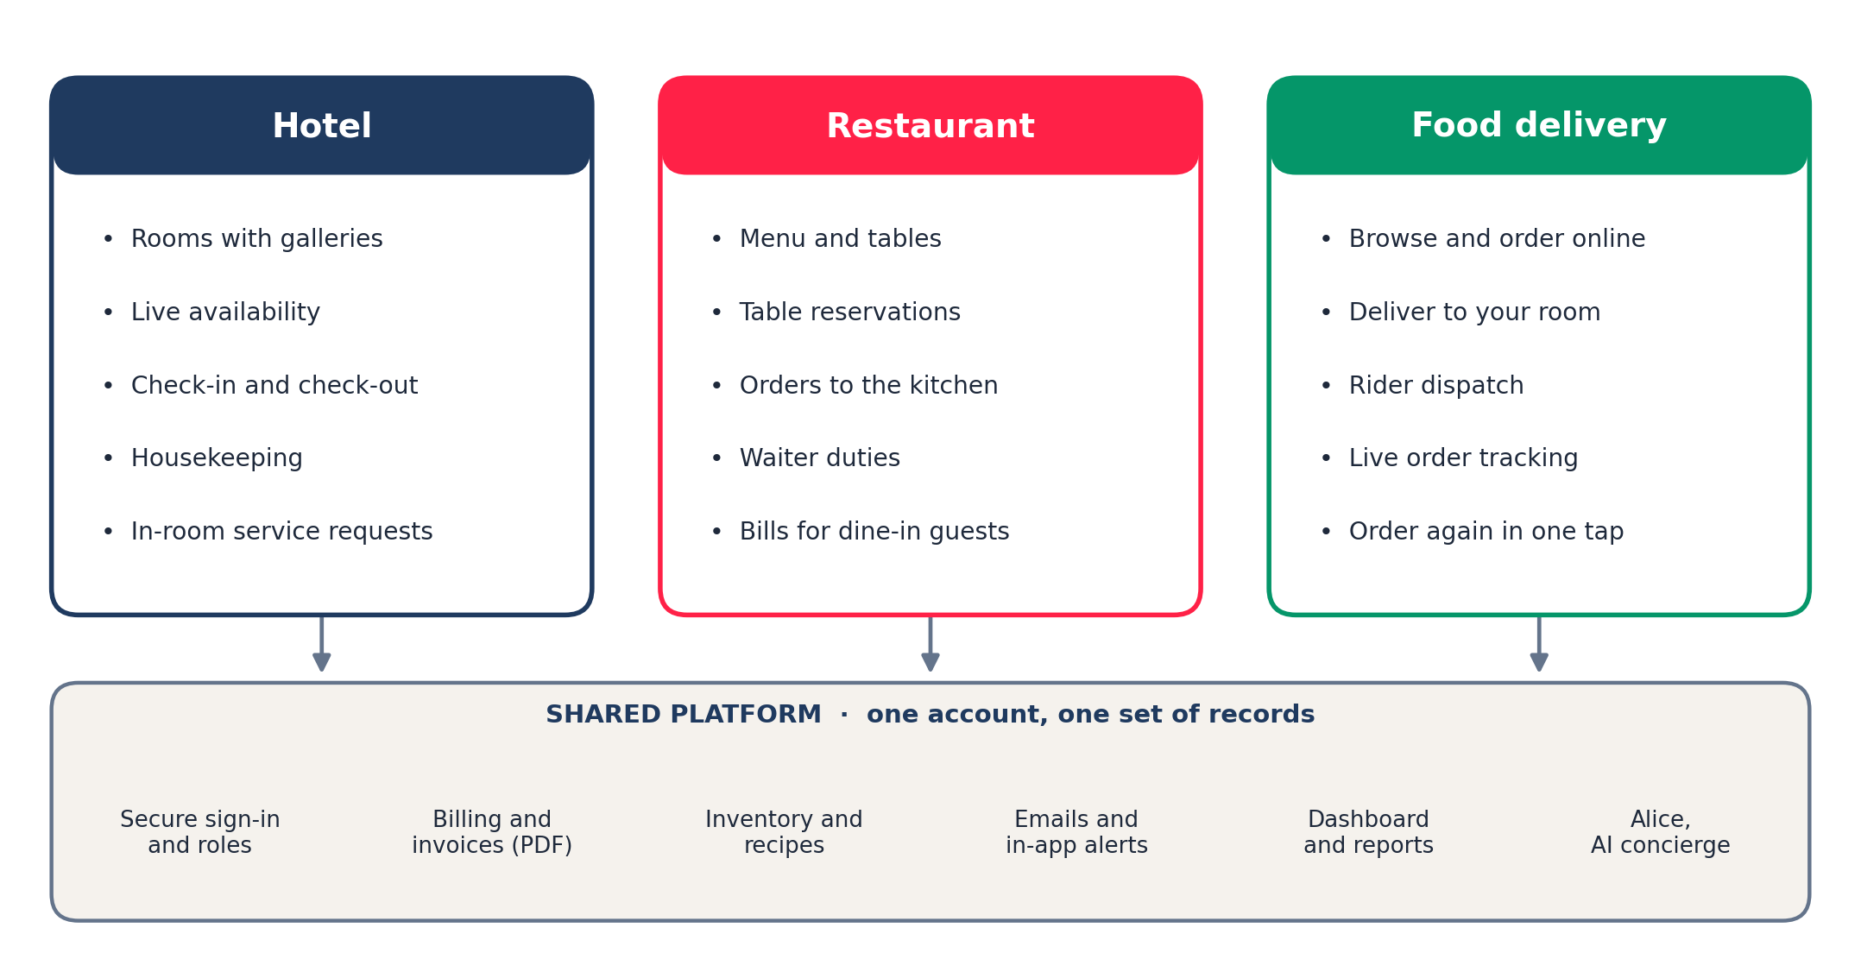
Figure 1 The three services and the platform they share

1.1 Who uses the platform
Role | What they do in the platform
Guest / customer | Book rooms, reserve tables, order delivery, request in-room service, view invoices (public website).
Receptionist | Check guests in and out, manage bookings and service requests, issue invoices.
Housekeeping | Clean rooms after check-out and mark them ready.
Waiter | Confirm orders, seat reservations, take payment on dine-in bills.
Kitchen | Prepare tickets in the order received and mark them ready.
Delivery rider / dispatcher | Assign riders to orders and take them to the guest.
Manager | Watch the dashboard and reports, set business rules, manage stock and messages for their property.
Administrator | Everything a manager does, across every property, plus platform-wide rules.

Payments are in demonstration mode
Wherever the platform asks for card or PayPal details, no real money is taken and no real card details are stored. The fields exist so the full journey can be shown from booking to invoice.

CHAPTER 02 · GETTING STARTED

Signing in and finding your way

2.1 Browse freely, sign in when you commit
Anyone can look around: rooms, prices, the menu, table availability and Alice. You only need an account at the moment you book a room, reserve a table, check out an order or track an order. When that moment comes, the platform asks you to sign in and then brings you straight back to where you were, with your choices kept.

2.2 Create an account
- Choose Join at the right of the top bar.
- Enter your details and a password, then submit the form.
- You are signed in and returned to the page you were on.

Staff do not register themselves. A manager or administrator sets up each staff account and its role.

2.3 Sign in and sign out
- Choose Sign in at the right of the top bar.
- Enter your email address and password.
- To sign out, open your name menu at the right of the top bar and choose Sign out.
SCREENSHOT
The top bar before and after signing in
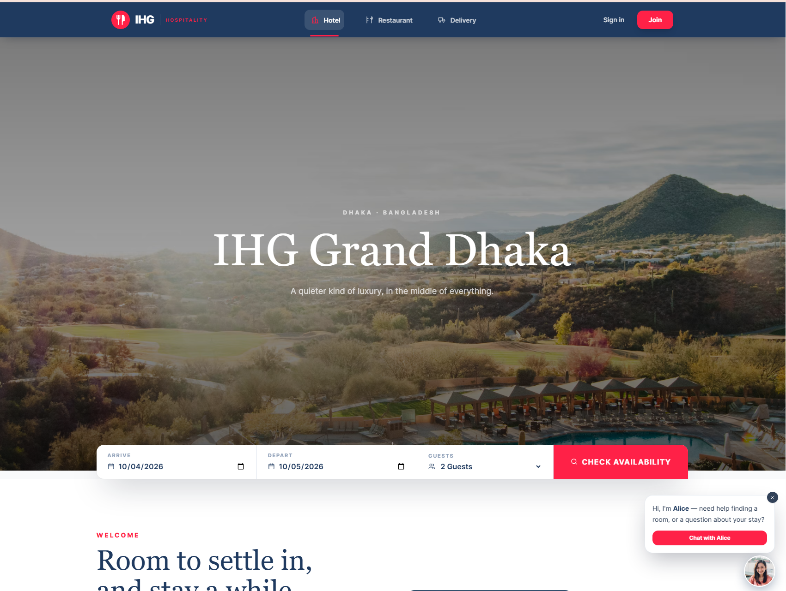

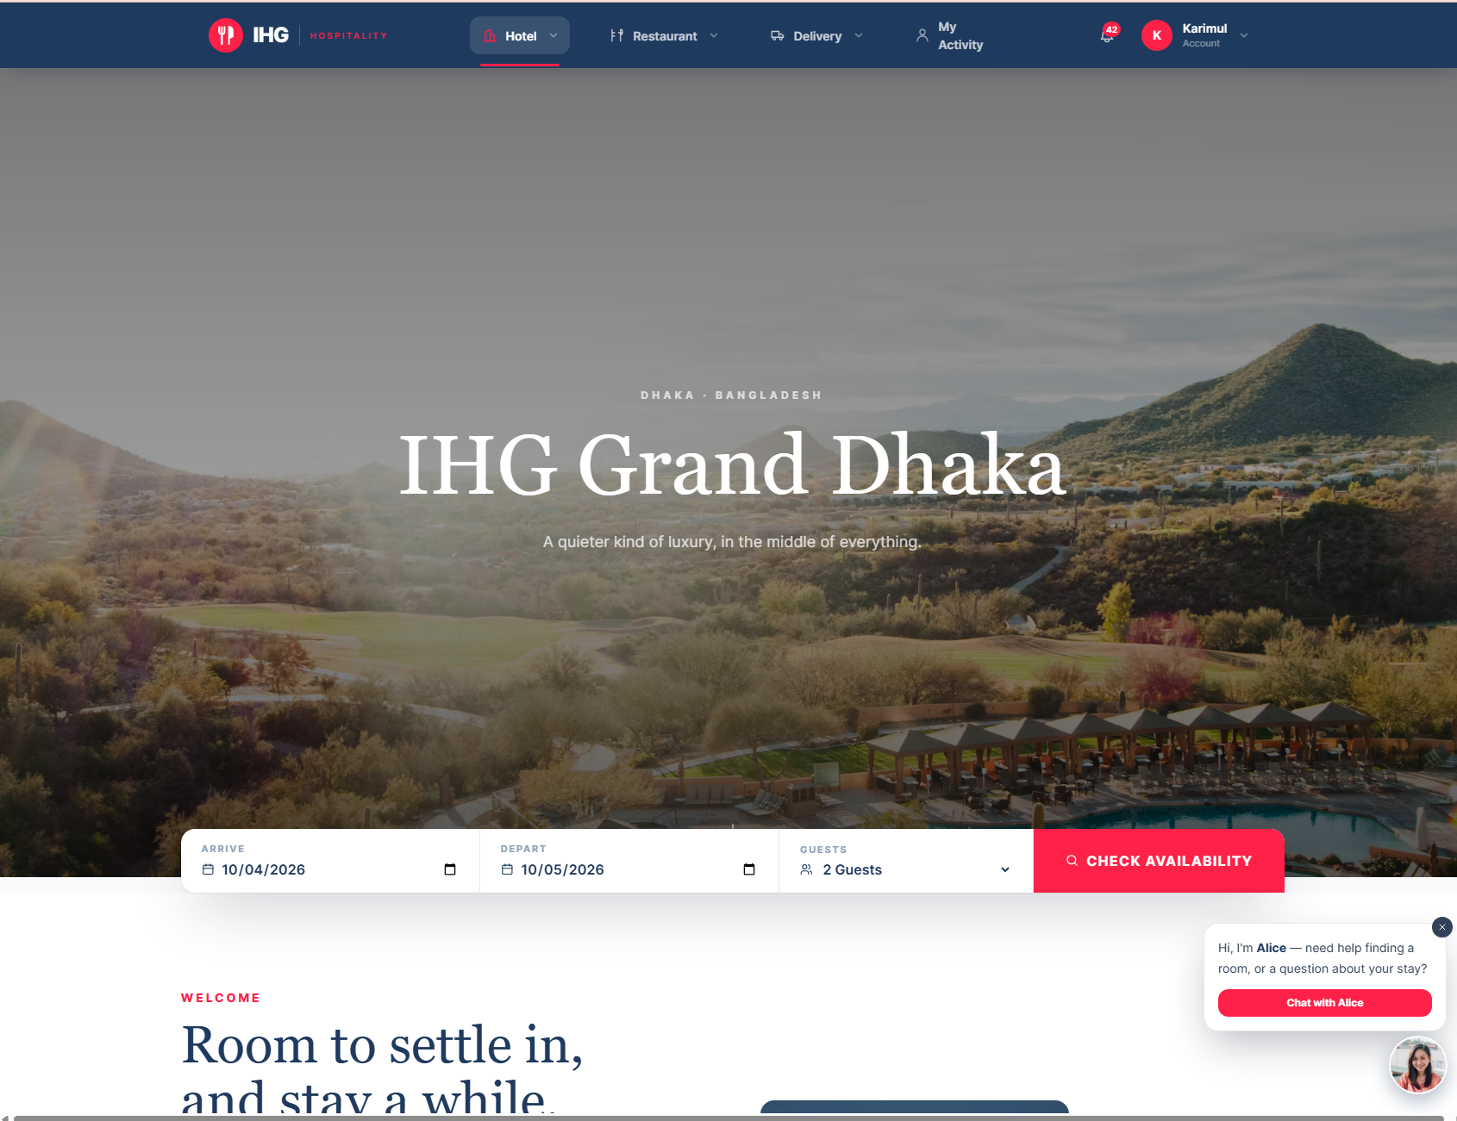
Figure 2 The top bar before and after signing in

2.4 The top bar
Item | What it does
Hotel | Rooms and suites, availability and booking.
Restaurant | The menu, table reservations and the dining concierge.
Delivery | Order food to your door or your room, and track it.
My Activity (My Account) | Your bookings, orders, reservations, invoices, service requests and notifications.
Bell icon | Alerts about your bookings and orders. The red number shows how many are unread.
Your name | Opens your account menu, including Sign out.

Works on a phone as well
The site adapts to small screens. Voice features work best in the current versions of Chrome and Edge; everywhere else, Alice works by typing.

CHAPTER 03 · GETTING STARTED

Meet Alice, your concierge
Alice is the platform’s AI concierge. She can answer questions and help you do things, by typing or by voice. She is available on every guest page, and she changes her role to match where you are.
On this page | Alice helps you
Hotel | Find a room that suits you, check real availability, and answer questions about your stay.
Restaurant | Reserve a table, choose a dish from the menu, or arrange delivery.
Delivery | Choose something to eat, tell you exactly where your order is, or answer any other question.

3.1 Opening her
- Look for Alice’s round photograph at the bottom right of the page.
- Click it to open the chat window. A small speech bubble also invites you to start.
- Choose what you want from the menu she shows, for example Find me a room or Ask a question.

SCREENSHOT
Alice’s chat window with its starting menu 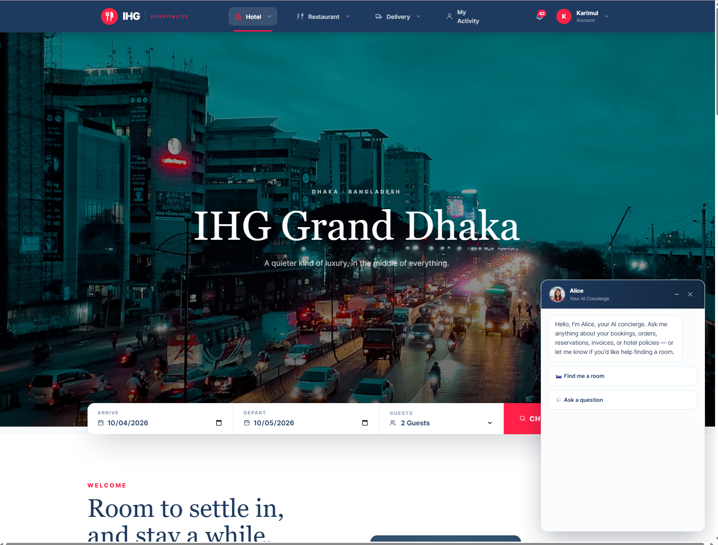
Figure 3 Alice’s chat window with its starting menu

3.2 Talking to her
- When the red Listening… line appears above the message box, speak a full sentence. A small bar moves as she hears you.
- Pause when you finish. After a moment you see Writing that down…, then your words appear in the chat.
- Alice answers once, in writing and aloud, and then listens again if she needs more from you.

- The first time, your browser asks permission to use the microphone. Choose Allow.
- If she cannot hear you, she tells you so in the chat. Type your answer instead, or press the microphone button to try again.
- If you stay silent, she does not answer. She only replies to what she hears.

3.3 Typing to her
Type in the box at the bottom of the chat and press Enter. When you type a question, Alice answers aloud but does not open the microphone afterwards, so she never waits for speech you did not intend.

3.4 Things worth saying
You say | Alice does
“I’d like a room with a balcony and a view.” | Asks for your dates and guests, then shows matching rooms that are really free.
“Room three hundred two.” | Takes you to book that room, asking you to sign in if needed.
“Reserve a table for four tomorrow at seven.” | Checks the floor plan and offers the tables that are free.
“Something spicy and vegetarian.” | Suggests real dishes from the menu and offers to add one to your order.
“Where is my order?” | Reads your real order status and links to the live tracker. Needs you signed in.
“Add it.” / “That’s all.” | Adds the suggested dish, or takes you to checkout.

3.5 Voice on, voice off, and closing
- The Voice on / Voice off button inside her window mutes her spoken replies. The text stays.
- Closing the window with × or minimising it stops her talking and listening at once.
- Moving to another page also silences her.
What Alice will and will not do
She reads real information: live availability, the real menu, your own orders. She does not invent rooms, dishes or prices. She cannot take payment; you always confirm and pay yourself at checkout. When you ask about your own bookings or orders and you are not signed in, she invites you to sign in.

CHAPTER 04 · GUESTS

Booking a hotel room
FOR Guests and customers
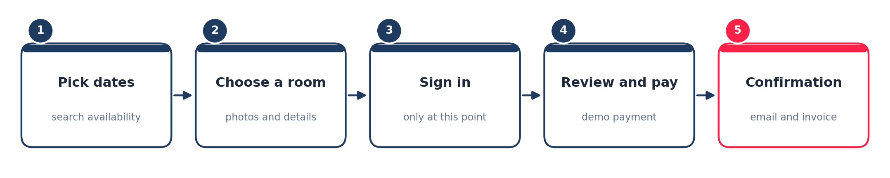
Figure 4 The booking journey

4.1 Find a room
- Choose Hotel in the top bar, then open the hotel.
- In the search bar, set Check in, Check out and Guests, then choose Check availability.
- Every room card now shows its state: Available, Booked for dates, Being prepared, or Select dates if you have not searched yet.

SCREENSHOT
The rooms page with the search bar and room cards
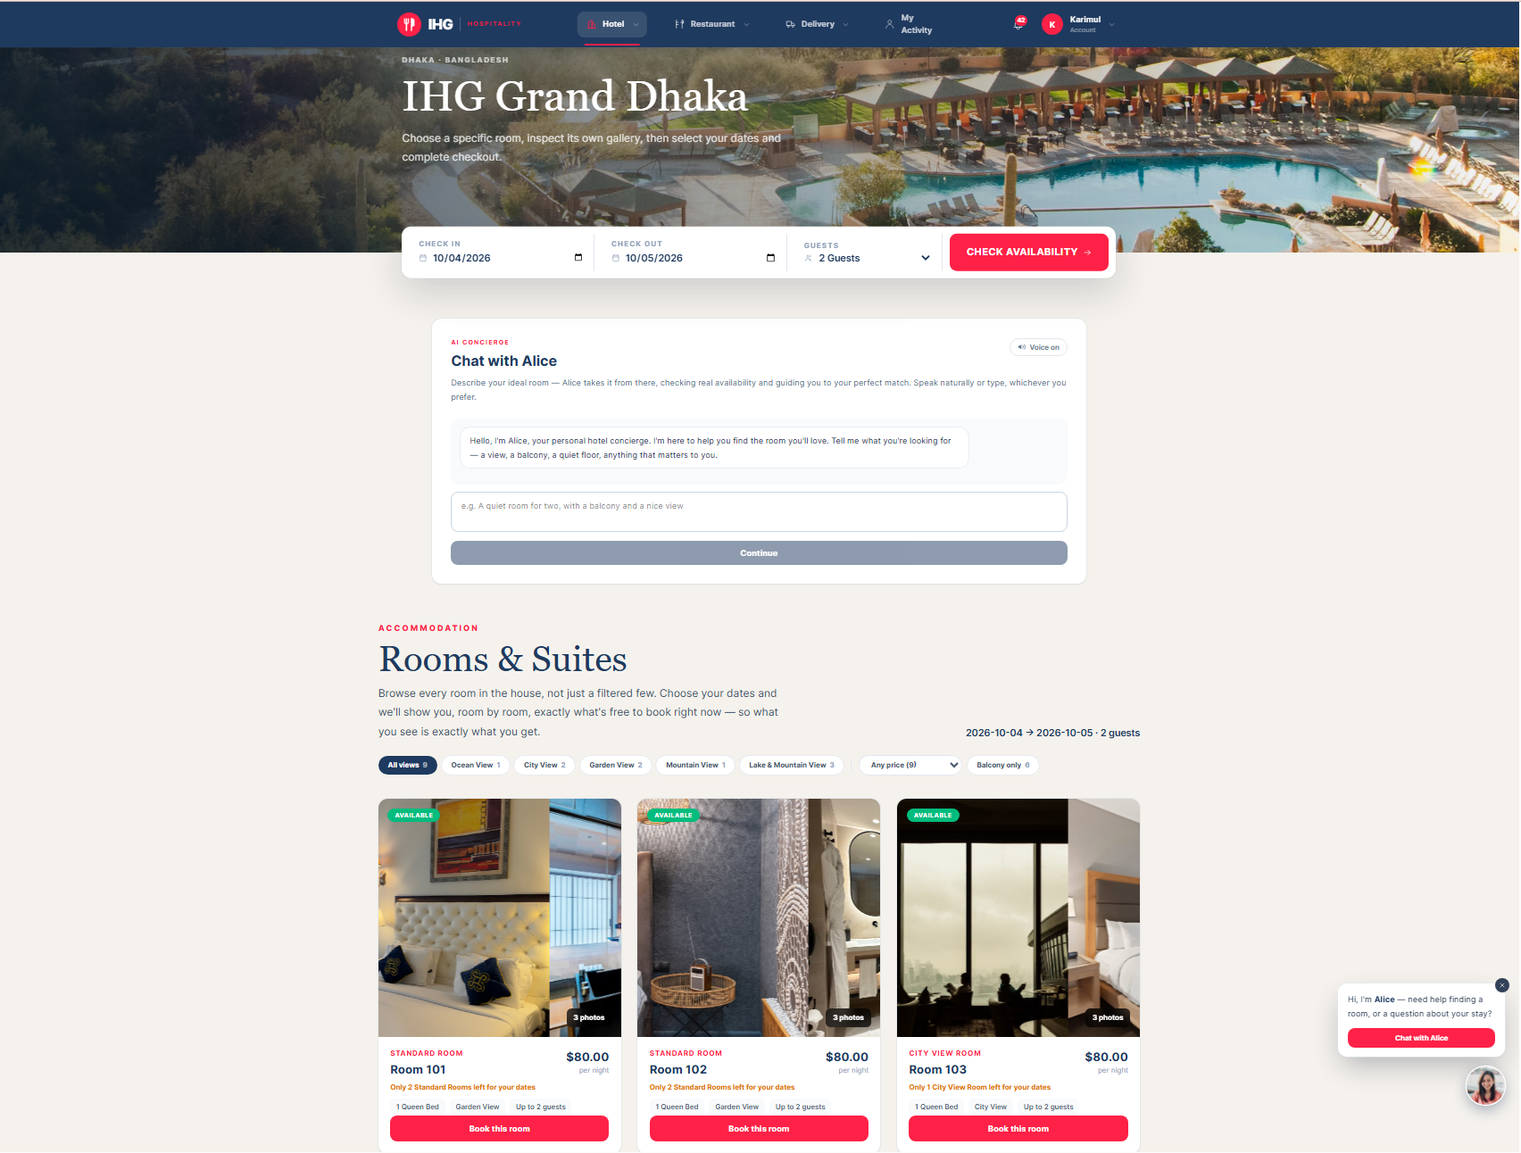
Figure 5 The rooms page with the search bar and room cards

4.2 Narrow the list
Above the rooms you can filter by view, by price, and by Balcony only. Each choice shows how many rooms it would leave, and a choice that would leave none is greyed out, so you cannot end up on an empty list by accident.
- Rooms are listed in order, 101 first, six to a page. Use the page buttons below the list to move on.
- Choose Clear filters at any time to see everything again.

4.3 Look at a room properly
Click the photograph of any room. A detail window opens with:
- A large photo gallery, with thumbnails and a full-screen view.
- A headline and a written description of the room.
- The essentials: how many it sleeps, the bed, the outlook and whether there is a balcony.
- Everything in the room, grouped: comfort, bathroom, food and drink, work and entertainment, service.
- What the hotel itself includes in your stay, such as breakfast and the pool, spa and fitness studio.
- Check-in and check-out times, the nightly price, and a Book this room button.

SCREENSHOT
A room’s detail window
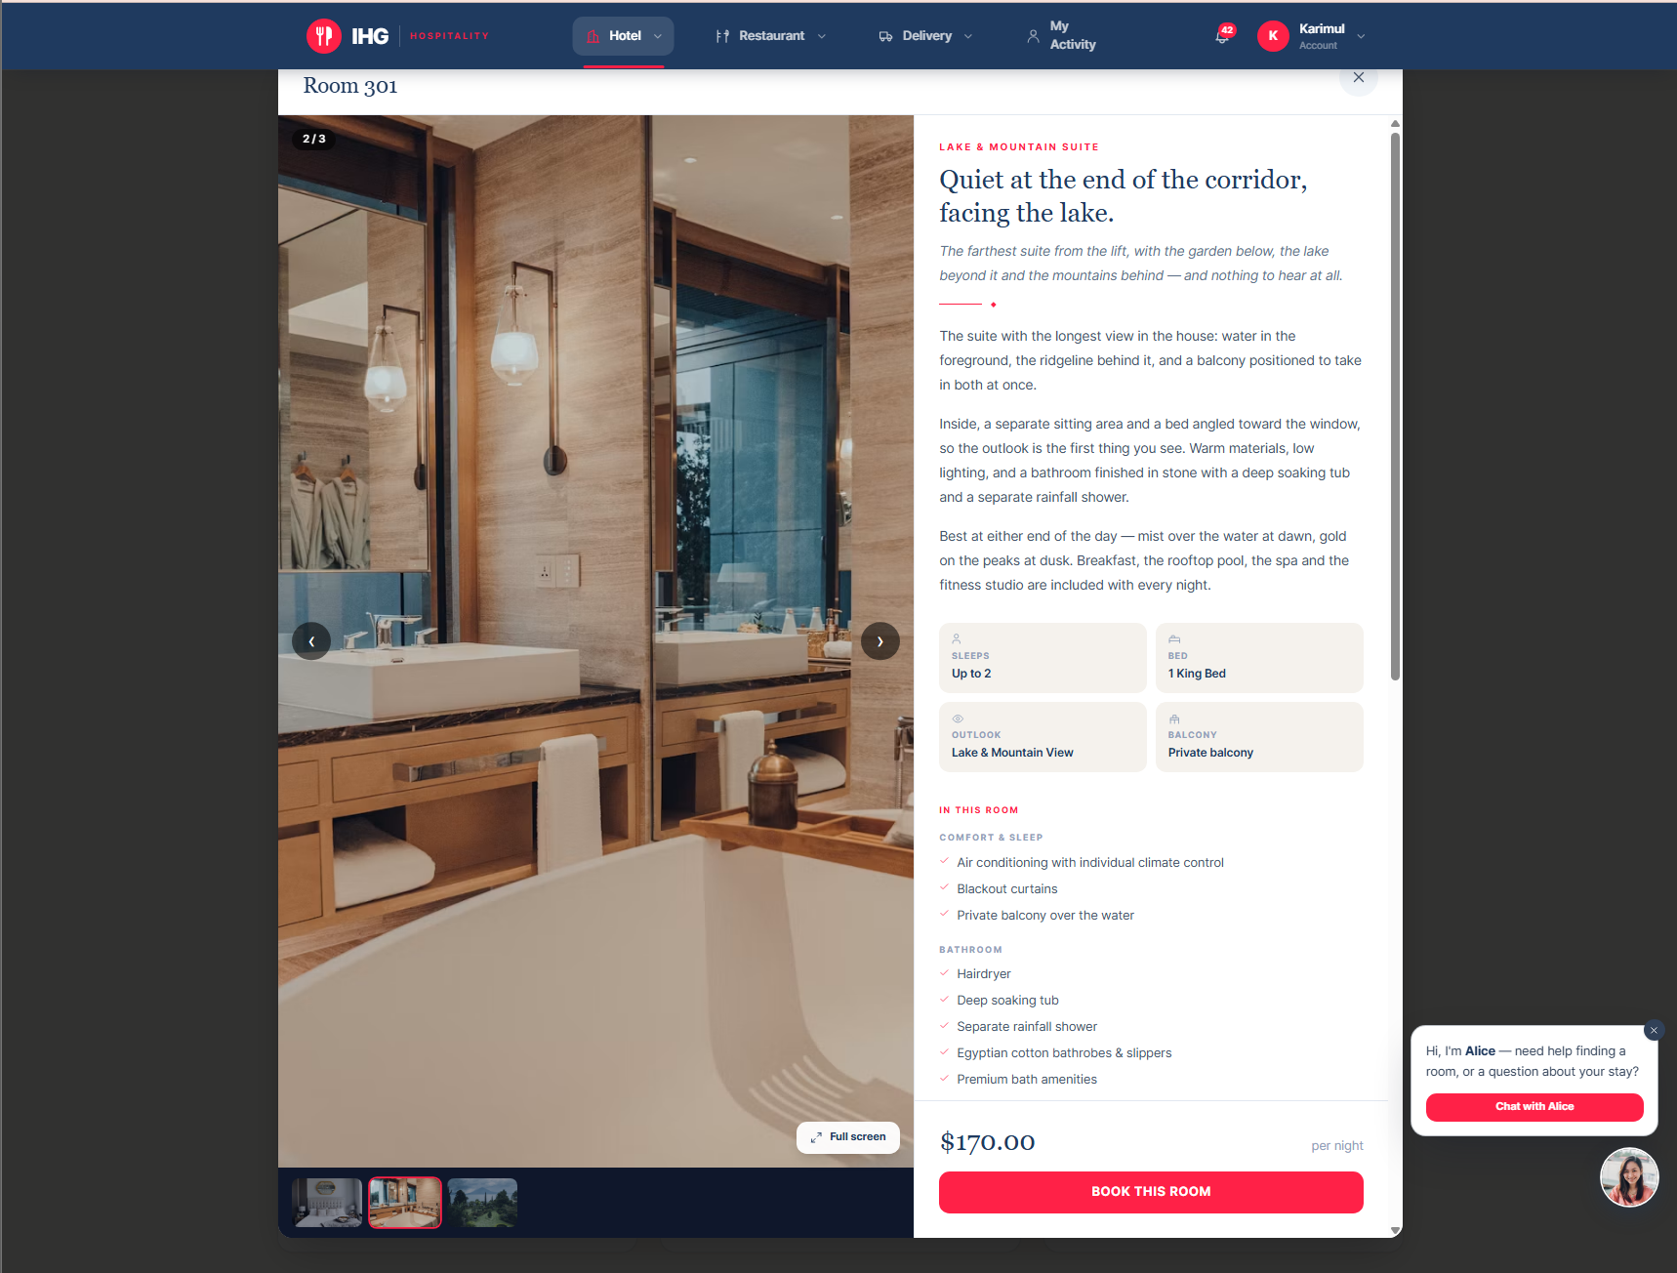
Figure 6 A room’s detail window
Closing the window
Press Esc, click the × at the top right, or click outside the window. Alice stops speaking when you open a room, so you can read in peace.

4.4 Book it
- Choose Book this room. If you are not signed in, you are asked to now; afterwards you return to this step with the room and dates kept.
- On Review your stay, check or change the dates and the number of guests. Choose Check live availability to confirm the room is still free.
- Under Guest information, confirm your name, email and phone. Add anything the hotel should know in Special requests.
- Under Payment Options, choose Visa, Mastercard or PayPal. This is demonstration mode: use sample details.
- If you have a promotional code, open Have a promotional code? in the summary (Chapter 7). The field appears once your dates are set.
- Check the Booking summary (nights, rate, tax, any discount, total), then choose Pay & book.

SCREENSHOT
The Review your stay page with the booking summary
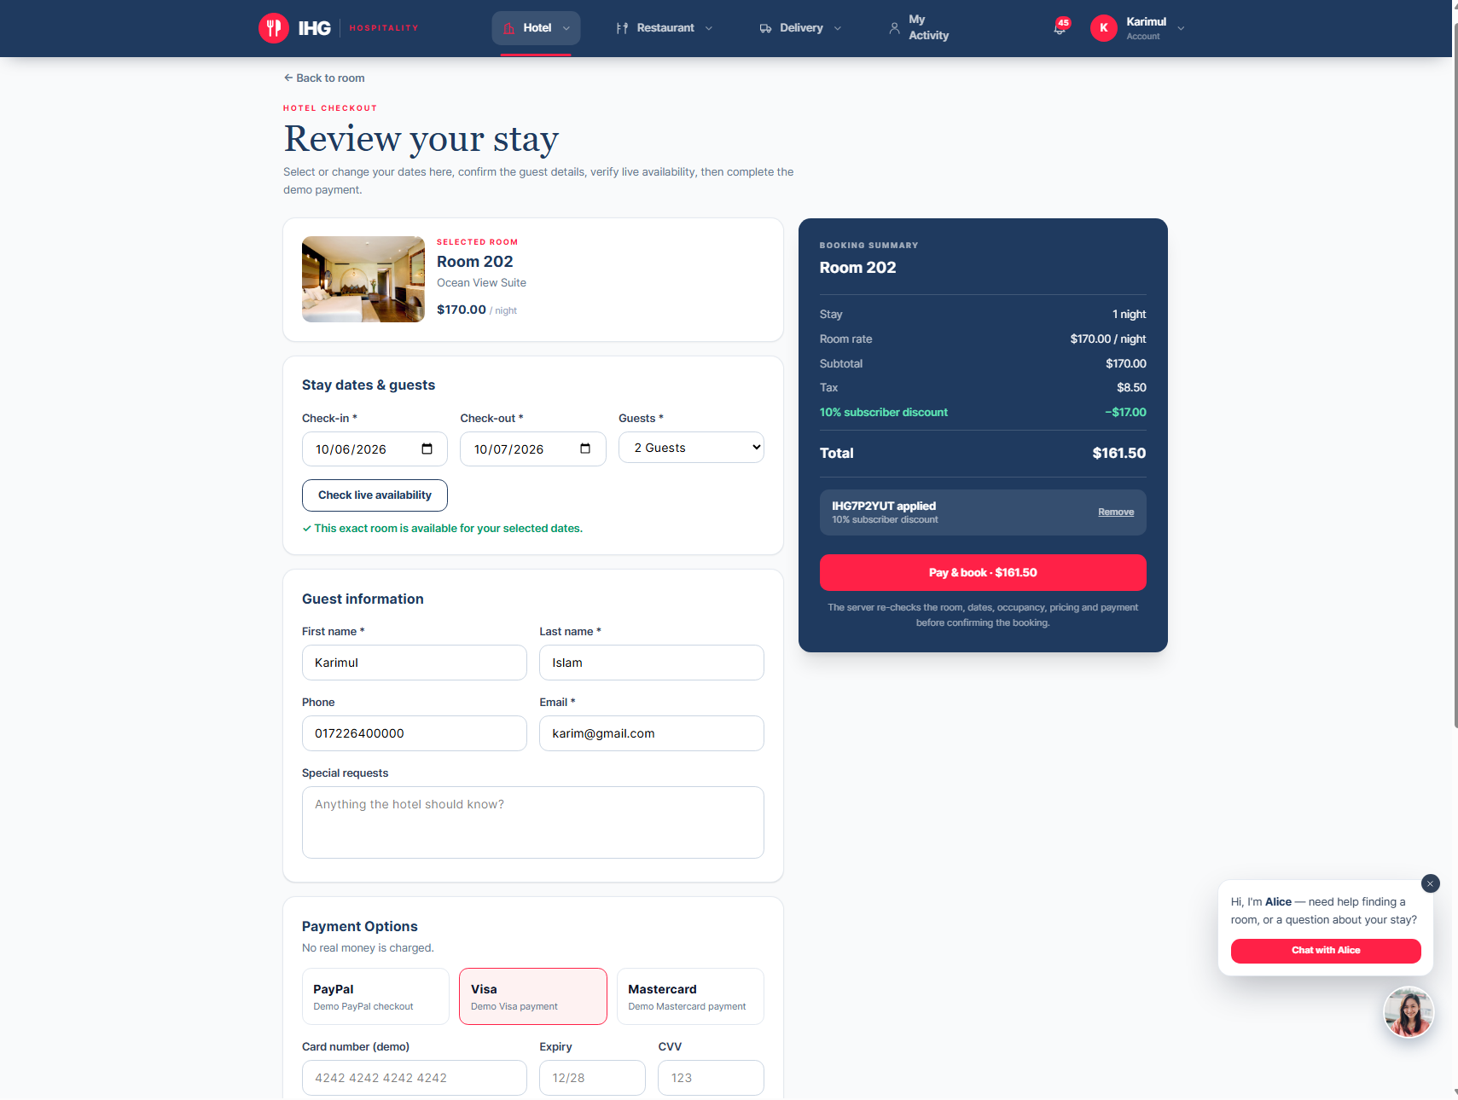
Figure 7 The Review your stay page with the booking summary

4.5 After you book
- A Booking confirmed page shows your booking reference and a full invoice.
- Choose Print / Download Invoice (PDF) and pick Save as PDF as the destination to keep a copy.
- A confirmation email arrives with the details. The invoice is attached as a PDF.
- Your booking appears under My Account → Bookings (Chapter 8).

4.6 Booking with Alice instead
You can do all of the above by conversation. Open Alice, choose Find me a room, and tell her what you want. She asks for your check-in date, check-out date and number of guests, shows real matching rooms with photographs, and when you say or tap a room number she takes you to the same checkout page.
If a room is “Booked for dates”
Another guest holds it for some or all of your dates. Try other dates, or another room: the platform will not let two bookings overlap.

CHAPTER 05 · GUESTS

Reserving a restaurant table
FOR Guests and customers
You can reserve a table without talking to anyone: the restaurant page has its own booking panel that checks the real floor plan, so any table it shows you is genuinely free.

5.1 Reserve a table
- Choose Restaurant in the top bar. Scroll to Book a table, or choose Reserve a table at the top of the page.
- Choose the Date and the number of Guests.
- Pick a Time from the lunch or dinner buttons.
- Choose Find a table.
- Tables that are free appear as cards showing the table number, how many it seats and its character:
  - Intimate for one or two guests.
  - Classic for three or four.
  - Family for five or six.
  - Private party for larger groups.
- Select a table. Your reservation summary appears on the right. Add a note if you like, for example a birthday or an allergy.
- Choose Confirm reservation. If you are not signed in you are asked to sign in first, and your choice is kept.

SCREENSHOT
The Book a table panel with free tables and the reservation summary
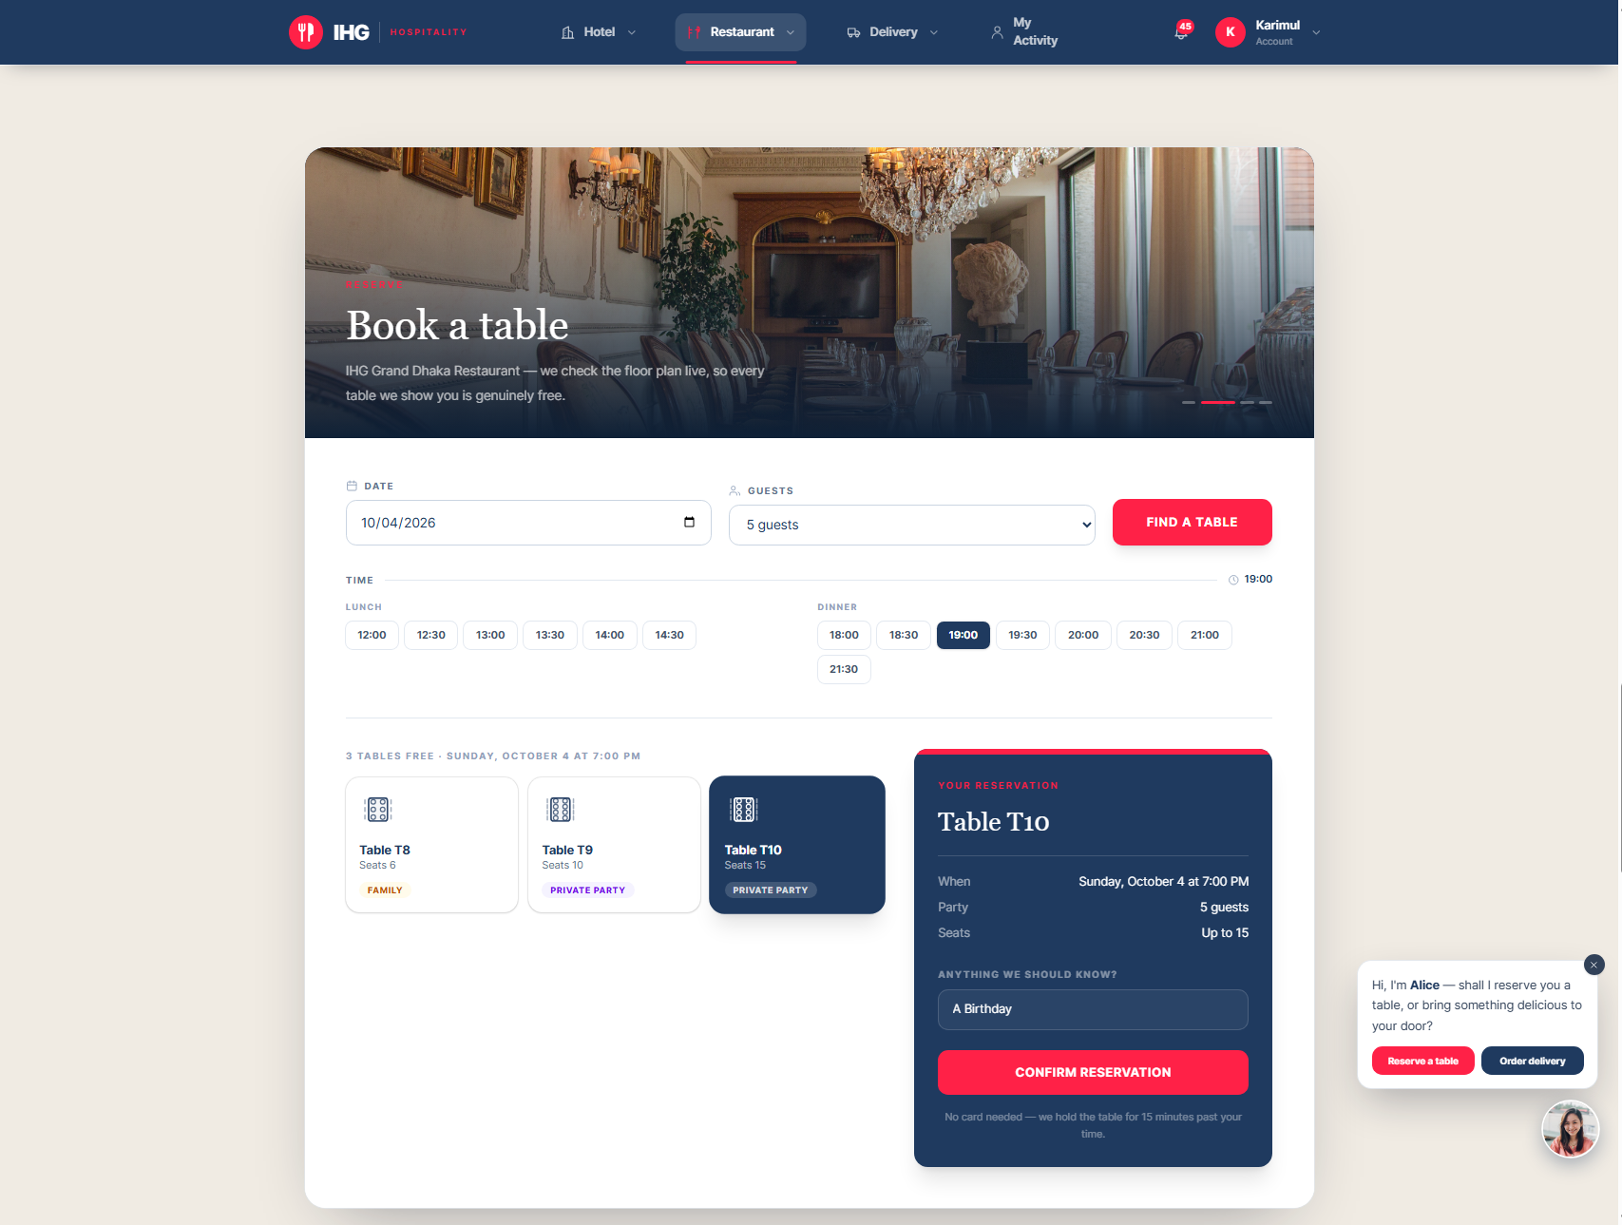
Figure 8 The Book a table panel with free tables and the reservation summary

5.2 If nothing is free
The panel says so plainly. Try a time half an hour either side, a smaller party, or another day. You can also choose Ask Alice to find an alternative.

5.3 Change your mind
Your reservation is listed under My Account → Reservations. Choose Cancel on a confirmed reservation and confirm. Cancelled tables are released straight away for others.

5.4 At the restaurant
When you arrive, your waiter seats you and takes your order. The kitchen receives it immediately, and your bill is settled with the waiter at the end of the meal. You can browse the full menu on the restaurant page beforehand.
CHAPTER 06 · GUESTS

Ordering food delivery
FOR Guests and customers
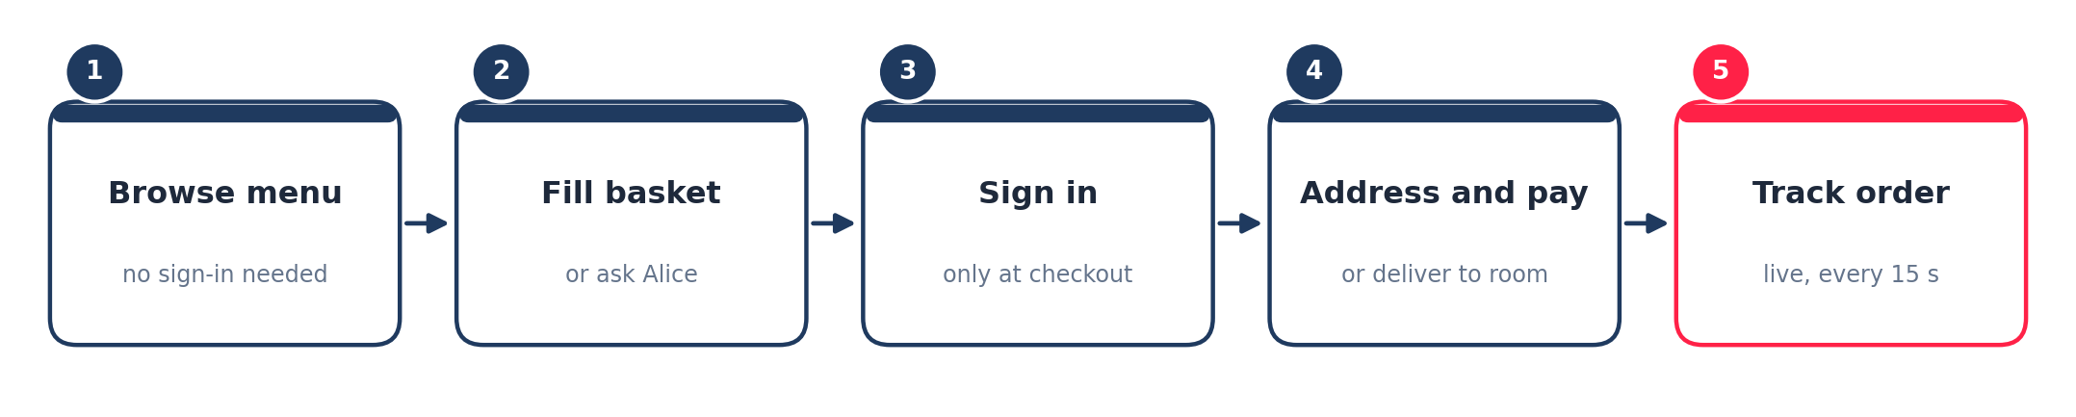
Figure 9 The delivery journey

6.1 Choose your food
- Choose Delivery in the top bar. The menu is open to everyone: no sign-in is needed to browse.
- Look through the sections. Dishes the chef is proud of are marked as signatures.
- Add dishes to your basket with the add button on each dish. Change quantities with the plus and minus buttons.

Your basket is remembered. If you leave the page, or sign in part-way, your dishes are still there when you return.
SCREENSHOT
The delivery menu with the basket
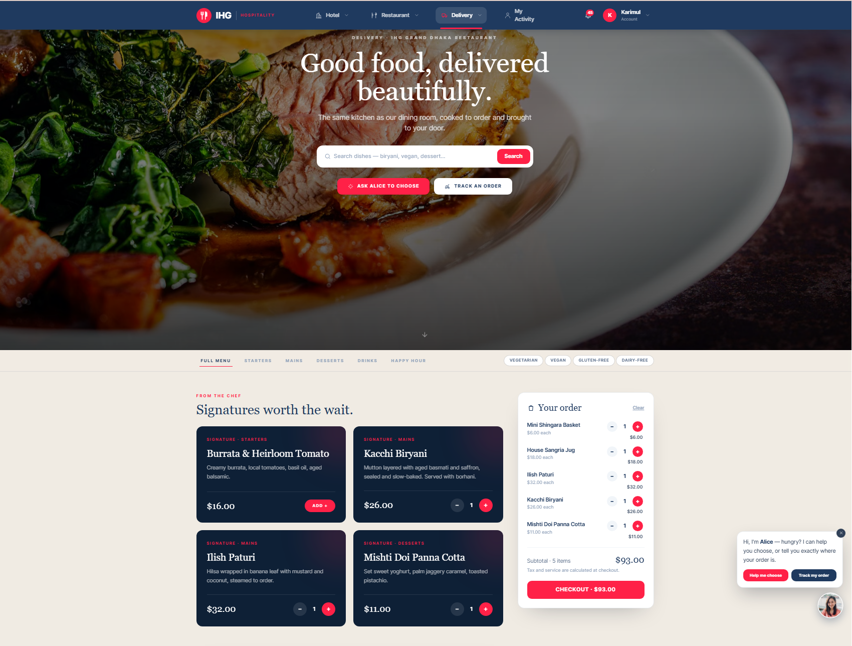
Figure 10 The delivery menu with the basket

6.2 Check out
- Choose to check out. You are asked to sign in if you have not already.
- Under Where should we deliver?, enter your address and a phone number for the rider. Add notes such as a gate code in Notes for the rider.
- Look at the line that says Typically 45–55 minutes. This is the kitchen and travel time the restaurant has set.
- Choose Visa, Mastercard or PayPal (demonstration mode).
- Optionally open Have a promotional code? (Chapter 7).
- Check the total in Your order, then choose Pay & place order.

Staying at the hotel? Deliver to your room
If you are checked in, a panel at the top of checkout reads Deliver to my room, already ticked, with your room number filled in. Untick it to type a different address.

SCREENSHOT
Delivery checkout with the room option and order summary
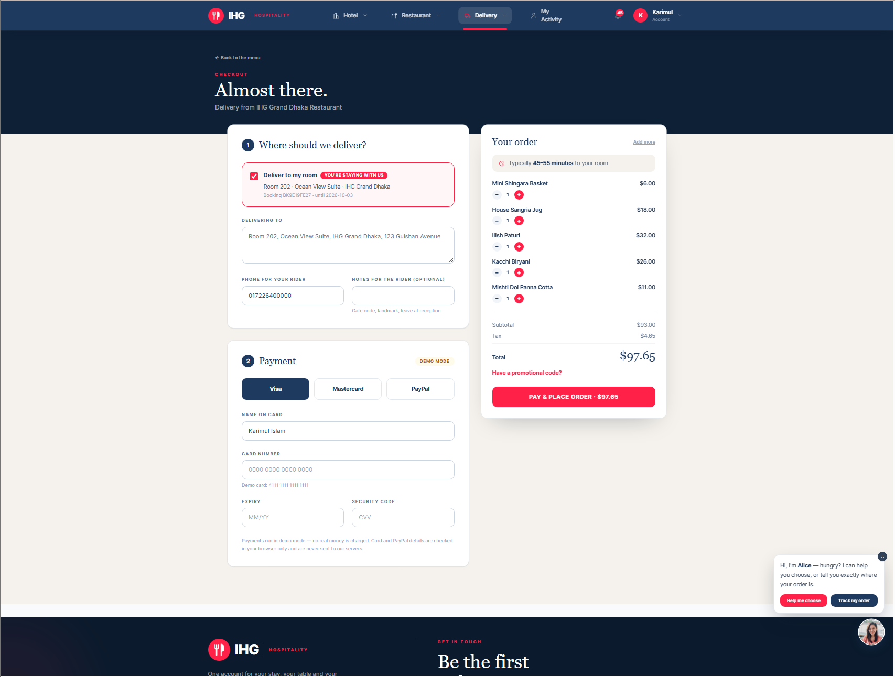
Figure 11 Delivery checkout with the room option and order summary

6.3 Follow your order
After you pay, the tracker opens. It shows each stage as it happens and refreshes by itself every 15 seconds:
- Received, then Confirmed by the kitchen.
- Being prepared, then Ready for the rider.
- On its way, with the rider’s first name once assigned.
- Delivered.
Your discount, if you used a code, appears as its own line in the summary.

6.4 Past orders and ordering again
Under Delivery → your orders you can see every earlier order and open its tracker. Choose Order again to put the same dishes back in your basket. Only dishes that are available today are added, so you never order something that is off the menu.

6.5 With Alice
On the delivery page Alice offers three things: Ask Alice to choose (tell her what you fancy and she suggests real dishes you can add with one word), Track an order (she reads out where it is), and Ask me anything.
CHAPTER 07 · GUESTS

Offers and promotional codes
FOR Guests and customers
Subscribers to the IHG list receive a personal discount code, 10% off by default, for their next hotel booking or delivery order. The percentage is set by management and can change.

7.1 Getting your code
- A subscribe invitation appears on the hotel, restaurant and delivery pages after you have been reading for a short while or scrolled part-way down. Each page has its own.
- Enter your email address (and first name if you wish), tick the consent box, and choose Join the list. The form at the bottom of every page does the same.
- Your code appears at once in a dashed box. Tap it to copy it. A welcome email also carries it.

SCREENSHOT
The subscribe invitation showing the offer
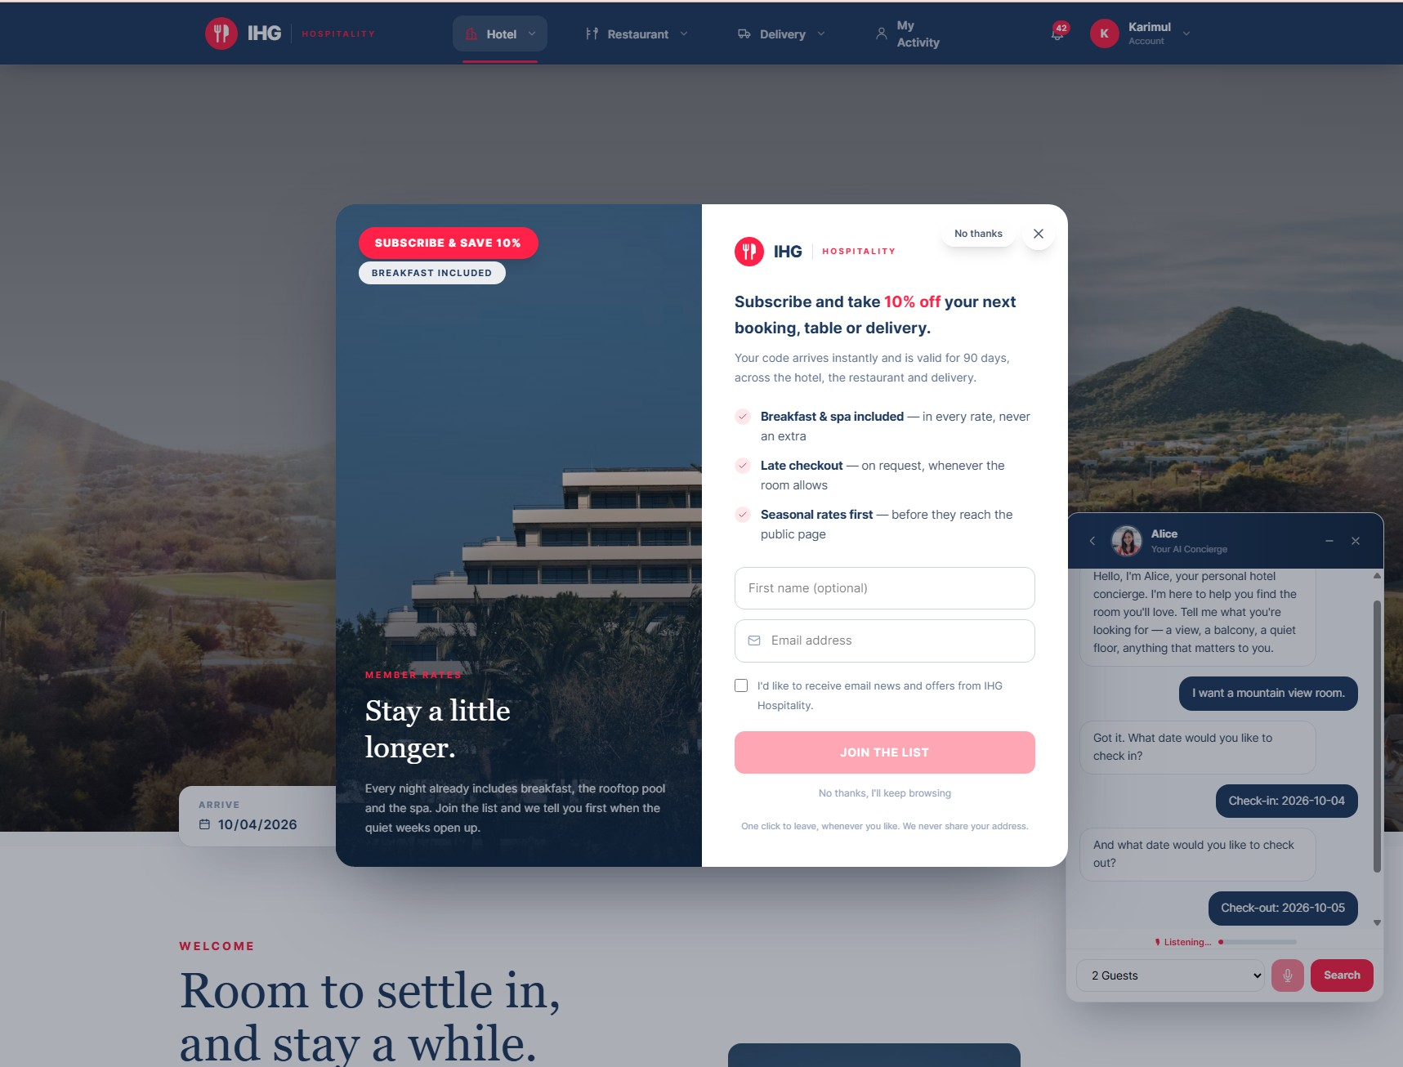
Figure 12 The subscribe invitation showing the offer

7.2 Using your code
- At hotel booking checkout or delivery checkout, open Have a promotional code?.
- Type or paste your code and choose Apply.
- A green bar confirms it and the saving appears as its own line in the summary, before you pay.
- Complete the booking or order as usual.

7.3 The rules
- One code per email address. Subscribing again shows you the same code.
- A code can be used once, on either a hotel booking or a delivery order.
- It is valid for 90 days from the day it is issued.
- It cannot be used on a dine-in restaurant bill, because those are settled with the waiter.
- If a payment fails because the code is wrong, nothing is booked and nothing is charged.

7.4 If a code is refused
Message | What it means
That code isn’t recognised. | A typing mistake. Codes use capital letters and numbers, without the letters O and I.
That code has already been used. | It was spent on an earlier booking or order.
That code has expired. | More than 90 days have passed.
That code is no longer active. | Management has switched it off.
Choose your dates first… | On the hotel page, the saving can only be worked out once dates are chosen.

CHAPTER 08 · GUESTS

Your account
FOR Guests and customers
Choose My Activity in the top bar to open My Account. Everything you have done is in one place, under six tabs.
SCREENSHOT
My Account with its six tabs
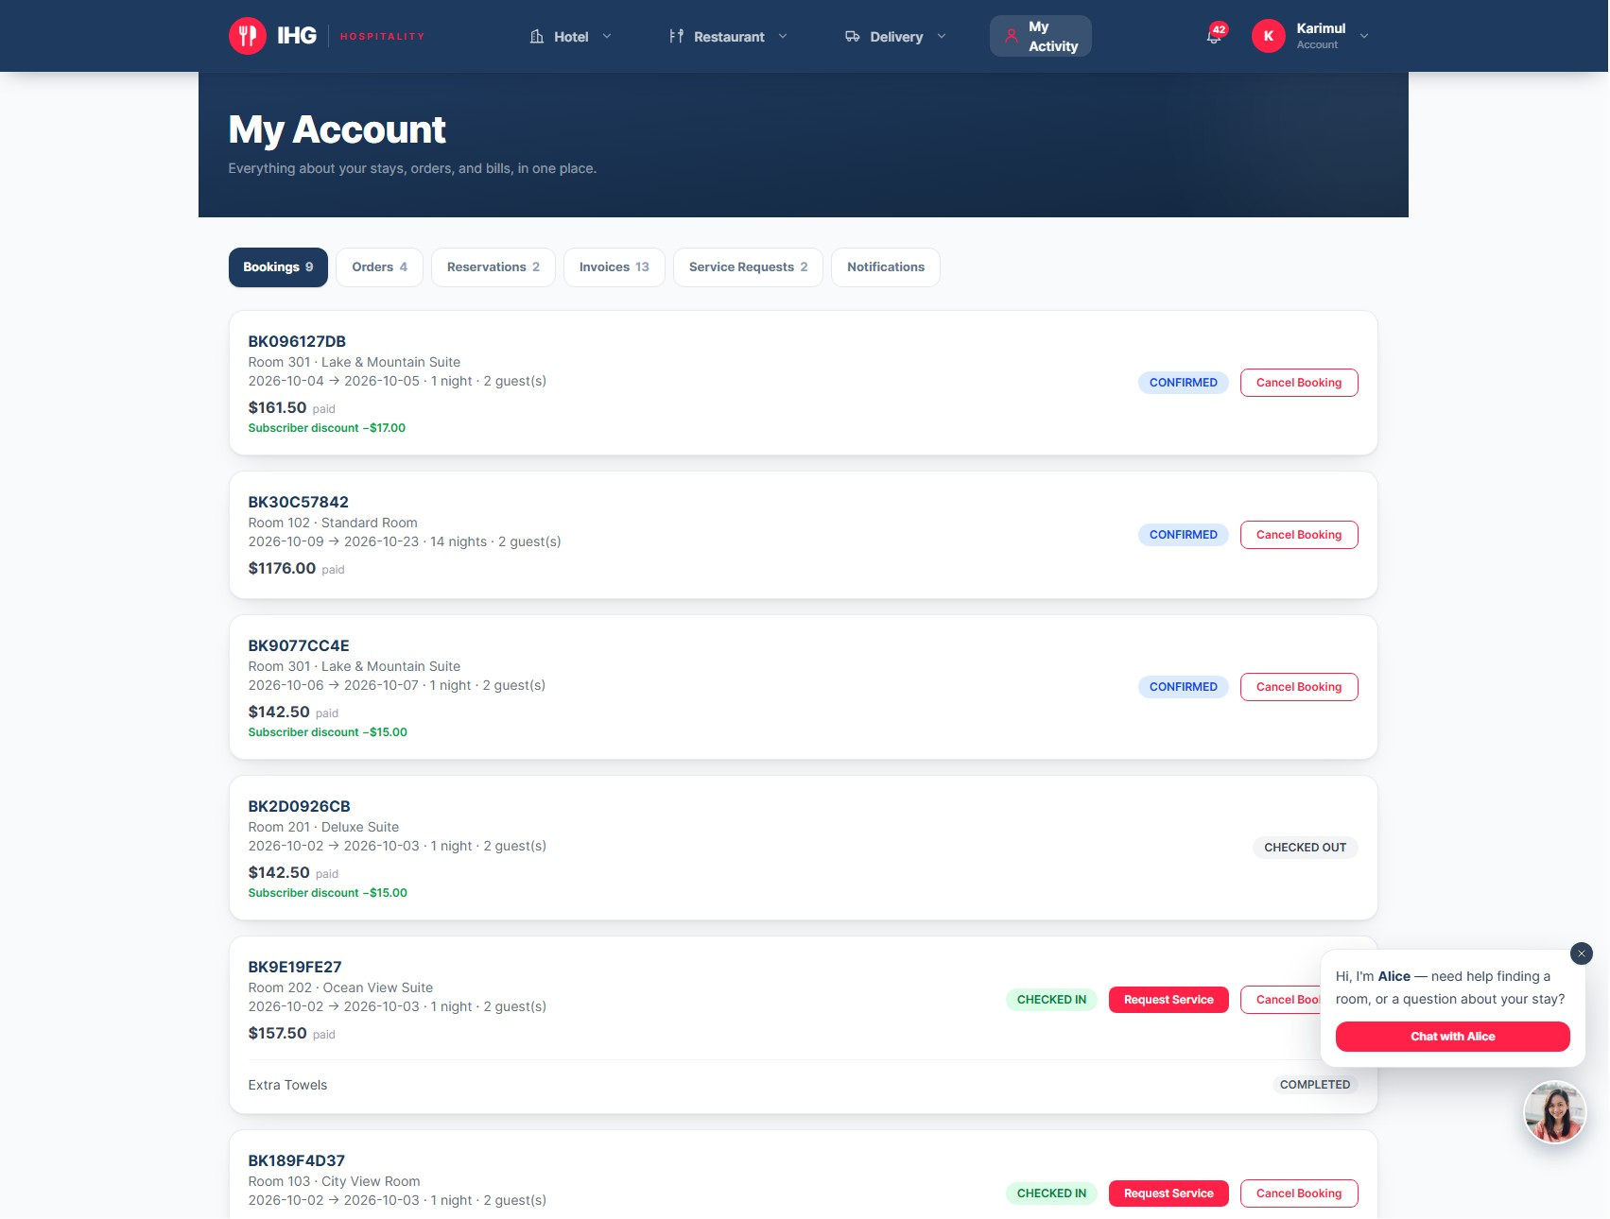
Figure 13 My Account with its six tabs
Tab | Shows | What you can do
Bookings | Reference, room number and type, dates, nights, guests, and what you paid with any discount. | Cancel a booking; request service once checked in.
Orders | Restaurant and delivery orders, their items, status and total. | Open a delivery’s status; see the rider.
Reservations | Your table reservations with date, time and party size. | Cancel a confirmed reservation.
Invoices | Hotel and restaurant invoices with their breakdown. | Pay an unpaid invoice (demonstration payment).
Service Requests | Every in-room request and its progress. | Follow a request through to completion.
Notifications | The history of your alerts. | Click one to jump to the matching tab.

8.1 Request a service during your stay
Once reception has checked you in, a Request Service button appears on your booking.
- Under Bookings, choose Request Service on your current stay.
- Pick the type: Room Cleaning, Extra Towels, Water, Food, Amenities or Other.
- Add a short note, for example “two extra towels”, and choose Request.
- Follow progress beneath the booking. When the request is completed you are notified.

Why the button might be missing
Service requests are only available during an active stay. Before check-in the booking shows no button, and after check-out the stay has ended.

8.2 Cancel a booking
On a confirmed booking choose Cancel Booking and confirm. Cancellation follows the hotel’s cancellation policy, which management sets in the business rules.

8.3 Invoices
Every booking and every delivery order creates an invoice with its subtotal, tax, any discount and total. Unpaid invoices show Pay Now (Demo). Invoices are also attached to your confirmation emails as PDF files.
CHAPTER 09 · STAFF

Working in the staff area
FOR All staff

9.1 Signing in
Sign in with the email address and password your manager gave you. The platform recognises your role and opens the staff area, showing only the screens your role needs. If a screen you expect is missing, your role does not include it.

9.2 The staff menu
A navy menu runs down the left of every staff page, in four groups. The page you are on is highlighted in red.
Group | Pages | Used for
Management | Dashboard, Reports, Business Rules, Audit Log, Inventory, Recipes, Notification Settings, Newsletter, Email Log | Running the business (managers and administrators).
Hotel | Bookings, Housekeeping, Service Requests, Invoices | Guests’ stays, cleaning and billing.
Restaurant | Tables, Orders, Reservations, Bills, Kitchen | The dining room and kitchen.
Delivery | Deliveries | Assigning riders and following orders to the door.

SCREENSHOT
The staff menu and a board page
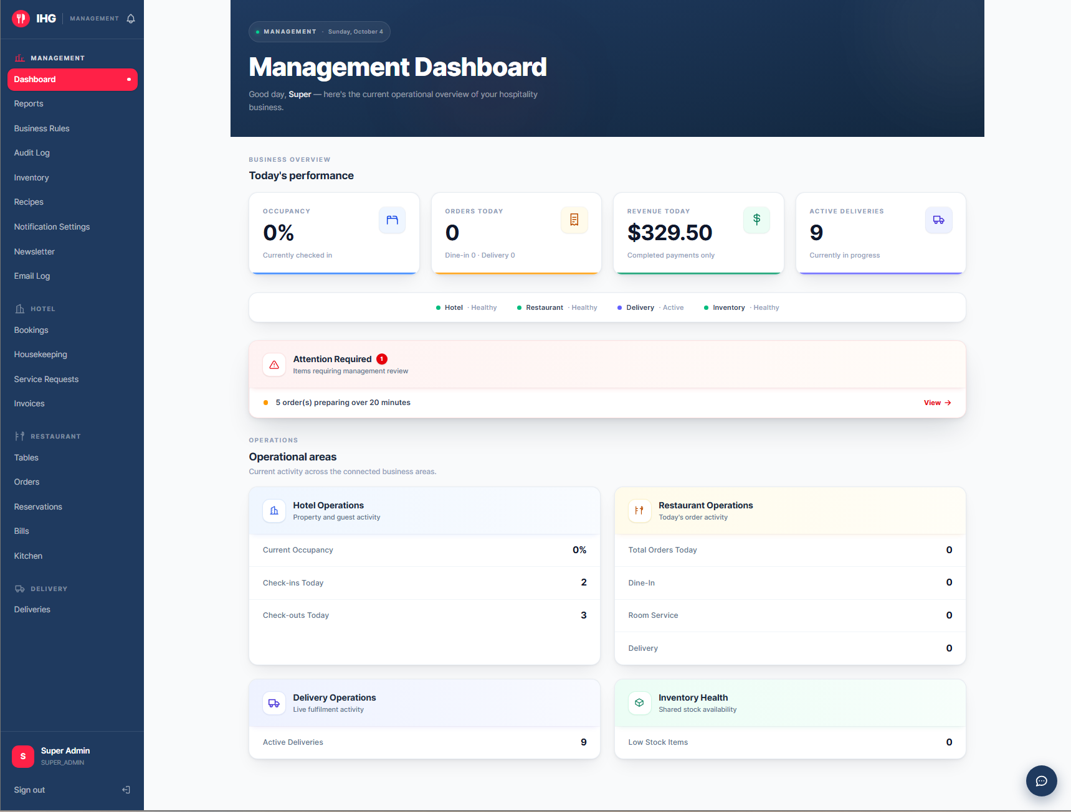
Figure 14 The staff menu and a board page

9.3 How the boards work
- Cards in groups. Work is shown as cards under headings with counts, for example “Needs confirming 4”. Each card shows what you need at a glance.
- Oldest first where waiting matters. Housekeeping, the kitchen and rider assignment list the longest-waiting work at the top. Bookings and orders show the newest first.
- Calm unless it is late. Cards are plain by default. Amber and red appear only when something has waited too long. Old test records over a day old are shown in grey, and often hidden by default behind a button such as Show 10 older than a day.
- They refresh themselves. The orders board refreshes every 20 seconds, the kitchen every 15, and deliveries every 20. You do not need to reload.
- Search and filters sit above each board. Show completed or Show closed reveals finished work.
- “All clear” is a good message: it means nothing is waiting.

9.4 Choosing a restaurant
Managers and administrators can see more than one restaurant, so the restaurant pages (Orders, Reservations, Kitchen, Deliveries, Bills) show a restaurant picker at the top. Waiters and kitchen staff are tied to their own restaurant and see no picker. If you see “Not assigned”, ask a manager to link your account to a restaurant.
Your first five minutes
Sign in, find your page in the menu, and check the count at the top of its first group. That number is the work waiting for you. Appendix A has a one-page quick-start card for each role.

CHAPTER 10 · STAFF

Reception
FOR Receptionists, managers, administrators
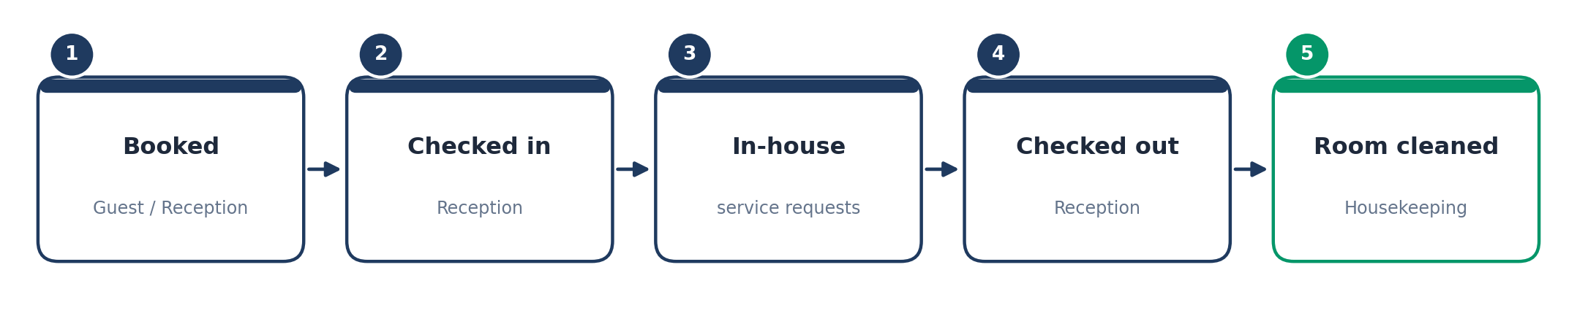
Figure 15 The life of a hotel stay

10.1 The Bookings board
Choose Hotel → Bookings. Bookings are grouped by where the guest is in their stay:
Group | Who is in it | Order
In house | Guests currently checked in | Newest booking first
Arriving today | Guests due to check in today | Newest booking first
Upcoming | Future arrivals | By arrival date
Past | Checked out or cancelled | Newest first

Each card shows the guest’s name, the room number and type, the dates and number of nights, any special requests, and what was paid, with any discount shown beside it.
SCREENSHOT
The Bookings board in its four groups
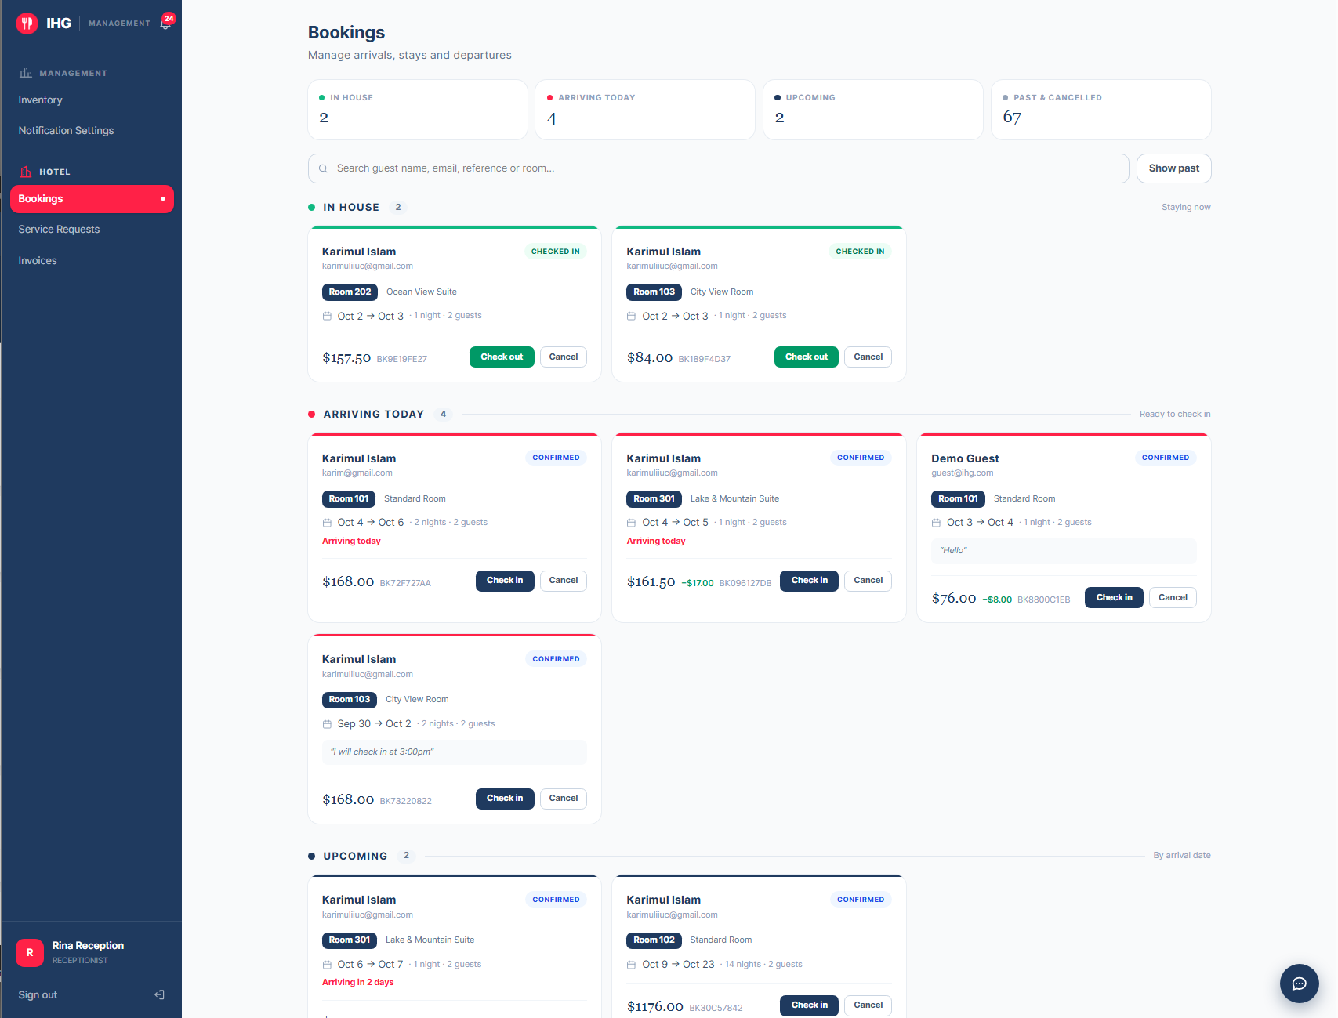

Figure 16 The Bookings board in its four groups

10.2 Checking a guest in
- Find the guest by name, room or booking reference in the search box, usually under Arriving today.
- Check the details on the card against the guest, including special requests.
- Choose Check in. The booking moves to In house, and the guest can now request services from their account.

10.3 Checking a guest out
- Find the booking under In house.
- Choose Check out. The booking moves to Past.
- The platform automatically creates a housekeeping task for that room, so cleaning starts without anyone passing a note.

A checked-in room cannot be double-booked
The platform refuses overlapping bookings for the same room, so you can never promise a room that is already taken for those nights.

10.4 Service requests
Choose Hotel → Service Requests. Requests from checked-in guests are grouped New, Being handled and Completed, with the longest-waiting at the top and the wait time on each card.
- Open a new request and read the type, the note and the room.
- Accept it so the guest and colleagues can see it is being handled.
- When it is done, mark it completed. If the service is chargeable, enter the price first. The guest is notified.

SCREENSHOT
Service Requests with new, in-progress and completed groups
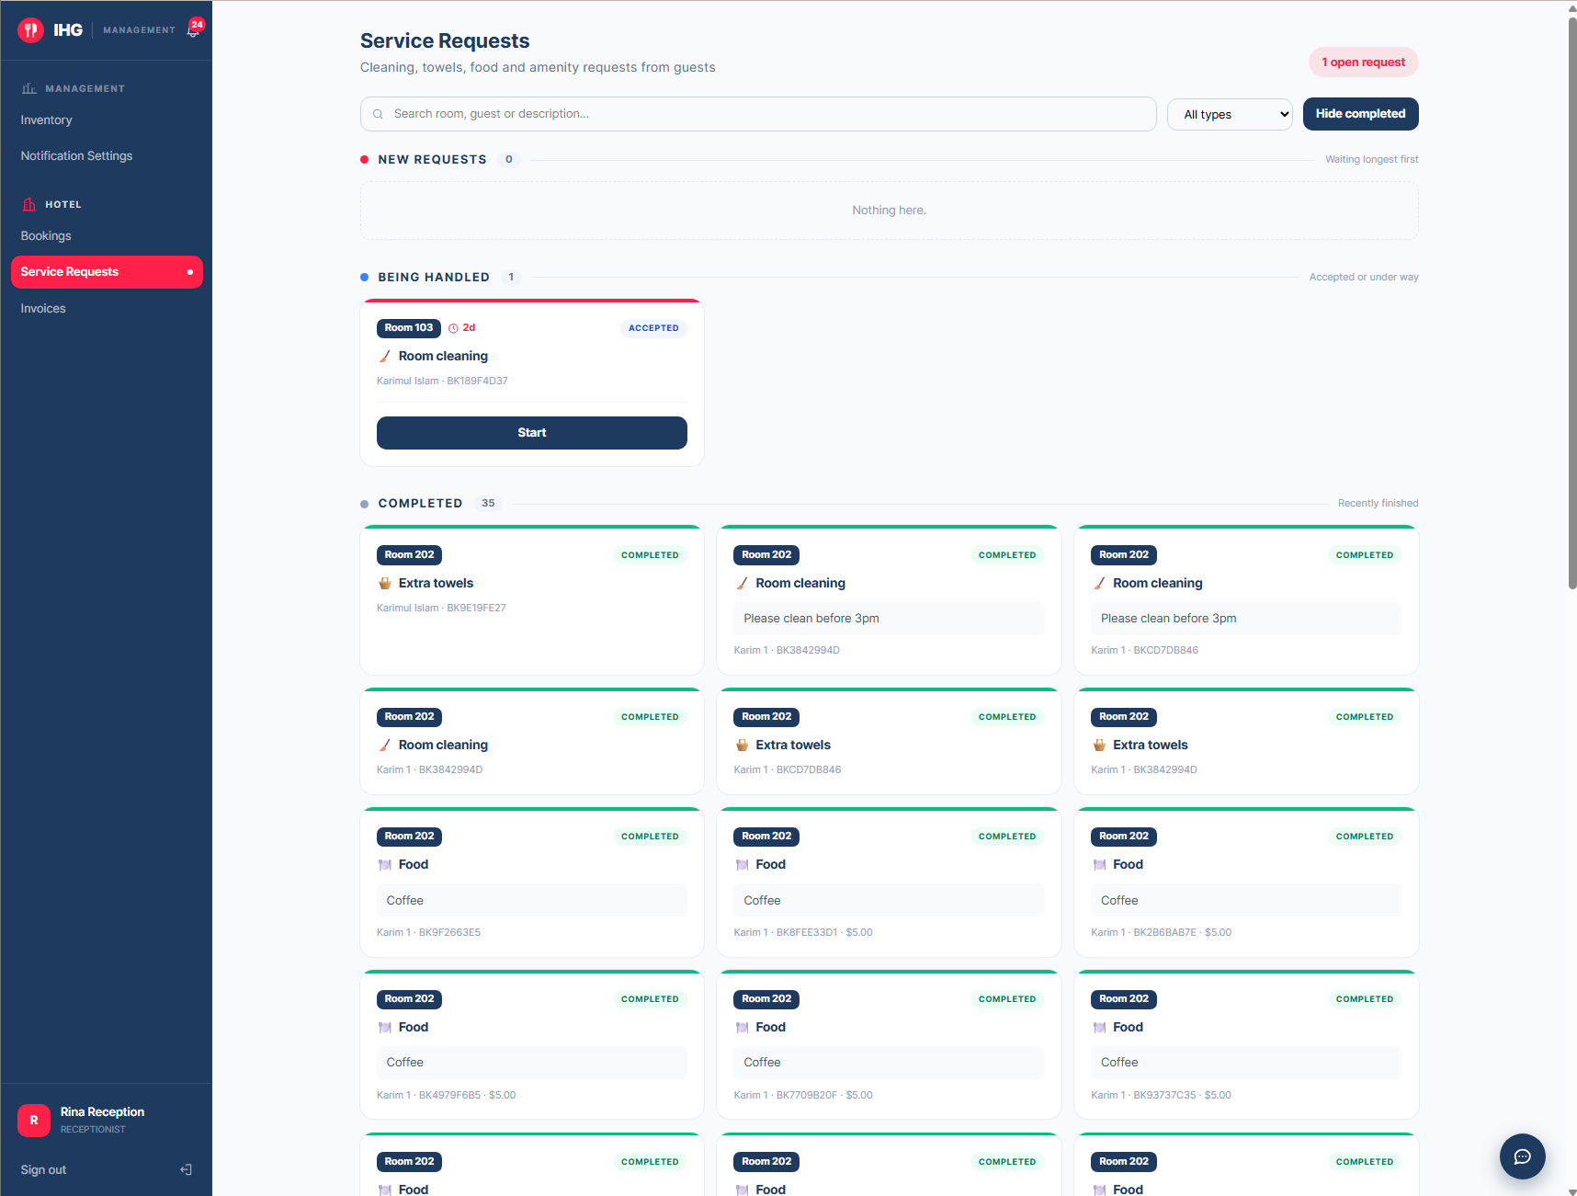
Figure 17 Service Requests with new, in-progress and completed groups

10.5 Invoices
Choose Hotel → Invoices for every hotel invoice. Use the search box, the four status filters and the four date ranges to find one. A summary at the top shows the total billed, collected and outstanding. Each row has buttons to download the invoice as a PDF or print it.
CHAPTER 11 · STAFF

Housekeeping
FOR Housekeeping staff, managers, administrators
Choose Hotel → Housekeeping. Every checked-out room becomes a cleaning task here. A red badge at the top right counts the rooms waiting.

11.1 The board
Group | Meaning
Waiting | Checked out, not yet started. The room that has waited longest is first: clean that one next.
Being cleaned | Someone has started.
Ready | Finished. Hidden until you choose Show finished.

11.2 Cleaning a room
- Find the room by number in the search box, or take the first card in Waiting.
- Choose Start cleaning. The task moves to Being cleaned.
- When the room is finished, complete the task from the same card. The room becomes available to sell again.

11.3 Reading the colours
Colour | Means
Navy edge | Recently added.
Amber | The room has waited over two hours.
Red | The room has waited over four hours. A room that cannot be sold holds up arrivals.
Grey | Waiting more than a day: almost certainly an old record to be tidied rather than a real emergency.

SCREENSHOT
The Housekeeping board
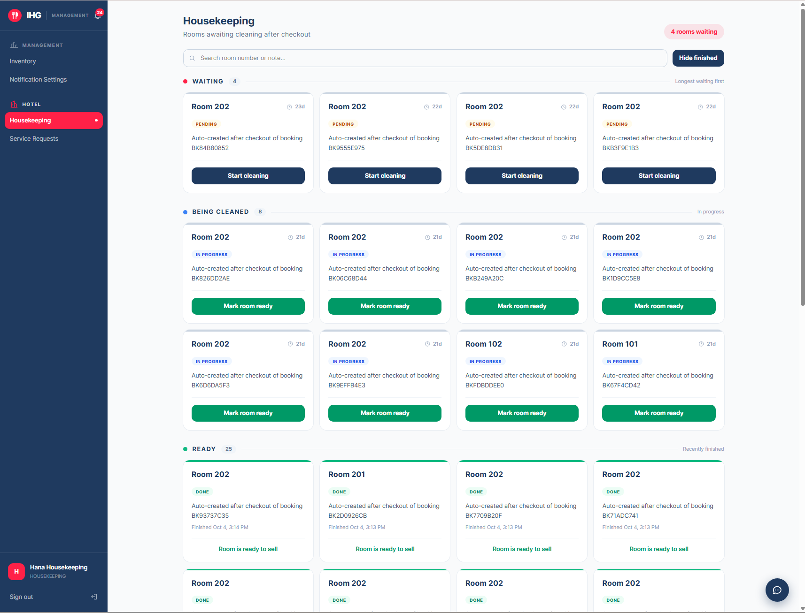
Figure 18 The Housekeeping board
CHAPTER 12 · STAFF

Restaurant floor: waiters
FOR Waiters, managers, administrators
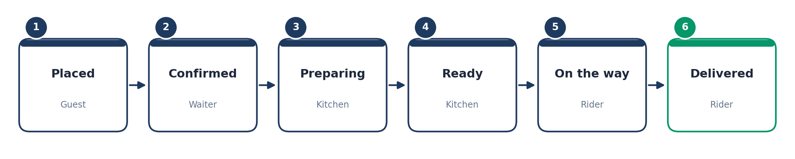
Figure 19 The life of an order, and who moves it

12.1 The Orders board
Choose Restaurant → Orders. Dine-in orders and delivery orders both arrive here. They are grouped by stage, newest first:
Group | Meaning | Your action
Needs confirming | A new order that the kitchen has not yet been told about | Confirm it.
With kitchen | Confirmed and being prepared | Nothing, unless it is running late.
Ready | Prepared and waiting | Serve it, or hand it to a rider.
Completed | Served, delivered or cancelled | None.

Each card shows the guest’s name, the table or delivery address, and the total number of dishes. The main button on a card is always the next step for that order.
Confirming is what sends the order to the kitchen
Confirming an order creates the kitchen ticket and also takes the ingredients out of stock, using each dish’s recipe. That is why stock levels stay accurate without anyone counting.

SCREENSHOT
The Orders board
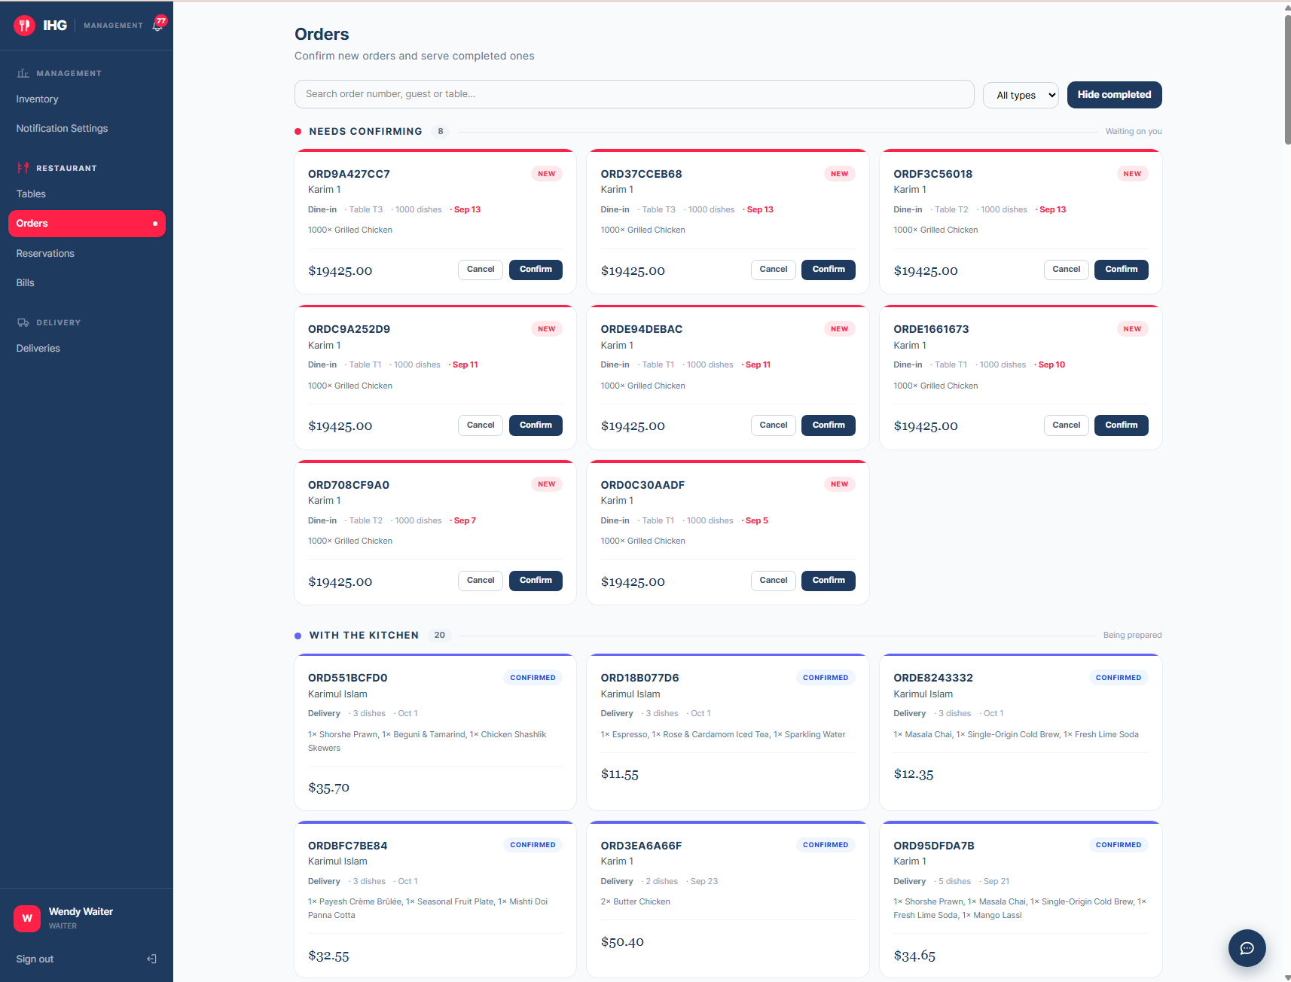
Figure 20 The Orders board

12.2 Reservations
Choose Restaurant → Reservations. Groups are Seated now, Arriving today, Upcoming and Past.
- When a party arrives, find them under Arriving today and mark them Seated.
- When they leave, mark the reservation Completed, which frees the table.
- If they do not come, mark No show. A guest who cancels beforehand cancels from their own account.

12.3 Tables
Restaurant → Tables lists the restaurant’s tables and how many each seats. The same list drives the floor plan guests see when they reserve, so a table you add or remove changes what guests can book.

12.4 Bills
Restaurant → Bills lists dine-in bills. Search by order number, filter by status and date, and see the totals billed, collected and outstanding. When a guest pays, choose Mark paid. Each row also has PDF and print buttons.
CHAPTER 13 · STAFF

Kitchen
FOR Kitchen staff, managers, administrators
Choose Restaurant → Kitchen. The board is a ticket display built to be read from a distance.

13.1 Two columns
Column | Contains | Order
To start | Confirmed orders nobody has begun | Oldest first: first in, first out
On the pass | Orders being prepared | Longest in progress first

Each ticket shows the order number, whether it is dine-in, delivery or room service, the table, and every dish with its quantity.

13.2 Working a ticket
- Take the ticket at the top of To start.
- Choose Start preparing. It moves across to On the pass.
- When the food is ready, choose Mark ready. The order moves to Ready for the waiter or rider to collect, and for a delivery the guest’s tracker shows “Ready”.

13.3 Reading the timers
Ticket looks like | Means
Navy edge, plain | Under 15 minutes. All is well.
Amber | Over 15 minutes. Getting long.
Red banner “Running late” | Over 25 minutes. Needs attention now.
Grey | More than a day old: an old record, hidden by default. Use Show … older than a day to reveal them.

SCREENSHOT
The Kitchen ticket board
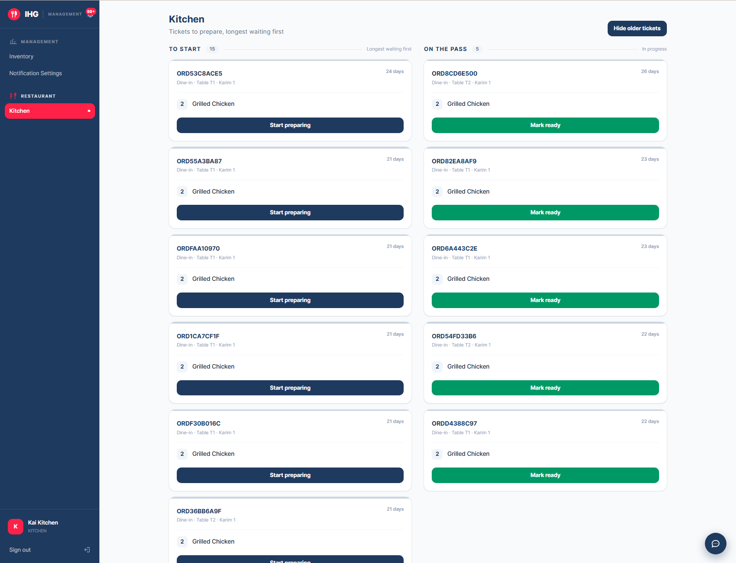
Figure 21 The Kitchen ticket board

CHAPTER 14 · STAFF

Deliveries and riders
FOR Dispatchers (waiters, managers, administrators) and riders

14.1 Dispatching orders
Choose Delivery → Deliveries. Four tiles across the top count the orders at each stage, and the cards below are grouped the same way:
Group | Meaning
Needs a rider | Confirmed and waiting to be assigned. Longest-waiting first. A card turns red if no rider has been assigned for over 20 minutes.
Rider assigned | A rider has been chosen and is collecting from the kitchen.
On the road | Picked up and out with the rider.
Delivered and cancelled | Closed. Shown when you choose Show closed.

- On a card under Needs a rider, open Choose a rider… and pick one.
- Choose Dispatch. The card moves to Rider assigned, shows the rider’s name, and the guest’s tracker shows who is bringing their food.

If the rider list is empty
A message above the cards says no riders are assigned to this restaurant. A manager or administrator must link rider accounts to the restaurant before orders can be dispatched.

SCREENSHOT
The Deliveries dispatch board
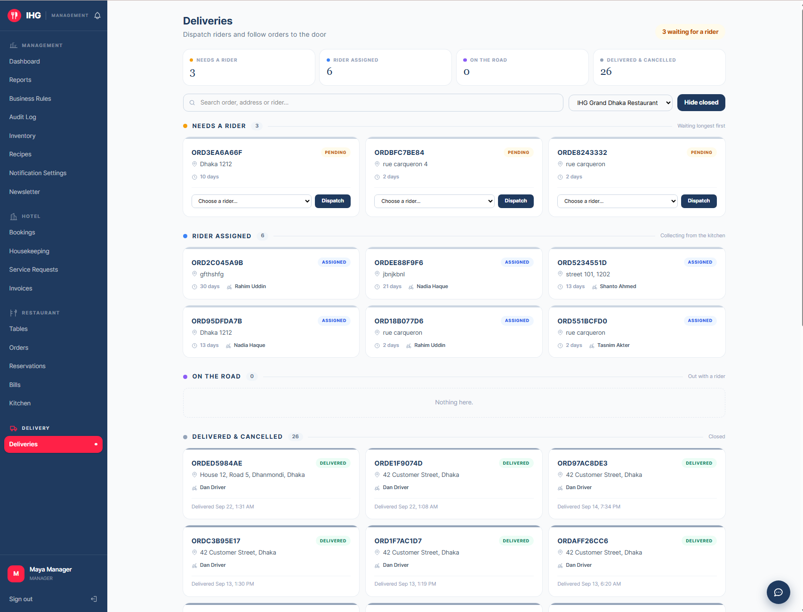
Figure 22 The Deliveries dispatch board

14.2 For riders
A rider signs in with a rider account and sees the deliveries assigned to them: the order number, the delivery address and the stage. As you collect an order from the kitchen and then hand it to the guest, you update its stage so that the guest’s tracker and the restaurant’s board stay correct.
Check this section against the live rider screen
This section describes a rider’s work from the platform’s delivery stages (assigned, picked up, out for delivery, delivered). The rider’s own screen was not reviewed when this manual was written, so confirm the exact button names before training riders, and add a screenshot below.

CHAPTER 15 · STAFF

Managers and administrators
FOR Managers and administrators
Managers run one property and its restaurants; administrators can see and change everything. Both have the Management group in the staff menu.

15.1 Dashboard
Management → Dashboard answers three questions: what is happening now, what needs attention, and how the business is doing. It shows live figures such as occupancy, orders today, active deliveries, low stock and today’s revenue, plus a list of items that need attention.
SCREENSHOT
The manager’s dashboard
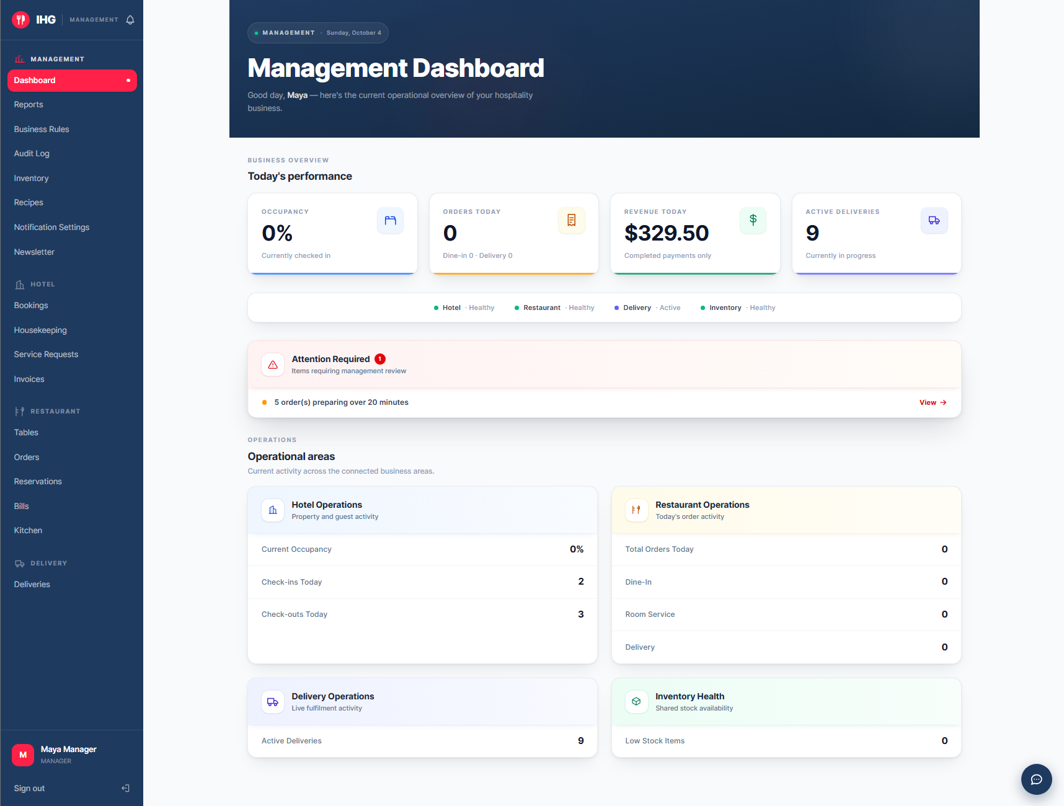
Figure 23 The manager’s dashboard

15.2 Reports
Management → Reports gives a performance report for a period you choose: today, yesterday, the last 7 days, the last 30 days, this month or last month. It covers revenue, bookings, orders, failed payments and inventory activity, each compared with the previous period so you can see the direction of travel.

15.3 Business Rules
Prices, taxes and policies are not fixed in the software. They are business rules that you change here, with no developer needed. Each change is recorded with who made it and why.
Rule | Controls
Tax rate | The tax added to bills and invoices.
Hotel cancellation deadline | How many hours before check-in a guest may still cancel.
Minimum and maximum stay | The fewest and most nights a booking may cover.
Maximum advance booking | How many days ahead guests may book.
Restaurant service charge | The service charge added to restaurant bills.
Default reservation length | How long a table is held for a reservation.
Kitchen bottleneck minutes | When the kitchen is flagged as running behind.
Service request escalation minutes | How long a request waits before it is flagged.
Kitchen preparation time, Rider travel time | Together they make the delivery estimate guests see.
Subscriber discount | The percentage taken off with a newsletter code.

Changing a rule
- Open Management → Business Rules and find the rule.
- Edit its value. Percentages are stored as fractions: 0.10 means 10%.
- Enter a short reason, then save. The change applies from now on and is kept in the rule’s history.

Who can change what
A manager can change rules for their own hotel and restaurants. Rules that apply to the whole platform can only be changed by an administrator. If two people edit the same rule, the second is told the rule changed and asked to reload, so nobody overwrites a colleague.

SCREENSHOT
The Business Rules page
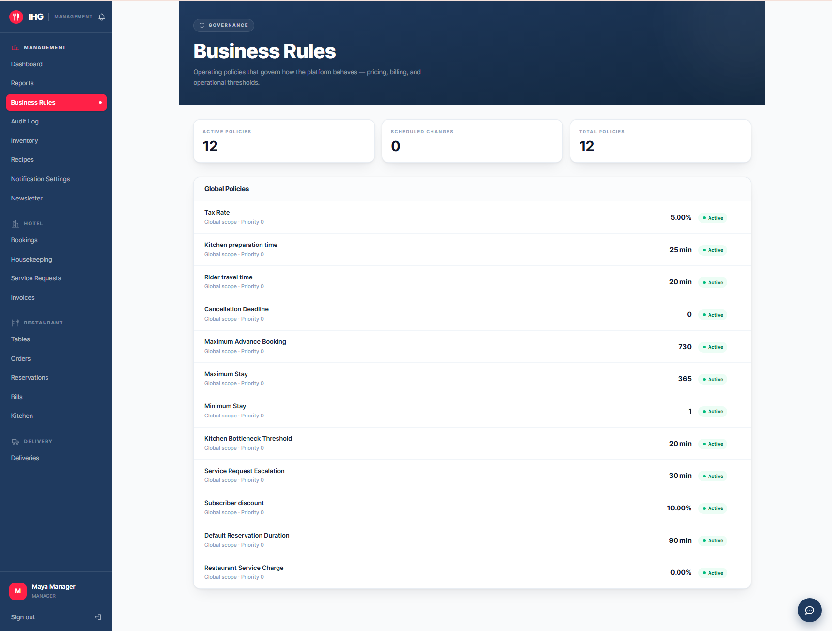
Figure 24 The Business Rules page

15.4 Inventory and recipes
Management → Inventory lists every ingredient and supply, with a stock bar, a search box, a low-stock filter and sorting. Open an item to see its history: every addition and every deduction, so a discrepancy can be traced. Create new items with the form at the top.
Management → Recipes defines what goes into each dish. When an order is confirmed, the platform deducts exactly those quantities from stock. Low stock raises an alert, and the dashboard counts it.

SCREENSHOT
Inventory with stock bars and the low-stock filter
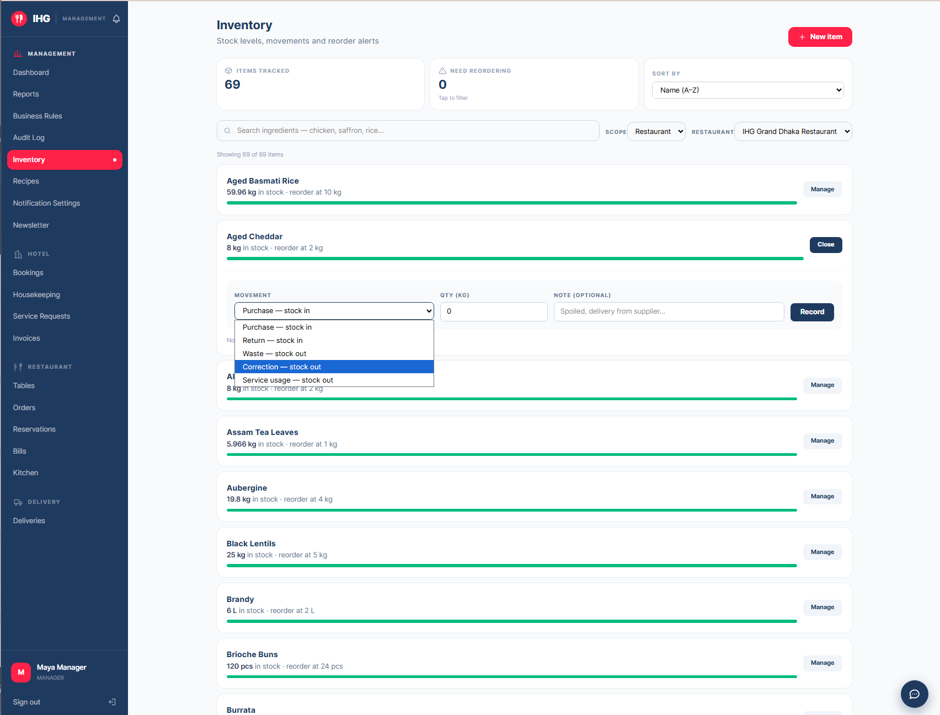
Figure 25 Inventory with stock bars and the low-stock filter

15.5 Newsletter and promotions
Management → Newsletter lists everyone who subscribed, with their name, email, and the source: which popup or form they used (for example the hotel, restaurant or delivery popup). Use the export button to download the list as a CSV file. The source column shows which page converts best.

15.6 Email Log and Notification Settings
Management → Email Log lists every email the platform has generated, with its delivery status and the reason for any failure. It is the first place to look when a guest says an email did not arrive. Notification Settings holds the preferences for alerts and emails.

15.7 Audit Log
Management → Audit Log records sensitive actions: changed business rules, completed service requests and similar, each with who did it and when. Use it to answer “who changed this?”.
CHAPTER 16 · REFERENCE

Statuses, alerts and emails

16.1 What each status means

Hotel booking
Status | Meaning
Confirmed | Booked and paid; the guest has not arrived.
Checked in | The guest is in the room.
Checked out | The stay is over.
Cancelled | Cancelled by the guest or staff.

Order (restaurant or delivery)
Status | Meaning
New | Placed; waiting for a waiter to confirm.
Confirmed | Sent to the kitchen; stock deducted.
Preparing | The kitchen has started.
Ready | Finished; waiting to be served or collected.
Served | Delivered to the table or the door.
Cancelled | Cancelled.

Delivery
Status | Meaning
Pending | Waiting for a rider.
Assigned | A rider is chosen.
Picked up | The rider has the order.
Out for delivery | On the way to the guest.
Delivered | Arrived.
Cancelled | Cancelled.

Other statuses
Item | Statuses
Table reservation | Confirmed, Seated, Completed, Cancelled, No show
Housekeeping task | Pending (Waiting), In progress (Being cleaned), Done (Ready)
Service request | Pending, Accepted, In progress, Completed
Invoice | Unpaid, Partially paid, Paid

16.2 Alerts and emails
The platform tells people what they need to know in two ways. The bell in the top bar shows an alert straight away. An email follows for the important moments. Examples include:
- A booking confirmation, with the invoice attached as a PDF.
- An invoice or payment confirmation.
- A new order for the restaurant, and “order ready” for the guest.
- A rider assigned to a delivery.
- A new service request for staff, and “completed” for the guest.
- Low-stock warnings for managers.
- A welcome email with the discount code when someone subscribes.
Emails are sent by the platform in the background, so a slow mail server never delays a booking or an order.
CHAPTER 17 · REFERENCE

Questions and troubleshooting

17.1 For guests
Question | Answer
The site is slow the first time I open it. | The platform sleeps when nobody has used it for a while. The first page can take up to a minute; after that it is fast.
Alice cannot hear me. | Allow the microphone when the browser asks, speak after “Listening…” appears, and use Chrome or Edge. Or simply type.
Alice’s voice sounds plainer today. | Her premium voice allowance has run out for now. She is using your browser’s voice, and everything still works.
I cannot see “Request Service”. | It appears only while you are checked in.
A room says “Booked for dates”. | Someone holds it on some of your nights. Try other dates or another room.
My promotional code is refused. | See the messages in section 7.4.
My booking email has not arrived. | Check your spam folder. The hotel can see in its Email Log whether it was sent.
“Order again” skipped a dish. | That dish is not available today, so it was left out on purpose.
Do I pay for real? | No. Payments are in demonstration mode.

17.2 For staff
Question | Answer
The page says “Not assigned”. | Your account is not linked to a restaurant. Ask a manager.
The Kitchen board looks empty. | “All clear” means nothing is waiting. Old tickets over a day are hidden: use Show … older than a day.
A card is red. | It has waited too long for its stage. Deal with it first.
There are no riders to choose. | Riders must be linked to the restaurant by a manager.
A guest says they did not get an email. | Open Email Log, search their address, and read the reason shown.
I changed a rule but guests still see the old figure. | Rules apply from the moment you save; ask the guest to reload the page.
The board has not updated. | Boards refresh themselves every 15 to 20 seconds. If something looks stuck, reload the page.

APPENDICES

Appendices

Appendix A. Quick-start cards
One short card per role, suitable for printing and pinning up. Each lists the first things to do on a shift.

Guest
- Browse freely; sign in only when you book, reserve or check out.
- Tap Alice, bottom right, for help finding a room, a table or a dish.
- Use Have a promotional code? at checkout if you subscribed.
- Find everything under My Activity.

Receptionist
- Open Hotel → Bookings and look at Arriving today.
- Check guests in; check them out when they leave. The room goes to housekeeping by itself.
- Open Service Requests; accept and complete what guests ask for.
- Use Invoices for PDFs and printing.

Housekeeping
- Open Hotel → Housekeeping.
- Take the first card under Waiting: it has waited longest.
- Choose Start cleaning, then complete it when the room is ready.
- Watch for amber and red cards.

Waiter
- Open Restaurant → Orders; confirm anything under Needs confirming.
- Seat guests from Reservations → Arriving today.
- Serve food when an order is Ready.
- Take payment and choose Mark paid under Bills.

Kitchen
- Open Restaurant → Kitchen.
- Start the top ticket under To start.
- Choose Mark ready when it is done.
- Amber after 15 minutes; red after 25.

Dispatcher and rider
- Open Delivery → Deliveries; look at Needs a rider.
- Choose a rider and Dispatch.
- Riders: collect from the kitchen, deliver, and update each stage.
- A red card has waited over 20 minutes.

Manager
- Start at Dashboard: what is waiting, what needs attention.
- Check Inventory for low stock.
- Adjust Business Rules for prices, tax and policies.
- Use Email Log and Audit Log to answer “what happened?”.

Appendix B. Training scenarios
Practice each scenario with a colleague playing the guest. A trainee has succeeded when they can do it unaided and say what the guest will see next.
# | Role | Scenario | Success looks like
1 | Guest | Find a room with a balcony for two nights next week, and book it using a promotional code. | Booking confirmed; the invoice shows the discount.
2 | Receptionist | A guest arrives for a booking made last week. Check them in, then later check them out. | Booking moves In house → Past; a housekeeping task appears.
3 | Housekeeping | Three rooms are waiting. Clean the one that has waited longest. | The right room is picked and ends up Ready.
4 | Waiter | A party of four arrives for their 7 pm reservation, orders, and pays. | Seated, order confirmed, bill marked paid.
5 | Kitchen | Two tickets arrive a few minutes apart. Prepare them in the right order. | The older ticket is started first; both are marked ready.
6 | Dispatcher | A delivery has waited 20 minutes. Assign a rider. | Card leaves Needs a rider; the guest’s tracker shows the rider.
7 | Manager | Change the subscriber discount from 10% to 15%, with a reason, then confirm it in the history. | New value saved; the change appears in the rule’s history.
8 | Guest | Order delivery to your room while checked in, and follow it on the tracker. | Address pre-filled; tracker updates through to Delivered.

Appendix C. Demonstration accounts
These accounts exist so each role can be tried out. Passwords are deliberately not printed in this document. The project owner supplies them separately, to the people who need them.
Role | Email address
Administrator | admin@ihg.com
Manager | manager@ihg.com
Receptionist | reception@ihg.com
Housekeeping | housekeeping@ihg.com
Waiter | waiter@ihg.com
Kitchen | kitchen@ihg.com
Delivery rider | driver@ihg.com (and other rider accounts)
Guest | guest@ihg.com

Retire these before real use
Change every password, or remove the accounts, before the platform holds real guest data. See Chapter 15 and the Deployment Guide.

Appendix D. Glossary
Term | Meaning
Alice | The platform’s AI concierge, which you can talk or type to.
Board | A staff page showing work as cards in groups.
Business rule | A setting such as the tax rate or cancellation window that managers can change without a developer.
Check-in / check-out | Marking a guest as arrived / departed. Reception does this.
Dispatch | Assigning a delivery rider to an order.
Folio / invoice | The itemised bill for a booking or an order.
Promotional code | A personal one-use discount code issued to newsletter subscribers.
Service request | A guest’s in-stay request: cleaning, towels, water, food or amenities.
Ticket | An order as the kitchen sees it.
Tracker | The live page showing where a delivery order is.

