CS352 Software Engineering II

Assignment

By

[Mohamed Samy Abbas] [20160208] [G-4] [ms2519299@gmail.com]

[Karim Mohamed Ali] [20160184] [G-4] [Kareem50329@gmail.com]

[Mohamed Ahmed Mostafa] [20160192] [G-4] [Mohammad.rady.98@gmail.com]

[2019]

Department of Computer Science

Faculty of Computers and Information

Cairo University

# 2019

1. Introduction:

An application that allows a client to send messages to all other clients on the network and receive from them all too.

1. System Architecture:

Peer To Peer Architecture

1. System Design:

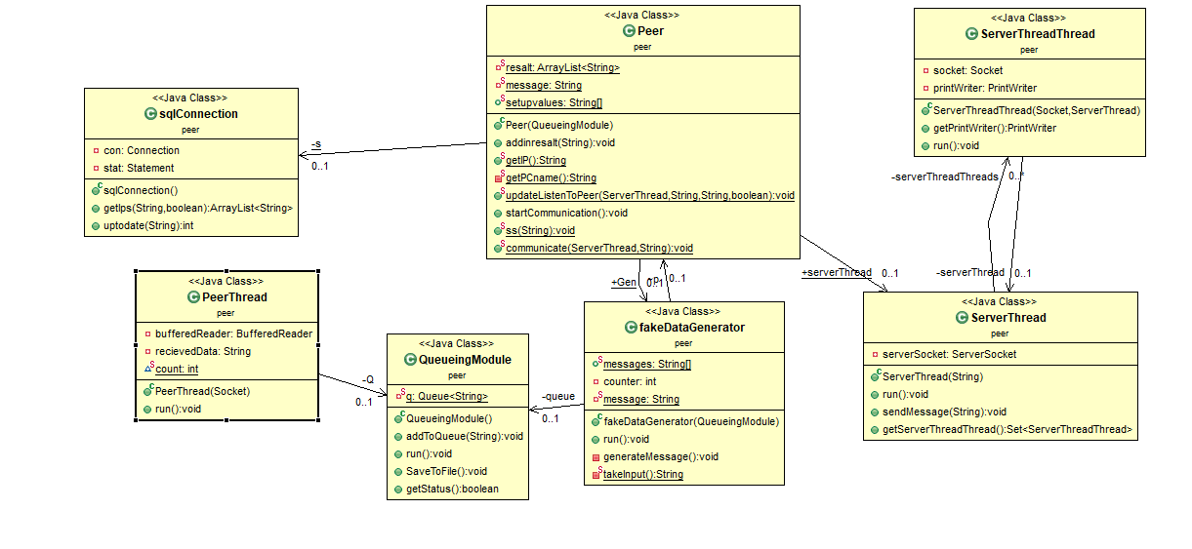

1. Description:

Peer:

Controls the peer as a client and as a server and starts the

PeerThread.

Responsible for receiving messages from other peers (Clients).

ServerThread:

Act as server and controls the ServerThreadThread

SreverThreadThread:

Responsible for sending the messages.

fakeDataGenerator:

Responsible for generating data an send it every random amount of time and send it to communicate method .

QeueingModule:

Responsible for adding in the queue then saving to the file the messages that the peer sends or receives.

1. Installation Guide

Run from jar file in dist folder with CMD   
Look at license file