SME Credit Default Prediction
Comparing Logistic Regression, Random Forest, Gradient Boosting and SVM
Technical and Results Report

Table of Contents
1. Introduction 3
2. Technical Part: The R Code 5
2.1 Libraries 5
2.2 Data Import and Preparation 6
2.3 Train/Test Split and Cross-Validation Setup 7
2.4 Model Training 7
Logistic Regression 8
Random Forest 9
Support Vector Machine 9
Gradient Boosting 9
2.5 Evaluation on the Test Set 9
2.6 Creation of the Figures 10
Figure 10: ROC-AUC and PR-AUC comparison 10
Figure 11: ROC curves 11
Figures 3 and 4: Brier scores and variable importance 11
2.7 Technical Remarks 12
3. Results and Graphs 12
3.1 Model Performance Comparison 12
3.2 ROC Curves 13
3.3 Calibration: Brier Scores 14
3.4 Variable Importance 15
3.5 Why the Linear Model Fails: An Interaction Effect 15
4. Conclusion 16

List of figures
Figure 1 : Libraries loaded at the start of the script 5
Figure 2 : Data import and conversion of the target and categorical variables 6
Figure 3 : Stratified 75/25 split and cross-validation configuration 7
Figure 4 : Training of the Logistic Regression and the Random Forest 8
Figure 5 : Training of the SVM and the Gradient Boosting model 8
Figure 6 : Computation of ROC-AUC, PR-AUC and Brier score for each model 10
Figure 7 : Code of the performance comparison chart 10
Figure 8 : Code of the ROC curves 11
Figure 9 : Code of the Brier score chart and the variable importance chart 11
Figure 10 : ROC-AUC and PR-AUC of the four models on the test set 12
Figure 11 : ROC curves of the four models on the test set 13
Figure 12 : Brier score of each model (lower is better) 14
Figure 13 : Top 10 most influential variables (Gradient Boosting) 15

List of tables

Tableau 1 : Packages and their roles 6
Tableau 2 : Summary of test-set metrics (ROC-AUC from the figure legend, others read from charts) 13
Tableau 3 : Default rate by median split of revenue growth and inventory change (full dataset) 16

1. Introduction
This report documents a machine-learning project whose goal is to predict whether a small or medium-sized enterprise (SME) will default on its loan within the next 12 months. Accurate default prediction is central to credit risk management: it supports loan approval, risk-based pricing and portfolio monitoring.
Four models are compared on the same data and with the same evaluation protocol: a Logistic Regression used as a baseline, a Random Forest, a Gradient Boosting Machine and a Support Vector Machine (SVM). The report has two main parts. Part 2 explains the R code step by step, with screenshots of the code (data preparation, split, cross-validated training, evaluation and figures). Part 3 presents and interprets the four figures produced by the project, and draws the conclusions.

2. Technical Part: The R Code
The whole project is written in R and relies on the caret package, which gives the four models the same training and evaluation protocol. The script follows a standard supervised-learning workflow: import and preparation of the data, a stratified train/test split, cross-validated training of four models, evaluation on the held-out test set, and creation of four figures. A fixed seed (set.seed(42)) makes the split and each model training reproducible. The screenshots below show the main parts of the code.

2.1 Libraries
The script starts by loading the following packages.
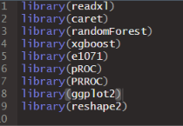
Figure 1 : Libraries loaded at the start of the script

Tableau 1 : Packages and their roles
Package | Role in the project
caret | Stratified split (createDataPartition), cross-validation and training (train, trainControl) of all four models
randomForest | Random Forest engine used by caret (method = "rf")
e1071 / kernlab | SVM with radial kernel (method = "svmRadial")
pROC | ROC curves and ROC-AUC
PRROC | Area under the precision-recall curve (pr.curve)
ggplot2, reshape2 | Bar charts; melt reshapes the results table for the grouped bar chart
readxl, xgboost | Loaded but not used in this script

2.2 Data Import and Preparation
The CSV file is read with read.csv. The target variable default_12m is converted into a factor with the valid level names "No" (0, no default) and "Yes" (1, default within 12 months). These names are required by caret when class probabilities are requested. The five text columns (loan_purpose, industry_sector, geographic_area, legal_form and application_channel) are converted to factors.
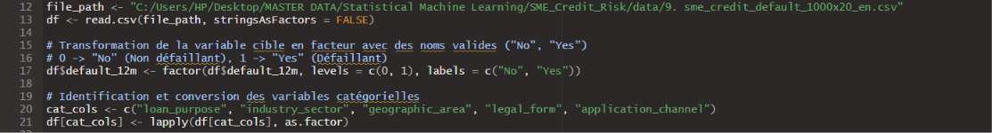
Figure 2 : Data import and conversion of the target and categorical variables
The dataset contains 1,000 SMEs and 21 columns: 20 predictors and the target. There are no missing values, and the classes are imbalanced, with 716 non-defaulting firms and 284 defaulting firms (a default rate of 28.4%). The predictors fall into three groups:
- Numerical financial variables: revenue_growth_pct, inventory_change_pct, debt_to_ebitda, cash_buffer_months, operating_margin_ratio, annual_revenue_eur_m, employee_count and firm_age_years.
- Binary indicators: prior_payment_delays, revolving_credit, personal_guarantees, export_activity, ecommerce_presence, iso_certification and audited_financials.
- Categorical variables: loan_purpose (4 levels), industry_sector (5), geographic_area (4), legal_form (4) and application_channel (3).

2.3 Train/Test Split and Cross-Validation Setup
The data is split into 75% for training and 25% for testing with createDataPartition. This function is stratified on the target, so both sets keep the same default rate. This gives about 750 training firms and about 250 test firms. The test set is used only once, for the final evaluation.
The object control, created by trainControl, defines the common training protocol: 5-fold cross-validation on the training set (method = "cv", number = 5), with class probabilities (classProbs = TRUE) and the twoClassSummary function. This function reports the ROC-AUC, the sensitivity and the specificity, and the ROC-AUC is the metric used to select the best hyperparameters.
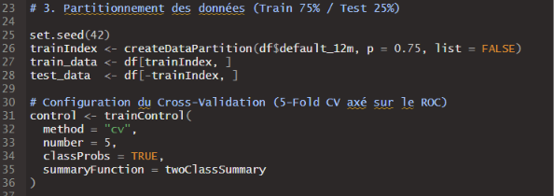
Figure 3 : Stratified 75/25 split and cross-validation configuration

2.4 Model Training
Four models are trained with the same formula (default_12m ~ .), the same training data, the same control object and the same selection metric (metric = "ROC"). Each call is preceded by set.seed(42) so that the cross-validation folds are comparable. Because the formula interface is used, caret automatically converts the categorical variables into dummy variables. This explains variable names such as loan_purposeinventory_financing in Figure 13.
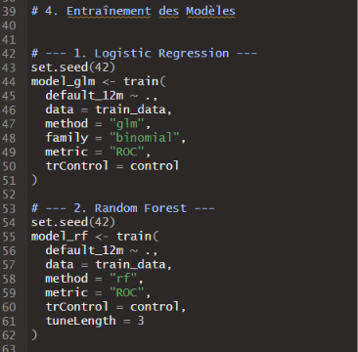
Figure 4 : Training of the Logistic Regression and the Random Forest
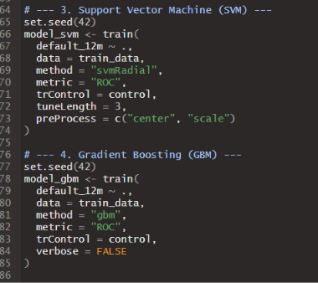
Figure 5 : Training of the SVM and the Gradient Boosting model

Logistic Regression
A generalised linear model with a binomial family (method = "glm"). It has no hyperparameter and serves as the baseline. It is linear in the log-odds, so it cannot capture interactions or non-linear effects unless they are added by hand.

Random Forest
An ensemble of decision trees built on bootstrap samples (method = "rf"). With tuneLength = 3, caret tests three values of mtry, the number of variables tried at each split, and keeps the one with the best cross-validated ROC-AUC.

Support Vector Machine
An SVM with a radial (RBF) kernel (method = "svmRadial"). The argument preProcess = c("center", "scale") standardises the predictors inside each cross-validation fold, which avoids data leakage. With tuneLength = 3, caret tests three values of the cost parameter, and the kernel width is estimated automatically.

Gradient Boosting
The gbm method builds trees one after another, each correcting the errors of the previous ones. No grid is given, so caret uses its default grid, which combines several numbers of trees and tree depths. The best combination is selected by cross-validated ROC-AUC.

2.5 Evaluation on the Test Set
The four trained models are stored in a named list and evaluated in a loop. For each model, the script predicts the probability of the class "Yes" on the test set, converts the true labels to 0/1, and computes three metrics, which are collected in the table results:
- ROC-AUC: computed with pROC. It measures how well the model ranks defaulters above non-defaulters.
- PR-AUC: computed with PRROC (pr.curve, auc.integral). It focuses on the minority class of defaulters and is more demanding than ROC-AUC when classes are imbalanced.
- Brier score: the mean squared difference between the predicted probability and the true outcome. It measures the quality of the probabilities, and lower is better.
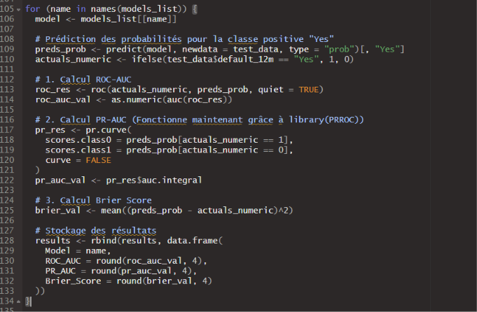
Figure 6 : Computation of ROC-AUC, PR-AUC and Brier score for each model
The results table is finally printed in decreasing order of ROC-AUC.

2.6 Creation of the Figures
Four figures are saved as PNG files in the figures folder, which is created if it does not exist. The code of the figures is summarised below.

Figure 10: ROC-AUC and PR-AUC comparison
The results are reshaped with melt into long format and drawn as horizontal grouped bars with ggplot2, ordered by score, with one colour per metric.
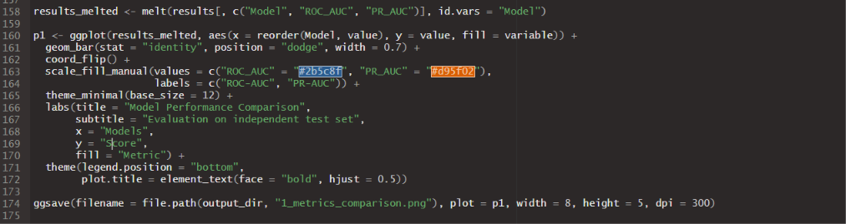
Figure 7 : Code of the performance comparison chart

Figure 11: ROC curves
The curve of the Gradient Boosting model is plotted first with the base plot function, and the other three models are added with lines, using a distinct colour and line type for each model. The AUC values in the legend are typed manually in the script.
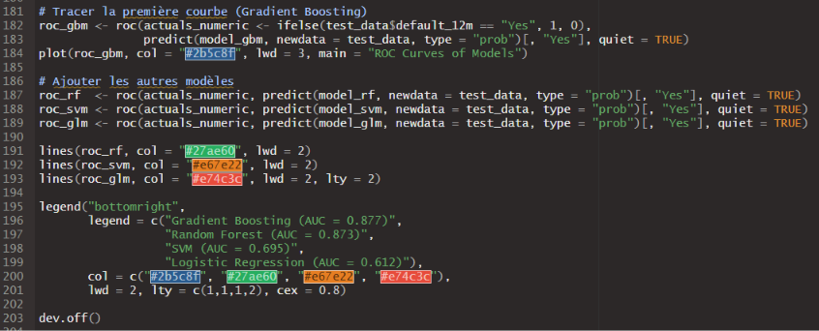
Figure 8 : Code of the ROC curves

Figures 3 and 4: Brier scores and variable importance
The Brier scores are drawn as a bar chart ordered from worst to best. The variable importance comes from the summary of the final gbm model, which gives the relative influence (rel.inf, in %) of each variable; the ten most influential are plotted.
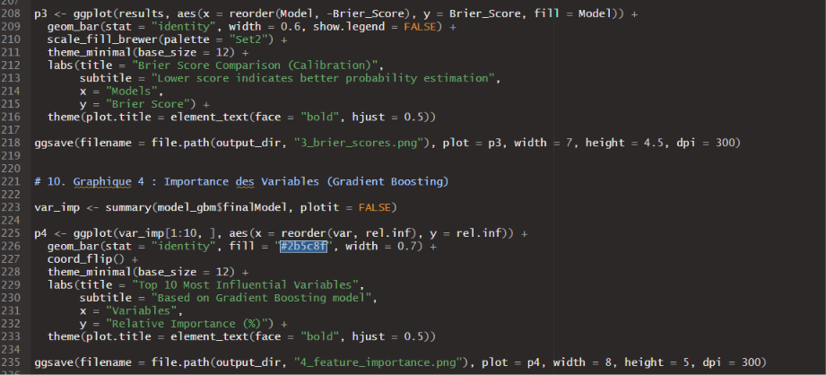
Figure 9 : Code of the Brier score chart and the variable importance chart

2.7 Technical Remarks
- Test set size: the test set contains about 250 firms, with roughly 70 defaults. The metrics therefore have a noticeable sampling uncertainty, and no confidence intervals are reported.
- Limited tuning: the Random Forest and SVM are tuned over three values only, and the Gradient Boosting over caret’s default grid. A wider search could improve the results.
- Hard-coded values: the AUC values in the ROC legend are typed by hand, and the file paths are fixed in the code. Both need to be updated if the script is run again on another machine or with another seed.
- Unused packages: the script loads readxl and xgboost but does not use them.

3. Results and Graphs
This part interprets the four figures produced by the project. All results are computed on the independent test set, which was not used for training or tuning.

3.1 Model Performance Comparison
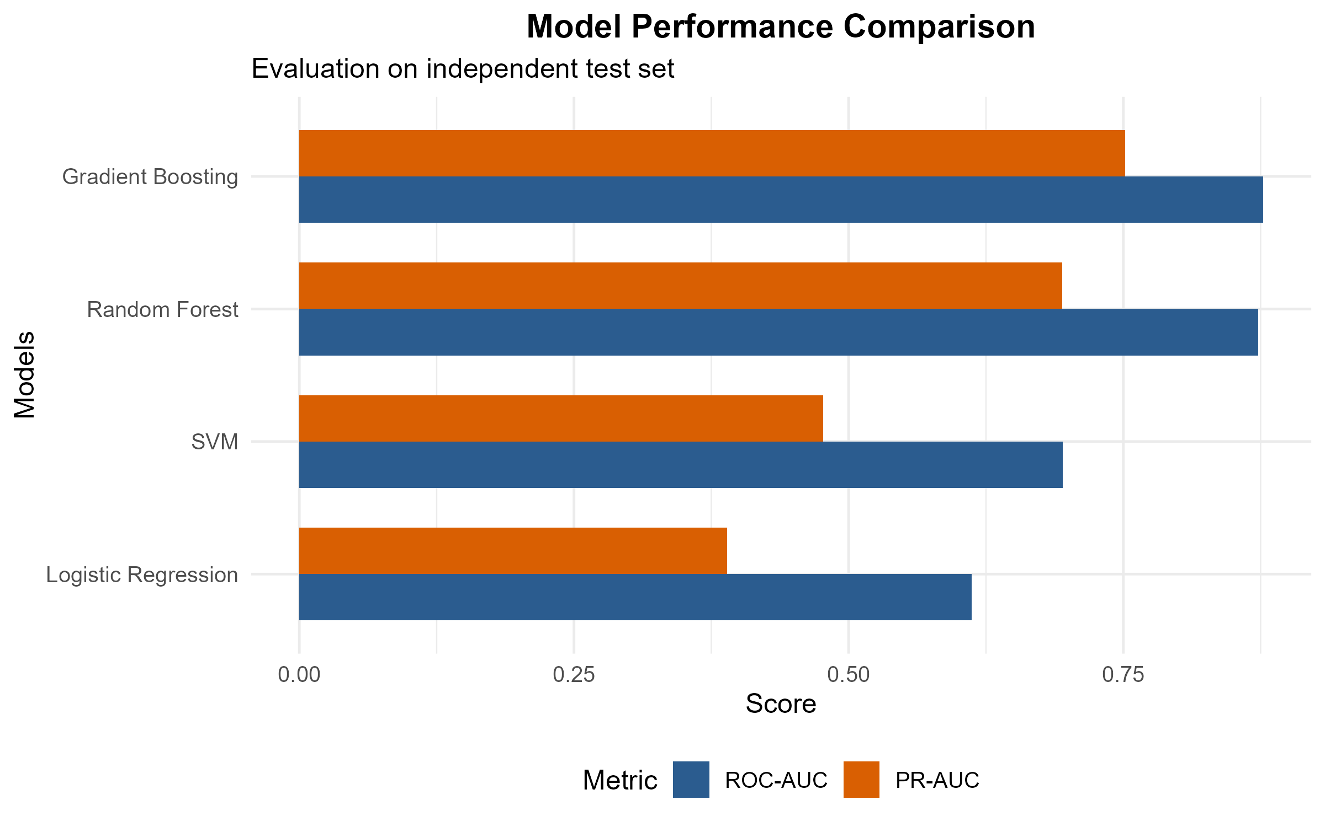
Figure 10 : ROC-AUC and PR-AUC of the four models on the test set
Figure 10 compares the models with two complementary metrics. Gradient Boosting is first on both, with a ROC-AUC of 0.877 and a PR-AUC of about 0.75. Random Forest is very close in ROC-AUC (0.873) but lower in PR-AUC (about 0.69). The SVM reaches 0.695 in ROC-AUC and about 0.47 in PR-AUC, and the Logistic Regression is the weakest (0.612 and about 0.39).
The PR-AUC values should be read against the default rate of 28.4%, which is the PR-AUC of a random classifier. The tree-based models are therefore far above chance, while the Logistic Regression is only moderately above it. PR-AUC values are read from the chart and are approximate.
Tableau 2 : Summary of test-set metrics (ROC-AUC from the figure legend, others read from charts)
Model | ROC-AUC | PR-AUC (approx.) | Brier (approx.)
Gradient Boosting | 0.877 | 0.75 | 0.131
Random Forest | 0.873 | 0.69 | 0.131
SVM | 0.695 | 0.47 | 0.186
Logistic Regression | 0.612 | 0.39 | 0.197

3.2 ROC Curves
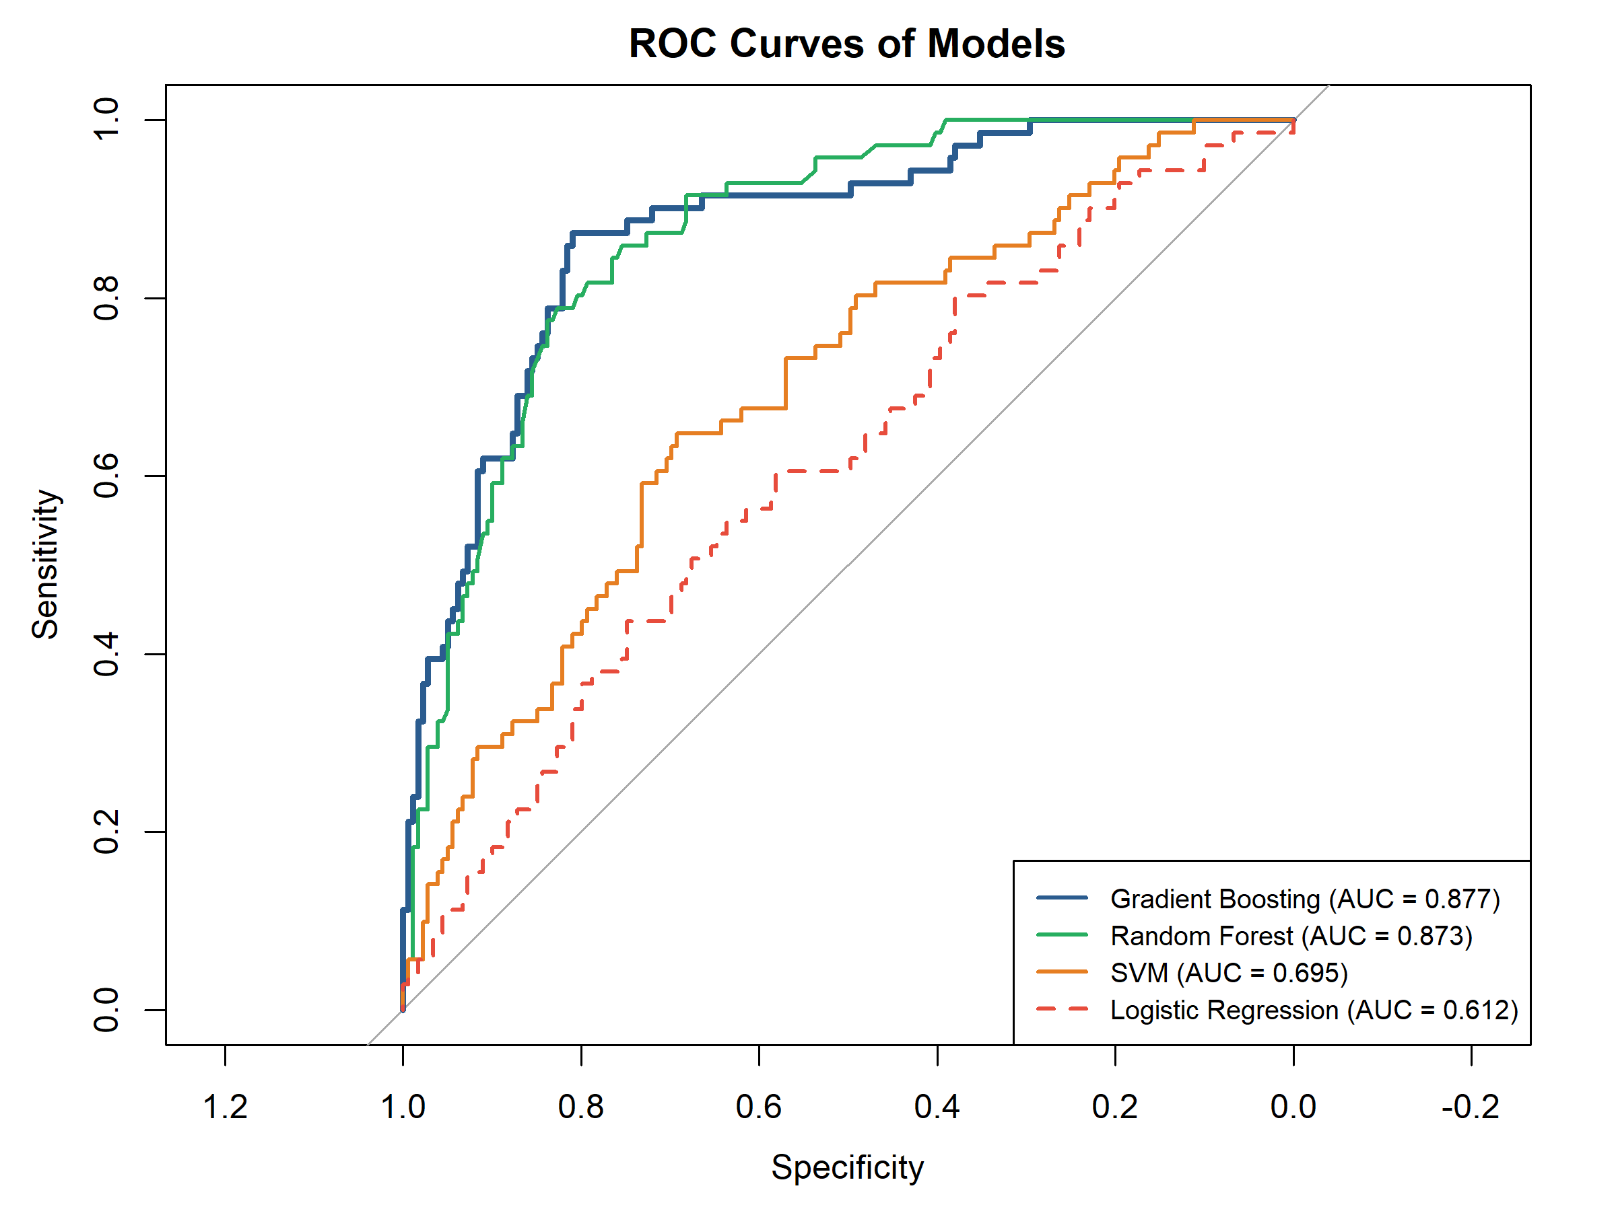
Figure 11 : ROC curves of the four models on the test set
The ROC curves in Figure 11 confirm the ranking of Figure 10. The Gradient Boosting (dark blue) and Random Forest (green) curves rise quickly towards the upper-left corner and stay close to each other. For example, they detect about 85% of defaulters while keeping the false positive rate around 25%. The Gradient Boosting curve is slightly higher in the low false-positive region, which is the zone that matters most for a lender who wants to avoid rejecting good clients.
The SVM curve (orange) is clearly lower and the Logistic Regression curve (red, dashed) stays close to the diagonal line of random guessing over a large part of the range. This means that these two models have only limited ability to separate defaulters from non-defaulters on this dataset.

3.3 Calibration: Brier Scores
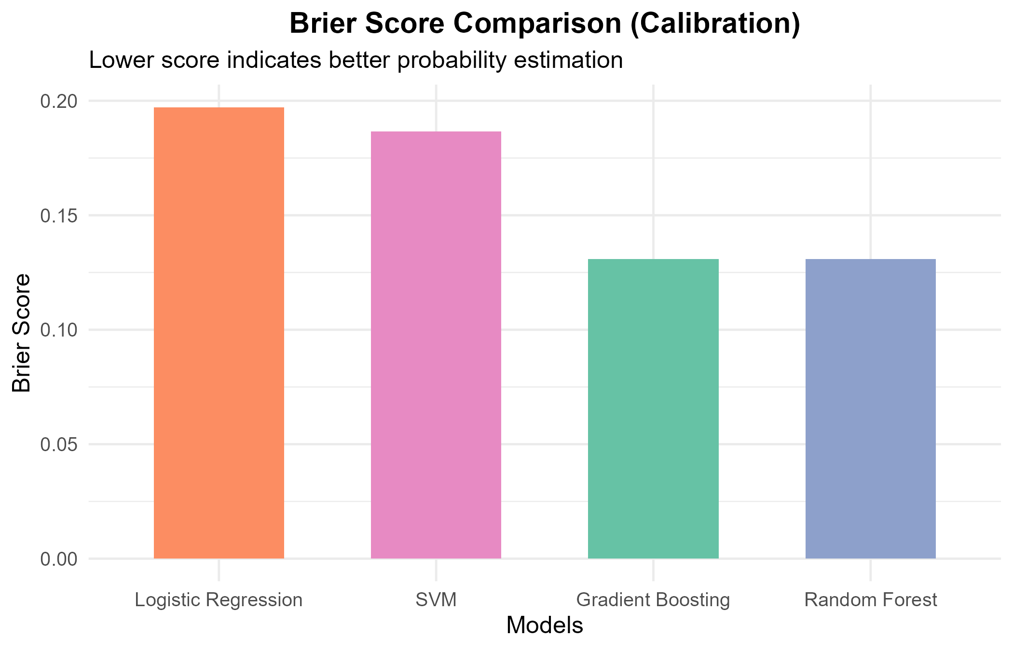
Figure 12 : Brier score of each model (lower is better)
The Brier score measures the quality of the predicted probabilities, not only the ranking. Gradient Boosting and Random Forest obtain the same, lowest score, about 0.131. The SVM follows with about 0.186 and the Logistic Regression is last with about 0.197.
A reference point helps to interpret these values. A naive model that always predicts the default rate of 28.4% would obtain a Brier score of 0.284 x 0.716, about 0.203. The Logistic Regression (0.197) is therefore barely better than this naive forecast, and the SVM improves on it only slightly. The two tree ensembles reduce the error by roughly one third, so their probabilities can be used more reliably for pricing or provisioning.

3.4 Variable Importance
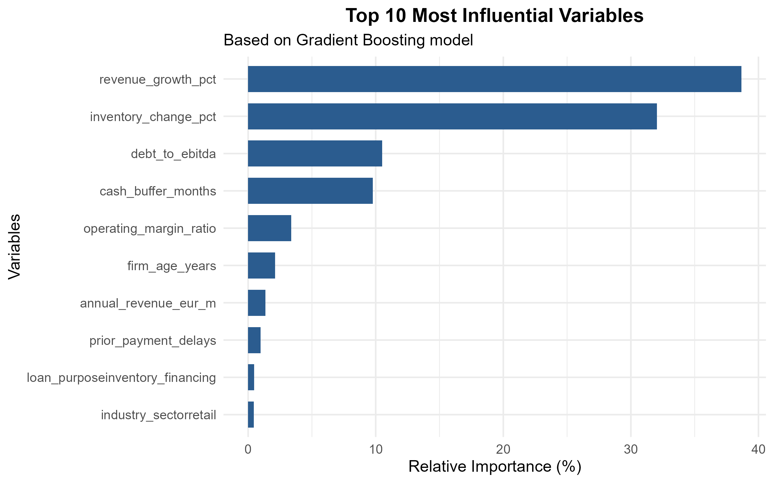
Figure 13 : Top 10 most influential variables (Gradient Boosting)
Figure 13 ranks the variables by their relative importance in the Gradient Boosting model. Two variables dominate: revenue_growth_pct (about 39%) and inventory_change_pct (about 32%), which together account for more than 70% of the total. They are followed by debt_to_ebitda (about 10%) and cash_buffer_months (about 10%). All other variables, such as operating_margin_ratio, firm_age_years, annual_revenue_eur_m, prior_payment_delays and the dummy variables for inventory financing and the retail sector, each contribute less than 4%.
This is consistent with the exploratory analysis: categorical variables such as sector or loan purpose show some default-rate differences, but the model finds the strongest signal in the dynamics of revenue and inventory, and in leverage and liquidity. Importance measures show how much a variable is used by the model; they do not indicate the direction of the effect.

3.5 Why the Linear Model Fails: An Interaction Effect
A striking feature of the results is the large gap between the tree-based models (AUC about 0.87) and the Logistic Regression (0.61), together with the dominance of revenue growth and inventory change in Figure 13. A supplementary check on the full dataset explains this. Individually, the two variables are almost uncorrelated with default (correlations of 0.013 and -0.029), so a linear model finds no signal. However, their combination is very informative. Splitting each variable at its median gives four groups with very different default rates:
Tableau 3 : Default rate by median split of revenue growth and inventory change (full dataset)
Revenue growth / Inventory change | Firms | Default rate
Low / Low | 246 | 9.3%
Low / High | 254 | 46.9%
High / Low | 255 | 49.0%
High / High | 245 | 6.9%

Firms where the two variables move in the same direction (both low or both high) rarely default, around 7% to 9%. Firms where they move in opposite directions default about half of the time. Economically, revenue growing while inventory shrinks, or revenue falling while inventory builds up, can signal stress such as unsold stock or overtrading. This pattern is an XOR-type interaction: no straight line in the log-odds can capture it, but decision trees find it naturally. A Logistic Regression that includes the interaction term revenue_growth_pct:inventory_change_pct should therefore perform much better than the plain version.

4. Conclusion
The project builds a complete and clean modelling pipeline in R: stratified 75/25 split, 5-fold cross-validated training with caret, and evaluation on an independent test set with three complementary metrics. The main findings are:
- Best model: Gradient Boosting is the best model (ROC-AUC 0.877, PR-AUC about 0.75, Brier about 0.131), closely followed by Random Forest (0.873).
- Reliable probabilities: the tree ensembles are also much better calibrated than the SVM and the Logistic Regression.
- Key drivers: revenue growth and inventory change drive the predictions, followed by leverage (debt_to_ebitda) and liquidity (cash_buffer_months).
- Reason for the gap: the main signal is a non-linear interaction between revenue growth and inventory change, which a standard Logistic Regression cannot capture.
For a practical deployment, Gradient Boosting is recommended as the scoring model. If regulators or credit committees require a transparent model, a Logistic Regression that includes the interaction term, or a small set of interaction-based risk bands, could be a more explainable alternative; its performance should then be checked with the same protocol.
Suggested next steps are: report confidence intervals (for example by bootstrap or repeated cross-validation) given the small test set; use wider tuning grids; add SHAP values or partial-dependence plots to show the direction of effects; and choose a decision threshold based on the relative costs of rejecting a good client and accepting a defaulter.

