**Report**

x = [16,24,32,40,48,56,64];

y = [0.000617,0.000832,0.019508,0.158078,2.817637,52.27,1290]; in seconds

figure

plot(x,y);

grid on;

title('break_RSA');

xlabel('num_of_bits')

ylabel('breaking_time in sec')

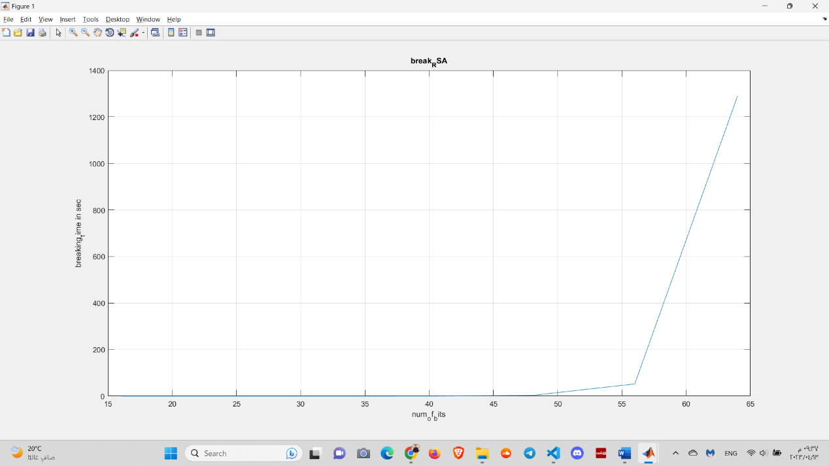

* This is the analysis result as the system take few time to break algorithm for keys with size to 48 bits and the time begins to increase and it increases significantly when key size is 64 bits as it takes about 21 minutes so I stopped here.
* For time of encryption/decryption, the system take 0 for encryption/decryption for keys with size to 116 bits and if I make key size is 128 bits, it takes large time so I stopped the system.