**Chandubhai S. Patel Institute of Technology, Department of Information and Technology. At. Changa, Dist. Anand-388421, Gujarat, India.**

**Prepared By : 20IT064 & 20IT082**

**Under Guidance of : Prof. Priyanka Patel**

**Project on Basic Travel Agency**

**Abstract :** The internet revolution has changed the scenario of travel industry through the easily accessible of travel products to the mass consumers by their virtual presence rather than physical. The online travel Portal is also known by Online Travel agent, E-travel agents and virtual travel agents . The concept of travel agents immersed as a connecting link between supplier and consumer. In a last 5-10 years techno friendly visitors prefer more to buy their travel services online like the online shopping of physical goods. The OTP has served vast prospects for travellers to buy their travel directly online thereby evading the traditional travel systems i.e. travel agencies. While serving as an intermediary means between service providers and tourists, internet has reduced the significance of the traditional intermediary (travel agents) or at the large extent traditional part became very uncommon in today's practice. Web-services may eventually progress to disintermediation of travel business since the travel facility and product suppliers can sell their products and services directly to the travellers. Yet, Traditional Travel agencies still have the benefit of serving personalized services particularly in giving advice to travellers with an individual touch.

1. **Introduction**

It is a basice website for tourism business. It is static and responsive web design. It is also called travel technology solution for agencies & tour operation. Nearly Everyone goes on a vacation for this a ‘travel system’ would play a vital role in planning the perfect trip. The main purpose is to help tourism companies to manage customer and hotels etc. The system can be used for both professional and business trips.

The proposed system maintains centralized respository to make necessary travel arrangements and to retrieve information easily. Tourists are more attractive for cultural diversity of the world.

Many entrepreneurs ask how to put up a travel agency; the following questions come into mind: Is the business profitable? Will I succeed in this field? What do I need to know?  
We, people who committed ourselves to study the ways of industry and how to adapt to technological and demographical changes in the travel and tour industry came up with this effective research to help entrepreneurs be able to benchmark on this study. In writing this we got the help of stakeholders, trusted websites, several printed materials, and we applied everything we learned in the four walls of our classroom, the different principles and methodologies to come up with this informative research.

1. **Objective**

The objective of this project is to develop a system that automates the process and activities a travel and agency and customer details. The purpose is to design a system using which one can perform all operation related to travelling and sight-seeing.

1. **Motivation**

The purpose of website is established fact that internet users are increasing today. Today one of the main purposes of the website is to facilitate the offline customer online because customers cannot spend their precious time in markets trying to find out the best deal. Our priority will be our customers and their travel requirements. we will putting an effort to provide the right choice to the people when they plan a holiday and beware them from the false advertising.

* **Proposed Model :**

The proposed website model has below mentioned features:

* LOGIN
* MANAGE TOUR PACKAGES
* MANAGE TICKET BOOKING
* VIEW FEEDBACK
* CONTACT FORM
* VIEW PACKAGES
* BOOKING
* GIVE FEEDBACK

1. **Our Approach**

**Flow Chart**

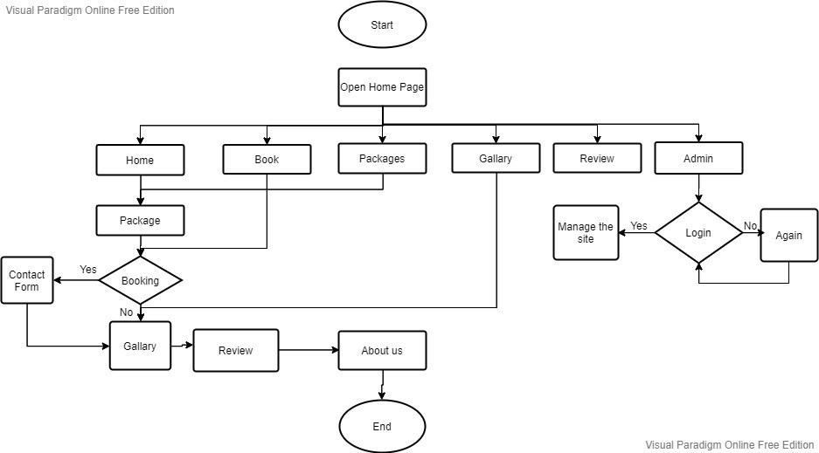

* **ABOUT THIS PROJECT :**
* This website is develop to provide best travelling services to the customers and travel agents. We have developed tours and travel management system to provide a search platform where a tourist can find their tour places according to their choices.
* This system also helps to promote responsible and interesting tourism so that people can enjoy their holidays at their favorable places.
* This system also helps to develop tourism with different cultures so that they enrich the tourism experience and build pride.
* The purpose of website is established fact that internet users are increasing today. Today one of the main purposes of the website is to facilitate the offline customer online because customers cannot spend their precious time in markets trying to find out the best deal.
* Our priority will be our customers and their travel requirements.
* we will putting an effort to provide the right choice to the people when they plan a holiday and beware them from the false advertising.

1. **Hardware and Software requirement**

**Hardware Requirements:**

Processor-At least 2.0 GHZ ,RAM-At least 2GB

**Software Requirements:**

Operating System-Windows, Front End-HTML , CSS, Javascript, Bootstrap,Runtime Environment- the Visual Studio Code IDE

**HOME PAGE & LOGIN PAGE :**

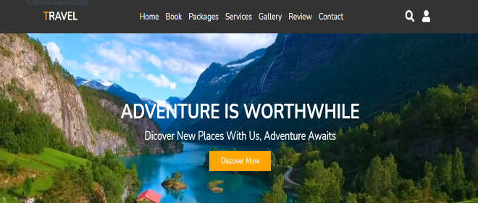

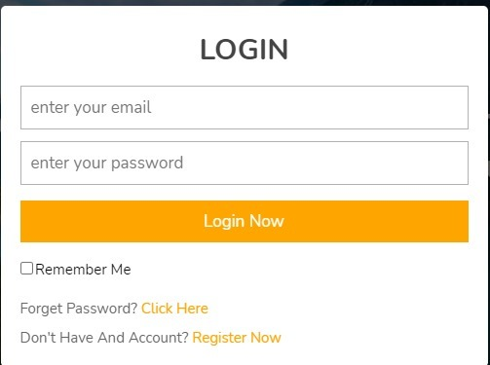

1. **Conclusion**

Tourism is currently recognized as a global industry which is highly growing at a high rate like other industry. There are many different activities are occurred in tour activities. My travel web

helps in online distribution of tour packages , booking, etc.

Finally, I can say that this Web site will help tour manager to control and handle the tour related activates effectively and efficiently.

1. **References**

* <https://www.yatra.com>[/](https://www.yatra.com/)
* <https://www.makemytrip.com/holidays-india/>
* <https://www.akshartours.com/india-tour/>
* https://www.google.com/