Programming Language

Links :

1.[c++](file:///E:/project/c++.html)

2.[programming languages](file:///E:/project/index.html)

3.[perl](file:///E:/project/perl.html)

4.[first-generation programming languages (1GL)](file:///E:/project/The%20%20First-generation%20Programming%20Languages%20(1GL).html)

5.[second-generation programming languages (2GL)](file:///E:/project/The%20Second-generation%20Programming%20Languages%20(2GL).html)

6.[c](file:///E:/project/c.html)

Source code:

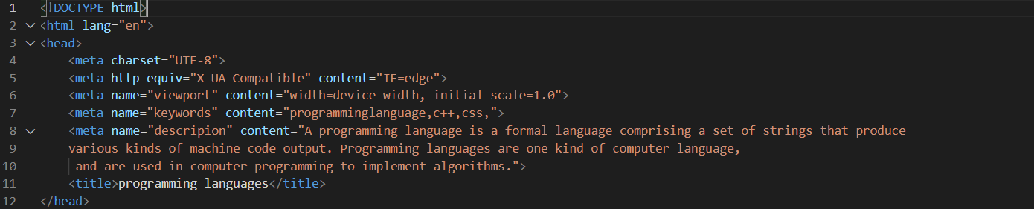

Name: kareem walid mamdoh

Section:27

ID:603

Githup link: <https://github.com/Karim832/html-project>

Githup pages link: <https://karim832.github.io/html-project/>