Hong Kong Institute of Information Technology

ITP4507 - Contemporary Topics in Software Engineering

Laboratory Exercise 5 – Command Pattern

Part 1

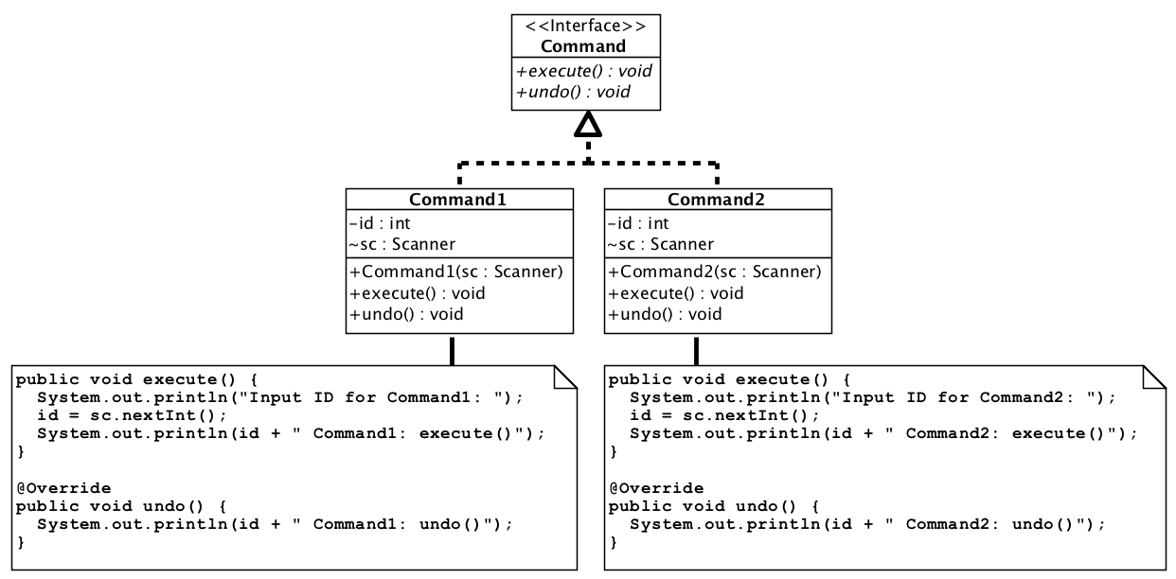

- Implement the above class diagram for the Command interface and Command1 and Command2 implementation classes

- Implement the Main class to execute Command1 and Command2 by using following menu:

Enter command: 0 = exit, 1 = undo, 2 = Commnad1, 3 = Command2

- With a Stack, write program codes to create various Command objects of Command1 and Command2, execute the Command objects in sequence, and perform undo operations of the Command objects in reverse sequence.

- Create two more commands: Exit and Undo

- Use Factory Pattern to create all command objects.

Hints: You can use System.exit(0) to quit your application.
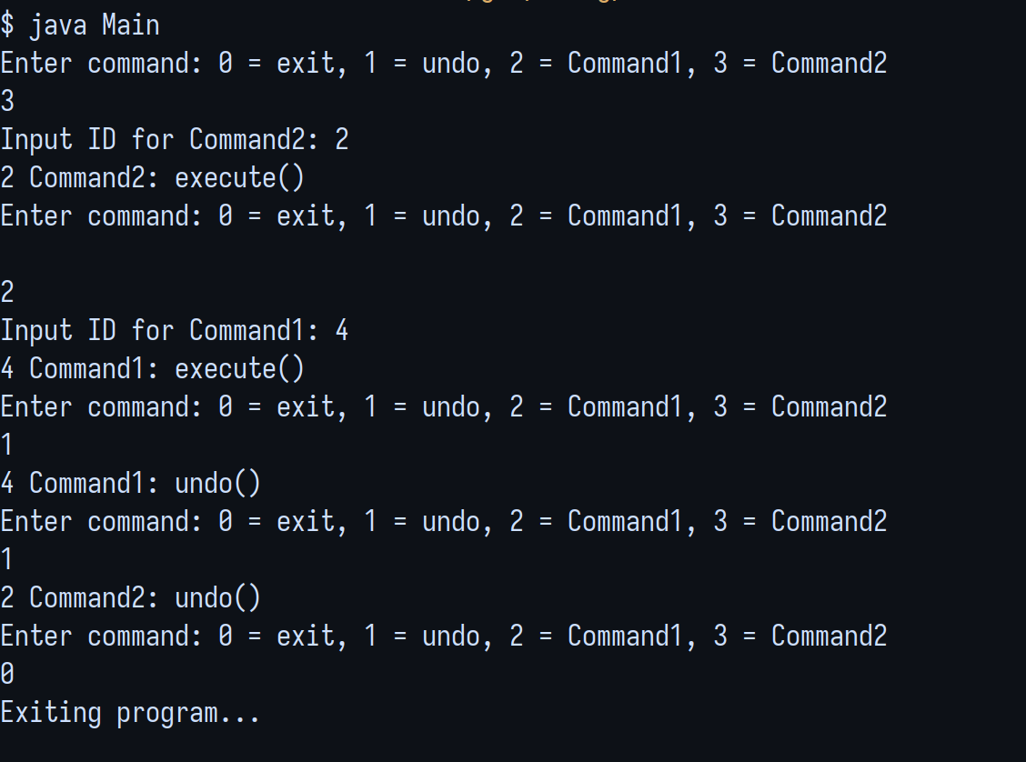
Hints:

To apply Stack, you need to import java.util.*.
To create a new Stack: Stack commands = new Stack();
To push: commands.push(com);
To pop: Command com = (Command) commands.pop();
To check the size of a Stack: commands.size();

Expected Output

Enter command: 0 = exit, 1 = undo, 2 = Command1, 3 = Command2
3
Input id for Command2:
2
2 Command2: execute()
Enter command: 0 = exit, 1 = undo, 2 = Command1, 3 = Command2
2
Input id for Command1:
4
4 Command1: execute()
Enter command: 0 = exit, 1 = undo, 2 = Command1, 3 = Command2
1
4 Command1: undo()
Enter command: 0 = exit, 1 = undo, 2 = Command1, 3 = Command2
1
2 Command2: undo()

Part 2

You are asked to download the source code of a sample program GenerateNumbers.java from web site of the module. Compile and test run the program.

The following is a sample run of the program:-

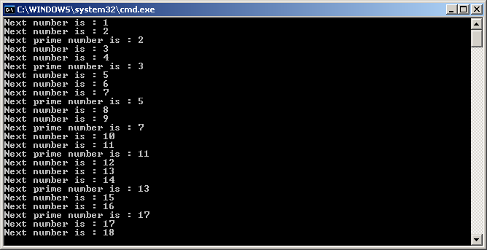

- You may find that the program will be very messy if more different types of number are to be generated periodically by the program. In fact the application can be re-designed based on the command pattern as shown in the following class diagram.

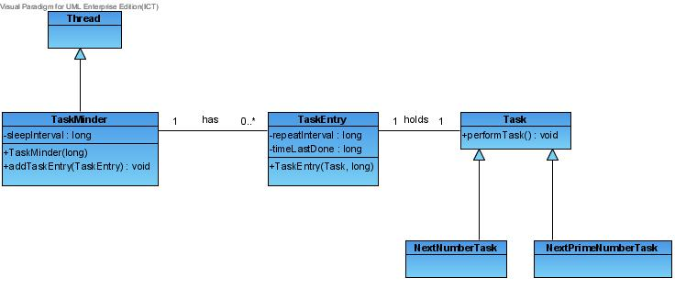

Given the following additional information:-

Class Name | Description
Task | An interface that has only one method performTask().
NextNumberTask | A class that implements the interface Task, it shows the next positive integer when the method performTask() is called (starting from 1).
NextPrimeNumberTask | A class that implements the interface Task, it shows the next prime number when the method performTask() is called (starting from 2).
TaskEntry | A class that is used to hold a command object (Task object). It also keeps 2 data members of type long : repeatInterval (how often the task should be executed) and timeLastDone(time which the task was last done).
TaskMinder | A thread that holds a list of TaskEntry objects and can periodically execute the method performTask() of Task objects. It also keep 1 data member of type long : sleepInterval (how often the TaskMinder should check for tasks to be run).

You are asked to implement the class diagram based on the given information. You may need to add more methods to classes if necessary.

The following is a test program for your implementation.

public class TestCommandPattern {
public static void main(String [] args) {
TaskMinder tm = new TaskMinder(100);

NextNumberTask next = new NextNumberTask();
TaskEntry numberTaskEntry = new TaskEntry(next, 3000);
tm.addTaskEntry(numberTaskEntry);

NextPrimeNumberTask nextPrime = new NextPrimeNumberTask();
TaskEntry primeTaskEntry = new TaskEntry(nextPrime, 7000);
tm.addTaskEntry(primeTaskEntry);

tm.start();
}
}

Part 3

Download your Lab04 Solution and then apply the command pattern to provide the undo function for a simple drawing program. Follow the steps below to complete this exercise:

- Download the simple drawing program (your Lab04 Solution) from the web site of the module.

- Identify the code fragments which implement commands. You should provide following menu:

Enter command: 0 = exit, 1 = undo, 2 = draw all shapes, 3 = delete a shape, 4 = create circle, 5 = create rectangle

- Apply the command pattern to revise the design of the program. You may apply the Factory pattern for creating the required commands.

- You are required to use a Stack to perform the undo Command.

- Implement the new design and test the program.
Hints

To remove an item from the Vector “shapes” by using an object “circle”:
shapes.remove(circle);

To remove an item from the Vector “shapes” by using an index (position of item) and then store the removed item into the object “shape”:
shape = (Shape) shapes.remove(index);

To add the object “shape” to the Vector “shapes” at the position “index”:
shapes.add(index, shape);

Remember that when you pass an object to a method, you are using “Pass By Reference”!

Expected Output

Enter command: 0 = exit, 1 = undo, 2 = draw all shapes, 3 = delete a shape, 4 = create circle, 5 = create rectangle
4
Enter x: 1
Enter y: 2
Enter radius: 3

Enter command: 0 = exit, 1 = undo, 2 = draw all shapes, 3 = delete a shape, 4 = create circle, 5 = create rectangle
5
Enter x: 6
Enter y: 5
Enter width: 3
Enter height: 2

Enter command: 0 = exit, 1 = undo, 2 = draw all shapes, 3 = delete a shape, 4 = create circle, 5 = create rectangle
2
index: 0 - Circle: topLeft [1, 2], Radius=3, Area = 28.274333882308138
index: 1 - Rectangle: topLeft [6, 5], Width=3, height=2, Area = 6.0

Enter command: 0 = exit, 1 = undo, 2 = draw all shapes, 3 = delete a shape, 4 = create circle, 5 = create rectangle
1
Enter command: 0 = exit, 1 = undo, 2 = draw all shapes, 3 = delete a shape, 4 = create circle, 5 = create rectangle
2
index: 0 - Circle: topLeft [1, 2], Radius=3, Area = 28.274333882308138

Enter command: 0 = exit, 1 = undo, 2 = draw all shapes, 3 = delete a shape, 4 = create circle, 5 = create rectangle
4
Enter x: 6
Enter y: 6
Enter radius: 6

Enter command: 0 = exit, 1 = undo, 2 = draw all shapes, 3 = delete a shape, 4 = create circle, 5 = create rectangle
2
index: 0 - Circle: topLeft [1, 2], Radius=3, Area = 28.274333882308138
index: 1 - Circle: topLeft [6, 6], Radius=6, Area = 113.09733552923255

Enter command: 0 = exit, 1 = undo, 2 = draw all shapes, 3 = delete a shape, 4 = create circle, 5 = create rectangle
3
Enter index of the shape: 1
Enter command: 0 = exit, 1 = undo, 2 = draw all shapes, 3 = delete a shape, 4 = create circle, 5 = create rectangle
2
index: 0 - Circle: topLeft [1, 2], Radius=3, Area = 28.274333882308138

Enter command: 0 = exit, 1 = undo, 2 = draw all shapes, 3 = delete a shape, 4 = create circle, 5 = create rectangle
1
Enter command: 0 = exit, 1 = undo, 2 = draw all shapes, 3 = delete a shape, 4 = create circle, 5 = create rectangle
2
index: 0 - Circle: topLeft [1, 2], Radius=3, Area = 28.274333882308138
index: 1 - Circle: topLeft [6, 6], Radius=6, Area = 113.09733552923255

Enter command: 0 = exit, 1 = undo, 2 = draw all shapes, 3 = delete a shape, 4 = create circle, 5 = create rectangle
0

