Hong Kong Institute of Information Technology

ITP4507 - Contemporary Topics in Software Engineering

Laboratory Exercise 4 – Factory Pattern

Q1

(a) You are asked to implement the following class diagram which is based on the Factory Method Design Pattern.

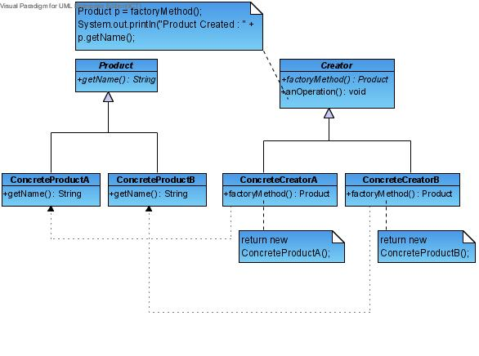
You may use the following Test Program to test the classes that you have implemented.

public class TestFactoryMethod {
public static void main(String [] args) {
String [] creators = {"ConcreteCreatorA", "ConcreteCreatorB"};
try {
int choice = Integer.parseInt(args[0]);
Creator c = (Creator)Class.forName(creators[choice]).newInstance();
c.anOperation();
} catch (Exception e) {
System.out.println("Problem Encoutered");
}
}
}
Sample output of the test program :-

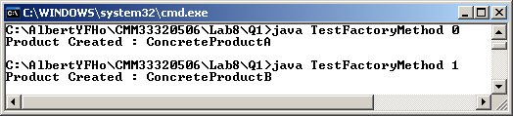

(b) You are asked to implement the following class diagram which is based on the Abstract Factory Design Pattern.

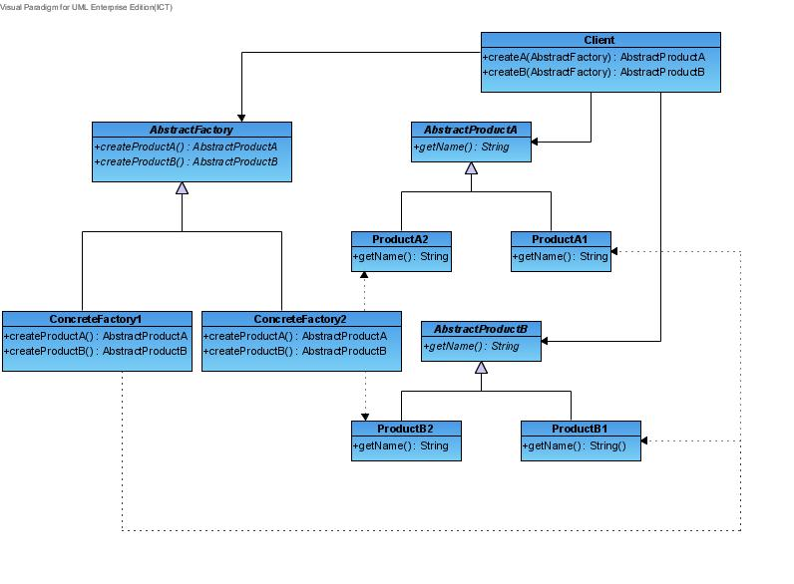You may use the following Test Program to test the classes that you have implemented.

public class TestAbstractFactory {
public static void main(String[] args) {
String[] factories = { "ConcreteFactory1", "ConcreteFactory2" };
try {
Client c = new Client();
int choice = Integer.parseInt(args[0]);

AbstractFactory af =
(AbstractFactory) Class.forName(factories[choice]).newInstance();

System.out.println("Product A Created : " + c.createA(af).getName());
System.out.println("Product B Created : " + c.createB(af).getName());
} catch (Exception e) {
System.out.println("Problem encountered");
}
}
}

Sample output of the test program :-

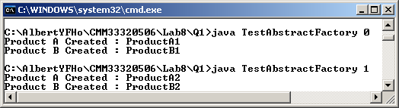

(c) By comparing part (a) and part (b), can you identify the main difference between Factory Method and Abstract Factory? Give one situation (other than the examples given in the lecture notes) in which Abstract Factory pattern is more suitable than Factory Method pattern.

Q2

Download the Lab4a solution (simple drawing program) from Moodle. Apply the Abstract Factory Method design pattern to the solution so that the main menu can be simplified.

Hints:

The java.lang.Class provides methods to load a class (String) and creates an object of the class dynamically. Study the following methods of java.lang.Class:

forName(String className).newInstance()

Use the methods of java.lang.Class to implement your design of solution for Abstract Factory Class.

Example:

ShapeFactory f = (ShapeFactory) Class.forName("CircleFactory").newInstance();

