2-

**a- retroactive:** retro + active

**b- befriended:** be + friend + ed

**c- televise:** tele + vise

**d- margin:** margin

**e- endearment:** en + dear + ment

**f- psychology:** psych + ology

**g- unpalatable:** un + palat + able

**h- holiday:** holi + day

**i- grandmother:** grand + mother

**j- morphemic:** morph + emic

**k- mistreatment:** mis + treat + ment

**l- deactivation:** de + active + ation

**m- saltpeter:** salt + peter

**n- airsickness:** air + sick + ness

**o- bureaucrat:** bureau + crat

**p-** **democrat**: demo + crat

**q- aristocrat**: aristo + crat

**r- plutocrat**: pluto + crat

**s- democracy**: demo + cracy

**t- democratic**: demo + crat + ic

**u- democratically:** demo + crat + ic + ally

**v- democratization:** demo + crat + iz +ation

**w- democratize:** demo + crat + ize

**x- democratizer:** demo + crat + izer

**y- democratizing**: demo + crat + izing

**z- democratized:** demo+crat+ized

**3-**

1. **Noisy crow:** phrase consisting of adjective plus noun (3)
2. **Scarecrow:** compound noun (1)
3. **The crow:** grammatical morphene followed by lexical morphene (6)
4. **Crowlike:** root morpheme plus derivational suffix (5)
5. **Crows:** root morpheme plus inflectional affix (4)

**11-**

I expect these definitions are derived from our interpretation of the words’ morphenes. By joining the morphenes, we can create a meaning that is unintended. For example, “dogmatic”, split into “dog” and “matic” may imply the word is related to dogs, but it is completely irrelevant.

**12-**

1. **Construal**

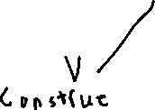

1. **Disappearances**

iii- **Irreplacability**

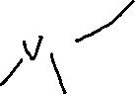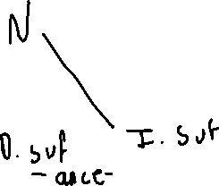

**iv- misconceive:**

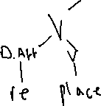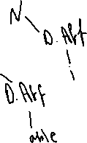

**v- indecipherable:**



**vi- redarken:**

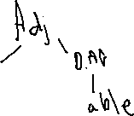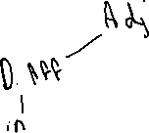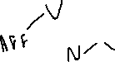

1. **Undarkenable**

**“able to be less dark” “unable to be made dark”**

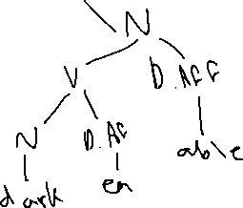

**13-**

**Descript:** indescript

**Cognito:** incognito

**Beknownst:** unbeknownst

**Peccable:** impeccable

**Promptu:** impromptu

**Plussed:** Surplussed

**Domitable:** Predomitable

**Nomer:** Misnomer

**Crat:** Democrat

1. **Prelude, Predict, Monolith, Hexagon, Pentagon**

**14-**

1. **Sci-fi tv series =** Star trek
2. **Campaign =** barnstorming
3. **At-home wear =**

**d- kind of pen =** ballpoint

1. **conservative =** rightwing

**15-**

