**House Light System**

**Team Name: The Others**

**Team members**

**Omar Essam 28-1820 T12**

**Karim Ihab El Sheikh 28-8603 T10**

**Mohamed El Ansary 28-1563 T10**

**Omar Hariry 28-2604 T12**

**Omar El Sharkawy 28-2087 T12**

* **The problem is energy wasted at homes as a result of using light bulbs when they are not needed.**
* **Our project was to design a smart room system that automatically turns on the light in the room you enter and turn it off when you leave the room.**

* **When you enter the room light is automatically set to the general light intensity. The number of people in the room is displayed on the board along with the number displaying the current activity . when the last person gets out of the room the light is automatically turned off.**

**The remote controls the activity by pressing a specific button for each , as follows:**

**1. Movie watching**

**2. Sleeping**

**3. General**

**4. Reading**

**5. Partying**

**these buttons on the remote also controls music :**

**6. stops**

**7. plays**

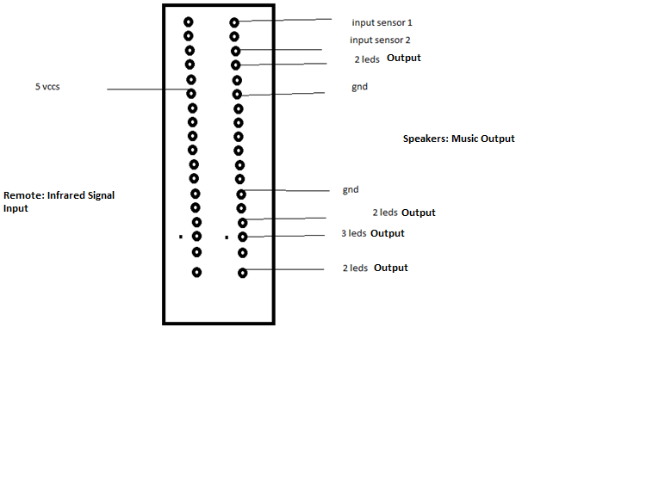

**- there were no specific roles for each member and we all participated equally in the project .**